3GPP TSG-RAN WG3 Meeting #130 R3-25xxxx
Dallas, US, 17-21 November , 2025

Agenda Item: 10.3.2

Source: ZTE Corporation

Title: pCR to TR 38.760-3 on 6G RAN-CN interface options

Document for: Approval

1 Introduction
This TP intends to capture the RAN3 agreements in RAN3#130 on 6G RAN-CN interface options.

5 Text Proposal for TR 38.914

6.1.3 RAN-CN Interface Options
Editor’s note: This chapter includes description of RAN-CN interface options including protocol stacks, considering new and existing services.

6.1.3.x1 Control Plane
Editor Note: The encoding (e.g., ASN.1) for control plane interface options below is FFS.

6.1.3.x1.y1 Point to Point(P2P)
In 6G, Control Plane (CP) signaling between the RAN node and NF in the CN (Core Network), e.g., the AMF (Access and Mobility Management Function).
In this solution, from a logical standpoint, the 6G RAN-CN interface is a point-to-point interface between an RAN node and a CN node. A point-to-point logical interface is feasible even in the absence of a physical direct connection between the RAN node and CN node. In the transport, IP layer point-to-point transmission is used to deliver the signalling PDUs. The application layer signalling protocol is referred to as NG+AP.
The options for the 6G P2P protocol stack are shown blow:

- P2P# option 1: SCTP based P2P protocol stack
Built on SCTP (Stream Control Transmission Protocol) at the transport layer above IP. The application layer uses 3GPP-specific protocols (like NGAP for NG-C) to encapsulate CP signaling.
Figure 6.1.3.x1.y1-1 legacy P2P protocol stack

- P2P# option 2: QUIC based P2P protocol stack
The QUIC based P2P interface represents an evolution of the legacy P2P with replacing the SCTP with UDP and QUIC.
Figure 6.1.3.x1.y1-2 QUIC based P2P protocol stack

6.1.3.x1.y2 Service based interface(SBI)
A RAN-CN SBI (service-based interface) represents how the set of services is provided by the 6G RAN node. RAN connects with CN NF(s) via the standardized SBI. RAN node no longer relies on fixed P2P anchors (e.g., AMF) but directly discovers and invokes new services based on signaling over this SBI between RAN and CN NF(s). SBI allows the application layer to send endpoint information in form of the network node’s/function’s FQDN instead of the network node’s/function’s TNL address. The peer can then resolve this FQDN to an TNL address via NRF or DNS. The message brokers rely on the HTTP layer can be used to routing SBI signaling messages.The options for the 6G SBI protocol stack are shown as blow:

- SBI#1: TCP+HTTP/2
TCP+HTTP/2 option uses TCP as transport protocol above IP and HTTP/2 on application layer. The application layer may use 3GPP-specific protocols (like NGAP for NG-C) to encapsulate CP signaling.
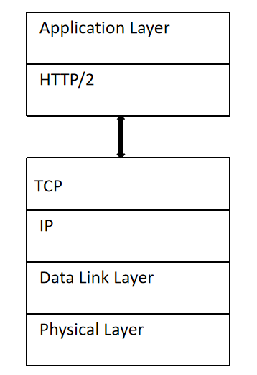
Figure 6.1.3.x1.y2-1 TCP+HTTP/2 SBI protocol stack

- SBI#2: QUIC+HTTP/3
QUIC+HTTP/3 option uses QUIC and UDP as transport protocol above IP and HTTP/3 on application layer. The application layer may use 3GPP-specific protocols (like NGAP for NG-C) to encapsulate CP signaling.
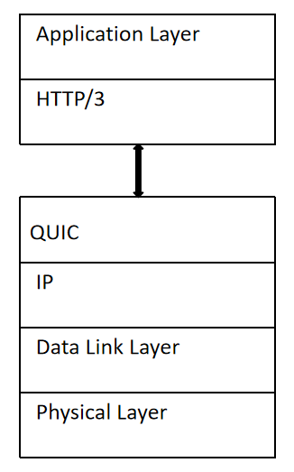
Figure 6.1.3.x1.y2-2 QUIC+HTTP/3 SBI protocol stack

6.1.4 Evaluation of RAN-CN Interface Options
Editor’s note: This chapter includes evaluation and comparison of RAN-CN interface options described in clause 6.1.3.
---------------End of the Change------------------

