3GPP TSG-RAN Meeting #110 R4-25xxxx
Baltimore, USA, December 8-11, 2025

Agenda item: 9.1.5.2
Source: Moderator (Apple)
Title: Topic summary for NR-NTN in terrestrial bands
Document for: Information

Introduction
This document summarizes the contributions submitted to the Rel-20 RAN4-led new WI/SI proposals related to spectrum (AI 9.1.5.2) focused on the topic of NR-NTN in terrestrial bands.

Summary of company contributions
T-doc number | Company | Proposals / Observations
RP-253608 | Telstra Limited, T-Mobile USA, KDDI, SpaceX, Apple, Mediatek, Qualcomm, Ericsson, Samsung, BMW, Rogers, Toyota ITC, Sony, Fraunhofer, Cohere | Motivation for NR-NTN in terrestrial band for Australia  - The Australian administration (the ACMA) has made the determination that  - a)IMT spectrum can be used for MSS today on a ‘no-interference, no-protection’ basis (ITU-R Article 4.4) and  - b)The outcome of WRC-27 AI1.13 will not impact this determination  - This means the IMT licence holder must continue to meet established national regulations:  - Coordinating with terrestrial services operating in the spectrum licence (our own)  - Protecting services in adjacent spectrum held by other licence holders (as usual)  - Receiving and transmitting ONLY in areas defined in our spectrum licence (current situation)  - As there is no regulatory uncertainty in Australia and MSS is already in use in band 7 in Australia, 3GPP can define a new NR-NTN band in the current band 7 spectrum specifically for Australia
RP-253609 | Telstra, T-Mobile USA, KDDI, Rogers, SpaceX, Apple, Mediatek, Qualcomm, Ericsson, Samsung, BMW, Toyota ITC, Sony, Fraunhofer IIS, Fraunhofer HHI, Cohere, UIC | New WID on Introduction of NR-NTN band for Australia  Objectives (please refer to the WID for detailed objectives):  - Specify a new NR-NTN FDD band with a UE transmitting at 2500 MHz – 2570 MHz and SAN transmitting at 2620 MHz – 2690 MHz  - For operation with LEO satellite orbit  - Re-use NR band n7 requirements as much as possible  - CBW: 5/10/15/20 MHz  - SCS: 15/30/60 kHz  - Support UE PC3 (+23dBm)  - Introduce the corresponding SAN and UE RF core requirements  - Introduce the corresponding RRM requirements  - Introduce the new band with appropriate definitions in the specifications that exclude usage of the band in countries/regions where existing regulatory rules do not allow NR-NTN in that mobile terrestrial bands  - The specification work of this WI shall leverage the studies and requirements for n7 and NR NTN n256, n255, n254, n252 where applicable.  - All UE requirements specified as part of this WI shall be Release-independent from Rel-17  WG leadership: RAN4  Supporting companies  - Telstra  - T-Mobile USA  - KDDI  - SpaceX  - Apple  - Mediatek  - Qualcomm  - BMW  - Rogers  - Ericsson  - Toyota ITC  - Sony  - Cohere  - Fraunhofer HHI  - Fraunhofer IIS  - Samsung  - UIC
RP-253699 | T-Mobile USA, Rogers | Motivation for Introduction of a new NR NTN PCS band (1850-1915 MHz UL and 1930-1995 MHz DL)  Proposal: Introduce a new WID for NR-NTN band with the UL part of 1850-1915 MHz and the DL part of 1930-1995 MHz.
RP-253700 | T-Mobile USA, Rogers | New WID: Introduction of NR-NTN PCS band  Objectives (please refer to the WID for detailed objectives):  - Specify a new NR-NTN FDD band with a UE transmitting at 2500 MHz – 2570 MHz and SAN transmitting at 2620 MHz – 2690 MHz;  - Re-use NR band n25 requirements as much as possible  - CBW: 5/10/15/20 MHz  - SCS: 15/30/60 kHz  - Support UE PC3 (+23dBm)  - Introduce the corresponding SAN and UE RF core requirements  - Introduce the corresponding RRM requirements  - Introduce the new band with appropriate definitions in the specifications that exclude usage of this band in countries/regions where existing regulatory rules do not allow NR-NTN in the mobile terrestrial bands  - The specification work of this WI shall leverage the studies and requirements for n25 and NR NTN n256, n255, n254, n252 where applicable.  - All UE requirements specified as part of this WI shall be Release-independent from Rel-17  WG leadership: RAN4  Supporting companies  - T-Mobile USA  - Telstra  - Qualcomm  - Rogers  - Ericsson  - Samsung  - Nokia
RP-253703 | ViaSat Satellite Holdings Ltd, IITH, WiSig, Omnispace,Terrestar | Views on specifying TN frequency bands for NTN  Observation 1: Several NTN bands have been defined as part of 3GPP NR and IoT specifications that may be adjacent to frequency bands that are authorized for TN bands.  Observation 2: Given the interest in enabling more MSS spectrum, ITU-R has initiated a study to evaluate the feasibility of utilizing IMT frequency bands for MSS without causing harm to other existing MS and MSS services in the vicinity of those bands.  Observation 3: Prior ITU-R studies for L-band have shown the need for technical measures such as guard band and/or reduced power and emission levels for TN and NTN services in adjacent channel/band to co-exist in the same geographic area.  Observation 4: Prior ITU-R studies for S-band have shown the need for technical measures such as reduced transmission power and emission levels for the TN and NTN services in the same channel/band to co-exist in geographically separate areas.  Observation 5: There are evaluations from some companies that justify the need for 3GPP to perform its independent co-existence study to evaluate the impact of NTN operations in n2/n25 and n256.  Observation 6: Prior non-3GPP work seems to suggest the need for 3GPP to perform its independent co-existence study to evaluate the impact of NTN operations in frequency range of n2/n25 on TN operations in n2/n25.  Observation 7: If the definition of new NTN band in the TN n7 frequency range is limited to 2500 2510 MHz UL and 2620 2630 MHz DL and if it can be confirmed that ACMA has not authorized MSS in 2500 MHz within its territory then NTN NTN co-existence may not be issue and such a bounded NTN band in a small portion of the TN n7 frequency range can be considered with input from n38/n41 terrestrial operators in the region.  Observation 8: 3GPP has previously performed co-existence studies and specified technical requirements to ensure that sufficient protection is available to adjacent channel/band operations.  Observation 9: To efficiently use allocated TUs, during 5G due to well-formed global regulations for MSS bands, NTN TN was prioritized and NTN-NTN was pushed out into the future.  Observation 10: As part of 6G, co-existence NTN NTN scenario has been prioritized in anticipation of future use of TN frequency bands for NTN.  Observation 11: 3GPP has developed additional technical co-existence emissions requirements to protect adjacent TN band operations from NTN operations despite relaxed regulatory requirements.  Observation 12: There is no technical reason to not perform co-existence studies to evaluate the impact of TN IMT frequency bands when deployed as NTN band on the existing NTN bands (e.g., n256).  Observation 13: If MSS operation in IMT band n1 is authorized by regional regulators globally then lack of protection from NTN operation in n2/n25 frequency range could jeopardize the use IMT band n1 as a future NTN band across several European, Asian and South American countries.  Observation 14: WRC-27 is expected to develop radio regulations related to the use of terrestrial IMT frequency bands for NTN.  Observation 15: RAN4 has already prioritized NTN-NTN scenario as part of 6G NTN co-existence studies and relevant non-spectrum work can start for assessing the impact of specifying NTN bands in the TN frequency ranges.  Observation 16: RAN TSG can specify a checkpoint can be specified for December 2026 to evaluate the study progress and initiating a spectrum work item with appropriate objectives.
RP-253704 | Sateliot | Observations on the status of WRC-27 Agenda Item 1.13 Studies  Observation 1: Recent discussions in 3GPP RAN TSG and the ongoing work in ITU-R under WRC-27 Agenda Item 1.13 show that NR-NTN use of MS bands intersects with several regulatory and technical considerations that are still under study internationally.  Observation 2: National regulatory frameworks enabling satellite or NTN operation in these bands vary significantly across administrations, with many relying on temporary, experimental or no-protection conditions (limiting the services to be provided) that may change following the completion of WRC-27 studies.  Observation 3: The timing of related work has also been noted in 3GPP RAN TSG discussions, given that the ITU-R study cycle under WRC-27 Agenda Item 1.13 is still in progress and is expected to clarify the regulatory framework for potential satellite use of MS bands.  Observation 4: The following elements reflect the broader context observed today:  - A detailed regulatory examination is currently underway in ITU-R, through the study cycle associated with WRC-27 Agenda Item 1.13, which is assessing potential new or modified MSS allocations and the conditions for direct satellite-to-IMT operation in Mobile Service bands.  - Temporary national frameworks governing satellite use of these bands remain heterogeneous, with differing authorisation conditions, allocation structures and protection requirements, and may evolve as ITU-R studies progress.  - Coexistence considerations involving MSS, IMT and NTN systems are being analysed in ITU-R, including directionality, adjacent-band protection and the relationship between existing MSS allocations and future NTN configurations.  - Different uplink and downlink arrangements across ITU regions and administrations have been highlighted in RAN, together with the relevance of ensuring compatibility with existing MSS deployments in adjacent territories.  - The long-standing cooperation between 3GPP and ITU-R has been noted, particularly in relation to NR-NTN’s integration into the IMT-2020 ecosystem and the role of ITU-R M.1036 in defining harmonised band arrangements.  - The cross-border nature of satellite systems and the emerging global market for NTN and D2D services have also been referenced as contextual factors relevant to ongoing international studies.
RP-253709 | Apple | Regulatory overview of satellite communication in terrestrial band frameworks  Since most Administrations just define a list of frequencies or ranges authorised for the satellite communication in terrestrial bands, 3GPP can:  - document the band plan and relevant regulation, as requested by operator(s);  - perform a survey of co-existence scenario; and  - consider additional emission and PFD limits, if any.  Proposal: We kindly ask 3GPP to consider the presented information to progress the discussion on satellite communication in terrestrial bands based on the 3GPP NTN technologies.

Topic #1: General Principles

Summary of open issues
Issue 1-1: Potential 3GPP activities related to the use of terrestrial IMT frequency bands for NTN
- Approach 1: Specify new NR NTN bands according to National regulations as they become available (e.g. see WIDs in RP-253609, RP-253700)
- Approach 2a: There is no technical reason to not perform co-existence studies to evaluate the impact of TN IMT frequency bands when deployed as NTN band on the existing NTN bands (e.g., n256) [ViaSat, RP-253703]
- Approach 2b: We kindly ask 3GPP to consider the presented information to progress the discussion on satellite communication in terrestrial bands based on the 3GPP NTN technologies. 3GPP can: [Apple, RP-253709]
- document the band plan and relevant regulation, as requested by operator(s);
- perform a survey of co-existence scenario; and
- consider additional emission and PFD limits, if any
- Approach 3: Initiating normative work such as a WID would be most productive once the international regulatory framework is clarified through WRC-27, consistent with the long-standing cooperation and alignment between ITU-R and 3GPP processes. [Sateliot, RP-253704]
- Temporary national frameworks governing satellite use of these bands remain heterogeneous, with differing authorisation conditions, allocation structures and protection requirements, and may evolve as ITU-R studies progress.
- Aligning the sequencing of 3GPP work with the results of WRC-27 can help prevent country-by-country fragmentation, avoid the need for subsequent revision, and ensure that any NR-NTN solution reflects the conditions ultimately adopted by ITU-R
- The cross-border nature of satellite systems and the emerging global market for NTN and D2D services have also been referenced as contextual factors relevant to ongoing international studies
Moderator’s note: the approaches listed above are not necessarily mutually exclusive, and companies are encouraged to elaborate on their vision in the company comments section.

Company comments and discussion
Please share your thoughts regarding the possible approach to proceed 3GPP activities for both bands n7 and n25 based on the Approaches listed above, a combination thereof, or other possible approaches.

Company | Comment

Summary of discussion and recommended way forward

Topic #2: Coexistence scenarios

Summary of open issues
Moderator’s note: the open issues listed below are summarized from the submitted contributions. The intention of this section of the summary is to capture all views, and companies are encouraged to describe any scenarios missed in this summary in the company comments section.

Issue 2-1: Band n2/n25 as NTN coexistence with NTN n256 (SAN-SAN)
- Option 1: There are evaluations from some companies that justify the need for 3GPP to perform its independent co-existence study to evaluate the impact of NTN operations in n2/n25 and n256 [ViaSat, RP-253703; figure below taken from the paper to illustrate the scenario]
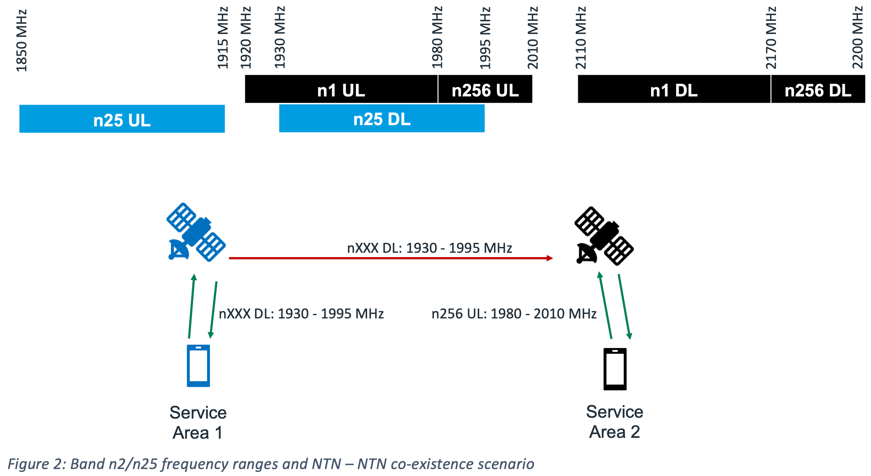
- Option 2: RAN4 to study impact of NGSO constellation deployed in the frequency range of n2/n25 (to provide service in one region) on GSO and NGSO systems deployed in n256 (to provide service in another region). Both co-channel and adjacent channel deployments scenarios to be considered with priority for co-channel evaluation [Sateliot, RP-253704]

Issue 2-2: Band n1 as NTN coexistence with NTN operation in n2/n25 (SAN-SAN)
- Option 1: If MSS operation in IMT band n1 is authorized by regional regulators globally then lack of protection from NTN operation in n2/n25 frequency range could jeopardize the use IMT band n1 as a future NTN band across several European, Asian and South American countries [ViaSat, RP-253703]

Issue 2-3: Band n2/n25 as NTN coexistence with TN system(s)
- Option 1: RAN4 to study impact of NGSO constellation deployed in the frequency range of n2/n25 on a TN system deployed in an adjacent channel providing service in the same geographic coverage area [Sateliot, RP-253704]
Moderator’s note: for Issue 2-3 it may be helpful to check what base station emission mask is assumed for the scenario with band n2/n25 as NTN.

Issue 2-4: Band n7 as NTN coexistence with MSS 2500 MHz
- Option 1: If the definition of new NTN band in the TN n7 frequency range is limited to 2500 – 2510 MHz UL and 2620 – 2630 MHz DL and if it can be confirmed that ACMA has not authorized MSS in 2500 MHz within its territory then NTN – NTN co-existence may not be issue and such a bounded NTN band in a small portion of the TN n7 frequency range can be considered with input from n38/n41 terrestrial operators in the region [ViaSat, RP-253703; figure below taken from the paper to illustrate the scenario]
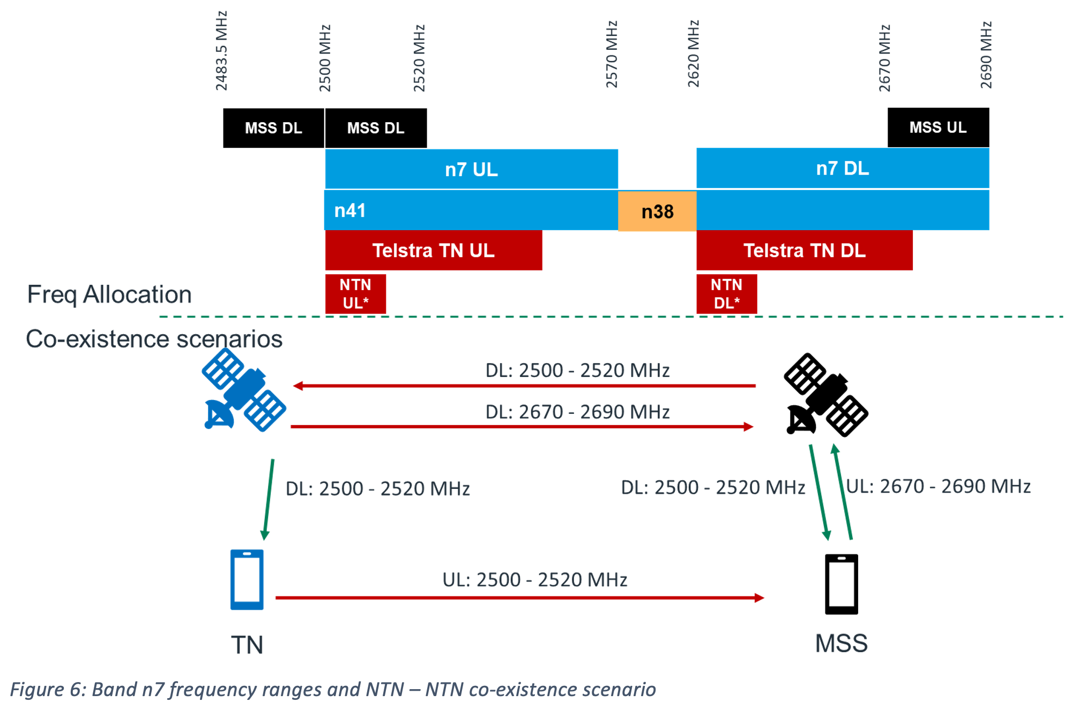
- Option 2: Introducing a new non-conforming (Art.4.4 of RR) satellite-based NTN service (de facto MSS) in the same frequency range on the basis of a national Mobile Service allocation, without relying on the MSS allocation or bearing equivalent ITU-R obligations, would create a regulatory asymmetry, and operate contrary to the provisions in Article 21 of ITU´s Radio Regulations. [Sateliot, RP-253704]

Issue 2-5: Coexistence study to assess the conditions under which NR-NTN or IoT-NTN can operate in downlink in the “upper C band” (3800 – 4200 MHz) and in uplink in the S band (n256)
- Option 1: Conduct coexistence study. Reuse S band coexistence study assumptions (see TR 38.863) as much as possible, with modifications where necessary, e.g. for coexistence scenario, frequency range and subcarrier spacing [SES, RP-253407]

Company comments and discussion
Please share your thought regarding whether/how to proceed the co-existence related issues in terms of 3GPP activities.

Company | Comment

Summary of discussion and recommended way forward

