3GPP TSG-RAN Meeting #110 RP-253819
Baltimore, USA, December 8-11, 2025

Agenda item: 9.1.5.2
Source: Moderator (Apple)
Title: Moderator’s summary for NR-NTN in terrestrial bands
Document for: Information

Introduction
This document summarizes the contributions submitted to the Rel-20 RAN4-led new WI/SI proposals related to spectrum (AI 9.1.5.2) focused on the topic of NR-NTN in terrestrial bands.

Summary of company contributions
T-doc number | Company | Proposals / Observations
RP-253608 | Telstra Limited, T-Mobile USA, KDDI, SpaceX, Apple, Mediatek, Qualcomm, Ericsson, Samsung, BMW, Rogers, Toyota ITC, Sony, Fraunhofer, Cohere | Motivation for NR-NTN in terrestrial band for Australia  - The Australian administration (the ACMA) has made the determination that  - a)IMT spectrum can be used for MSS today on a ‘no-interference, no-protection’ basis (ITU-R Article 4.4) and  - b)The outcome of WRC-27 AI1.13 will not impact this determination  - This means the IMT licence holder must continue to meet established national regulations:  - Coordinating with terrestrial services operating in the spectrum licence (our own)  - Protecting services in adjacent spectrum held by other licence holders (as usual)  - Receiving and transmitting ONLY in areas defined in our spectrum licence (current situation)  - As there is no regulatory uncertainty in Australia and MSS is already in use in band 7 in Australia, 3GPP can define a new NR-NTN band in the current band 7 spectrum specifically for Australia
RP-253609 | Telstra, T-Mobile USA, KDDI, Rogers, SpaceX, Apple, Mediatek, Qualcomm, Ericsson, Samsung, BMW, Toyota ITC, Sony, Fraunhofer IIS, Fraunhofer HHI, Cohere, UIC | New WID on Introduction of NR-NTN band for Australia  Objectives (please refer to the WID for detailed objectives):  - Specify a new NR-NTN FDD band with a UE transmitting at 2500 MHz – 2570 MHz and SAN transmitting at 2620 MHz – 2690 MHz  - For operation with LEO satellite orbit  - Re-use NR band n7 requirements as much as possible  - CBW: 5/10/15/20 MHz  - SCS: 15/30/60 kHz  - Support UE PC3 (+23dBm)  - Introduce the corresponding SAN and UE RF core requirements  - Introduce the corresponding RRM requirements  - Introduce the new band with appropriate definitions in the specifications that exclude usage of the band in countries/regions where existing regulatory rules do not allow NR-NTN in that mobile terrestrial bands  - The specification work of this WI shall leverage the studies and requirements for n7 and NR NTN n256, n255, n254, n252 where applicable.  - All UE requirements specified as part of this WI shall be Release-independent from Rel-17  WG leadership: RAN4  Supporting companies  - Telstra  - T-Mobile USA  - KDDI  - SpaceX  - Apple  - Mediatek  - Qualcomm  - BMW  - Rogers  - Ericsson  - Toyota ITC  - Sony  - Cohere  - Fraunhofer HHI  - Fraunhofer IIS  - Samsung  - UIC
RP-253699 | T-Mobile USA, Rogers | Motivation for Introduction of a new NR NTN PCS band (1850-1915 MHz UL and 1930-1995 MHz DL)  Proposal: Introduce a new WID for NR-NTN band with the UL part of 1850-1915 MHz and the DL part of 1930-1995 MHz.
RP-253700 | T-Mobile USA, Rogers | New WID: Introduction of NR-NTN PCS band  Objectives (please refer to the WID for detailed objectives):  - Specify a new NR-NTN FDD band with a UE transmitting at 2500 MHz – 2570 MHz and SAN transmitting at 2620 MHz – 2690 MHz;  - Re-use NR band n25 requirements as much as possible  - CBW: 5/10/15/20 MHz  - SCS: 15/30/60 kHz  - Support UE PC3 (+23dBm)  - Introduce the corresponding SAN and UE RF core requirements  - Introduce the corresponding RRM requirements  - Introduce the new band with appropriate definitions in the specifications that exclude usage of this band in countries/regions where existing regulatory rules do not allow NR-NTN in the mobile terrestrial bands  - The specification work of this WI shall leverage the studies and requirements for n25 and NR NTN n256, n255, n254, n252 where applicable.  - All UE requirements specified as part of this WI shall be Release-independent from Rel-17  WG leadership: RAN4  Supporting companies  - T-Mobile USA  - Telstra  - Qualcomm  - Rogers  - Ericsson  - Samsung  - Nokia
RP-253703 | ViaSat Satellite Holdings Ltd, IITH, WiSig, Omnispace,Terrestar | Views on specifying TN frequency bands for NTN  Observation 1: Several NTN bands have been defined as part of 3GPP NR and IoT specifications that may be adjacent to frequency bands that are authorized for TN bands.  Observation 2: Given the interest in enabling more MSS spectrum, ITU-R has initiated a study to evaluate the feasibility of utilizing IMT frequency bands for MSS without causing harm to other existing MS and MSS services in the vicinity of those bands.  Observation 3: Prior ITU-R studies for L-band have shown the need for technical measures such as guard band and/or reduced power and emission levels for TN and NTN services in adjacent channel/band to co-exist in the same geographic area.  Observation 4: Prior ITU-R studies for S-band have shown the need for technical measures such as reduced transmission power and emission levels for the TN and NTN services in the same channel/band to co-exist in geographically separate areas.  Observation 5: There are evaluations from some companies that justify the need for 3GPP to perform its independent co-existence study to evaluate the impact of NTN operations in n2/n25 and n256.  Observation 6: Prior non-3GPP work seems to suggest the need for 3GPP to perform its independent co-existence study to evaluate the impact of NTN operations in frequency range of n2/n25 on TN operations in n2/n25.  Observation 7: If the definition of new NTN band in the TN n7 frequency range is limited to 2500 2510 MHz UL and 2620 2630 MHz DL and if it can be confirmed that ACMA has not authorized MSS in 2500 MHz within its territory then NTN NTN co-existence may not be issue and such a bounded NTN band in a small portion of the TN n7 frequency range can be considered with input from n38/n41 terrestrial operators in the region.  Observation 8: 3GPP has previously performed co-existence studies and specified technical requirements to ensure that sufficient protection is available to adjacent channel/band operations.  Observation 9: To efficiently use allocated TUs, during 5G due to well-formed global regulations for MSS bands, NTN TN was prioritized and NTN-NTN was pushed out into the future.  Observation 10: As part of 6G, co-existence NTN NTN scenario has been prioritized in anticipation of future use of TN frequency bands for NTN.  Observation 11: 3GPP has developed additional technical co-existence emissions requirements to protect adjacent TN band operations from NTN operations despite relaxed regulatory requirements.  Observation 12: There is no technical reason to not perform co-existence studies to evaluate the impact of TN IMT frequency bands when deployed as NTN band on the existing NTN bands (e.g., n256).  Observation 13: If MSS operation in IMT band n1 is authorized by regional regulators globally then lack of protection from NTN operation in n2/n25 frequency range could jeopardize the use IMT band n1 as a future NTN band across several European, Asian and South American countries.  Observation 14: WRC-27 is expected to develop radio regulations related to the use of terrestrial IMT frequency bands for NTN.  Observation 15: RAN4 has already prioritized NTN-NTN scenario as part of 6G NTN co-existence studies and relevant non-spectrum work can start for assessing the impact of specifying NTN bands in the TN frequency ranges.  Observation 16: RAN TSG can specify a checkpoint can be specified for December 2026 to evaluate the study progress and initiating a spectrum work item with appropriate objectives.
RP-253704 | Sateliot | Observations on the status of WRC-27 Agenda Item 1.13 Studies  Observation 1: Recent discussions in 3GPP RAN TSG and the ongoing work in ITU-R under WRC-27 Agenda Item 1.13 show that NR-NTN use of MS bands intersects with several regulatory and technical considerations that are still under study internationally.  Observation 2: National regulatory frameworks enabling satellite or NTN operation in these bands vary significantly across administrations, with many relying on temporary, experimental or no-protection conditions (limiting the services to be provided) that may change following the completion of WRC-27 studies.  Observation 3: The timing of related work has also been noted in 3GPP RAN TSG discussions, given that the ITU-R study cycle under WRC-27 Agenda Item 1.13 is still in progress and is expected to clarify the regulatory framework for potential satellite use of MS bands.  Observation 4: The following elements reflect the broader context observed today:  - A detailed regulatory examination is currently underway in ITU-R, through the study cycle associated with WRC-27 Agenda Item 1.13, which is assessing potential new or modified MSS allocations and the conditions for direct satellite-to-IMT operation in Mobile Service bands.  - Temporary national frameworks governing satellite use of these bands remain heterogeneous, with differing authorisation conditions, allocation structures and protection requirements, and may evolve as ITU-R studies progress.  - Coexistence considerations involving MSS, IMT and NTN systems are being analysed in ITU-R, including directionality, adjacent-band protection and the relationship between existing MSS allocations and future NTN configurations.  - Different uplink and downlink arrangements across ITU regions and administrations have been highlighted in RAN, together with the relevance of ensuring compatibility with existing MSS deployments in adjacent territories.  - The long-standing cooperation between 3GPP and ITU-R has been noted, particularly in relation to NR-NTN’s integration into the IMT-2020 ecosystem and the role of ITU-R M.1036 in defining harmonised band arrangements.  - The cross-border nature of satellite systems and the emerging global market for NTN and D2D services have also been referenced as contextual factors relevant to ongoing international studies.
RP-253709 | Apple | Regulatory overview of satellite communication in terrestrial band frameworks  Since most Administrations just define a list of frequencies or ranges authorised for the satellite communication in terrestrial bands, 3GPP can:  - document the band plan and relevant regulation, as requested by operator(s);  - perform a survey of co-existence scenario; and  - consider additional emission and PFD limits, if any.  Proposal: We kindly ask 3GPP to consider the presented information to progress the discussion on satellite communication in terrestrial bands based on the 3GPP NTN technologies.

Topic #1: General Principles

Summary of open issues
Issue 1-1: Potential 3GPP activities related to the use of terrestrial IMT frequency bands for NTN
- Approach 1: Specify new NR NTN bands according to National regulations as they become available (e.g. see WIDs in RP-253609, RP-253700)
- Approach 2a: There is no technical reason to not perform co-existence studies to evaluate the impact of TN IMT frequency bands when deployed as NTN band on the existing NTN bands (e.g., n256) [ViaSat, RP-253703]
- Approach 2b: We kindly ask 3GPP to consider the presented information to progress the discussion on satellite communication in terrestrial bands based on the 3GPP NTN technologies. 3GPP can: [Apple, RP-253709]
- document the band plan and relevant regulation, as requested by operator(s);
- perform a survey of co-existence scenario; and
- consider additional emission and PFD limits, if any
- Approach 3: Initiating normative work such as a WID would be most productive once the international regulatory framework is clarified through WRC-27, consistent with the long-standing cooperation and alignment between ITU-R and 3GPP processes. [Sateliot, RP-253704]
- Temporary national frameworks governing satellite use of these bands remain heterogeneous, with differing authorisation conditions, allocation structures and protection requirements, and may evolve as ITU-R studies progress.
- Aligning the sequencing of 3GPP work with the results of WRC-27 can help prevent country-by-country fragmentation, avoid the need for subsequent revision, and ensure that any NR-NTN solution reflects the conditions ultimately adopted by ITU-R
- The cross-border nature of satellite systems and the emerging global market for NTN and D2D services have also been referenced as contextual factors relevant to ongoing international studies
Moderator’s note: the approaches listed above are not necessarily mutually exclusive, and companies are encouraged to elaborate on their vision in the company comments section.

Company comments and discussion
Please share your thoughts regarding the possible approach to proceed 3GPP activities for both bands n7 and n25 based on the Approaches listed above, a combination thereof, or other possible approaches.

Company | Comment
Telecom Italia | We need to consider ITU-R; should we send an LS and ask for feedback?  In our understanding, the solution under discussion is proprietary; if the current solution is already using 3GPP technology, then we should not be here discussing it.
Eutelsat | There will be other WRCs during the lifetime of 5G NTN; not in favor for waiting for WRC-27; Approach 1 or Approach 2 or some combination is worth exploring
Vodafone | The WIDs did not convince us that LTE cannot already support the use case proposed; we prefer to wait for WRC-27 outcome to avoid fragmentation in global certification of terminals; early adoption schemes like this could result in optimization for satellite rather than terrestrial operation (where we see the capacity driver)
Ericsson | Is it possible to treat the WIDs separately if we need to? We support both WIDs and support Approach 1
KDDI | We support Approach 1; we should follow Administration decision
CATT | It is premature to discuss these issues; we should wait for WRC-27
ZTE | It is premature to go with these approaches; coexistence study is the critical issue; we should have a clear understanding of the regulation first
AST SpaceMobile | We agree with TIM and Vodafone; the ITU may be surprised by this in 3GPP; we seek a better understanding of the use case; if the target is to support voice by end of 2027, we wonder if devices will be ready; we should wait for WRC-27 and so support Approach 3.  On comments related to proprietary satellite operations, yes, several satellite systems are using proprietary solutions today precisely because they are required to stay within existing interim/temporary national and global ITU/WRC regulatory frameworks until those are harmonized globally for everyone (first priority on MSS spectrum [which is originally designated as the NTN world] and possibly as well on IMT bands) – that is a regulatory and legal task, not a 3GPP task. 3GPP is NOT the entity developing a joint legal-technical inter-system framework for every global satellite operation. In our view, such proposals however lead to a global technical shift across the NTN ecosystem without such regulatory backing and likely lead to a defacto of similar proposals on other IMT bands (i.e., fully away from Australia) forcing 3GPP, for fairness basis, to handle country-by-country proposals and all of this, is totally outside the 3GPP scope.  In addition, the stated urgency (that 4G traffic will be insufficient to carry mandated voice by end-2027) is neither substantiated nor realistic when you factor in the time needed to agree the work, upgrade devices, ship, and deploy them on a scale before that date.  That is said, we support Approach 3 in the first place but can be open to a full-fledged coexistence study at minimum (not only on proposed bands) despite this being highly overlapping with active ITU/WRC 27 agenda items and with a lack of justification why should 3GPP duplicate such work that quick?
CMCC | In 3GPP we don’t perform inter-frequency and inter-system coexistence; this is ITU responsibility; waiting for WRC-27 is one direction; another could be a better interaction with the ITU to understand their status
ViaSat | We are proponents of Approach 2; as NTN becomes more and more popular, we will need to consider this use case; we should consider systems that transcend ITU regions; 3GPP should take up these coexistence studies properly  Prior to Rel-17 3GPP did not perform NTN-TN coexistence; eventually we find a way to work on technical work in 3GPP
Orange | 3GPP should not perform coexistence studies and should not replace regulatory activities; whatever we agree should be on the basis of no overlap between the two systems; we are worried about external understanding if 3GPP does not follow this approach
Huawei | 3GPP coexistence domain is adjacent channel; ITU is inter-system and inter-frequency, which is important here; our preference is Approach 3; we are also OK for 3GPP to ask for regulatory status as proposed by Telecom Italia (e.g. AI 1.13); there is another ITU study under AI 7 to discuss potential improvement for ITU-R Article 4.4, for which we would like to know the status  We can ask the ITU about progress in AI 7 related to Article 4.4
Samsung | As a supporter of the two WIDs, we support Approach 1; we share the Ericsson proposal to treat the WIDs first; ViaSat’s paper is useful to consider, which seems to suggest that the band n7 case may have the least complex coexistence scenario
China Unicom | For the Telstra proposal the case belongs to ITU discussion; we should follow the ITU timeline; next we can discuss in 3GPP whether we study the coexistence issue; if we want to align with the ITU, then we need to send an LS to ITU first
Sateliot | We wanted to provide a full visibility of what is going on in the ITU in our contribution; ITU is ahead of us in terms of the completion of these studies – about 24 months. The studies commenced in March 2024, and they have gone through several liaison processes between WP-4C (satellite) and WP-5D (terrestrial), to reach protection criteria and operational scenarios (see Annex 8 in our contribution). WP4C is mandated to send the result of studies to CPM in less than 18 months; In these studies, (please see Table 5 of our contribution) the scope of ITU is (and owes to be much wider given the PFD and OOBE adjustments to MSS operations in the MSS 2600 band, currently limited under Article 21 of the Radio Regulations)  At a minimum, the work should start by engaging with the ITU, asking:  1) clarify on the status and progress of technical studies under of AI 1.13 and  2) clarify ITU´s ongoing discussions and views on the use of Article 4.4 for commercial services and whether this is sustainable for the development of a standard.  If studies were to be conducted, we should widen their scope substantially, beyond a national defined standard, considering:  - The MS 2600 FDD arrangement (UL and DL as per ITU-r M1036) corresponding with n7  - To conduct these studies for a global standard in n7  - To consider the necessary PFD and OOBE limits, to guide ITU in the process of optimal regulatory amendment of operational characteristics for MSS 2600 under Article 21 of the RR.
OPPO | We prefer Approach 3; coexistence study should be done in the ITU; liaison with ITU could be a good way to go
Echostar | At very minimum, we should consider Approach 2a and 2b to perform the necessary coexistence analysis; this is necessary before considering Approach 1
Terrestar | We support Approach 2; if 3GPP is not comfortable performing coexistence study ahead of ITU, then an LS can be a good idea
Novamint | We support Approach 3; we can send an LS to ITU; if we go into coexistence studies, then we have to do this globally and properly
KT | We support Approach 3; ITU covers all the aspects; in the meanwhile, 3GPP could figure out the framework how to capture these ideas; will we use a note? Notes with applicability notes could become very complicated
Rogers | We support Approach 1; the ITU in Article 4.4 indicated that there are some exceptions in some requirements; we have seen this with national regulations and related etails
LG Electronics | We support Approach 1 to address urgent operator needs; if using unmodified is currently OK according to some national regulations, then what is the problem with changing this to NR NTN?
Hutchison | We should reduce fragmentation of device ecosystem; if there is a requirement specific to Australia, then we should consider it; n7 could be considered by other administrations; we should strive for a global solution
MediaTek | Our view is visible in the list of co-signers; what is proposed to be send in an LS to the ITU? At least the use case is very clear
ITU-R Ad-Hoc Convenor | If 3GPP were to decide to liaise with ITU, the document should be approved by SA and PCG according to the procedure in 3GPP
ETRI | We are fine with Approach 1 or 2
AT&T | It is reasonable to send an LS to the ITU to check status; they can give us guidance
China Telecom | We have some concern on coexistence issues; we can await the outcome of WRC-27
Verizon | We prefer to wait for WRC-27
Nokia | We support Approach 1; we should work on use cases proposed by operators that are allowed by regulation to be deployed
Qualcomm | We support Approach 1; we should find a way to enable the use of this technology; can we blend some of these approaches to address some of these concerns? We worry about proprietary solutions emerging if we don’t solve this
Boost Mobile | We are supportive of performing a study (Approach 2)
T-Mobile | We support Approach 1; we would like to see the work begin; given the diverse views, it will be hard to find a way forward that makes everyone happy; there are proprietary systems in operation using unmodified LTE; if there are enough delays, then the shift to NR may also feature a proprietary solution
Telstra | We have an imperative to move on this, and our preference is to proceed with the technology specified by 3GPP since Rel-17; we have the regulatory approval to proceed; we support Approach 1
Ofinno | We support Approach 1; if efforts are already happening, we should support standardization and discourage long-term use of proprietary solutions
Thales | If the feasibility of defining MS bands for NR-NTN is assessed from a regulatory point of view, RAN to ensure that the introduction of these new bands shall not impact the existing specifications and shall not cause degradation (in the sense of RAN4 co-existence studies) to terrestrial and non-terrestrial networks in 3GPP specified bands which are adjacent/overlapping to the proposed new bands.
Lockheed Martin | We support approach 2a/2b as it has potential to offer more deployment options
Gatehouse Satcom | We do note that Telstra is moving in-right forward by using their licensed, national spectrum for the use of satellite coverage (as allowed by national/ACMA regulatory guidelines, ITU Article 4.4).  However, to keep future control of spectrum and avoid possible interference and co-existing issues, and not to create additional load on 3GPP performing necessary co-existence studies, we prefer to trust that the outcome of current ITU activities (ITU/AI 1.13) will guide how to operate with this. For this reason, we support Approach 3.
IITH, Wisig | We support 2a/2b and their existing satellites in MSS 2600 MHz band that conform to ITU allocations. 3GPP needs to study the impact/co-existence with the existing service before moving forward on the WI.
Aalyria | We believe Approach 1 is a non-starter. It goes fundamentally against the basic principles of MSS spectrum regulation and operation by looking at this with a “terrestrial” view, where spectrum can be country-specific because base stations and their emissions are fully localized, that does not apply when the base station emitters are moved to space, in which the emissions have effects that are much wider than a single country – this is what has driven the global harmonization (as much as possible) of MSS spectrum.  If 3GPP were to just specify the band specs without doing any study, it would amount to an endorsement of Article 4.4, which we think is a non-starter, because it is a fall-back approach that is understood not to actually protect spectrum users.  We believe Approach 3 is formally correct for the normative aspects, however, Approach 2 is what 3GPP can actually do starting from now and contribute a technical view on.  Rationale:  - Whether we like it or not, this deployment mode is a reality and is of wide interest.  - Whether we like it or not, 3GPP’s output (either way it goes) will indirectly guide the regulatory process. 3GPP thus should provide a comprehensive and practical technical view, not bury our heads under the sand. Especially in light of operators/vendors saying that they will implement this anyways in proprietary means.  - These issues are not specific to bands n7 or n25 and are not specific to Australia or North America.  - 3GPP has the ability of studying concrete technical solutions that can actually help the ITU/WRC process, help open the market and protect spectrum users.  - The final say will inevitably be ith ITU/WRC  Way forward:  - Perform a comprehensive study on possible coexistence scenarios, aspects, challenges and potential solutions, with deployment configurations based on real references (including multiple satellite constellations based on actual deployment plans)  - Include also NTN-NTN space-to-space coexistence  - Study possible band definitions and pairings – comprehensively.  - Band specific aspects  - E.g. In case of n7 frequencies, include at least consideration for Region 3 wide MSS allocations in reverse pairing and study coexistence also defining hypothetical bands supporting these MSS allocations, possibly with different band configuration/pairing scenarios.  - E.g. In case of n25, consider the implications of coexistence with all applicable bands and deployment scenarios.  - FFS whether considering other FCC SCS bands, as a secondary priority and based on operator interest.  - Send an LS to ITU-R to communicate 3GPP’s intentions.  Monitor the progress of ITU/WRC process and later evaluate whether some initial new NTN band normative specifications can be introduced and how.

Summary of discussion and recommended way forward
The table below provides a summary of the company positions after the offline discussion of Topic 1. One new approach was proposed: Approach 3b - “liaise with the ITU.” It was noted by the ITU-R Ad-Hoc Convenor that if 3GPP were to decide to liaise with the ITU, then the document should be approved by SA and PCG according to the procedure in 3GPP.
Approach | Supporting companies
Approach 1: Specify new NR NTN bands according to National regulations as they become available (e.g. see WIDs in RP-253609, RP-253700) | Ericsson, KDDI, Samsung, Rogers, LGE, , MediaTek, ETRI, Nokia, Qualcomm, Telstra, Ofinno, Apple (12)
Approach 2a/2b: perform co-existence studies to evaluate the impact of TN IMT frequency bands when deployed as NTN band on the existing NTN bands [ViaSat, RP-253703] and/or 3GPP can document the band plan and relevant regulation, as requested by operator(s); perform a survey of co-existence scenario; and consider additional emission and PFD limits, if any. [Apple, RP-253709] | Eutelsat, ViaSat, Echostar, Terrestar, ETRI, Boost Mobile, Apple, Lockheed Martin , IITH, Wisig (10)
Some combination of Approach 1 and/or Approach 2a/2b | Ericsson, KDDI, Samsung, Rogers, LGE, , MediaTek, ETRI, Nokia, Qualcomm, Telstra, Ofinno, Apple, Eutelsat, ViaSat, Echostar, Terrestar, Boost Mobile, Lockheed Martin, IITH, Wisig (20)
Approach 3: Initiating normative work such as a WID would be most productive once the international regulatory framework is clarified through WRC-27, consistent with the long-standing cooperation and alignment between ITU-R and 3GPP processes. [Sateliot, RP-253704] | Telecom Italia, Vodafone, CATT, ZTE, AST SpaceMobile, CMCC, Orange, Huawei, China Unicom, Sateliot, OPPO, Novamint, KT, China Telecom, Verizon, Gatehouse Satcom (16)
Approach 3b: liaise with the ITU; we could ask the ITU to:  1) clarify the status of AI 1.13 and  2) request information on the current considerations of ITU-R for the use of Article 4.4 | Telecom Italia, Huawei, China Unicom, Sateliot, OPPO, Novamint, AT&T, Gatehouse Satcom (8)
Some combination of Approach 3 and/or 3b: Either wait for WRC-27 or liaise with the ITU to ask for status | Telecom Italia, Vodafone, CATT, ZTE, AST SpaceMobile, CMCC, Orange, Huawei, China Unicom, Sateliot, OPPO, Novamint, KT, China Telecom, Verizon, AT&T, Gatehouse Satcom (17)

Topic #2: Coexistence scenarios

Summary of open issues
Moderator’s note: the open issues listed below are summarized from the submitted contributions. The intention of this section of the summary is to capture all views, and companies are encouraged to describe any scenarios missed in this summary in the company comments section.

Issue 2-1: Band n2/n25 as NTN coexistence with NTN n256 (SAN-SAN)
- Option 1: There are evaluations from some companies that justify the need for 3GPP to perform its independent co-existence study to evaluate the impact of NTN operations in n2/n25 and n256 [ViaSat, RP-253703; figure below taken from the paper to illustrate the scenario]
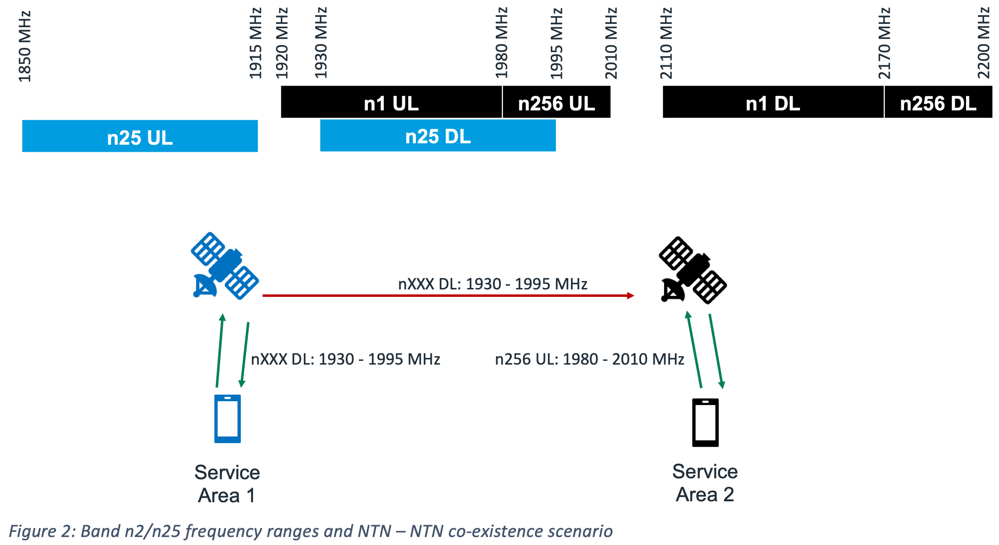
- Option 2: RAN4 to study impact of NGSO constellation deployed in the frequency range of n2/n25 (to provide service in one region) on GSO and NGSO systems deployed in n256 (to provide service in another region). Both co-channel and adjacent channel deployments scenarios to be considered with priority for co-channel evaluation [Sateliot, RP-253704]

Issue 2-2: Band n1 as NTN coexistence with NTN operation in n2/n25 (SAN-SAN)
- Option 1: If MSS operation in IMT band n1 is authorized by regional regulators globally then lack of protection from NTN operation in n2/n25 frequency range could jeopardize the use IMT band n1 as a future NTN band across several European, Asian and South American countries [ViaSat, RP-253703]

Issue 2-3: Band n2/n25 as NTN coexistence with TN system(s)
- Option 1: RAN4 to study impact of NGSO constellation deployed in the frequency range of n2/n25 on a TN system deployed in an adjacent channel providing service in the same geographic coverage area [Sateliot, RP-253704]
Moderator’s note: for Issue 2-3 it may be helpful to check what base station emission mask is assumed for the scenario with band n2/n25 as NTN.

Issue 2-4: Band n7 as NTN coexistence with MSS 2500 MHz
- Option 1: If the definition of new NTN band in the TN n7 frequency range is limited to 2500 – 2510 MHz UL and 2620 – 2630 MHz DL and if it can be confirmed that ACMA has not authorized MSS in 2500 MHz within its territory then NTN – NTN co-existence may not be issue and such a bounded NTN band in a small portion of the TN n7 frequency range can be considered with input from n38/n41 terrestrial operators in the region [ViaSat, RP-253703; figure below taken from the paper to illustrate the scenario]
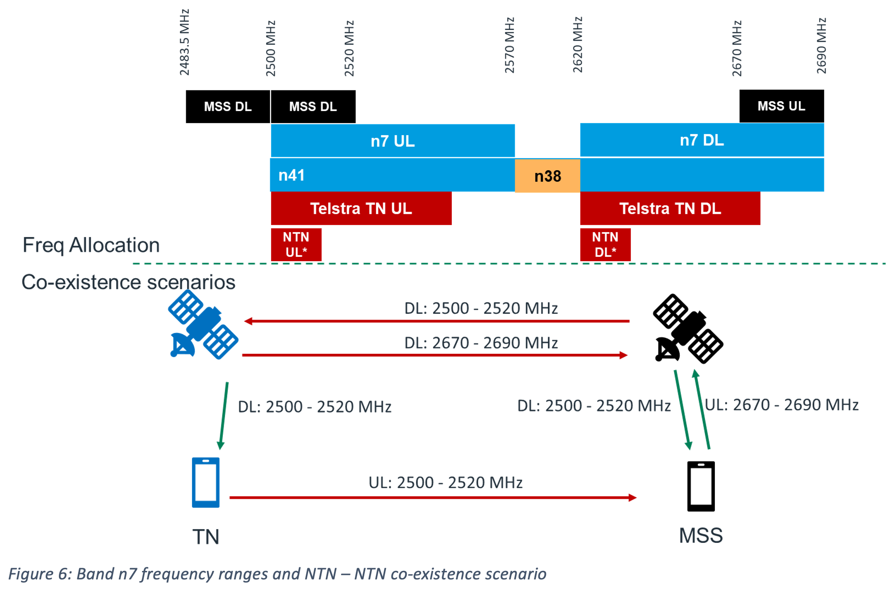
- Option 2: Introducing a new non-conforming (Art.4.4 of RR) satellite-based NTN service (de facto MSS) in the same frequency range on the basis of a national Mobile Service allocation, without relying on the MSS allocation or bearing equivalent ITU-R obligations, would create a regulatory asymmetry, and operate contrary to the provisions in Article 21 of ITU´s Radio Regulations. [Sateliot, RP-253704]

Issue 2-5: Coexistence study to assess the conditions under which NR-NTN or IoT-NTN can operate in downlink in the “upper C band” (3800 – 4200 MHz) and in uplink in the S band (n256)
- Option 1: Conduct coexistence study. Reuse S band coexistence study assumptions (see TR 38.863) as much as possible, with modifications where necessary, e.g. for coexistence scenario, frequency range and subcarrier spacing [SES, RP-253407]

Company comments and discussion
Please share your thought regarding whether/how to proceed the co-existence related issues in terms of 3GPP activities.

Company | Comment
Orange | We do not agree to go into this realm, as this is ITU responsibility
Sateliot | We provided a reference to the ITU annex 8 that already lists the coexistence scenarios; we support Orange proposa that we are not in the realm of establishing scenarios yetl; AI 1.13 is considering the MSS 2600 (UL and DL) which corresponds with Region 3 MSS allocations, so we would need to include this in the scope of what we consider; ITU Recommendation M.1036 (particular arrangement C3 for this band; FDD) should be included as part of the studies; to avoid a clash with potential ITU outcomes.  If we were to perform similar coexistence studies, we would not be ahead of the ITU; are we only considering a single NTN operator in n7;  If studies were to be conducted, we should widen their scope substantially, beyond a national defined standard, considering:  - The MS 2600 FDD arrangement (UL and DL as per ITU-r M1036) corresponding with n7  - To conduct these studies for a global standard in n7  - To consider the necessary PFD and OOBE limits, to guide ITU in the process of optimal regulatory amendment of operational characteristics for MSS 2600 under Article 21 of the RR.
ViaSat | We have done NTN-TN coexistence in 3GPP, and it could have been claimed that ITU did this work as well; we also perform UE-UE coexistence limits in 3GPP, which does not have such requirements in regulation; we don’t see a difference here when it comes to protecting NTN systems  One approach we have proposed to avoid the coexistence with the Region 3 MSS band (let’s call it the MSS 2600 band) is to consider restricting the frequency range of n7 as NTN operation
Telecom Italia | Agree with Orange; we have an ITU adhoc to ensure alignment; it is not a good precedent to do something different
Novamint | If we perform a coexistence study, we have to perform it properly; one scenario we can add is n7 as NTN with the MSS Region 3 allocation that is the opposite duplex (new scenario)
Vodafone | We should consider n7 as NTN DL and n38 UL; also potentially consider n7 as NTN UL and n38 DL
AST SpaceMobile | We support Orange view that coexistence is ITU responsibility
AT&T | The scope of ITU coexistence studies is greater than 3GPP coexistence studies; there might be impacts that we may not be able to anticipate; if 3GPP chooses to take on coexistence work, we would like to understand where 3GPP would get the resources
Eutelsat | Coexistence scenarios related to n7 as NTN can be done as a small study in 3GPP; RAN4 does have the competence to do some of this work; there is a radio astronomy incumbent at the other end of the band, although our understanding of the Telstra proposal is that they do not intend to use that end of the band
Ericsson | Prior 3GPP coexistence studies were performed within the framework of known regulatory requirements; at that time it was discussed whether to perform NTN-NTN coexistence, and it was agreed not to do that based on the international regulations; in this case, the coexistence is NTN to NTN in outer space; this may not be within a well-defined global scenario
Telstra | In Australia we do not have n38; if we were to have a coexistence study as part of getting the band n7 work going, we should tighten the scenario definition to align with Australia arrangements
Huawei | Different size of constellation will generate different levels of interference; we are not sure if 3GPP has sufficient input on different constellations; ITU has this information
Alyria | Our proposal would have been to proceed with coexistence studies; we worry some background is missing; the reason MSS rules are globally defined is to ensure emissions are managed in space; Australia is confined geographically, but we worry about side lobe emissions to the rest of Region 3, which has the reverse-duplex MSS band allocation; space to space coexistence analysis needs a closer look
ZTE | The proposed coexistence study here is different from previous release; this seems to include a subset of ITU work; we should understand the expected outcome
Samsung | We support the approach to review every scenario; the discussion just now somehow identified that n7 does not have a coexistence issue with n38; space to space coexistence seems to be out of scope of 3GPP
Echostar | 3GPP has done coexistence analysis ahead of ITU in the past; the best way is to analyze this to see the issues and to find resolutions
CATT | If 3GPP performs a coexistence study, we could be duplicating ITU efforts; if we were to have a study, we prefer to consider the complete scope
Aalyria | Consider all proposed coexistence scenarios, and include hypothetical bands/deployments considering Region-wide MSS allocations and their pairing configurations (e.g. Region 3 MSS allocations with reverse pairing)  (See our detailed Way Forward proposal in Topic #1 above)

Summary of discussion and recommended way forward
Next steps for this meeting
Moderator: can we try to take these proposed WIDs one at a time and collect a picture of the coexistence scenarios as accurately as we can? This does not necessarily mean we endorse any coexistence work: the outcome would just give the RAN Chair a snapshot of the technical understanding.
Telstra: it is a good way forward to try to proceed on the WIDs separately; we think it is a good idea to work toward the correct picture of the coexistence scenario for n7 in Australia this meeting
T-Mobile/Rogers: we would be fine to work this week to collect a clear picture of the coexistence scenario around our band n25 proposal (for the US and Canada)
Orange: we don’t agree to collect the coexistence scenario details this week
ViaSat: this is a good next step; at a minimum, we can consider liaising with the ITU-R; it can be helpful to list everything we could potentially need to ask ITU-R
Telstra: the scenario we are considering is specific to n7 rather than just Telstra
Telecom Italia: support Orange
Sateliot: how many satellite systems should we consider when carrying out coexistence studies? Looking at ITU coexistence scenarios can be a good starting point
AT&T: we are OK to collect information; what kind of coexistence scenario? Are we expecting an exhaustive list by this week?
Echostar: the action is for Telstra and T-Mobile/Rogers to collect information to get the correct picture
Hutchison: n38 is allocated for commercial free-to-air television broadcasters and the ABC for television outside broadcast (TOB) via apparatus-licensing arrangements in Australia;
Moderator’s note: I will speak with several companies offline to collect the related description to include in this summary for information to report to the RAN Chair. Further comments from all interested companies are very welcome.
Band n2/n25 as NTN coexistence with NTN n256 (SAN-SAN and SAN-UE)
- Consider the scenario shown in the figure below, where the interference mechanisms consist of the following:
- the DL signal from NTN operation in the frequency range defined by n2/n25 and another SAN’s reception of MSS band n256 UL signal (adjacent channel and co-channel)
- The DL signal from NTN operation in the frequency range defined by n2/n25 and another operator’s UE’s reception of terrestrial band n2/n25 (adjacent channel)
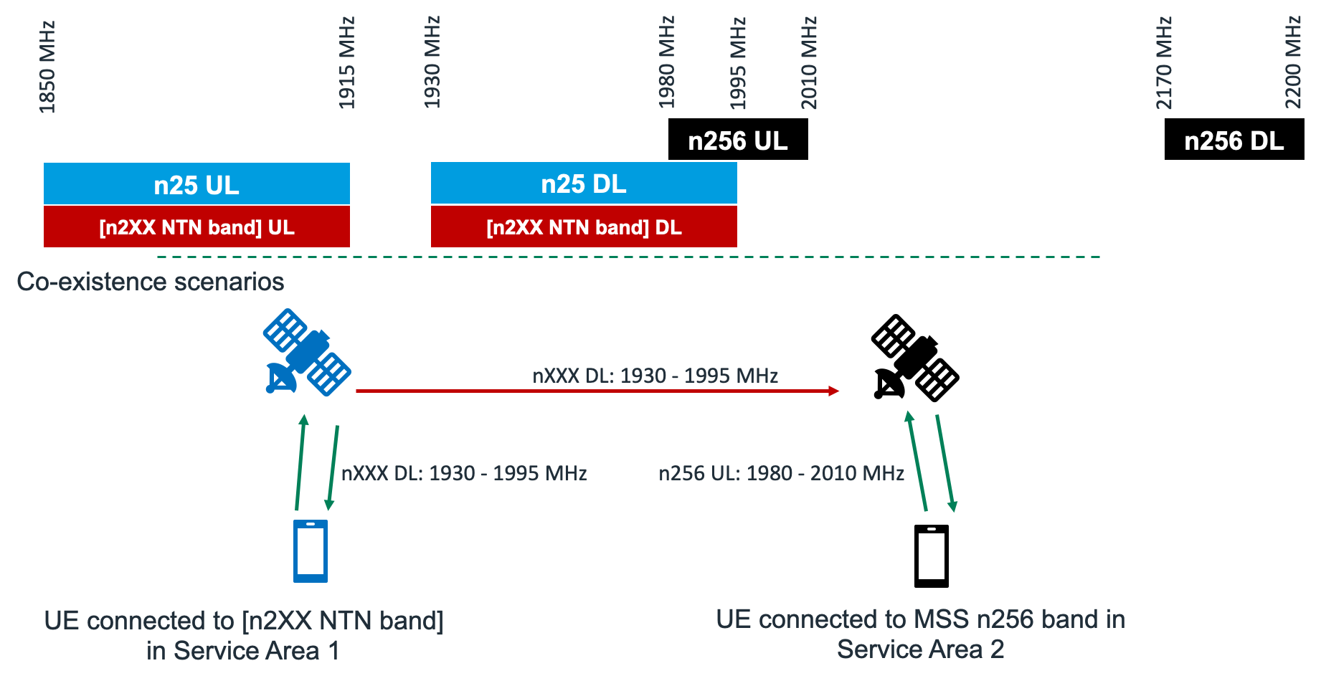

Band n7 as NTN coexistence with MSS 2600 MHz (SAN-SAN and UE-UE)
- Consider the scenario shown in the figure below, where the interference mechanisms consist of the following:
- The DL signal from NTN operation in the frequency range defined by n7 and another SAN’s reception of the MSS 2600 MHz UL signal
- The UL signal from NTN operation in the frequency range defined by n7 and another UE’s reception of the MSS 2600 MHz DL signal
- Protection of radio astronomy in nearby bands will be per ITU-R regulations; a coexistence study by 3GPP is not needed for this case
- For operation of n7 as NTN in Australia, we can assume that a terrestrial network with band n38 is not present
- For operation of n7 as NTN in Australia, we can assume that the MSS 2600 MHz band is not allocated in Australia
