3GPP TSG SA5 Meeting #165 S5-260786d1

Goa, India, 9-13 February 2026
CR-Form-v12.5
CHANGE REQUEST
 | 28.541 | CR | 1679 | rev |  | Current version: | 19.6.0
For HELP on using this form: comprehensive instructions can be found at
https://www.3gpp.org/Change-Requests.

Proposed change affects: | UICC apps |  | ME |  | Radio Access Network | X | Core Network | X

Title: | Correct definition of EP_RP
Source to WG: | Ericsson Canada Inc.
Source to TSG: | S5
Work item code: | AdNRM_Ph3 |  |  |  |  |  | Date: |  |  | 2026-01-24
Category: | F |  |  |  |  |  | Release: |  |  | Rel-19
 | Use one of the following categories:  F (correction)  A (mirror corresponding to a change in an earlier release)  B (addition of feature),  C (functional modification of feature)  D (editorial modification)  Detailed explanations of the above categories can  be found in 3GPP TR 21.900. |  |  |  |  |  |  |  | Use one of the following releases:  Rel-8 (Release 8)  Rel-9 (Release 9)  Rel-10 (Release 10)  Rel-11 (Release 11)  …  Rel-18 (Release 18)  Rel-19 (Release 19)  Rel-20 (Release 20)  Rel-21 (Release 21)
Reason for change: |  | The definition of EP_RP is inconsistent between the attributes table and UML definition. The UML diagram is also missing the association names.
Summary of change: |  | Align the multiplicity of the attribute definition and the UML. Add the missing association names to the UML diagram. Add the UML source to the
Consequences if not approved: |  | Inconsistency can lead to incorrect implementation and impact interoperability.
Clauses affected: |  | 4.2.1.1, Q.5
 |  | Y | N
Other specs |  |  | N | Other core specifications |  |  |  | TS/TR ... CR ...
affected: |  |  | N | Test specifications |  |  |  | TS/TR ... CR ...
(show related CRs) |  |  | N | O&M Specifications |  |  |  | TS/TR ... CR ...
Other comments:
This CR's revision history:

==============First change==============

4.2 Class diagram

4.2.1 Class diagram for gNB and en-gNB

4.2.1.1 Relationships
This clause depicts the set of classes (e.g. IOCs) that encapsulates the information relevant for this gNB and en-gNB. For the UML semantics, see 3GPP TS 32.156 [43]. Subsequent clauses provide more detailed specification of various aspects of these classes.
The model fragments are for management representation of gNB and en-gNB for all NG-RAN deployment scenario as listed below.
- Non-split NG-RAN deployment scenario, represents the gNB defined in TS 38.401[4]. In this scenario, a gNB is represented by a combination of a GNBCUCPFunction, one or more GNBCUUPFunctions and one or more GNBDUFunctions.
- 2-split NG-RAN deployment scenario, represents the gNB consist of gNB-CU and gNB-DU defined in TS 38.401[4] clause 6.1.1. In this scenario, a gNB-CU is represented by a combination of a GNBCUCPFunction and one or more GNBCUUPFunctions, whereas a gNB-DU is represented by a GNBDUFunction.
- 3-split NG-RAN deployment scenario, represents the gNB consist of gNB-CU-CP, gNB-CU-UP and gNB-DU defined in TS 38.401[4] clause 6.1.2. In this scenario, a gNB-CU-CP is represented by a GNBCUCPFunction, a gNB-CU-UP is represented by a GNBCUUPFunction, and a gNB-DU is represented by a GNBDUFunction.
Figure 4.2.1.1-1: NRM for all deployment scenarios

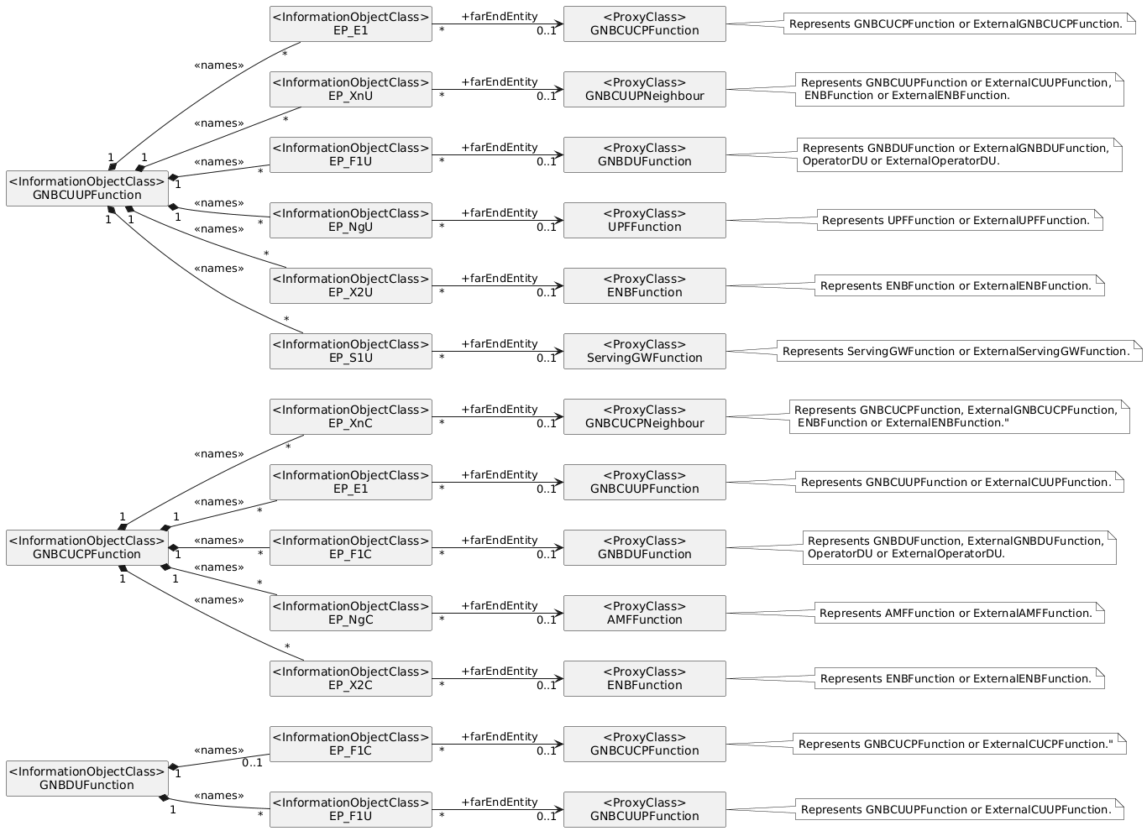
Figure 4.2.1.1-2: NRM for EPs for all deployment scenarios
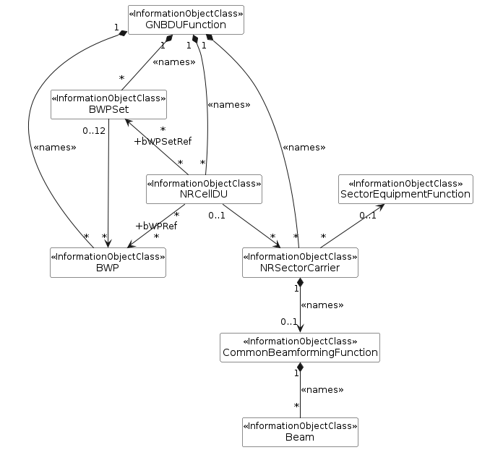
Figure 4.2.1.1-3: NRM for <<IOC>>NRSectorCarrier,<<IOC>>BWP, <<IOC>>SectorEquipmentFunction and <<IOC>> BWPSet for all deployment scenarios
Figure 4.2.1.1-4: Cell Relation view for all deployment scenarios
NOTE 1: The above NRM fragment uses SubNetwork to hold both NR and LTE external entities and frequencies.
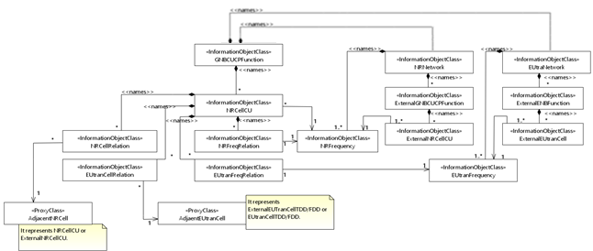Figure 4.2.1.1-5: Cell Relation view for all deployment scenarios
NOTE 2: The above NRM fragment uses ExternalNRNetwork to hold NR external entities and frequency and using ExternalEUtraNetwork to hold LTE external entities and frequency.
Figure 4.2.1.1-6: NRM fragment for abstract RRM Policies
Figure 4.2.1.1-6a: NRM fragment for RRMPolicyRatio
Figure 4.2.1.1-7: NRM fragment to support RIM
Figure 4.2.1.1-8: NRM fragment for pre-configured 5QIs in NG-RAN
NOTE 3: Void.
Figure 4.2.1.1-9: NRM fragment for DANR Management
Figure 4.2.1.1-10: NRM fragment for DES Management
Figure 4.2.1.1-11: NRM fragment for DRACH Management
Figure 4.2.1.1-12: NRM fragment for DMRO Management
Figure 4.2.1.1-13: NRM fragment for DPCI Management
Figure 4.2.1.1-14: NRM fragment for CES Management
Figure 4.2.1.1-15: NRM fragment for CPCI Management
Figure 4.2.1.1-16: NRM fragment for dynamically assigned 5QIs in NG-RAN
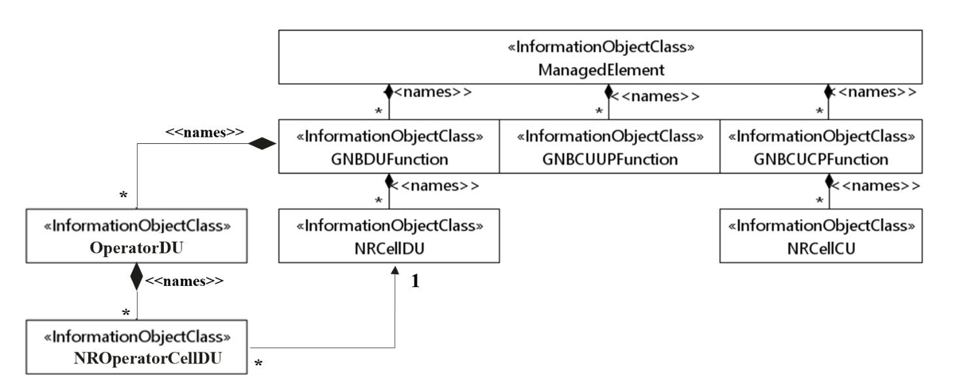
Figure 4.2.1.1-17: NRM fragment for NG-RAN MOCN network sharing with multiple cell identity broadcast feature
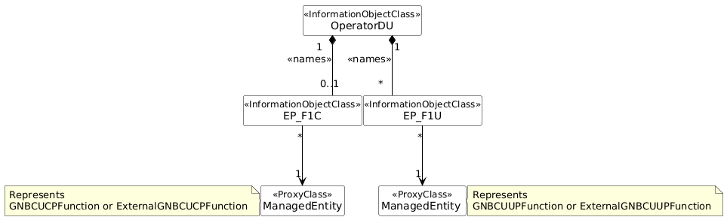
Figure 4.2.1.1-18: NRM fragment for F1 related EPs to support individual F1 interface for NG-RAN MOCN network sharing with multiple cell identity broadcast feature
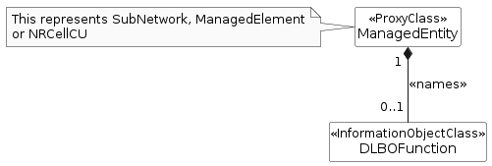
Figure 4.2.1.1-19: NRM fragment for DLBO Management
Figure 4.2.1.1-20: NRM fragment for CCO Management
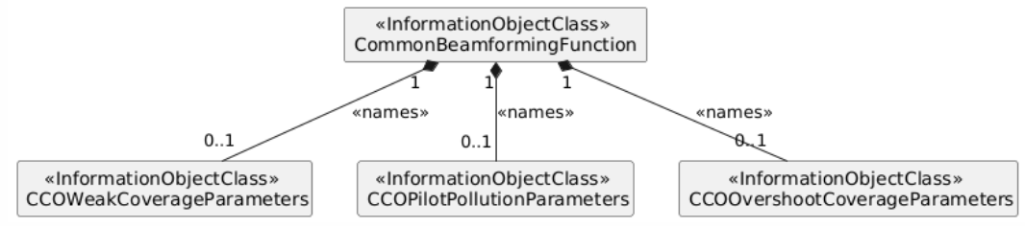
Figure 4.2.1.1-20A: NRM fragment for distribute CCO Management
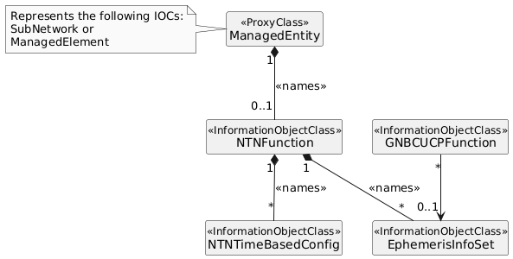
Figure 4.2.1.1-21: NRM fragment to support NTN management
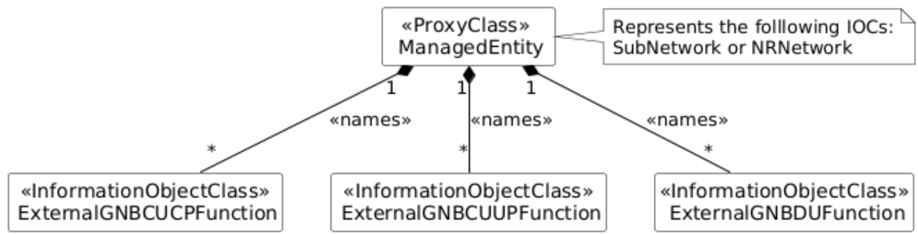
Figure 4.2.1.1-22: NRM fragment for ExternalGNBCUCPFunction, ExternalGNBCUUPFunction and ExternalGNBDUFunction
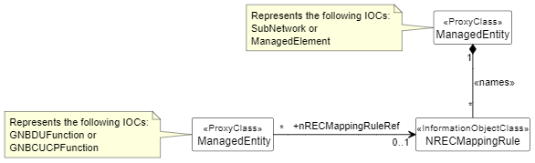
Figure 4.2.1.1-23: NRM fragment for energy cost mapping rule
Figure 4.2.1.1-24: NRM fragment for MWAB
Note: The above figure is subject to change as appropriate.
Figure 4.2.1.1-25: NRM relationship fragment for AIOT
Figure 4.2.1.1-26: NRM fragment for RedCap Access
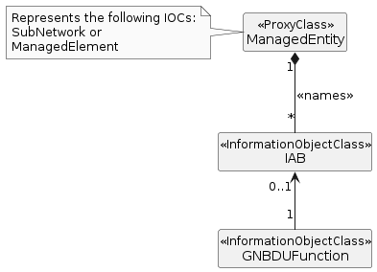
Figure 4.2.1.1-27: NRM fragment for IAB

4.2.1.2 Inheritance
This clause depicts the inheritance relationships.
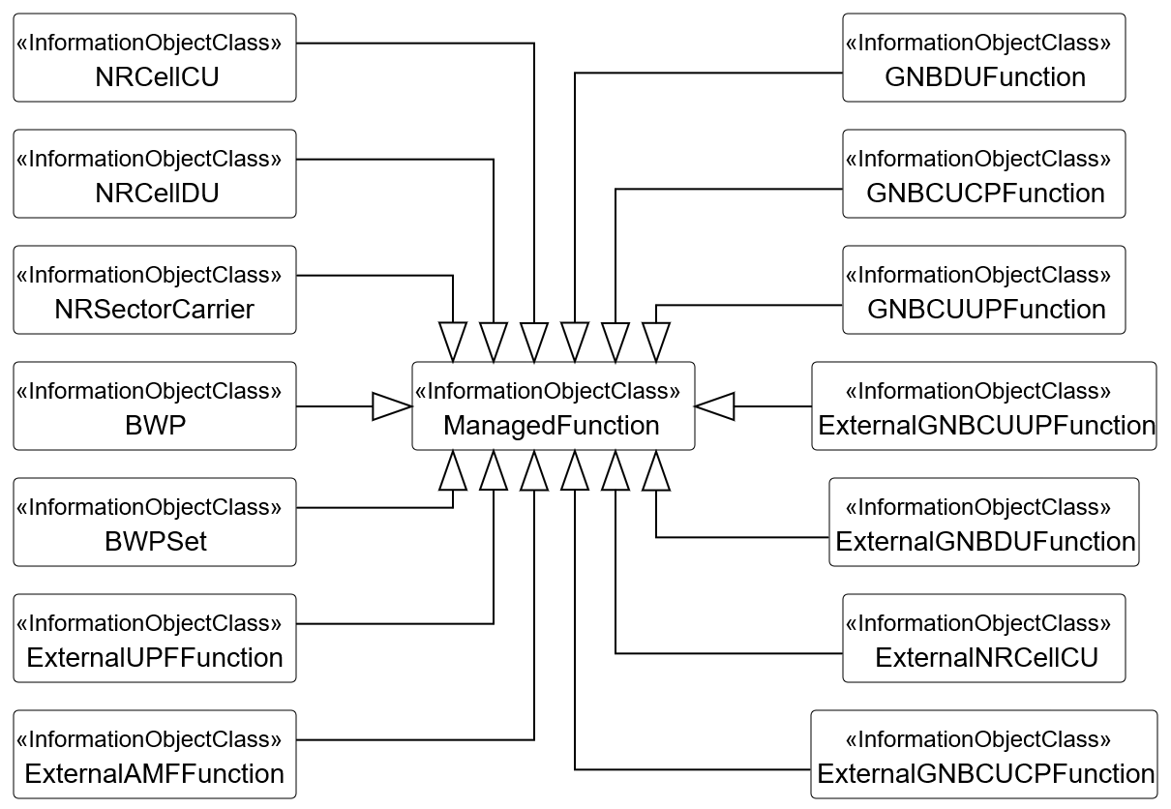
Figure 4.2.1.2-1: NR NRM fragment in all deployment scenarios
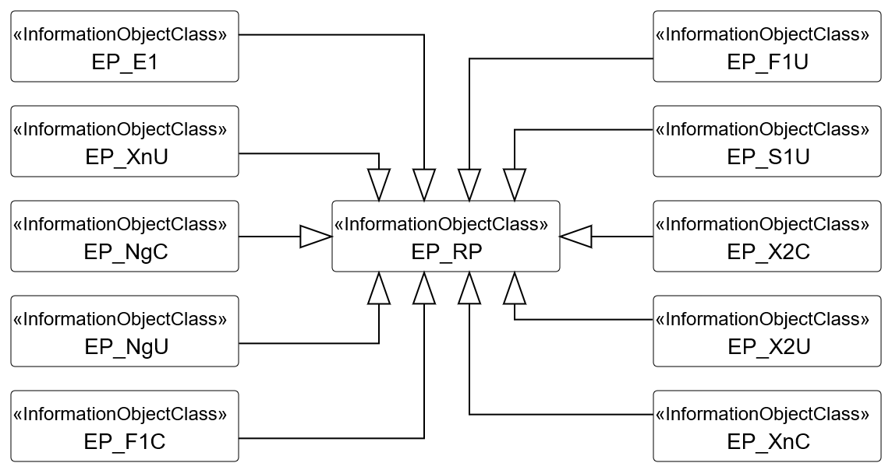
Figure 4.2.1.2-2: NRM fragment for EPs in all deployment scenarios

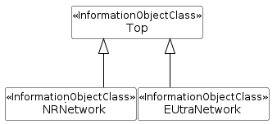
Figure 4.2.1.2-3: NRM fragment for NRNetwork and EUtraNetwork
Figure 4.2.1.2-4: NRM fragment for Beam, CommonBeamformingFunction
Figure 4.2.1.2-5: NRM fragment for RRM Policies
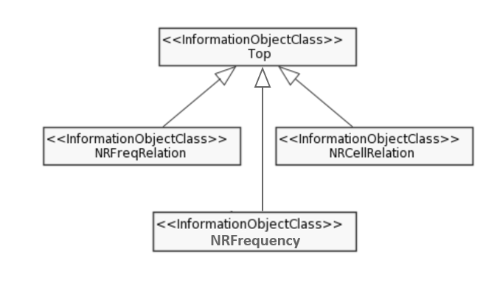
Figure 4.2.1.2-6: NRM fragment for NRFreqRelation, NRFrequency and NRCellRelation
Figure 4.2.1.2-7: NRM fragment for C-SON, D-SON
Figure 4.2.1.2-8: NRM fragment to support RIM
Figure 4.2.1.2-9: NRM fragment for OperatorDU and NROperatorCellDU
Figure 4.2.1.2-10: NRM fragment for CCO Management
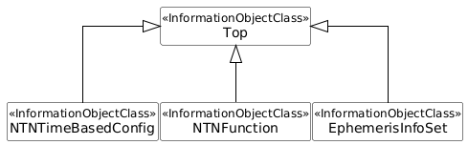
Figure 4.2.1.2-11: NRM fragment for NTN management
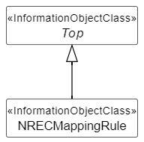
Figure 4.2.1.2-12: NRM fragment for energy cost mapping rule
Figure 4.2.1.2-13: NRM Inheritance fragment for MWAB
Note: The above figure is subject to change as appropriate.
Figure 4.2.1.2-14: NRM Inheritance fragment for AIOT
Figure 4.2.1.2-15: NRM Inheritance fragment for RedCap access
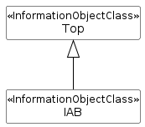
Figure 4.2.1.2-16: NRM Inheritance fragment for IAB

Q.5 NR-NRM diagrams
Note: To avoid diagrams that are in a different order than in the main body of the document (clause 4.2) and to avoid later reordering the diagrams, here all diagrams for clause "4.2 Class diagram" for the NR-NRM are kept in a single clause (Q.x).

@startuml
'Figure 4.2.1.1-2: Figure 4.2.1.1-2: NRM for EPs for all deployment scenarios
skinparam monochrome true
skinparam sameClassWidth true
skinparam shadowing false
skinparam linetype poly
skinparam responseMessageBelowArrow true
hide circle
hide empty members
left to right direction

' ===================== TOP BLOCK (GNBCUUPFunction) =====================

class "<InformationObjectClass>\nGNBCUUPFunction" as GNBCUUPFunction
class "<InformationObjectClass>\nEP_E1" as EP_E1
class "<InformationObjectClass>\nEP_XnU" as EP_XnU
class "<InformationObjectClass>\nEP_F1U" as EP_F1U
class "<InformationObjectClass>\nEP_NgU" as EP_NgU
class "<InformationObjectClass>\nEP_X2U" as EP_X2U
class "<InformationObjectClass>\nEP_S1U" as EP_S1U

class "<ProxyClass>\nGNBCUUPNeighbour" as GNBCUUPNeighbour
class "<ProxyClass>\nGNBCUCPFunction" as GNBCUCPFunction
class "<ProxyClass>\nGNBDUFunction" as GNBDUFunction
class "<ProxyClass>\nUPFFunction" as UPFFunction
class "<ProxyClass>\nENBFunction" as ENBFunction
class "<ProxyClass>\nServingGWFunction" as ServingGatewayFunction

EP_XnU "*" -u-* "1" GNBCUUPFunction : <<names>>
EP_E1 "*" -u-* "1" GNBCUUPFunction : <<names>>
EP_NgU "*" -u-* "1" GNBCUUPFunction : <<names>>
EP_F1U "*" -u-* "1" GNBCUUPFunction : <<names>>
EP_X2U "*" -u-* "1" GNBCUUPFunction : <<names>>
EP_S1U "*" -u-* "1" GNBCUUPFunction : <<names>>

EP_E1 "*" -d-> "0..1" GNBCUCPFunction: " +farEndEntity"
EP_XnU "*" -d-> "0..1" GNBCUUPNeighbour: " +farEndEntity"
EP_F1U "*" -d-> "0..1" GNBDUFunction: " +farEndEntity"
EP_NgU "*" -d-> "0..1" UPFFunction: " +farEndEntity"
EP_X2U "*" -d-> "0..1" ENBFunction: " +farEndEntity"
EP_S1U "*" -d-> "0..1" ServingGatewayFunction: " +farEndEntity"

note right of GNBCUCPFunction
Represents GNBCUCPFunction or ExternalGNBCUCPFunction.
end note

note right of GNBCUUPNeighbour
Represents GNBCUUPFunction or ExternalCUUPFunction,
ENBFunction or ExternalENBFunction.
end note

note right of GNBDUFunction
Represents GNBDUFunction or ExternalGNBDUFunction,
OperatorDU or ExternalOperatorDU.
end note

note right of ENBFunction
Represents ENBFunction or ExternalENBFunction.
end note

note right of UPFFunction
Represents UPFFunction or ExternalUPFFunction.
end note

note right of ServingGatewayFunction
Represents ServingGWFunction or ExternalServingGWFunction.
end note

' ===================== MIDDLE BLOCK (GNBCUCPFunction) =====================

class "<InformationObjectClass>\nGNBCUCPFunction" as GNBCUCPFunction2
class "<InformationObjectClass>\nEP_XnC" as EP_XnC2
class "<InformationObjectClass>\nEP_E1" as EP_E12
class "<InformationObjectClass>\nEP_F1C" as EP_F1C2
class "<InformationObjectClass>\nEP_NgC" as EP_NgC2
class "<InformationObjectClass>\nEP_X2C" as EP_X2C2

class "<ProxyClass>\nGNBCUCPNeighbour" as GNBCUCPNeighbour2
class "<ProxyClass>\nGNBCUUPFunction" as GNBCUUPFunction2
class "<ProxyClass>\nGNBDUFunction" as GNBDUFunction2
class "<ProxyClass>\nAMFFunction" as AMFFunction2
class "<ProxyClass>\nENBFunction" as ENBFunction2

EP_XnC2 "*" -u-* "1" GNBCUCPFunction2 : <<names>>
EP_E12 "*" -u-* "1" GNBCUCPFunction2 : <<names>>
EP_NgC2 "*" -u-* "1" GNBCUCPFunction2 : <<names>>
EP_F1C2 "*" -u-* "1" GNBCUCPFunction2 : <<names>>
EP_X2C2 "*" -u-* "1" GNBCUCPFunction2 : <<names>>

EP_E12 "*" -d-> "0..1" GNBCUUPFunction2: " +farEndEntity"
EP_XnC2 "*" -d-> "0..1" GNBCUCPNeighbour2: " +farEndEntity"
EP_F1C2 "*" -d-> "0..1" GNBDUFunction2: " +farEndEntity"
EP_NgC2 "*" -d-> "0..1" AMFFunction2: " +farEndEntity"
EP_X2C2 "*" -d-> "0..1" ENBFunction2: " +farEndEntity"

note right of GNBCUCPNeighbour2
Represents GNBCUCPFunction, ExternalGNBCUCPFunction,
ENBFunction or ExternalENBFunction."
end note

note right of GNBCUUPFunction2
Represents GNBCUUPFunction or ExternalCUUPFunction.
end note

note right of GNBDUFunction2
Represents GNBDUFunction, ExternalGNBDUFunction,
OperatorDU or ExternalOperatorDU.
end note

note right of AMFFunction2
Represents AMFFunction or ExternalAMFFunction.
end note

note right of ENBFunction2
Represents ENBFunction or ExternalENBFunction.
end note

' ===================== BOTTOM BLOCK (GNBDUFunction) =====================

class "<InformationObjectClass>\nGNBDUFunction" as GNBDUFunction3
class "<InformationObjectClass>\nEP_F1C" as EP_F1C3
class "<InformationObjectClass>\nEP_F1U" as EP_F1U3
class "<ProxyClass>\nGNBCUUPFunction" as GNBCUUPFunction3
class "<ProxyClass>\nGNBCUCPFunction" as GNBCUCPFunction3

EP_F1C3 "0..1" -u-* "1" GNBDUFunction3 : <<names>>
EP_F1U3 "*" -u-* "1" GNBDUFunction3 : <<names>>

EP_F1C3 "*" -d-> "0..1" GNBCUCPFunction3: " +farEndEntity"
EP_F1U3 "*" -d-> "0..1" GNBCUUPFunction3: " +farEndEntity"

note right of GNBCUCPFunction3
Represents GNBCUCPFunction or ExternalCUCPFunction."
end note

note right of GNBCUUPFunction3
Represents GNBCUUPFunction or ExternalCUUPFunction.
end note
'@enduml

