3GPP TSG-SA5 Meeting #163 S5-254733
Wuhan, China, 13. -17. October 2025

Source: Ericsson
Title: Rel-20 pCR TR 28.883 Defining the Lifecycle and Runtime Behaviour of NDT Jobs
Document for: Approval
Agenda item: 6.20.3
Spec: 3GPP TR 28.883
Version: V0.0.0
Work Item: FS_NDT_Ph2

Comments
The following pCR introduces potential changes which would help define the lifecycle and runtime behaviour of the NDT Jobs for the MnS consumer of the NDT MnS Producer.

Proposed Changes
* * * First Change * * * *

5 Use cases

5.X Use Case #<A> Defining the Lifecycle and Runtime Behaviour of NDT Jobs

5.X.1 Description
The NDTJob lifecycle is not clear, there are some items open to interpretation and some items missing which are described below.

All excerpts are from v19.0.0 of TS 28.561.

Potential_Change#1: It would be beneficial to the MnS Consumer to have a clear way of interacting with the NDT MnS Producer. In Clause 4.4 creation and execution is handled in a single use-case, whereas in clause 6.4 there is separate requests from the MnS Consumer to the MnS Producer for creation and execution of an NDTJob, then in Clause 7.1 there is only the createMOI operation defined for an NDTJob.

Clause 4.4 excerpt:
“NDT job instantiation: NDT MnS producer receives the request to create a job. The NDT MnS producer instantiates and executes the simulation/emulation for this job, which is an NDT job instance. The NDT job instance can be configured by the MnS consumer at any time.”
Clause 6.4.1 except:
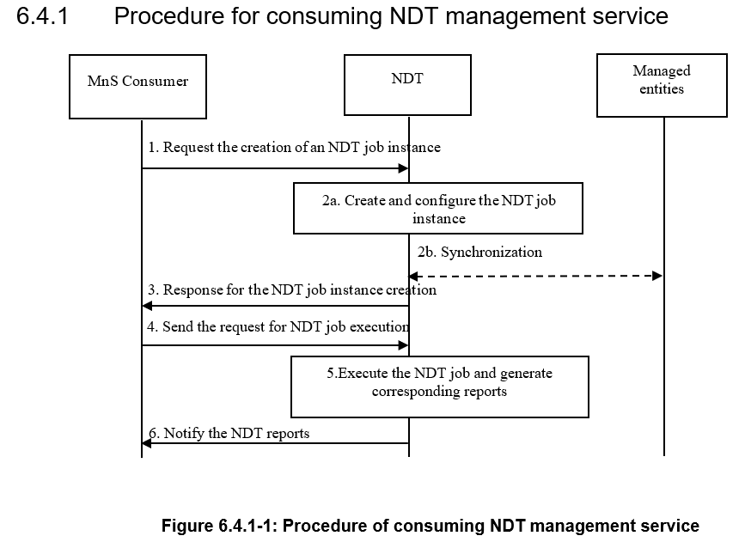
Clause 7.1 except:
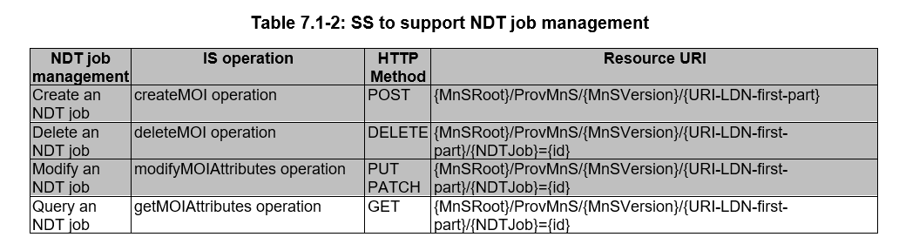
Potential_Change#2: The MnS Consumer should have a method to know which configuration of NDTJob has produced a given report. The current spec has the NDTReport refer to the NDTJobRef, in the existing specification, it is possible to modify the NDTJob, and there is no identifier associated with an NDTJob which changes during the Modify NDT Job operation.
Excerpt: Table 6.2.1.3.8.2-1 describes the attributes associated with the NDTReport <<IOC>>
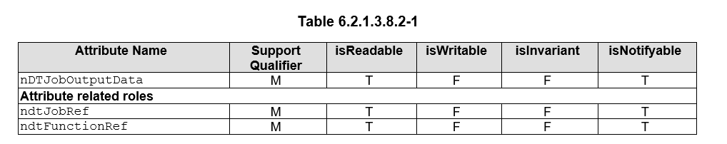
Excerpt: From 6.3 Attribute definitions, the explanation of the ndtJobRef of the NDTReport <<IOC>> refers to
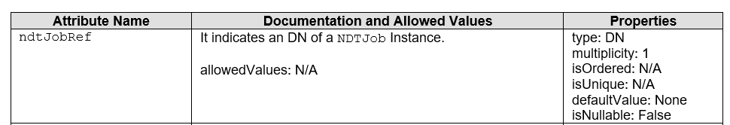
Potential_Change#3: The MnS Consumer would benefit from a method to obtain the NDTReport from the NDTJob, where the NDTJob has been removed from the system. This would not be possible as the NDTReport refers to the DN of the NDTJob (see change#2 for relevant excerpts)
Potential_Change#4: The MnS consumer needs to understand whether an NDTJob can be suspended or resumed. The current specification has references to suspension use-case, it has the term “resume” provided as an example. It would help to clarify whether NDTJob’s can be suspended, and if so, whether suspended jobs can be resumed as they are referenced in the spec but have no associated modelling.
Excerpt: From Clause 4.4:
“NDT job suspension: NDT MnS producer receives the request to pause or suspend a job.”
Excerpt: From Clause 5.1.2.2. Control of NDT Instances:
“The 3GPP management system should support capabilities enabling consumers to define the network scenario, to control (start, suspend, resume or stop) the simulation/emulation of that network scenario and to provide outcomes representing measurements and counters from metrics in the simulated/emulated network scenario.”
Potential_Change#5: The MnS Consumer would benefit from understanding the implications of reconfiguring the NDTJob. At the moment, the NDTReports refer to the DN of the NDTJob – if a NDTJob is reconfigured, this means the same DN is applied to each report, even if the simulation has changed. Likewise, there is no clear procedure described in Clause 6.4, despite the “Modify” use-case being possible for the NDTJob Instances.

The Potential_Changes in the description apply in relation to the following existing requirement:
REQ-DTLCM-02: | The 3GPP management system should support a capability enabling an authorized MnS consumer to control the simulation/emulation of a network scenario, e.g. to start, or stop the simulation/emulation.

- As part of this study, we should study how to address these Potential_Changes.

5.X.2 Potential requirements

5.X.3 Potential solutions

5.X.4 Evaluation of potential solutions

6 Conclusions and Recommendations

6.X Use case #<X>: <use case title>
Editor's note: This clause provides conclusions and recommendations for the corresponding use case.

* * * End of Changes * * * *

