3GPP TSG-SA5 Meeting #163 S5-254685
Wuhan, China, 13.-17. October 2025

Source: China Unicom
Title: Rel-20 pCR TR 28.886 Add new use case on radio resource optimization based on per SSB usage
Document for: Approval
Agenda item: 6.20.7
Spec: 3GPP TR 28.886
Version: 0.1.0
Work Item: FS_eMDAS_Ph4

Comments
Current use cases in TS 28.104 do not have radio resource optimization based on per SSB usage. This use case is proposed to provide intelligently adjust the SSB beam configuration to improve the efficiency of radio resource.
Proposed Changes
* * * First Change * * * *

2 References
The following documents contain provisions which, through reference in this text, constitute provisions of the present document.
- References are either specific (identified by date of publication, edition number, version number, etc.) or non-specific.
- For a specific reference, subsequent revisions do not apply.
- For a non-specific reference, the latest version applies. In the case of a reference to a 3GPP document (including a GSM document), a non-specific reference implicitly refers to the latest version of that document in the same Release as the present document.
[1] 3GPP TR 21.905: "Vocabulary for 3GPP Specifications".
[2] 3GPP TS 28.104: " Management Data Analytics (MDA)".
[3] 3GPP TS 28.541: " 5G Network Resource Model (NRM);Stage 2 and stage 3".

* * * Second Change * * * *

5.3.y Use case#y: Radio resource optimization based on per SSB usage

5.3.y.1 Description
5G NR adopts massive MIMO technology, where the base station employs directional beams for both UE initial access on common channels and subsequent connection during the RRC_CONNECTED state. Common signals/channels for initial access are transmitted within the Synchronization Signal Block (SSB). SSBs are designed with different patterns, corresponding to the number of SSB beams and their distinct directions.
In Clause 4.3.39 of TS 28.541[x], <<IOC>>CommonBeamformingFunction is defined to represents common beamforming functionality (eg: SSB beams). The CommonBeamformingFunction provides capability to configure the advanced antenna for a sector carrier. The configuration capability is provided by selection of coverageShape, digitalTilt and digitalAzimuth. These attributes represent the wanted coverage area and radiation pattern on a sector carrier related to an antenna transmission point.
For example, the area where a large outdoor stadium holds some competitions is characterized by a high number of users which is challenging to guarantee enough radio resource in this scenario. It is necessary to consider using MDAS to improve radio resource usage. MnS consumer could request MDAS to acquire beam-level management data and recommend coverage shape based on analysis. The beam-level data includes Number of UE related the SSB beam Index (mean), DL PRB Usage per SSB, etc. The recommendation could be used for 3GPP Management System to update the configuration of the target cell's coverage shape on gNodeB.
Figure 1 depicts SSB beams covering full cell coverage area. Figure 2 depicts SSB beams covering to meet the UE central coverage after updating the coverage shape for target cell of gNodeB using the recommendation by MDAS.
It is anticipated that MDAS can be used to obtain an analysis of the usage of each SSB. This information can then be used to adjust the coverage shape.
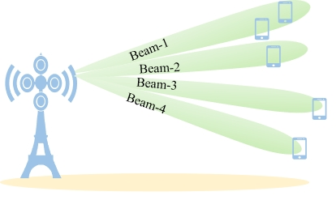  Figure 1: Illustration of SSB beams covering full cell coverage area | 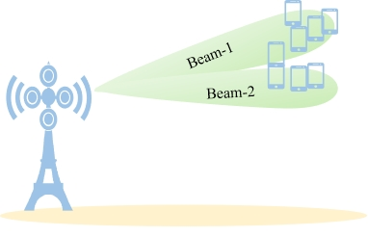  Figure 2: Illustration of SSB beams covering to meet the UE centralized coverage with MDAS recommendation

5.3.y.2 Potential requirements
REQ-RRO-FUN-01: MDA should have capability for radio resource optimization analysis.
REQ-RRO-FUN-02: MDA capability for radio resource optimization analysis should include the capability of the beam-level radio resource utilisation assessment to indicate if coverage shape configuration of gNodeB is proper based on beam-level management data analytics.
REQ-RRO-FUN-03: MDA capability for radio resource optimization analysis should include the capability to recommend coverage shape configuration for target cell of gNodeB.

5.3.y.3 Potential solutions

TBD

5.3.y.4 Evaluation of solutions

TBD

* * * End of Changes * * * *

