3GPP TSG-SA5 Meeting #163 S5-254338
Wuhan, China, 13 – 17 October 2025

Source: Nokia
Title: Pseudo-CR on CCL interactions with other functionalities
Document for: Approval
Agenda item: 6.20.10
Spec: 3GPP TS28.889
Version: 0.0.0
Work Item: Closed Control Loop Management phase2

Comments
In TS 28.537 [X] has outlined requirements for dynamic composition of a CCL as well as the related information modelling for the CCL. Thereby CCL MnS Producer can have capabilities:
  - To provide information about the management functions and services that make up the CCL and the functionality accomplished by the components.
  - To enable the MnS consumer to request for a CCL (instance) to be composed from a set of management function types or instances or management services
  - To enable the MnS consumer to request that a CCL of a specific type or fulfilling stated requirements should be composed from a set of management function types or instances or services
Rel20 5GA study proposes to study interactions between CCL and other management functions to enable stages of CCL
This pCR is to add use case and requirements for enabling interactions between CCL and other management functions to realize the dynamic composition.

Proposed Changes
* * * First Change * * * *

2 References
The following documents contain provisions which, through reference in this text, constitute provisions of the present document.
- References are either specific (identified by date of publication, edition number, version number, etc.) or non-specific.
- For a specific reference, subsequent revisions do not apply.
- For a non-specific reference, the latest version applies. In the case of a reference to a 3GPP document (including a GSM document), a non-specific reference implicitly refers to the latest version of that document in the same Release as the present document.
[X] 3GPP TS 28.567: “Management and orchestration; Management Aspects of Closed Control Loops”

* * * Next Change * * * *

5. Use Cases

5.X CCL CCL interactions with other functionalities
5.X.1 Description
TS 28.537[X] has outlined requirements for dynamic composition of a CCL and the related modelling. To enable the CCL to integrate a network capability as part of the CCL, the CCL may need to search for a candidate MnS producer that is appropriate to be a CCL component (i.e., one that satisfies the requirements for the stage), to then use it as a stage the E2E CCL use-case.
The CCL should be enabled to discover details about the MnS related to the components which the CCL needs to use as part of the CCL, i.e.,to find an MnS according to the use-case capability required for that stage. For example, the CCL should be able to discover the MDA MnS that supports a specific analytics or NDT that supports a specific simulation scenario.
The CCL needs to configure the MnS producers to then be components fulfilling the stages of the CCL, i.e., to act as Monitoring, Analysis, Decision or Execution stages.. In Fig 5.X.1-1 for example, Stage X could be an NDT functionality that provides scenario analytics for decision making /recommendation Stage Y accomplished by an MDA capability. The CCL should be enabled to configure the MDA decision functionality to act as a MnS consumer of the NDT MnS.
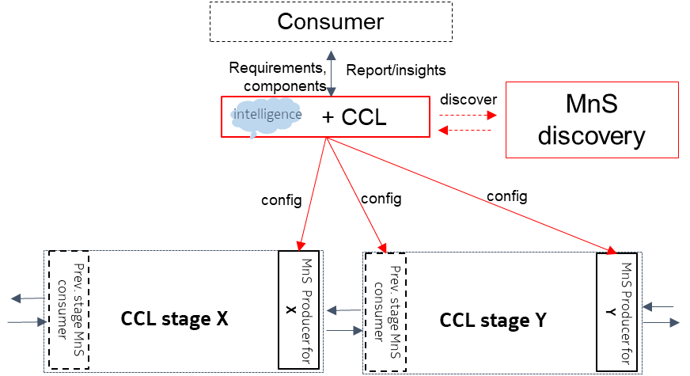
Fig. 1: A CCL can configure stage Y to consume services of management functionalities at stage X

5.X.2 Potential requirements

5.x.3 Possible solutions
TBA
5.X.4 Evaluation of solutions
TBA
* * * End of Changes * * * *

