3GPP SA WG2 Meeting #171 S2-2508729r01 (merging 8533)
Wuhan, China, 13 – 17 Oct, 2025

Title: [DRAFT] Reply LS on business model and architecture for SNPN cellular hotspots
Response to: LS on business model and architecture for SNPN cellular hotspots (S2-2508196 / S3-253046)
Release: Rel-19
Work Item: eNPN_Ph2, Interconnect of SNPN (ISN)
Source: Samsung, Cisco Systems (to be SA2)
To: SA3
Cc:

Contact Person:

Name: Sang-Jun Moon

Tel. Number:

E-mail Address: moonst(at)samsung(dot)com
Send any reply LS to: 3GPP Liaisons Coordinator, mailto:3GPPLiaison@etsi.org

Attachments:

1. Overall Description:
SA2 would like to thank SA3’s LS (S2-2508196 / S3-253046) on business model and architecture for SNPN cellular hotspots.

Regarding the following, SA2 would like to provide feedback.

SA3 kindly ask SA2 if additional work is needed in SA2 to address architectural aspects of SA1 requirements for SNPN cellular hotspots.

Answer: No. Additional work is not needed in SA2 to address architectural aspects of SA1 requirements for SNPN cellular hotspots.
In Release 17, the 3GPP architecture was enhanced to enable a Credentials Holder (CH) responsible for authenticating User Equipment (UE) to be decoupled from the operator of the SNPN, as shown in the following figure from TS 23.501.
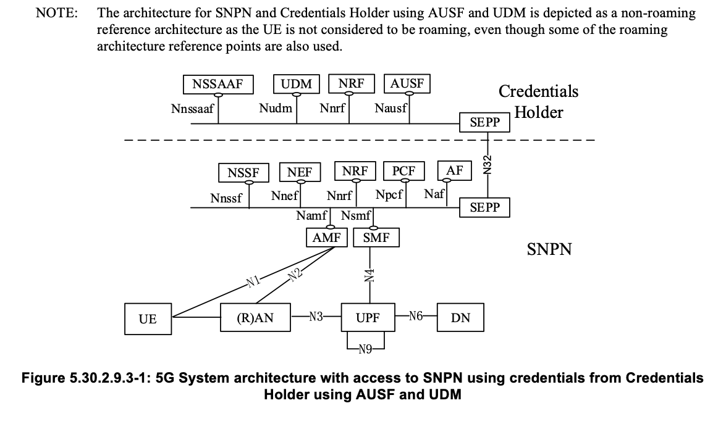
The CH equates to an SNPN Credentials Provider in the 3GPP Stage 1 requirements for SNPN cellular hotspots as defined in TS 22.261. The CH and SNPN communicate through the SEPP over the N32 reference point. These components cover the architectural aspects of SNPN cellular hotspots.

2. Actions:
SA3:
ACTION: SA2 kindly asks SA3 to consider the above information.

3. Date of Next TSG SA WG2 Meetings:
TSG-SA2 Meeting #172 17 - 21 November, 2025 Dallas, US
TSG-SA2 Meeting #173 09 - 13 February, 2026 India, In

