3GPP TSG-RAN4 Meeting #119 R4-2607219

Dalian, China, 18th Nov 2025 – 22nd May 2026

Agenda item: 4.1.3
Source: Moderator (Eutelsat Group)
Title: [119][307] Ku_band_Maintenance
Document for: Information

Introduction
This is the topic summary for Ku Band maintenance.
:
    - Introduction of Ku Band for NR NTN [NR_NTN_Ku_bands-Core]
      - System parameters [NR_NTN_Ku_bands-Core]
      - UE RF requirements [NR_NTN_Ku_bands-Core]
      - SAN RF core requirements
      - RRM core requirements
.

Topic #1: System parameters (agenda 4.2.1.1)

Companies’ contributions summary
All Tdocs related to the following topics (agenda 4.2.1.1) are listed here:

Tdoc | Company | Proposals / Observations
R4-2606845 | Nokia, SES, Eutelsat, Thales | CR for removal of CSI-RS for Beam Acquisition  Table 11.2.2-1: Common test parameters  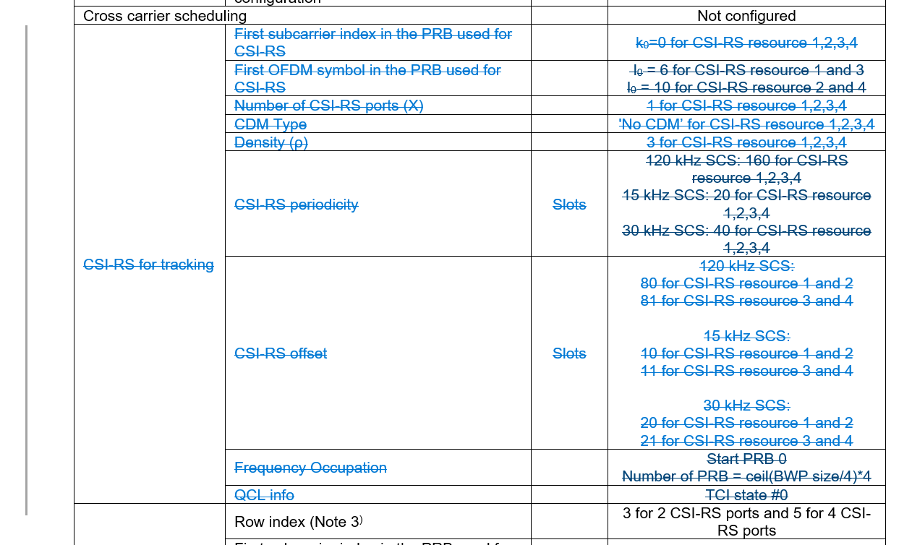

Open issues summary

Sub-topic 1-1: Removal of CSI-RS for Beam Acquisition
- Proposals:
- Proposal from Nokia, SES, Eutelsat, Thales in R4-2606845
Table 11.2.2-1: Common test parameters
- Moderator Recommendation:
- Should this impact Rel-18 as well?
- Discussion required

Topic #2: UE RF requirements (agenda 4.2.1.2)

Companies’ contributions summary
All Tdocs related to the following topics (agenda 4.2.1.2) are listed here:

T-doc | Company | Proposals / Observations
R4-2606002 | Sharp, CHTTL | Correction on release independent support for Ku-band
R4-2606120 | ZTE Corporation, Sanechips, CHTTL | Revise clause number for NS_206N in Table 9.7.1-1 and void section 10.8.3.
R4-2606371 | Sharp | Correction on max TRP for mobile VSAT with Ku-band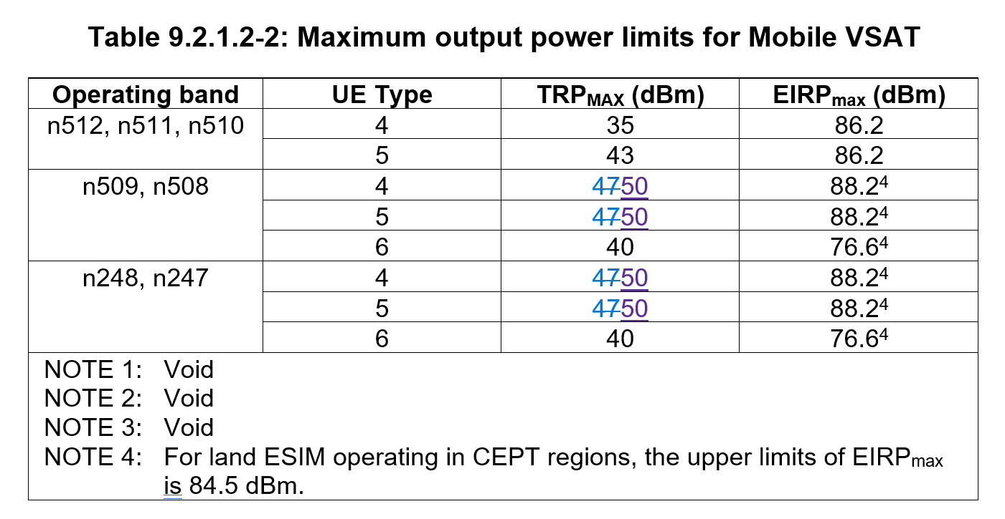
R4-2606827 | SKY Perfect JSAT Corporation | Observation 1: According to the general 3GPP principle, new bands are, in principle, treated as release independent.  Observation 2: Practical NR NTN operation in the Ku-band mainly depends on NTN-specific system features rather than the release in which the band was introduced. Since the key features required for Ku-band GEO NTN operation were already specified in Rel-18, there appears to be limited technical necessity to restrict Ku-band operation exclusively to Rel-19 and beyond.  Proposal 1: RAN4 should consider Ku-band as a release independent feature, including Rel-18, and should not solely rely on the release in which the Ku-band RF requirements were introduced to determine its applicability, from an operator deployment perspective.

Open issues summary

Sub-topic 2-1: Ku band Release independnce
- Proposals:
- CR from CHTTL. in R4-2606002
  - Correction on release independent support for Ku-band
- Proposal 1 from SKY Perfect JSAT Corporation R4-2606827
  - Proposal 1: RAN4 should consider Ku-band as a release independent feature, including Rel-18, and should not solely rely on the release in which the Ku-band RF requirements were introduced to determine its applicability, from an operator deployment perspective.
- Moderator Recommendation:
- Reason for change text is confusing: “Hence, it is not considered that the additional NR NTN bands, VSAT types and channel bandwidth for NR NTN above 10 GHz and below 14.5 GHz as release independent features.” Should this simply say, “The additional NR NTN bands, VSAT types and channel bandwidths for NR NTN above 10 GHz and below 14.5 GHz are not currently defined as release independent in 38.307”?
- Should the title in 9.1 be “Additional NR operating bands for NR NTN in FR1-NTN below 10 GHz” since FR1 is not defined for NTN. This also aligns with the table titles.
- Similarly, should the title in 9.1a be “Additional NR operating bands for NR NTN in FR1-NTN above 10 GHz” since FR1 is not defined for NTN.
- Similarly, should the title in 9.2 be “Other release independent features for NR NTN in FR1-NTN below 10 GHz
- Similarly, should the title in 9.3 be “Other release independent features for NR NTN in FR2-NTN
- Discussion required

Sub-topic 2-2: Correction to NS_206N requirements
- Proposals:
- CR from ZTE Corporation, Sanechips, CHTTL in R4-2606120
  - Revise clause number for NS_206N in Table 9.7.1-1 and void section 10.8.3.
- Moderator Recommendation:
- Approve the CR in R4-2606120

Sub-topic 3-3: Correction on max TRP for mobile VSAT with Ku-band
- Proposals:
- CR from Sharp in R4-2606371
- Moderator Recommendation:
- Approve the CR in R4-2606371

Topic #3: SAN RF requirements (agenda 4.2.1.3)

Companies’ contributions summary
There were no contributions to agenda 4.2.1.3.

T-doc | Company | Proposals / Observations

Topic #4: RRM requirements (agenda 4.2.1.4)

Companies’ contributions summary
All Tdocs related to the following topics (agenda 4.2.1.4) are listed here:

T-doc | Company | Proposals / Observations
R4-2605345 | MediaTek inc. | CR on scheduling restriction for VSAT  6.1C.3.2.3 Satellite switch delay for soft satellite switch with re-sync  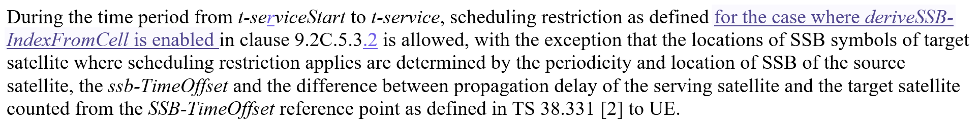
R4-2606537 | ZTE Corporation, Sanechips | Modification on scheduling restriction on Ku band  6.1C.3.2.3 Satellite switch delay for soft satellite switch with re-sync  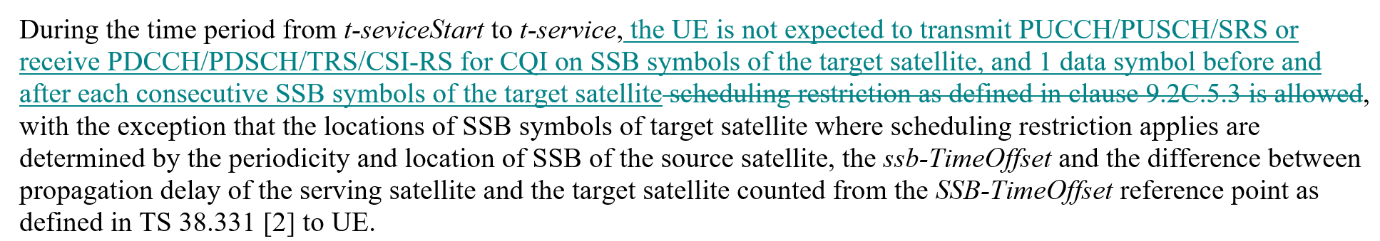
R4-2607079 | Nokia | Proposal 1: Discuss whether the capability of cross polarization isolation shall depend on VSAT Type  Observation 1: In certain scenarios, the cross polarization isolation might not be necessary, because the frequency separation is enough to guarantee protection against self interference. RAN4 shall discuss these limits.  Proposal 2: In case the cross polarization isolation cannot be maintained in certain scenarios, discuss the impact over FD-FDD operation.  Proposal 3: RAN4 to discuss whether it is a valid scenario that a VSAT UE does not support simultaneous reception of signals with different polarizations.  Proposal 4: In case not all VSAT UEs support simultaneous receptions of signals with different polarizations, RAN4 to discuss whether an update on the scheduling restrictions is needed.  Proposal 5: RAN4 to discuss whether it is a valid scenario that a VSAT UE does not support simultaneous reception and transmission of signals with different polarizations.  Proposal 6: In case not all VSAT UEs support cross-polarized DL receptions and UL transmissions, RAN4 to discuss whether a FD-FDD UE could behave like a HD-FDD UE in this scenario, and whether additional scheduling restrictions are needed.

Open issues summary

Sub-topic 4-1: Scheduling restriction for Ku band VSAT
- Proposals:
- CR from MediaTek Inc. in R4-2605345
Clarify in clause 6.1C.3.2.3 that the scheduling restriction refers to the case where deriveSSB-IndexFromCell is enabled (i.e., the restriction applies only to +/- 1 symbol, rather than the entire SMTC window duration).
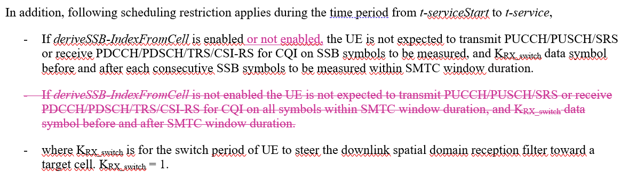
- CR from ZTE Corporation, Sanechips in R4-2606537
Modify the scheduling restriction for Ku band NTN.
- Moderator Recommendation:
- Discussion required.

Sub-topic 4-2: Further polarization indication for VSAT
- Proposals:
- Proposals from Nokia in R4-2607079
  - Proposal 1: Discuss whether the capability of cross polarization isolation shall depend on VSAT Type
  - Observation 1: In certain scenarios, the cross polarization isolation might not be necessary, because the frequency separation is enough to guarantee protection against self interference. RAN4 shall discuss these limits.
  - Proposal 2: In case the cross polarization isolation cannot be maintained in certain scenarios, discuss the impact over FD-FDD operation.
  - Proposal 3: RAN4 to discuss whether it is a valid scenario that a VSAT UE does not support simultaneous reception of signals with different polarizations.
  - Proposal 4: In case not all VSAT UEs support simultaneous receptions of signals with different polarizations, RAN4 to discuss whether an update on the scheduling restrictions is needed.
  - Proposal 5: RAN4 to discuss whether it is a valid scenario that a VSAT UE does not support simultaneous reception and transmission of signals with different polarizations.
  - Proposal 6: In case not all VSAT UEs support cross-polarized DL receptions and UL transmissions, RAN4 to discuss whether a FD-FDD UE could behave like a HD-FDD UE in this scenario, and whether additional scheduling restrictions are needed.
- Moderator Recommendation:
- Discussion required.

