3GPP TSG-RAN WG4 Meeting # 119 R4-2607306
Dalian, China, 18 May – 22 May 2026

Agenda item: 8.1.1
Source: vivo
Title: Simulation assumption for FR2-1 L3 spatial domain beam level prediction
Document for: Approval

Introduction
In this contribution, the simulation assumption for for FR2-1 L3 spatial domain beam level prediction.

Simulation assumption

2.1 Use cases and scenario
Use case
As starting point, evaluate the following use case:
- Wide-to-wide FR2-1 L3 spatial domain beam level prediction (SSB to SSB)
Scenario
- Baseline:
  - Scenario 1: model input and output are from the same cell
    - Predict all beams of the neighbor cell using only a subset of beams of the neighbor cell
      - Only one neighbor cell is considered
- Additionally:
  - Scenario 2: model inputs are from multiple measured cells is not precluded
Specifically, Model input and output
- The model input:
  - Baseline: L3 beam measurement results (Point E)
  - Other options can be further evaluated by companies, e.g., L1 beam measurement results (Point A/A¹)
- The model output:
  - L3 beam prediction results corresponding to L3 beam measurement results (Point E)
    - beam-level RSRP and beam index

2.2 System level simulation assumptions for FR2
Table 2.2-1
Parameters | Value for FR2
Frequency Range | FR2 @ 30 GHz; SCS: 120 kHz
Deployment | 2-tier model with wrap-around (7 sites, 3 sectors/cells per site)
Channel model | Umi with the assumption of Tx height 10m, ISD 200m and minimum gNB-UE distance for studying different locations 10m  With distance-dependent LoS probability function defined in Table 7.4.2-1 in TR 38.901, fast fading and optional LOSsoft;  without UE rotation,Oxygen absorption, Time-varying Doppler shift, Explicit ground reflection model and blockage
System BW | 100MHz
UE speed | 30,90km/h
UE distribution | 100% outdoor
BS Antenna Configuration | Antenna setup and port layouts at gNB: (4, 8, 2, 1, 1, 1, 1), (dV, dH) = (0.5, 0.5) λ  32 TX beams are assumed
BS Antenna radiation pattern | TR 38.802 Table A.2.1-6,
UE Antenna Configuration | Antenna setup and port layouts at UE: (1, 4, 2, 1, 2, 1, 1), 2 panels (left, right)  4RX beams for each panel are assumed
UE Antenna radiation pattern | TR 38.802 Table A.2.1-8,
BS Tx Power | 40 dBm
Maximum UE Tx Power | 23 dBm
BS receiver Noise Figure | 7 dB
UE receiver Noise Figure | 10 dB
Inter site distance | 200 m
BS Antenna height | 10m
UE Antenna height | 1.5 m
Spatial consistency | companies report one of the spatial consistency procedures:  - Procedure A in TR38.901  - Procedure B in TR38.901
UE trajectory model | 3 options in 38.843 section 6.3.1, companies report which option is used.
UE trajectory boundary processing model | Companies report which of the following models they used:  wrap-around model,  circle-bouncing model,  boundary-terminated model
Sampling period | 160ms

Table 2.2-2 (Table 5.2.1.1-2)
L1 filtering | value
Number of L1 samples | Baseline: 5
L3 filtering parameter | value
FR2 FilterCoefficient | 0

Table 2.2-3: 3-Sector BS antenna radiation pattern for above 6GHz (TR 38.802 Table A.2.1-6)
Parameter | Values
Antenna element vertical radiation pattern (dB)
Antenna element horizontal radiation pattern (dB)
Combining method for 3D antenna element pattern (dB)
Maximum directional gain of an antenna element G_{E,max} | 8dBi

Table 2.2-4: UE antenna radiation pattern model 1 (TR 38.802 Table A.2.1-8)
Parameter | Values
Antenna element radiation pattern in $θ''$ dim (dB)
Antenna element radiation pattern in $φ''$ dim (dB)
Combining method for 3D antenna element pattern (dB)
Maximum directional gain of an antenna element G_{E,max} | 5dBi
Note: are in local coordinate system.

Table 2.2-5 UE trajectory model and boundary processing model
Parameters | Values
UE trajectory model | Option 1: Linear trajectory model with random direction change.  - UE moving trajectory: UE will move straight along the selected direction to the end of an time interval, where the length of the time interval is provided by using an exponential distribution with average interval length, e.g., 5s, with granularity of 100 ms.  - UE moving direction change: At the end of the time interval, UE will change the moving direction with the angle difference A_diff from the beginning of the time interval, provided by using a uniform distribution within [-45°, 45°].  - UE moves straight within the time interval with the fixed speed.  Option 2: Linear trajectory model with random and smooth direction change.  - UE moving trajectory: UE will change the moving direction by multiple steps within an time internal, where the length of the time interval is provided by using an exponential distribution with average interval length, e.g., 5s, with granularity of 100 ms.  - UE moving direction change: At the end of the time interval, UE will change the moving direction with the angle difference A_diff from the beginning of the time interval, provided by using a uniform distribution within [-45°, 45°].  - The time interval is further broken into N sub-intervals, e.g. 100ms per sub-interval, and at the end of each sub-interval, UE change the direction by the angle of A_diff/N.  - UE moves straight within the time sub-interval with the fixed speed.  Option 3: Random direction straight-line trajectories.  - Initial UE location, moving direction and speed: UE is randomly dropped in a cell, and an initial moving direction is randomly selected, with a fixed speed.  - The initial UE location should be randomly drop within the following blue area:  where d1 is the minimum distance that UE should be away from the BS.  - Each sector is a cell and that the cell association is geometry based.  - During the simulation, inter-cell handover or switching should be disabled.
UE trajectory boundary processing model | Option 1: wrap-around model,  Option 2: circle-bouncing model,  Option 3: boundary-terminated model
Note 1: For training data generation:
- For each UE moving trajectory: the total length of the UE trajectory can be set as T seconds if it is in time, or set as D meter if it is in distance.
- The trajectory sampling interval granularity depends on UE speed.
- UE can move straight along the entire trajectory, or
- UE can move straight during the time interval, where the time interval is provided by using an exponential distribution with average interval length ΔT
- UE may change the moving direction at the end of the time interval. UE will change the moving direction with the angle difference A_diff from the beginning of the time interval, provided by using a uniform distribution within [-45°, 45°]
- If the UE trajectory hits the cell boundary (the red line), the trajectory should be terminated.
- If the trajectory length (in time) is less than the length of observation window + prediction window, the trajectory should be discarded.
- The length of observation window + prediction window is not fixed and companies can report their values.
Note 2: For the wrap-around model (option 1), when the UE hit the simulation border (the wrap-around contour), it will wrap around and enter the simulation area from a different point on the wrap-around contour. For the bouncing-circle model (option 2), when the UE hit the simulation border (the bouncing-circle), it will bounce back with a random angle and hence only area within circle can be used. For option 3, UE trajectory is terminated when UE hits the simulation border. Then another UE will be dropped randomly.

2.3 Link level simulation assumptions for baseband error
Table 2.3-1 General parameters for measurement prediction evaluations
Parameter | Value for FR2
Carrier frequency | 30GHz
Subcarrier spacing | 120kHz
Channel bandwidth | 100MHz
Channel model | Fading channel  - Baseline:  - TDL-C, DS=100ns  - Optional:  - CDL-C, DS=100ns
BS antenna configurations | Same as SLS;
UE antenna configurations | Same as SLS;  2Rx is assumed
UE moving speed | 30, 90km/h
Reference signal | SSB
DRX | No
Number of samples in L1 filtering | 1 sample

Table 2.3-2 Cell-specific parameters for FR2
Parameter | Unit | Value for FR2
 |  | Cell 1
RF channel | - | Channel 2
PBCH and DMRS power offset with respect to NR-PSS and NR-SSS | dB | 0
Data and control PSD relative to NR-PSS and NR-SSS | dB | 0
SSB periodicity | ms | 20
SSB bandwidth | RB | 20
SSB SCS | kHz | 120
RB Utilization | % | 100
Data Modulation | - | QPSK
CP Length | - | Normal
SINR | dB | Data filtering based on a predefined SINR threshold to be applied  - Companies report SINR threshold used in the simulation  - Only samples within a valid operating range are considered in the evaluation.

Table 2.3-3 Beamforming characteristic of the BS pattern for System-Level simulation assumption
Parameter | Value
Beam pattern legend for Set A and Set B | 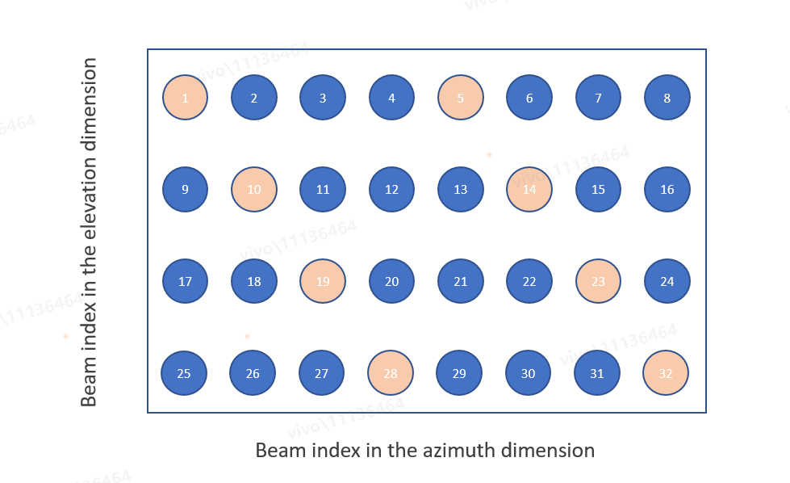
Azimuth and elevation angle ranges | 32 beams with grid of 4 elevation angles from (100°to 150°) and 8 azimuth angles from (-60°to 60°)  Note: here the 0 degree in Elevation refers to +Z axis
AoDs of Set A and Set B (°) | - Set A:  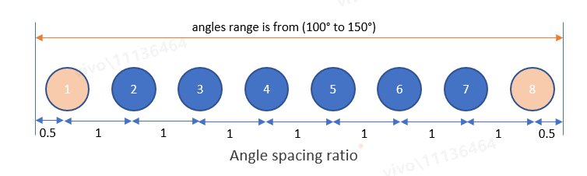  - 4 elevation DFT beams: [106.25, 118.75, 131.25, 143.75]  - 8 azimuth DFT beams: [-52.5, -37.5, -22.5, -7.5, 7.5, 22.5, 37.5, 52.5]  - Set B [(azimuth, elevation)]:  - [(-52.5, 143.75), (-37.5, 131.25), (-22.5, 118.75), (-7.5, 106.25), (7.5, 143.75), (22.5, 131.25), (37.5, 118.75), (52.5, 106.25)

2.4 Simulation assumptions for RF error
The following assumptions can be used to generate RF errors.
  - For FR2, follows a Gaussian distribution with (${μ=0, σ}^{2}$=4) and with the limits of ±4dB.
    - Each TX beam are Independent

2.5 Performance metrics
At least the following performance characteristics are to be provided
KPI1: The accuracy of the prediction of the beam ID of Top-K L3 beams, which are defined based on ground truth
The following definition of KPI1 can be the reference:
- The successful rate for the correct prediction which is considered as maximum ground truth RSRP among top-K predicted beams is larger than the ground truth RSRP of the strongest genie-aided beam – x dB, where K=1,2,3,4,5, X= 0, 1, 2, 3dB

KPI2: The accuracy of corresponding reported beam level RSRP
The following definition of KPI2 can be the reference:
- Max (abs (95%-tile L3-RSRP), abs (5%-tile L3-RSRP)) on the CDF curve of L3 beam level RSRP difference between the predicted L1-RSRP of the 1st, 2nd,3rd, 4th,5th strongest predicted beam(s) and the ground truth L1-RSRP of the same beams

Note: the ‘ground truth’ underlined refers to:
- Case 1: the label data with baseband and RF error.
- Case 2: the label data without baseband and RF error.

2.6 Simulation procedures
The following procedures are provided for companies to perform simulations to evaluate the predicted L3-RSRP accuracy considering the impact of measurement error.
The simulation procedures include:
- Companies to generate ideal L1-RSRP dataset from the SLS assumption.
- Use the LLS assumptions to generate L1-RSRP difference as the baseband errors based on one shot measurement.
- Use the RF error model assumption to generate RF errors.
- Add the baseband error into the ideal SLS dataset in 1st step to derive the dataset with baseband errors.
- Baseband error assumptions follow 2nd step.
- Add L1 filtering to the dataset with added baseband error generated from the 4th step.
- Add RF error into the dataset in 5th step to generate the dataset with both baseband and RF errors.
- RF error assumptions follow 3rd step.
- Use subset samples of the dataset generated from the 6th step for training models.
- Use the other subset samples of the dataset with added measurement error (non-overlapped samples with the subset dataset in 7th step) to derive the dataset for inference.
- Use the dataset with measurement error in 8th step for inference to evaluate the performance metrics (predicted L3 beam level RSRP).
Note: L1-RSRP in 1st and 2nd step means the L1 RSRP measurement without L1 filtering.
Note: The baseband and RF errors should be considered in training dataset (for both input and output), model input during inference.
  - For the benchmark for comparison, both with and without error can be considered.

2.6 Reference model
For better alignment of the performance between companies, it would be better to perform simulations based on a reference model. The model description in Fig. 1 is an example of reference model for BM-case 1 performance evaluation, while it is not the intention to preclude other reference models.
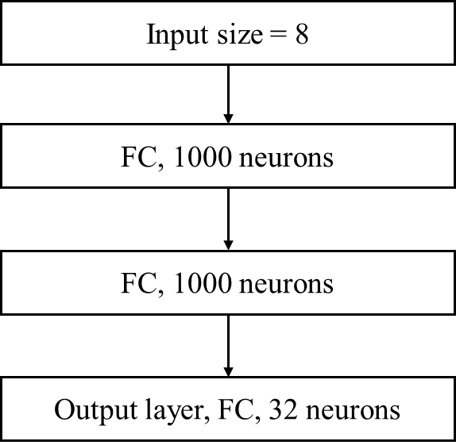
Figure 2: Reference model description

References

