3GPP TSG RAN WG1 #123 R1- 250xxxx
Dallas, USA, November 17th – 21st, 2025

Agenda Item: 7
Source: Moderator (Apple Inc.)
Title: Summary on CR for uplink Tx switching with dualUL
Document for: Discussion/Decision

Introduction
In R1-2509080, an issue regarding timeline to fully utilize both available Tx chains at UE, before DCI triggering uplink Tx switching is detected, is discussed. In current specification, the timeline between triggering DCI and 1-port uplink transmission on a carrier for which uplink switching is not triggered, is not specified. When current switching state allows both Tx chains available on that carrier (e.g. 0T+2T), UE should be able to utilize all Tx chains for 1-port transmission.

Problem statement
In current specification, if an uplink switching is triggered for an uplink transmission starting at T₀, the UE is not expected to cancel the uplink switching after T₀-T_{offset}, where T_{offset} is the UE processing procedure time. More precisely, the following text is captured in 38.214, 6.1.6.

6.1.6 Uplink switching
….
If an uplink switching is triggered for an uplink transmission starting at T₀, after T₀-T_{offset}, the UE is not expected to cancel the uplink switching, or to trigger any other new uplink switching occurring before T₀ for any other uplink transmission that is scheduled after T₀-T_{offset}, where T_{offset} is the UE processing procedure time defined for the uplink transmission triggering the switch given in clause 5.3, clause 5.4, clause 6.2.1, clause 6.4 and in clause 9 of [6, TS 38.213].
….

As it is shown above, the specification is concerned about the timeline between DCI triggering an uplink switching and “the uplink transmission triggering the switch”. Indeed, for most NR scenarios, it is sufficient to specify only this timeline (to make sure UE and NW are aligned on switching requirements).

For the case that the UE is configured with uplinkTxSwitchingOption set to 'dualUL', when current state is 0T+2T, and as long as UE has not detected an indication for 1-port transmission on carrier1, the UE remains on 0T+2T and in theory it should be able to utilize both Tx chains for 1-port transmission on carrier2 (e.g. for antenna virtualization, best antenna selection, etc). When UE detects a DCI scheduling for 1-port transmission on carrier1, UE is supposed to switch from 0T+2T to 1T+1T. With that triggering DCI, UE cannot utilize both Tx chains for 1-port transmission on carrier2 anymore. Now the problem is, the timeline between DCI triggering uplink switching and 1-port transmission on carrier2 is not specified. Without this specification when uplinkTxSwitchingOption set to 'dualUL', there can be the following outcomes, none is desired
- At 0T+2T, UE does not utilize both Tx chains for 1-port transmission on carrier2, since later a DCI “may” be detected to indicate switching to 1T+1T, and 1-port transmission on carrier1 overlapping with 1-port transmission on carrier2.
- At 0T+2T, UE utilizes both Tx chains for 1-port transmission on carrier2, but at the time that UE detects DCI triggering uplink switching, UE has already utilized switchable Tx chain for 1-port transmission on carrier2, and UE cannot revert that decision.

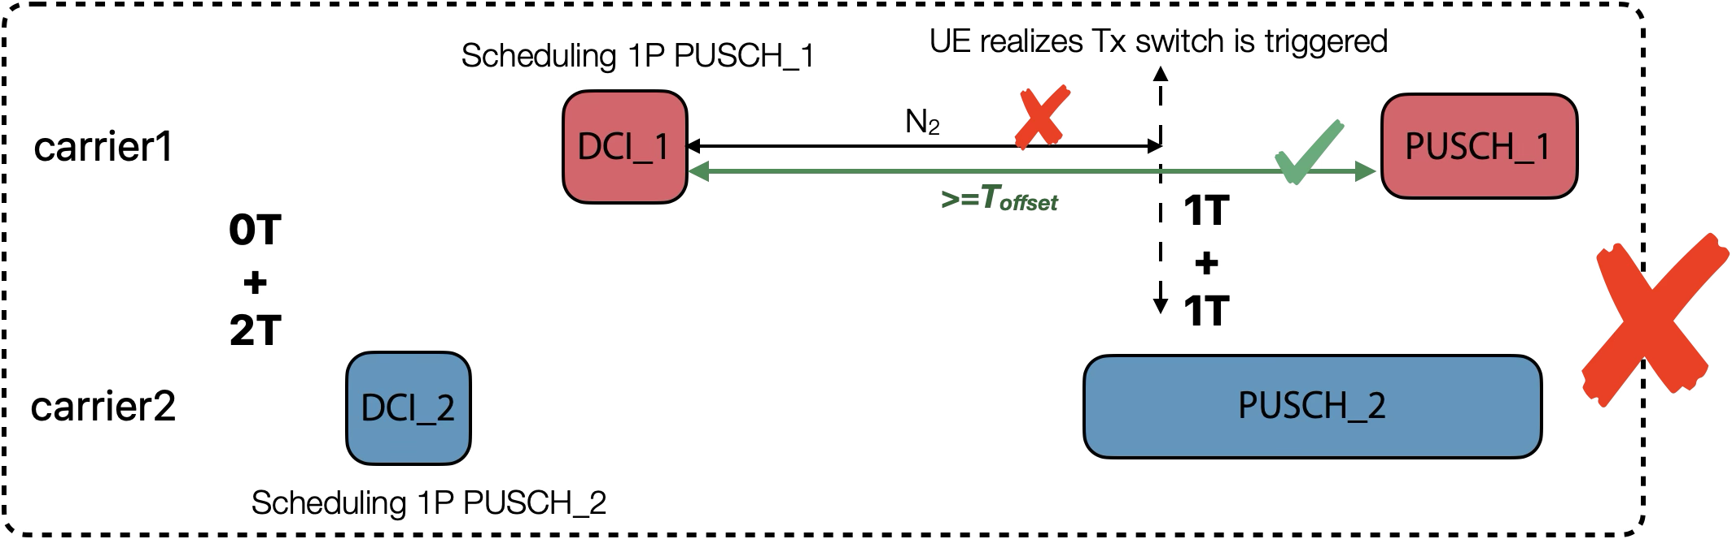

Fig. 1: when UE detects Tx switch is triggered, UE is already using switchable Tx chain for 1P transmission on carrier2

Fig. 1 above depicts the above issue, where late Tx switch indication can impact ongoing 1-port transmission on carrier2.

Another issue for simultaneous 1-port transmissions on carrier1 and carrier2 when UE switches from 0T+2T to 1T+1T, is directly related to the fact that UE is not expected to transmit on any of the carriers within the switching gap, as shown below [38.214, Sec. 6.1.6.2]. In the above example, 1-port transmission on carrier2 will be impacted within $N_{\text{Tx1-Tx2}}$. Here again spec is not clear whether/how UE should keep transmission on carrier2 after and before symbols impacted due to uplink switching from 0T+2T to 1T+1T.

6.1.6.2 Uplink switching for carrier aggregation
….
For the UE configured with uplinkTxSwitchingOption set to 'dualUL', when the UE is to transmit a 1-port transmission on one uplink carrier on one band and if the preceding uplink transmission was a 1-port transmission on another uplink carrier on another band and the UE is under the operation state in which 2-port transmission can be supported in the same band, then the UE is not expected to transmit for the duration of $N_{\text{Tx1-Tx2}}$ on any of the carriers.
….

Solution to both issues is to specify the time gap between DCI triggering Tx switch and 1-port transmission on carrier2 not to be less than $N_{\text{2}}$ symbols (this is the processing time to detect triggering DCI), as shown in Fig. 2.

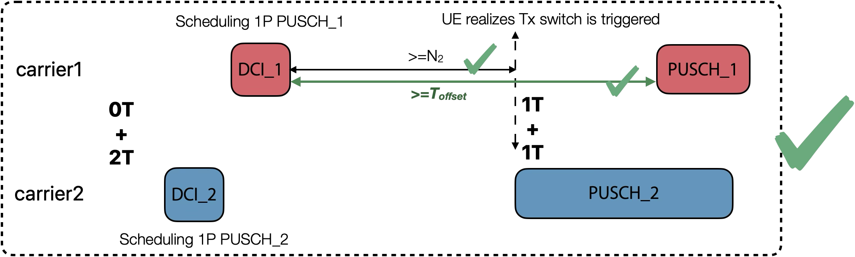
Fig. 2: Time gap between triggering DCI and simultaneous 1P transmission on carrier2.

Discussion

1st Round

Based on this discussion in previous sections, the following proposals are given to address the above issues.
Proposal 1: For the UE configured with uplinkTxSwitchingOption set to ‘dualUL’, when the UE is to transmit a 1-port transmission on the first uplink carrier on one band and if the preceding uplink transmission is a 1-port transmission on the second uplink carrier on another band and the UE is under the operation state in which 2-port transmission can be supported in the same band, then the DCI triggering uplink switching on the first carrier cannot be received after T_{offset} symbols before the start of 1-port transmission on the second uplink carrier.

Please provide your feedback regarding the above Proposal 1.
Company | Comments
MediaTek | This proposal is reasonable and we support it.
Vivo1 | Our understanding is that if the UE always maps only 1TX to the 1-port transmission on the second uplink carrier in another band, the existing specification already supports this behaviour, and no change is required. The proposal appears to allow the UE to dynamically determine whether to map 2TX to a 1-port transmission. From this perspective, this proposal seems more like an optimization.
Huawei, HiSilicon | The proposal is covered by the following agreement when the scheduling restriction introduced in Rel-16 was clarified in Rel-18 UL Tx switching.  It seems not necessary to make an alternative agreement but only focus on whether the conclusion made in RAN1#116 is good enough.  RAN1#115  Agreement  For UL Tx switching, if an UL transmission with starting symbol at T0 is scheduled to a UE, the UE is not expected to be scheduled with another UL transmission overlapping with the first UL transmission in time and resulting in interruption on the first UL transmission by a DCI arriving later than T0-Toffset.  - FFS: whether any specification impact is needed considering the existing cut-off time specified in S6.1.6 of TS 38.214.  If the two Tx chains are triggered to switch between two different band pairs (e.g., band A + band B->band C+ band D), and when the two UL transmissions on band C and band D are at least partially overlapped in time domain, the T_{offset} of timeline T₀-T_{offset} for switching is determined based on the switching gap defined for a single Tx switching in [8, TS 38.101-1].  - T0 is the starting point of the earlier transmission among the two uplink transmissions (band C + band D). This does not change the definition of T0 in current specifications.  - FFS: whether any specification impact is needed.  RAN1#116  Conclusion  Following scheduling restriction is covered by section 6.1.6 in TS38.214.  - For UL Tx switching, if an UL transmission with starting symbol at T0 is scheduled to a UE, the UE is not expected to be scheduled with another UL transmission overlapping with the first UL transmission in time and resulting in interruption on the first UL transmission by a DCI arriving later than T0-Toffset.

Proposal 2: Agree with the following TP to capture the above discussion.

6.1.6.2 Uplink switching for carrier aggregation
….
For the UE configured with uplinkTxSwitchingOption set to 'dualUL', when the UE is to transmit a 1-port transmission on one uplink carrier on one band and if the preceding uplink transmission was a 1-port transmission on another uplink carrier on another band and the UE is under the operation state in which 2-port transmission can be supported in the same band, then the UE is not expected to transmit for the duration of $N_{\text{Tx1-Tx2}}$ on any of the carriers.

For the UE configured with uplinkTxSwitchingOption set to ‘dualUL’, when the UE is to transmit a 1-port transmission on the first uplink carrier on one band and if the preceding uplink transmission is a 1-port transmission on the second uplink carrier on another band and the UE is under the operation state in which 2-port transmission can be supported in the same band, then the DCI triggering uplink switching on the first carrier cannot be received after T_{offset} symbols before the start of 1-port transmission on the second uplink carrier.
…

Please provide your feedback regarding the above Proposal 2.
Company | Comments
MediaTek | Fine with Proposal 2.
Huawei, HiSilicon | - Better to clarify which release is the CR applied to. The conclusion made in RAN1#116 is sufficient to at least Rel-16, Rel-17 and Rel-18. Because those release of specs have been frozen for long time, if any spec change is needed, prefer to only impact on Rel-19 specs.  - In current specification, all preceding uplink transmissions refer to transmissions without any overlap in time with the current transmission. However, here the second uplink transmission overlaps with the first one. Additionally, preceding uplink transmissions refer to transmissions that have been completed rather than ones that are to be transmitted. Therefore, suggest to clarify it with better term than “preceding uplink transmission”  - Suggest that “cannot be received” is replaced with “is not expected to be received”  - Suggest that “the DCI triggering uplink switching” is replaced with “the DCI scheduling the first uplink transmission” because there may be no uplink switching triggered by the DCI especially in the concerned case.

