3GPP TSG RAN WG1 #123 R1- 250xxxx
Dallas, USA, Nov 17th – 21st, 2025
Agenda item: 7
Source: Qualcomm Incorporated
Title: Discussion on simultaneous PUCCH and PUSCH transmission in CA scenarios
WI code: NR_newRAT-Core
Document for: Discussion/Decision

Clarification on simultaneous PUCCH and PUSCH transmission in CA scenarios
With the following agreement in RAN1 #115, the feature of simultaneous PUCCH and PUSCH transmissions of same priority was introduced in Rel-17 for the scenario of interband CA. In the agreement, it is clear that the feature only applies to different cells belonging to different bands in inter-band CA.
Agreement
Simultaneous PUSCH and PUCCH transmissions of same priority on different inter-band cells is supported.
- Note 1: Above applies since Rel-17.
- Note 2: Above applies only for inter-band CA
- Note 3: Above is subject to one new RRC parameter and one new UE capability (per BC). When the new RRC parameter is provided, simultaneous PUSCH and PUCCH transmission of same priority is always applied on different cells belonging to different bands.
Send an LS to RAN2 to inform them of the above agreement. Final LS in R1-2312456.

The agreement is captured in TS 38.306 and TS 38.213 as the following.
If a UE
- is provided simultaneousPUCCH-PUSCH and would transmit a PUCCH with a first priority index and PUSCHs with a second priority index that is different than the first priority index, where the PUCCH and the PUSCHs overlap in time on different respective cells
- can simultaneously transmit the PUCCH and the PUSCHs with different priority indexes [18, TS 38.306],
the UE excludes the PUSCHs for resolving the time overlapping between the PUCCH and PUSCHs with different priority indexes, where the timeline conditions for resolving the overlapping PUCCH and PUSCHs are not required for the excluded PUSCHs.
If a UE
- is provided simultaneousPUCCH-PUSCH-SamePriority and would transmit a PUCCH and PUSCHs with same priority index, where the PUCCH and the PUSCHs overlap in time on different respective cells
- can simultaneously transmit the PUCCH and the PUSCHs with same priority index [18, TS 38.306],
the UE excludes the PUSCHs for resolving the time overlapping between the PUCCH and PUSCHs with same priority index, where the timeline conditions for resolving the overlapping PUCCH and PUSCHs are not required for the excluded PUSCHs.

parallelTxPUCCH-PUSCH-r17  Indicates whether the UE supports simultaneous PUCCH and PUSCH transmissions of different priority across CCs in an inter-band CA band combination for NR SA or NR SCG in (NG)EN-DC. | BC | No | N/A | N/A
parallelTxPUCCH-PUSCH-SamePriority-r17  Indicates whether the UE supports simultaneous PUCCH and PUSCH transmissions of same priority across CCs in an inter-band CA band combination for NR SA or NR SCG in (NG)EN-DC as specified in clause 9 of TS 38.213 [11]. | BC | No | N/A | N/A

When one reads the TS 38.306 and TS 38.213 specifications, it is not crystal clear that whether this feature applies to the following 3-CC UL CA scenarios where the two TDD CCs are intra-band contiguous CCs and the FDD CC is inter-band CC w.r.t. the two TDD CCs. If a UE reports support parallelTxPUCCH-PUSCH-SamePriority-r17 for the FDD+TDD band combination, from the English of TS 38.306, it seems a UE should support simultaneous PUCCH and PUSCH transmissions on TDD Pcell + TDD Scell, because the capability parallelTxPUCCH-PUSCH-SamePriority-r17 is reported per band combination and this band combination is FDD+TDD inter-band CA. But it is not the intention of agreement, as note 3 of the agreement clearly says “simultaneous PUSCH and PUCCH transmission of same priority is always applied on different cells belonging to different bands”. Also, from technical perspective, simultaneous PUCCH and PUSCH should not be applied to intra-band TDD Pcell + Scell as it will create large IM and PA phase non-continuity issue.

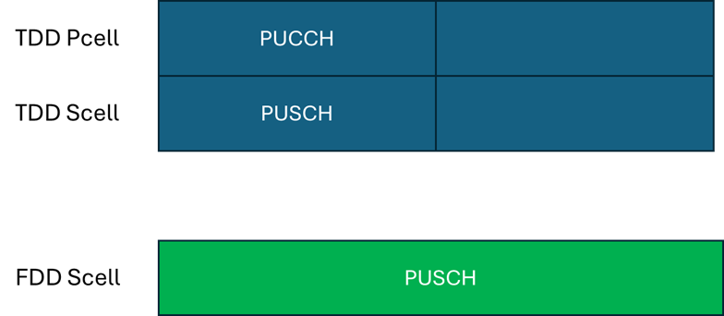

Figure 1: An example of TDD+TDD+FDD UL CA scenario.
With the above analysis, we suggest to clarify that parallelTxPUCCH-PUSCH-r17 and parallelTxPUCCH-PUSCH-SamePriority-r17 only applies to different CCs belong to different bands in inter-band CA.
Proposal 1: Send an LS to RAN2 to clarify that parallelTxPUCCH-PUSCH-r17 and parallelTxPUCCH-PUSCH-SamePriority-r17 only applies to different CCs belong to different bands in inter-band CA, with the following suggested TP for TS 38.306 for Rel-17.
- Note: The following TP is just an exemplary suggestion to RAN2. It is up to RAN2 to decide the final TP to clarify the issue.
parallelTxPUCCH-PUSCH-r17  Indicates whether the UE supports simultaneous PUCCH and PUSCH transmissions of different priority across different CCs belong to different bands in a an inter-band CA band combination for NR SA or NR SCG in (NG)EN-DC. | BC | No | N/A | N/A
parallelTxPUCCH-PUSCH-SamePriority-r17  Indicates whether the UE supports simultaneous PUCCH and PUSCH transmissions of same priority across different CCs belong to different bands in a an inter-band CA band combination for NR SA or NR SCG in (NG)EN-DC as specified in clause 9 of TS 38.213 [11]. | BC | No | N/A | N/A

In the following table, companies please add comments to the above proposal, if any.
Company name | Comments

Conclusions
TBD

