3GPP TSG RAN WG#123 R1-251xxxx
Dallas, USA, Nov 17th – 21st, 2025

Title: Draft LS on clarification on simultaneous PUCCH and PUSCH transmission in CA
Response to:
Release: Rel-17
Work Item: NR_newRAT-Core
Source: RAN1
To: RAN2
Cc: RAN4
Contact Person:
Name: Yi Huang
E-mail: yihuang@qti.qualcomm.com

Send any reply LS to: 3GPP Liaisons Coordinator, mailto:3GPPLiaison@etsi.org

Attachments: None

1. Overall Description
With the following agreement in RAN1 #115, the feature of simultaneous PUCCH and PUSCH transmissions of same priority was introduced in Rel-17 for the scenario of interband CA. In the agreement, it is clear that the feature only applies to different cells belonging to different bands in inter-band CA.
Agreement
Simultaneous PUSCH and PUCCH transmissions of same priority on different inter-band cells is supported.
- Note 1: Above applies since Rel-17.
- Note 2: Above applies only for inter-band CA
- Note 3: Above is subject to one new RRC parameter and one new UE capability (per BC). When the new RRC parameter is provided, simultaneous PUSCH and PUCCH transmission of same priority is always applied on different cells belonging to different bands.
Send an LS to RAN2 to inform them of the above agreement. Final LS in R1-2312456.

The agreement is captured in TS 38.306 as the following.

parallelTxPUCCH-PUSCH-r17  Indicates whether the UE supports simultaneous PUCCH and PUSCH transmissions of different priority across CCs in an inter-band CA band combination for NR SA or NR SCG in (NG)EN-DC. | BC | No | N/A | N/A
parallelTxPUCCH-PUSCH-SamePriority-r17  Indicates whether the UE supports simultaneous PUCCH and PUSCH transmissions of same priority across CCs in an inter-band CA band combination for NR SA or NR SCG in (NG)EN-DC as specified in clause 9 of TS 38.213 [11]. | BC | No | N/A | N/A

When one reads the TS 38.306 specification, it is not crystal clear that whether this feature applies to the following 3-CC UL CA scenario, where the two TDD CCs are intra-band contiguous CCs and the FDD CC is an inter-band CC w.r.t. the two TDD CCs. If a UE reports support parallelTxPUCCH-PUSCH-SamePriority-r17 for the FDD+TDD band combination, based on the above text of TS 38.306, it seems a UE should support simultaneous PUCCH and PUSCH transmissions on TDD Pcell + TDD Scell, because the capability parallelTxPUCCH-PUSCH-SamePriority-r17 is reported per band combination and this band combination is FDD+TDD inter-band CA. But it is not the intention of agreement, as note 3 of the agreement clearly says “simultaneous PUSCH and PUCCH transmission of same priority is always applied on different cells belonging to different bands”. Also, from technical perspective, simultaneous PUCCH and PUSCH should not be applied to intra-band TDD Pcell + Scell as it will create large IM and PA phase non-continuity issues.

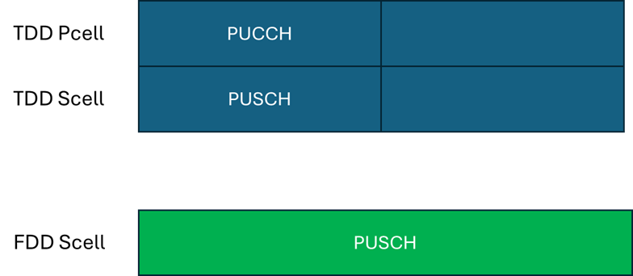

Figure 1: An example of TDD+TDD+FDD UL CA scenario.

With the above analysis, it is needed to clarify that parallelTxPUCCH-PUSCH-r17 and parallelTxPUCCH-PUSCH-SamePriority-r17 only applies to different CCs belong to different bands. A secondary point is that it is not crystal clear whether the above scenario is considered as inter-band CA or intra-band CA. To avoid ambiguity, “an inter-band” can be removed in the above cited TS 38.306 specification, because clarifying simultaneous PUCCH and PUSCH transmission applies to “different CCs belong to different bands” would make the specification sufficiently clear.

In RAN1# 123, the following agreement is made in RAN1. RAN1 respectfully ask RAN2 to take into account the information contained in this LS and consider updating TS 38.306 Rel-17 accordingly.
Agreement:
Send an LS to RAN2 to clarify that parallelTxPUCCH-PUSCH-r17 and parallelTxPUCCH-PUSCH-SamePriority-r17 only applies to different CCs belong to different bands in inter-band CA, with the following suggested TP for TS 38.306 for Rel-17.
- Note: The following TP is just an exemplary suggestion to RAN2. It is up to RAN2 to decide the final TP to clarify the issue.
parallelTxPUCCH-PUSCH-r17  Indicates whether the UE supports simultaneous PUCCH and PUSCH transmissions of different priority across different CCs belong to different bands in a an inter-band CA band combination for NR SA or NR SCG in (NG)EN-DC. | BC | No | N/A | N/A
parallelTxPUCCH-PUSCH-SamePriority-r17  Indicates whether the UE supports simultaneous PUCCH and PUSCH transmissions of same priority across different CCs belong to different bands in a an inter-band CA band combination for NR SA or NR SCG in (NG)EN-DC as specified in clause 9 of TS 38.213 [11]. | BC | No | N/A | N/A

2. Actions
To RAN2: RAN1 respectfully ask RAN2 to take into account the information contained in this LS and consider updating TS 38.306 Rel-17 accordingly.

3. Date of Next TSG-RAN1 Meetings
TSG RAN WG1 Meeting #124 February 9 – 13, 2026 Gothenburg, SE
TSG RAN WG1 Meeting #124-bis April 13 – 17, 2026 Malta, MT

