3GPP TSG-SA WG6 Meeting #70 S6-255345
Dallas, USA, 17th – 21st November 2025 (revision of S6-254142, 255101)
CR-Form-v12.3
CHANGE REQUEST
 | 23.180 | CR | 0017 | rev | 2 | Current version: | 19.1.0
For HELP on using this form: comprehensive instructions can be found at
http://www.3gpp.org/Change-Requests.

Proposed change affects: | UICC apps |  | ME | X | Radio Access Network |  | Core Network | X

Title: | Add service flow in a new annex
Source to WG: | Huawei, Hisilicon
Source to TSG: | S6
Work item code: | Generic_IOPS |  |  |  |  |  | Date: |  |  | 2025-09-24
Category: | F |  |  |  |  |  | Release: |  |  | Rel-19
 | Use one of the following categories:  F (correction)  A (mirror corresponding to a change in an earlier release)  B (addition of feature),  C (functional modification of feature)  D (editorial modification)  Detailed explanations of the above categories can  be found in 3GPP TR 21.900. |  |  |  |  |  |  |  | Use one of the following releases:  Rel-8 (Release 8)  Rel-9 (Release 9)  Rel-10 (Release 10)  Rel-11 (Release 11)  …  Rel-17 (Release 17)  Rel-18 (Release 18)  Rel-19 (Release 19)  Rel-20 (Release 20)
Reason for change: |  | The annex K in 3GPP TS 23.401 provides an example of Local EPC based IOPS operation, however it is not suffcient due to: a) it is only applicable for LTE, b) it is only about the network layer/system switching where the MCX application system are totally not captured.  Currently 3GPP TS 23.180 only defines the procedures under IOPS mode. However the whole work flow about switching between the normal MCX system with the normal network and the IOPS MC system with IOPS 3GPP system is missing.  Such work flow could help the reader to have a overall view of how a user obtains the MCX service when entering into IOPS mode and recovering from IOPS mode.
Summary of change: |  | Add a overall work flow about switching between the normal MCX system with the normal network and the IOPS MC system with IOPS 3GPP system is missing.
Consequences if not approved: |  | The relationship between the normal MCX system and the IOPS MC system, and how a user interact with the normal MCX system and the IOPS MC system when entering and leaving the IOPS mode is not clear.
Clauses affected: |  | A.x
 |  | Y | N
Other specs |  |  | X | Other core specifications |  |  |  | TS/TR ... CR ...
affected: |  |  | X | Test specifications |  |  |  | TS/TR ... CR ...
(show related CRs) |  |  | X | O&M Specifications |  |  |  | TS/TR ... CR ...
Other comments:
This CR's revision history: |  | In Rev1, the coversheet are updated. Some minor changes to the descriptions.

/**************************** First changes **********************/

Annex B (informative):
Switching between normal MC system and IOPS MC system
This clause provides an overall description about switching between normal MC system with macro network and the IOPS MC system with the IOPS 3GPP system.
The figure B.x-1 provides an example of high-level workflow of switching between normal MC system and IOPS MC system.

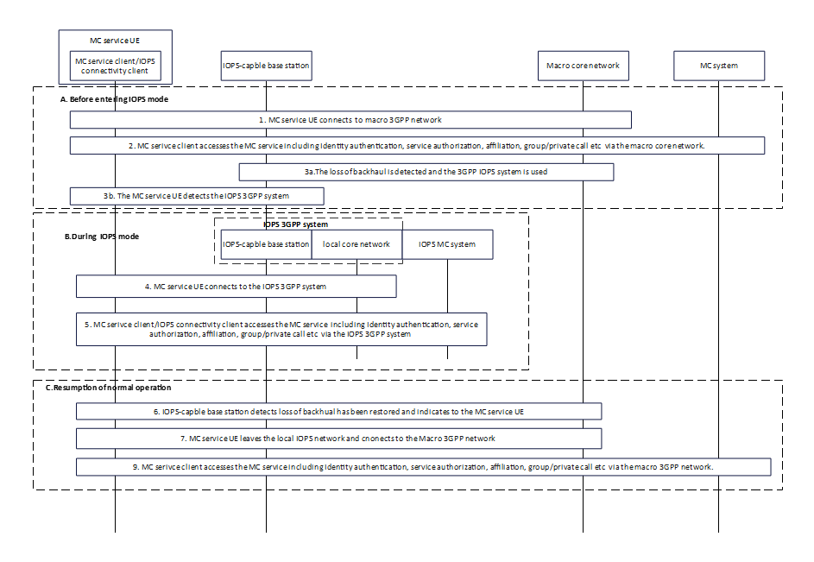
Figure B.x-1: example of switching between normal MC system and IOPS MC system
1. The MC service UE has attached/registered to the macro 3GPP network.
2. MC service client accesses the MC service via the macro 3GPP network. The MC service client performs identity authentication, service authorization, affiliation, group call, private call etc.
3. The loss of backhaul is detected and the 3GPP IOPS system is used. Further the the MC service UE detects the IOPS 3GPP system.
4. Then the MC service UE attaches/registered to the 3GPP IOPS system.
5. The MC service client accesses the MC service via the 3GPP IOPS system network. The IOPS connectivity client performs IOPS user authentication and authorisation towards the IOPS MC connectivity function. The MC service client then performs the affiliation, initiates group/private call based on existing procedures towards local MC service users.
Editor’s Note: Further alignment with SA3 about the identity authentication and service authorization is FFS.
6. The backhaul has been restored and the macro 3GPP network is used. The MC service UE detects the the macro 3GPP network.
7. The MC service UE releases the connection towards the 3GPP IOPS system.
8. The MC service client accesses the MC service including identity authentication, service authorization, affiliation, group/private call etc via the macro core network.
NOTE 1: There is no service continuity during switching between the MC system and the IOPS MC system.
NOTE 2: The MC service client can use other means e.g., enabling 5G ProSe feature (including multihop) to obtain MC services.

