3GPP TSG-SA5 Meeting #165 S5-260815
Goa, India, 09 - 13 February 2026

Source: China Mobile, ZTE
Title: Pseudo-CR on TR 32.801-01 Add use case on Management data handling and exposure to support the AI operations and services
Document for: Approval
Agenda item: 6.20.6
Spec: 3GPP TR 32.801-01
Version: 0.0.0
Work Item: FS_6G_OAM

Comments
This contribution proposes to add use case on Management data handling and exposure to support the AI operations and services for TR 32.801-01.

Proposed Changes
* * * First Change * * * *

5 6G Management Architecture Principles
Editor's note: This clause will contain the common 6G management architecture principles identified for the study.

6 6G Management Scenarios

6.1 Identified 6G management scenarios
Editor's note 1: This clause will contain identified 6G management scenarios and the related requirements.

6.1.1 <Management Scenario Category# >

6.1.1.x Management Scenario #<1>: Management data handling and exposure to support the AI operations and services

6.1.1.x.1 Description

In the 3GPP management system, the systematic management, processing, and utilization of network data are essential to realize data-driven value addition for operators' networks in 6G:

- Advancing network intelligent operations and maintenance (O&M) as well as network autonomy capabilities, when supports the management services on fault prediction, network status analysis, network service modelling prior to new service launches by leveraging the management capabilities (e.g., NDT, AIML, Intent). As described in TS 28.561, the Network Digital Twin (NDT) facilitates modelling the behaviour of a mobile network, and the analytic data from automation functions (e.g., MDA) may also be utilized when needed. And network digital twins could provide modelling capabilities that support network automation functions (e.g. MDA, SON) to accomplish their automation objectives. To fulfil this role, NDT requires synchronized acquisition of scenario specific data during modelling, including network data, service traffic data, and user behaviour data, ensuring accurate simulation and effective support for intelligent O&M decisions.
- Enabling the third parties’ services. the 3GPP management system could expose properly processed network data to authorized third parties, fostering innovation for industries. Typical scenarios include supporting Vehicle-to-Everything (V2X) services, where anonymized user mobility patterns and traffic condition data enhance situational awareness for vehicles and enable emergency rerouting, and facilitating global digital twin initiatives (e.g., India’s "Digital Twin Sangam") by providing multi-source integrated data for large-scale event management or industrial digital twin construction. Additionally, anonymized and aggregated network data can serve as a valuable resource for third parties to conduct AI inference, train industrial models, and develop industry specific digital twins, creating new monetization avenues for operators.
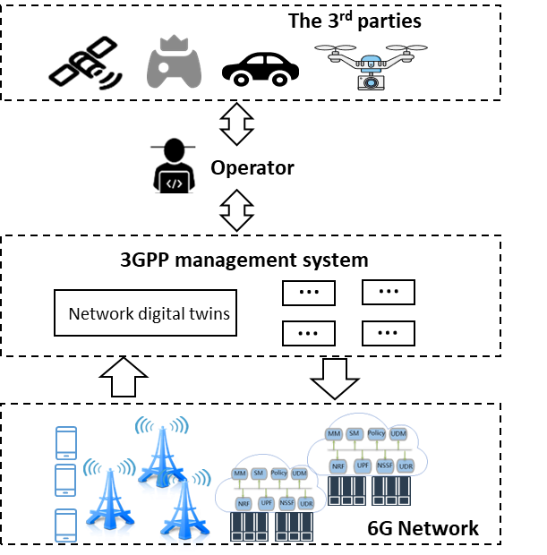

To achieve these two objectives, advancing network intelligent O&M and empowering third parties, the 3GPP management system should support more flexible and enhanced mechanisms for the handling and exposure of management data. This involves integrating fragmented data distributed in the network, such as CM/PM/FM data, user traffic data, CN network function data, RAN management data, and external data, to enable the provision of data services (e.g., AI training, AI inference, NDT), thereby seamlessly supporting both intelligent network O&M and diversified third-party services.

* * * End of Changes * * * *

