3GPP TSG SA5 Meeting #165 S5-260749

Goa, India, 9-13 February 2026
CR-Form-v12.5
CHANGE REQUEST
 | 28.533 | CR | 0177 | rev | 3 | Current version: | 19.4.0
For HELP on using this form: comprehensive instructions can be found at
https://www.3gpp.org/Change-Requests.

Proposed change affects: | UICC apps |  | ME |  | Radio Access Network |  | Core Network | X

Title: | Architecture changes for NF Deployment LCM
Source to WG: | Rakuten Mobile, Inc, Orange, China Mobile
Source to TSG: | SA5
Work item code: | NF_Deployment_LCM-OAM |  |  |  |  |  | Date: |  |  | 2026-01-30
Category: | B |  |  |  |  |  | Release: |  |  | Rel-20
 | Use one of the following categories:  F (correction)  A (mirror corresponding to a change in an earlier release)  B (addition of feature),  C (functional modification of feature)  D (editorial modification)  Detailed explanations of the above categories can  be found in 3GPP TR 21.900. |  |  |  |  |  |  |  | Use one of the following releases:  Rel-8 (Release 8)  Rel-9 (Release 9)  Rel-10 (Release 10)  Rel-11 (Release 11)  …  Rel-18 (Release 18)  Rel-19 (Release 19)  Rel-20 (Release 20)  Rel-21 (Release 21)
Reason for change: |  | The CMO study in TR 28869-200 documents recommendations for lifecycle management of Network Functions.
Summary of change: |  | This change introduces a deployment management reference point to the orchestration systems
Consequences if not approved: |  | New interfaces for cloud-based management and orchestration are not defined.
Clauses affected: |  | 3.1, 5.2
 |  | Y | N
Other specs |  |  | X | Other core specifications |  |  |  | TS/TR ... CR ...
affected: |  |  | X | Test specifications |  |  |  | TS/TR ... CR ...
(show related CRs) |  | X |  | O&M Specifications |  |  |  | TS 28.531 CR 0248
Other comments:
This CR's revision history:

==============First change==============

3.1 Definitions
For the purposes of the present document, the terms and definitions given in 3GPP TR 21.905 [1] and the following apply. A term defined in the present document takes precedence over the definition of the same term, if any, in 3GPP TR 21.905 [1] or NFV-MANO [27].
Exposure governance management function: Management Function entity with the role of management service exposure governance.
Management Service (MnS): set of offered management capabilities.
External MnS consumer: MnS consumer outside the PLMN trust domain.
Internal MnS consumer: MnS consumer within the PLMN trust domain.
NOTE: the concept of PLMN trust domain is defined in TS 23.222 [76].
Management Function (MnF): logical entity playing the roles of Management Service consumer and/or Management Service producer.
Network Function (NF): defined in TS 23.501[31].
NOTE: In 3GPP NRM, the Network Functions are modeled using the ManagedFunction IOC and its sub-classes (e.g. AMFFunction).
NF Deployment: defined in TS 28.531 [8]
NF Deployment instance: defined in TS 28.531 [8]

==============Next change==============

5.2 Management interactions with External Orchestration and Management systems
The 3GPP management system interacts with an external orchestration and management systems to support lifecycle management (LCM) of NF Deployment instances. The figure 5.2-1 below illustrates the interaction between 3GPP management system and a generic orchestration and management entity in a simplified view:
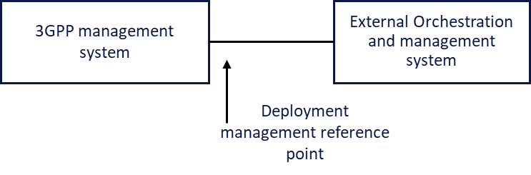

Figure 5.2-1: Lifecycle management of NF Deployment instance
The deployment management reference point supports the lifecycle of NF Deployment instances. The reference point includes the ETSI NFV MANO interfaces and other industry solutions e.g. Kubernetes based systems.
For the case of ETSI NFV-MANO,
- The deployment management reference point includes the exchange of information over the ETSI GS NFV-IFA 013 [8] and ETSI GS NFV-IFA 008 [9]).

- 3GPP management system shall be capable to consume NFV MANO interface (e.g. Os-Ma-nfvo, Ve-Vnfm-em and Ve-Vnfm-vnf reference points).
- The
- producer of management services can consume management interfaces provided by NFV MANO for following purposes:
- Network service LCM.
- VNF LCM, PM, FM, CM on resources supporting VNF.

==============End of change==============

