3GPP TSG SA5 Meeting #165 S5-260748

Goa, India, 9-13 February 2026
CR-Form-v12.5
CHANGE REQUEST
 | 28.531 | CR | 0248 | rev | 2 | Current version: | 19.2.0
For HELP on using this form: comprehensive instructions can be found at
https://www.3gpp.org/Change-Requests.

Proposed change affects: | UICC apps |  | ME |  | Radio Access Network |  | Core Network | X

Title: | Provisioning changes for NF Deployment LCM
Source to WG: | Rakuten Mobile, Inc
Source to TSG: | SA5
Work item code: | NF_Deployment_LCM-OAM |  |  |  |  |  | Date: |  |  | 2026-01-30
Category: | B |  |  |  |  |  | Release: |  |  | Rel-20
 | Use one of the following categories:  F (correction)  A (mirror corresponding to a change in an earlier release)  B (addition of feature),  C (functional modification of feature)  D (editorial modification)  Detailed explanations of the above categories can  be found in 3GPP TR 21.900. |  |  |  |  |  |  |  | Use one of the following releases:  Rel-8 (Release 8)  Rel-9 (Release 9)  Rel-10 (Release 10)  Rel-11 (Release 11)  …  Rel-18 (Release 18)  Rel-19 (Release 19)  Rel-20 (Release 20)  Rel-21 (Release 21)
Reason for change: |  | The CMO study in TR 28869-200 documents recommendations for lifecycle management of Network Functions.
Summary of change: |  | The change introduces the concept of NF Deployment and updated procedures to use deployment management reference point.
Consequences if not approved: |  | New interfaces for cloud-based management and orchestration are not defined.
Clauses affected: |  | 3.1,  5.1.17, 5.1.18, 5.1.19, 5.1.20, 5.1.24,  7.3, 7.5, 7.10, 7.11, 7.12,  Appendix C
 |  | Y | N
Other specs |  |  | X | Other core specifications |  |  |  | TS/TR ... CR ...
affected: |  |  | X | Test specifications |  |  |  | TS/TR ... CR ...
(show related CRs) |  | X |  | O&M Specifications |  |  |  | TS 28.533 CR 0177
Other comments:
This CR's revision history:

==============First change==============

3.1 Definitions
For the purposes of the present document, the terms and definitions given in TR 21.905 [1], TS 28.530 [4] and the following apply. A term defined in the present document takes precedence over the definition of the same term, if any, in TR 21.905 [1] and TS 28.530 [4].
IAB-node: as defined in TS 38.401 [18].
NF Deployment: NF Deployment represents the virtualized software deployment used to realize a part of, or the full function of, one or multiple 3GPP network functions. The use of NF Deployment is not limited by any specific virtualization technology, e.g. VM based, or container based.
NF Deployment instance: Particular instance of a NF Deployment

==============Next change==============

5.1.17 Creation of a 3GPP NF
Use case stage | Evolution/Specification | <<Uses>>  Related use
Goal | To enable the authorized consumer to request creation of an instance of 3GPP NF.
Actors and Roles | An authorized consumer of the NF creation provisioning management service.
Telecom resources | VNF package(s) of the virtualized part of 3GPP NF;  ETSI NFV MANO system or other industry solution;  NF provisioning management service producer.
Assumptions | N/A
Pre-conditions | The VNF package(s) of the virtualized part of 3GPP NF have been on-boarded to ETSI NFV MANO system.
Begins when | The authorized consumer needs to create a new instance of 3GPP NF.
Step 1 (M) | The authorized consumer requests the NF provisioning management service producer to create a new instance of 3GPP NF.
Step 2 (M) | The NF provisioning management service producer checks the subject 3GPP NF contains virtualized part and/or non-virtualized part. If it contains virtualized part, then the NF instantiation service producer performs the step 3 and 4 to instantiate the virtualized part of the subject 3GPP NF.  How to instantiate the non-virtualized part of the subject 3GPP NF is out of scope of present specification.
Step 3 (M) | The NF provisioning management service producer interacts, or requests another NF provisioning management service producer to interact, with ETSI NFV MANO system (or other industry solution) to instantiate the NF Deployment instance(s) that are realizing the virtualized part of subject 3GPP NF.
Step 4 (M) | If all of the contained parts (i.e., virtualized part and non-virtualized part if any) of the 3GPP NF have been successfully instantiated, the NF provisioning management service producer informs the consumer(s) (who have subscribed to the notifications for NF creation) that the instance of 3GPP NF has been created, and creates the MOI(s) for the subject 3GPP NF.
Step 5 (M) | Created MOI(s) may be maintained by a Management Function which has the NF provisioning management service or the 3GPP NF. When the MOI(s) is maintained by the 3GPP NF, the NF provisioning management service producer sends a request of creating the MOI(s) to the corresponding NF provisioning management service producers in the created NF.
Ends when | All the steps identified above are successfully completed.
Exceptions | One of the steps identified above fails.
Post-conditions | The instance of 3GPP NF has been created, and the MOI(s) of the 3GPP NF have been created.
Traceability | REQ-PRO_NF-FUN-1, REQ-PRO_NF-FUN-2, REQ-PRO_NF-FUN-7

==============Next change==============

5.1.18 Configuration of a 3GPP NF instance
Use case stage | Evolution/Specification | <<Uses>>  Related use
Goal | To enable the authorized consumer to request configuration of a 3GPP NF instance.
Actors and Roles | An authorized consumer of the NF provisioning management service.
Telecom resources | ETSI NFV MANO system or other industry solution;  NF provisioning management service producer.
Assumptions | N/A
Pre-conditions | The NF to be configured has been instantiated;  The MOI of the NF has been created.
Begins when | The authorized consumer needs to configure a 3GPP NF instance.
Step 1 (M) | The consumer requests the NF provisioning management service producer to modify the attribute(s) of the MOI of the 3GPP NF instance.
Step 2 (O) | If the 3GPP NF contains virtualized part and the corresponding NF Deployment instance(s) need to be updated, the NF provisioning management service producer interacts, or requests another NF provisioning management service producer to interact, with ETSI NFV MANO system (or other industry solution) to update the corresponding NF Deployment instance(s).
Step 3 (M) | The NF provisioning management service producer configures the 3GPP NF instance, per the MOI attribute modification request received from the consumer.
Step 4 (M) | The NF provisioning management service producer modifies the attributes of the MOI and informs the consumer that the 3GPP NF instance has been configured successfully.
Ends when | All the steps identified above are successfully completed.
Exceptions | One of the steps identified above fails.
Post-conditions | The 3GPP NF instance has been configured.
Traceability | REQ-PRO_NF-FUN-4, REQ-PRO_NF-FUN-5, REQ-PRO_NF-FUN-6, REQ-PRO_NF-FUN-3

==============Next change==============

5.1.19 Creation of a 3GPP sub-network
NOTE: This use case is only specified for the case where a ETSI NFV-MANO solution is used for the creation of a 3GPP NF.

Use case stage | Evolution/Specification | <<Uses>>  Related use
Goal | To enable the authorized consumer to request creation of a 3GPP sub-network.
Actors and Roles | An authorized consumer of the sub-network provisioning management service.
Telecom resources | VNF package(s) of the virtualized part of 3GPP NF(s);  NSD(s) of the NS(s);  ETSI NFV MANO system;  Network provisioning service producer;  NF provisioning service producer.
Assumptions | N/A
Pre-conditions | The non-virtualized part of the NFs (including completely non-virtualized NFs) constituting the 3GPP sub-network have been deployed;  The VNF package(s) of the virtualized part of 3GPP NF(s) have been on-boarded to ETSI NFV MANO system;  The NSD(s) of the NS realizing the 3GPP sub-network have been on-boarded to ETSI NFV MANO system.
Begins when | The authorized consumer needs to create a 3GPP sub-network.
Step 1 (M) | The authorized consumer requests the sub-network provisioning management service producer to create a 3GPP sub-network. The request needs to indicate the network capacity (e.g., the number of instances of each kind of NFs, and the capacity of each NF instance, for example, number of flows with certain QoS attributes to be supported), network topology information (e.g., the connections between NF instances), and the network QoS requirements (e.g., bandwidth and latency requirements of the interface between two NF instances).
Step 2 (M) | The network provisioning management service producer interacts, or requests another network provisioning management service producer to interact, with ETSI NFV MANO system to instantiate the NS(s) realizing the sub-network.
Step 3 (M) | ETSI NFV MANO system informs the NF provisioning management service producer about the instantiation of the NSs and the new VNFs.
Step 4 (M) | The NF provisioning management configuration service producer creates the MOI(s) of the 3GPP NFs that are realized by the newly instantiated VNF(s); there may be MOI(s) that specify the topology of the instantiated NSs.
Step 5 (M) | The sub-network provisioning management service producer is using the NF provisioning management service to configure the 3GPP NF instance(s) that are constituting the subject 3GPP sub-network. | NF configuration service
Ends when | All the steps identified above are successfully completed.
Exceptions | One of the steps identified above fails.
Post-conditions | The 3GPP sub-network has been created.
Traceability | REQ-PRO_NW-FUN-1, REQ-PRO_NW-FUN-2

==============Next change==============

5.1.20 Configuration of a 3GPP sub-network
NOTE: This use case is only specified for the case where a ETSI NFV-MANO solution is used for the creation of a 3GPP NF
Use case stage | Evolution/Specification | <<Uses>>  Related use
Goal | To enable the authorized consumer to request configuration of a 3GPP sub-network.
Actors and Roles | An authorized consumer of the network provisioning management service.
Telecom resources | 3GPP network;  3GPP NFs;  ETSI NFG MANO system;  Network provisioning management service producer.
Assumptions | N/A
Pre-conditions | The 3GPP sub-network has been created;  The MOI(s) related to the sub-network has been created.
Begins when | The authorized consumer needs to configure a 3GPP sub-network.
Step 1 (M) | The authorized consumer requests to configure a 3GPP sub-network.
Step 2 (M) | The consumer requests the network provisioning management management service producer to modify the attribute of the MOI(s) related to the 3GPP sub-network.
Step 3 (O) | If the 3GPP network is realized by NS(s) (ETSI ISG NFV concept), the network provisioning management service producer requests (directly or indirectly via another) ETSI NFV MANO system to update the NS(s) realizing the 3GPP sub-network.
Step 4 (O) | If there are new VNFs instantiated by the NS update, ETSI NFV MANO system informs the NF provisioning management service producer about the instantiation of VNFs.
Step 5 (O) | The NF provisioning management service producer creates the MOI(s) of the 3GPP NFs that are realized by the newly instantiated VNF(s).
Step 6 (M) | The network provisioning management service producer consumes the NF provisioning management service to configure the impacted 3GPP NF instance(s). | NF configuration service
Step 7 (M) | The network provisioning management service producer configures the 3GPP sub-network, per the MOI attribute modification request received from the consumer.
Step 8 (M) | The NF provisioning management service producer modifies the attributes of the MOI(s) of the 3GPP network and informs the consumer that the 3GPP sub-network has been configured successfully.
Ends when | All the steps identified above are successfully completed.
Exceptions | One of the steps identified above fails.
Post-conditions | The 3GPP network has been configured.
Traceability | REQ-PRO_NW-FUN-3, REQ-PRO_NW-FUN-4

==============Next change==============

5.1.24 Management interaction with NFV MANO for network service priority
NOTE: This use case is only specified for the case where a ETSI NFV-MANO solution is used for the creation of a 3GPP NF

Use case stage | Evolution/Specification | <<Uses>>  Related use
Goal | To enable the authorized consumer to request creation of a 3GPP sub-network, management interactions with NFV MANO is needed. This management interaction will assign priority on NFV NS(s).
Actors and Roles | An authorized consumer of 3GPP sub-network creation.
Telecom resources | VNF package(s) of the virtualized part of 3GPP NF(s);  NSD(s) of the NS(s);  ETSI NFV MANO system;
Assumptions | N/A
Pre-conditions | The ETSI NFV VNF package(s) of the virtualized part of 3GPP NF(s) have been on-boarded to ETSI NFV MANO system;  The ETSI NFV NSD(s) used to instantiate NS(s) for realizing the 3GPP sub-network have been on-boarded to ETSI NFV MANO system.
Begins when | The authorized consumer needs to create a 3GPP sub-network. This creation operation also needs to assign priority on 3GPP sub-network and on related ETSI NFV NS(s).
Step 1 (M) | The authorized consumer requests the 3GPP sub-network creation service producer to create a 3GPP sub-network.
Step 2 (M) | The sub-network creation service producer interacts, or requests another sub-network creation service producer to interact, with ETSI NFV MANO system to instantiate the NS(s) realizing the 3GPP sub-network.
Step 3 (M) | ETSI NFV MANO is informed about NS priority.
Ends when | All the steps identified above are successfully completed.
Exceptions | One of the steps identified above fails.
Post-conditions | The 3GPP sub-network has been created. Network service priority is identified by NFVO to support the 3GPP sub-network.
Traceability | REQ-PRO_NW-FUN-1, REQ-PRO_NW-FUN-2

==============Next change==============

5.2.3 Requirements for NF provisioning service
REQ-PRO_NF-FUN-1 The NF provisioning service producer shall have the capability allowing its authorized consumer to request creation of an instance of 3GPP NF.
REQ-PRO_NF-FUN-2 The NF provisioning service producer shall have the capability to fulfill the consumer’s request to create an instance of 3GPP NF.
REQ-PRO_NF-FUN-3 The NF provisioning service producer shall have the capability to provide the VNF and VNFC related information of the NF instance to its authorized consumer.
REQ-PRO_NF-FUN-4 The NF provisioning service producer shall have the capability allowing its authorized consumer to request configuration of a 3GPP NF instance.
REQ-PRO_NF-FUN-5 The NF provisioning service producer shall have the capability to request updating the VNF(s) that are realizing the virtualized part of a 3GPP NF.
REQ-PRO_NF-FUN-6 The NF provisioning service producer shall have the capability to fulfill the consumer’s request to configure a 3GPP NF instance.
REQ-PRO_NF-FUN-7 The NF provisioning service producer shall have the capability to request NF management service producers working in the concerned NF instance to create and maintain the MOI(s) for it.
REQ-PRO_NF-FUN-Y The NF provisioning service producer shall have the capability to provide the NF Deployment instance related information of the NF instance to its authorized consumer.
REQ-PRO_NF-FUN-X The NF provisioning service producer shall have the capability to request updating the NF Deployment instance(s) that are realizing the virtualized part of a 3GPP NF.

==============Next change==============

7.3 Procedure of Network Slice Subnet Instance Allocation
NOTE: This procedure is only specified for the case where a ETSI NFV-MANO solution is used for the creation of a 3GPP NF instance
The Figure 7.3-1 illustrates the procedure of creating a new network slice subnet instance or using an existing network slice subnet instance to satisfy the required network slice subnet related requirements.
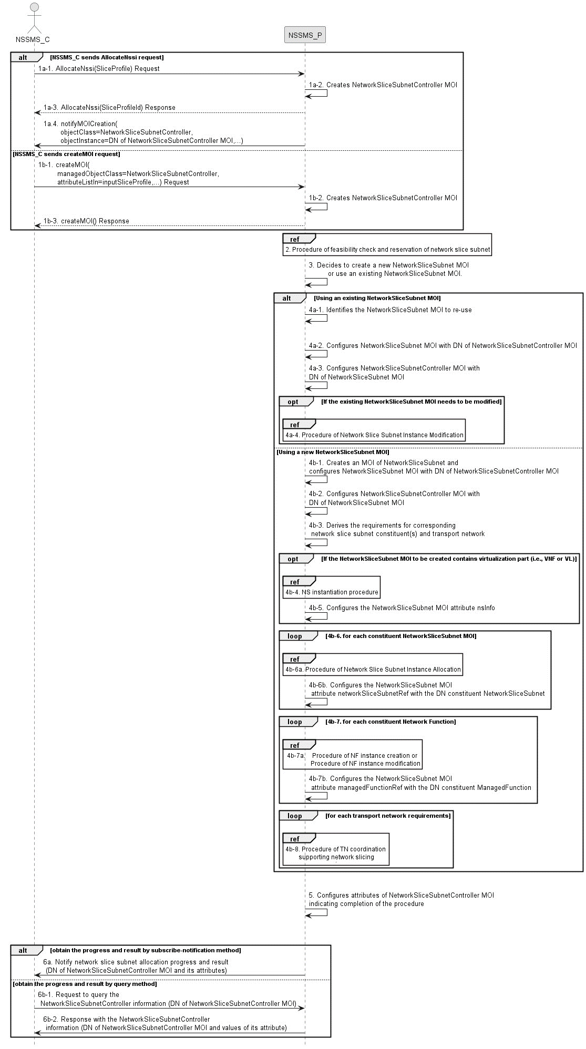
Figure 7.3-1: Network Slice Subnet Instance Allocation Request procedure
1a-1) Network Slice Subnet Management Service Provider (NSSMS_P) receives an AllocateNssi request (see AllocateNssi operation defined in clause 6.5.2) from Network Slice Subnet Management Service Consumer NSSMS_C with network slice subnet related requirements (network slice subnet related requirements defined in SliceProfile see clause 6.3.4 in TS 28.541 [6]).
1a-2) The NSSMS_P creates an MOI of NetworkSliceSubnetController and configures attribute sliceProfileId to control and monitor network slice subnetallocation process. NSSMS_P starts to perform the network slice subnet allocation process.
1a-3) The NSSMS_P sends AllocateNssi response to the NSSMS_C. The sliceProfileId is included in the AllocateNssi response.
1a-4) NSSMS_P sends notification (see notifyMOICreation defined in TS 28.532 [8]) to NSSMS_C to notify the DN of the created NetworkSliceSubnetController instance.
1b-1) NSSMS_P receives a createMOI request (see createMOI operation defined in TS 28.532 [8]) from NSSMS_C with network slice subnet controller (see NetworkSliceSubnetController IOC and its attributes defined in TS 28.541[6])) including the network slice subnet related requirements in attribute inputSliceProfile.
1b-2) The NSSMS_P creates an MOI of NetworkSliceSubnetController.
1b-3) The NSSMS_P sends the response to NSSMS_C for the createMOI request.
NOTE: Network slice subnet allocation may be initiated using AllocateNssi operation as described in steps 1a or createMOI operation as described in steps 1b.
2) NSSMS_P may invoke corresponding procedure of feasibility check and reservation of network slice subnet as described in clause 7.14. If the network slice subnet related requirements can be satisfied, the following step 3) to step 5) are needed, else go to step 6).
3) Based on the network slice subnet related requirements and the existing NetworkSliceSubnet MOI capabilities, NSSMS_P decides whether to use an existing NetworkSliceSubnet MOI or create a new NetworkSliceSubnet MOI. If the network slice subnet related requirements allow the requested NetworkSliceSubnet MOI to be shared and if an existing suitable NetworkSliceSubnet MOI can be reused, the NSSMS_P decides to use the existing NetworkSliceSubnet MOI.
4a-1) If using an existing NetworkSliceSubnet MOI, the NSSMS_ P identifies the NetworkSliceSubnet MOI to be reused.
4a-2) The NSSMS_P configures NetworkSliceSubnet MOI (attribute networkSliceSubnetControllerRef) with the DN of NetworkSliceSubnetController MOI.
4a-3) NSSMS_P configures the NetworkSliceSubnetController MOI (attribute networkSliceSubnetRef) with DN of NetworkSliceSubnet MOI (identified in step 4a-1).
4a-4) If the existing NetworkSliceSubnet MOI needs to be modified to satisfy the network slice subnet related requirements, the NSSMS_P invokes the procedure of network slice subnet instance modification as described in clause 7.7.
4b-1) If creating a new NetworkSliceSubnet MOI, the NSSMS_P creates an MOI of NetworkSliceSubnet. The NSSMS_P configures NetworkSliceSubnet MOI (attribute networkSliceSubnetControllerRef) with DN of NetworkSliceSubnetController MOI.
4b-2) NSSMS_P configures the NetworkSliceSubnetController MOI (attribute networkSliceSubnetRef) with DN of NetworkSliceSubnet MOI (identified in step 4b-1).
4b-3) NSSMS_P derives the corresponding network slice subnet constituent (i.e., NF, constituent NetworkSliceSubnet) related requirements and transport network related requirements (e.g., 3GPP endpoint information, latency requirements, bandwidth requirements and isolation requirements) from the received network slice subnet related requirements. Part of these requirements may be referenced by attribute epTransportRef as defined in clause 6.3.2.2 in TS 28.541[6]. Before NSSMS_P derives the constituent network slice subnet related requirements, NSSMS_Provider may invoke corresponding network slice subnet capability information querying procedure as described in clause 7.8.2.
4b-4) If the NetworkSliceSubnet MOI contains virtualisation part (i.e. VNF or VL), NSSMS_P derives the NS instance instantiation information (the NS instance instantiation information is described in clause 7.3.2.2 and clause 7.3.3.2 [3]) based on network slice subnet related requirements. NSSMS_P determines new VNF instance(s) that need to be deployed and the existing VNF instance(s) that need to be reused according to the necessary network function(s) and then derives the profile of virtual link(s) according to the connection requirements between the network functions. NSSMS_P chooses a proper NSD deployment flavour and creates data concerning the SAPs of the NS instance. NSSMS_P invokes the NS instantiation procedures to create a NS instance.

Note: For the interaction with ETSI NFV MANO, NS instantiation procedure is described in clause 7.3.3 in ETSI GS NFV-IFA 013 [3].
4b-5) NSSMS_P configures NetworkSliceSubnet MOI attribute nsInfo with NS instance information.
4b-6) For each required constituent network slice subnet (NetworkSliceSubnet MOIs), the following step 4b-6a) and 4b-6b) are needed:
4b-6a) NSSMS_P invokes procedure of network slice subnet instance allocation.
4b-6b) NSSMS_P configures NetworkSliceSubnet MOI attribute networkSliceSubnetRef with DN of NetworkSliceSubnet MOI.
4b-7) For each required constituent NF instance (ManagedFunction MOI), the following step 4b-7a) and 4b-7b) are needed:
4b-7a) NSSMS_P invokes procedure of NF instance creation described in clause 7.10 or procedure of NF instance modification described in clause 7.11.
4b-7b) NSSMS_P configures NetworkSliceSubnet MOI attribute managedFunctionRef with DN of ManagedFunction MOI.
4b-8) For each required transport network related requirements, NSSMS_P invokes corresponding procedure of coordination with relevant TN Manager to handle the TN part as described in clause 7.9.
5) NSSMS_P configures NetworkSliceSubnetController MOI attributes operationalState, administrativeState, availabilityStatus and processMonitor to indicate completion of the procedure.
The NSSMS_C may check the status and completion of the network slice subnet allocation procedure any time by monitoring the values of NetworkSliceSubnetController MOI attributes operationalState, administrativeState, availabilityStatus and processMonitor by querying the values or by subscribing to notifications.
Following step 6) describes the procedures for NSSMS_C to monitor network slice subnet allocation progress and result. These steps can happen anytime after the NetworkSliceSubnetController MOI is created and its DN is notified to the NSSMS_C (step 1a-4 or step 1b-3).
6a) The NSSMS_P sends notification (see notifyMOIAttributeValueChanges defined in TS 28.532 [8]) to NSSMS_C to notify the progress and result for network slice subnet allocation process (see attributes in NetworkSliceSubnetController IOC).
6b-1) The NSSMS_C sends query request to NSSMS_P to query the attribute value of NetworkSliceSubnetController MOI (see getMOIAttributes operation defined in TS 28.532 [8]) to obtain the progress and result (including DN of theNetworkSliceSubnet MOI) for network slice subnet allocation process.
6b-2) The NSMS_P sends the response to NSMS_C with the NetworkSliceSubnetController information

==============Next change==============

7.5 Procedure of network slice subnet instance deallocation
NOTE: This procedure is only specified for the case where a ETSI NFV-MANO solution is used for the deletion of a 3GPP NF
Figure 7.5-1 depicts the procedure of deallocating a network slice subnet instance by the network slice subnet management service provider to satisfy the NSSI deallocation request received from an authorized consumer.
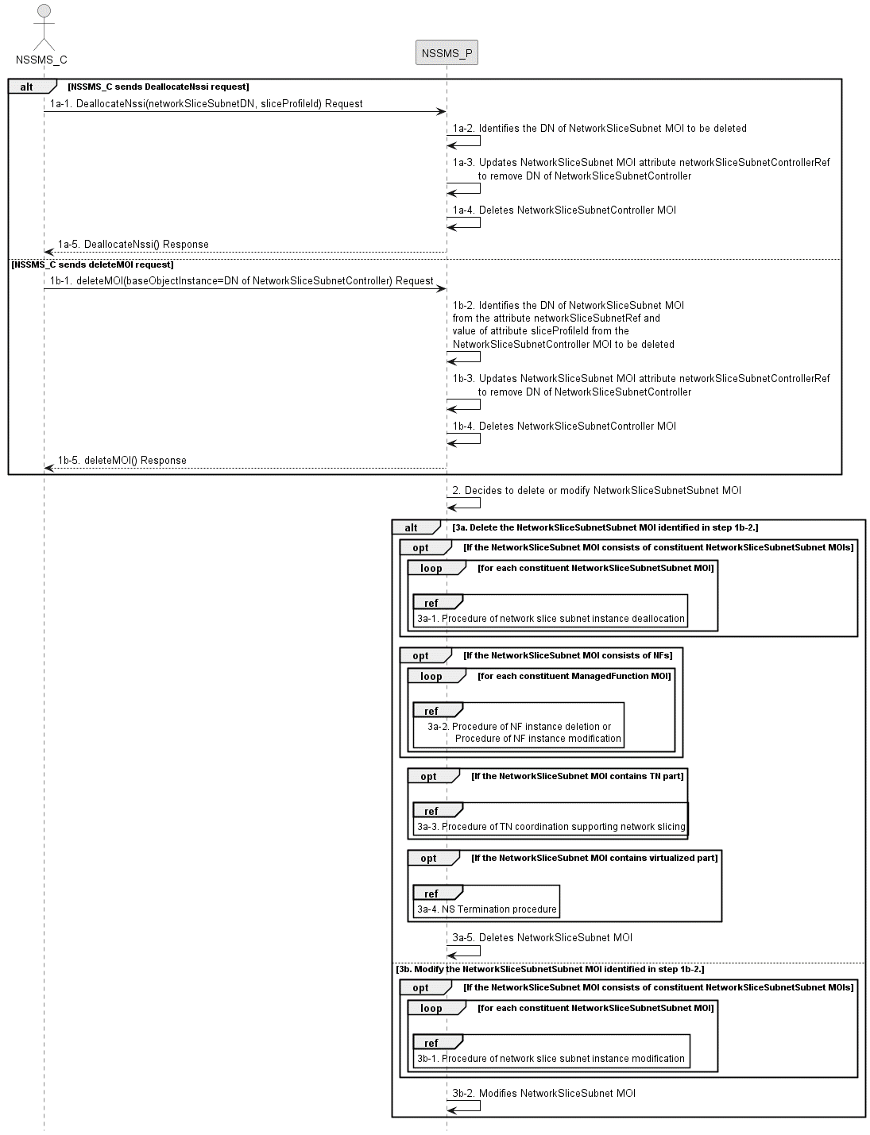
Figure 7.5-1: Network slice subnet instance deallocation procedure
1a-1) The network slice subnet management service provider (NSSMS_P) receives DeallocateNssi request (see DeallocateNssi operation defined in clause 6.5.4) from network slice subnet management service consumer (NSSMS_C) indicating that the NetworkSliceSubnet MOI is no longer needed for the given requirements i.e SliceProfile.
1a-2) NSSMS_P identifies the DN of NetworkSliceSubnet MOI from the attribute networkSliceSubnetRef and value of attribute sliceProfileId from the NetworkSliceSubnetController MOI to be deleted.
1a-3) NSSMS_P updates NetworkSliceSubnet MOI (identified in step 1b-2) attribute networkSliceSubnetControllerRef to remove the DN of NetworkSliceSubnetController MOI to be deleted.
1a-4) NSSMS_P deletes NetworkSliceSubnetController MOI.
1a-5) NSSMS_P sends response (see DeallocateNssi operation defined in clause 6.5.4) of NSSI deallocation service to NSSMS_C.
1b-1) NSSMS_P receives a deleteMOI request (see deleteMOI operation defined in TS 28.532 [8]) from NSSMS_C with network slice controller (see NetworkSliceSubnetController IOC and its attribute defined in TS 28.541[6])).
1b-2) NSSMS_P identifies the DN of NetworkSliceSubnet MOI from the attribute networkSliceSubnetRef and value of attribute sliceProfileId from the NetworkSliceSubnetController MOI to be deleted.
1b-3) NSSMS_P updates NetworkSliceSubnet MOI (identified in step 1b-2) attribute networkSliceSubnetControllerRef to remove the DN of NetworkSliceSubnetController MOI to be deleted.
1b-4) NSSMS_P deletes NetworkSliceSubnetController MOI.
1b-5) NSSMS_P sends the response to NSSMS_C for the deleteMOI request.
NOTE: Network slice subnet deallocation may be initiated using DeallocateNssi operation as described in steps 1a or using deleteMOI operation as described in steps 1b.
2) The NSSMS_P may decide to delete or modify the NetworkSliceSubnet MOI (identified in step 1b-2).
3a) If NSSMS_P decides to delete the NetworkSliceSubnet MOI, then it performs the following steps:
3a-1) NSSMS_P invokes procedure of network slice subnet instance deallocation as described in clause 7.5 for each constituent NetworkSliceSubnet MOI(s) that is configured in attribute networkSliceSubnetRef of NetworkSliceSubnet MOI (identified in step 1b-2).
3a-2) For each constituent NF instance (ManagedFunction MOI DN that is configured in attribute of managedFunctionRef of NetworkSliceSubnet MOI identified in step 1b-2), NSSMS_P invokes procedure of NF instance deletion as described in clause 7.12 only if the NF is dedicated for the NetworkSliceSubnet MOI (identified in step 1b-2) and not being used by any other NetworkSliceSubnet MOIs in the network, otherwise, NSSMS_P procedure of NF instance modification as described in clause 7.11.
3a-3) NSSMS_P invokes TN related coordination procedure with responsible manager as described in clause 7.9 if the NetworkSliceSubnet MOI consists of TN part.
3a-4) NSSMS_P invokes NS termination procedure if the NetworkSliceSubnet MOI contains virtualized part.

Note: For the interaction with ETSI NFV MANO, NS termination procedure is described in clause 7.3.7 in ETSI GS NFV-IFA 013 [3]..
3a-5) NSSMS_P deletes the NetworkSliceSubnet MOI.
3b) If NSSMS_P decides to modify the NetworkSliceSubnet MOI, then it performs the following sub steps:
3b-1) For each constituent NetworkSliceSubnet MOI, NSSMS_P invokes the procedure of network slice subnet instance modificationas described in clause 7.6.
3b-2) NSSMS_P modifies the NetworkSliceSubnet MOI to update the sliceProfileList (using the sliceProfileId identified in step 1b-2) and may update other attributes.
If the NSSMS_C has subscribed for the notification, then NSSMS_P sends notification for deletion (see notifyMOIDeletion operation defined in TS 28.532 [8]) and notification for the attribute value changes (see notifyMOIAttributeValueChanges operation defined in TS 28.532 [8]) of NetworkSliceSubnetController MOI and NetworkSliceSubnet MOI.
==============Next change==============

7.10 Procedure of NF instance creation
The Figure 7.10-1 illustrates the procedure of creating a new network function instance to satisfy the required network function related requirements.
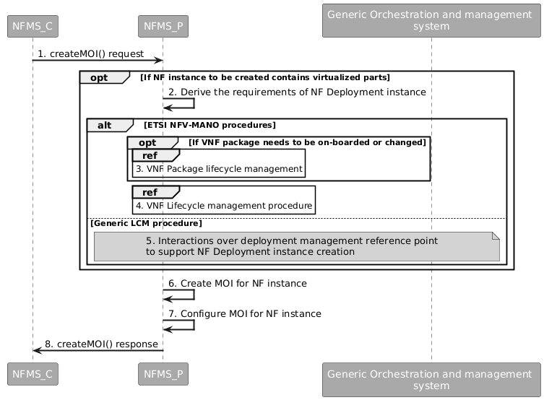
Figure 7.10-1: Network Function Instance Creation procedure
1) Network Function Management Service Provider (NFMS_P) receives a createMOI, for ManagedFunction IOC, request from Network Function Management Service Consumer (NFMS_C) with network function related requirements.
Note: The network function related requirements see information model definition for NR NRM in clause 4 and information model definition for 5GC NRM in clause 5 in TS 28.541[6].
2) If NF instance to be created contains virtualized part, NFMS_P derives the requirements for NF Deployment instance based on the network function related requirements.
3) If ETSI NFV-MANO procedure are used and the corresponding VNF Package needs to be on-boarded or changed, the NFMS_P invoke corresponding VNF Package management. For the interaction with ETSI NFV MANO, the procedure is described in clause 7.7 in ETSI GS NFV-IFA013 [3]. The VNF package is compliant with ETSI GS NFV-IFA011 [14].
4) The NFMS_P invokes VNF lifecycle management. For the interaction with ETSI NFV MANO, the procedure is as described in clause 7.3.5 (Update NS operation) in ETSI GS NFV-IFA013 [3] or clause 7.2.2 (Create VNF Identifier operation) and clause 7.2.3 (Instantiate VNF operation) in ETSI GS NFV-IFA008 [15].
5) If other industry solutions are used, the NFMS_P interacts with the external orchestration and management system to support NF Deployment instance creation.
6) The NFMS_P creates the MOI for the ManagedFunction to be created. If the ManagedFunction contains virtualized part, the NFMS_P may send the request of creating the MOI to the NFMS_P in the ManagedFunction.
7) The NFMS_P configures the new created MOI with corresponding configuration information (see information model definition for NR NRM in clause 4 and information model definition for 5GC NRM in clause 5 in TS 28.541[6]).
8) The NFMS_P sends the createMOI response to NFMS_C with DN of MOI for ManagedFunction.

==============Next change==============

7.11 Procedure of NF instance modification
The Figure 7.11-1 illustrates the procedure of modify NF instance.
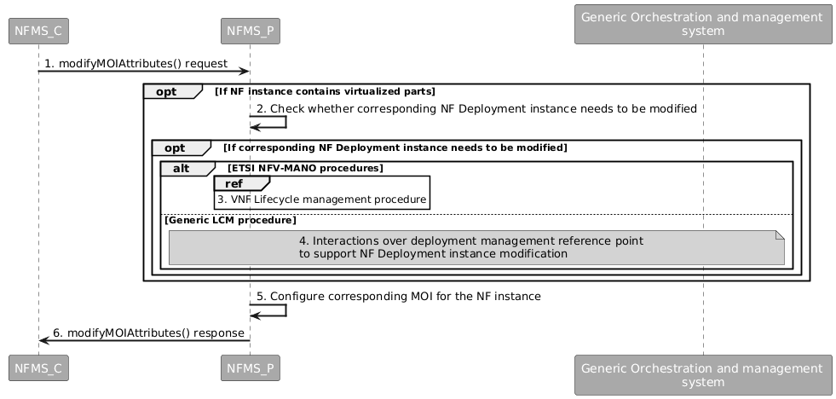
Figure 7.11-1: Network Function Instance Modify procedure
1) Network Function Management Service Provider (NFMS_P) receives a modifyMOIAttributes operation defined in TS 28.532 [8] from Network Function Management Service Consumer (NFMS_C) with DN of MOI for ManagedFunction and network function related requirements.
Note: The network funcation related requirements see information model definition for NR NRM in clause 4 and information model definition for 5GC NRM in clause 5 in TS 28.541[6].
2) If ManagedFunction instance contains virtualized part, NFMS_P checks whether corresponding NF Deployment instance needs to be modified to satisfy the network function related requirements.
3) If ETSI NFV-MANO procedures are followed and if corresponding VNF instance needs to be modified, NFMS_P invokes corresponding VNF instance lifecycle procedure. For the interaction with ETSI NFV MANO, the procedures are described in clause 7.2 in ETSI GS NFV-IFA008 [15] or clause 7.3 in ETSI GS NFV-IFA013 [3].
4) If other industry solutions are used, the NFMS_P interacts with the external orchestration and management system to support NF Deployment instance modification.
5) NFMS_P reconfigures corresponding ManagedFunction MOI.
6) The NFMS_P sends the response (see modifyMOIAttributes operation defined in TS 28.532 [8]) to NFMS_C.
==============Next change==============

7.12 Procedure of NF instance deletion
The Figure 7.12-1 illustrates the procedure of deleting NF instance.
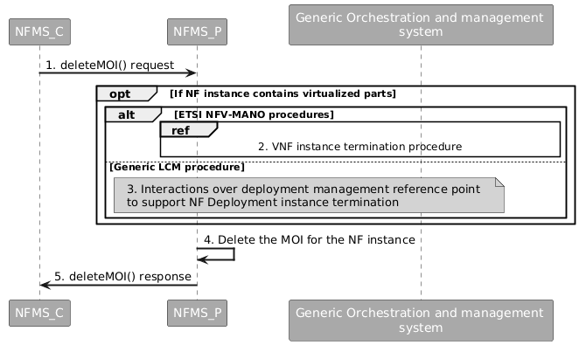
Figure 7.12-1: Network Function Instance Deletion procedure
1) Network Function Management Service Provider (NFMS_P) receives deletetMOI from Network Function Management Service Consumer (NFMS_C) with DN of ManagedFunction MOI.
2) If the ManagedFunction instance contains virtualized part and if ETSI NFV-MANO procedures are followed, NFMS_P invokes VNF instance termination procedure. For the interaction with ETSI NFV MANO, the procedure is with ETSI NFV MANO as described in clause 7.2.7 (Terminate VNF operation) and clause 7.2.8 (Delete VNF Identifier operation) in ETSI GS NFV-IFA008 [15] or clause 7.3.5 (Update NS operation) in ETSI GS NFV-IFA013 [3].
3) If other industry solutions are used, the NFMS_P interacts with the external orchestration and management system to support NF Deployment instance deletion.
4) NFMS_P deletes the ManagedFunction MOI.
5) NFMS_P sends the response (see deleteMOI operation defined in TS 28.532 [8]) to NFMS_C.

==============Next change==============

C.x Procedure of NF instance creation

@startuml
hide unlinked
skinparam sequenceArrowThickness 2
skinparam ParticipantPadding 5
skinparam ParticipantFontColor white
skinparam NoteBackgroundColor white
skinparam BoxPadding 10
skinparam SequenceReferenceAlign center

participant "NFMS_C" as nfms_c #DarkGrey
participant "NFMS_P" as nfms_p #DarkGrey
participant "Generic Orchestration and management \nsystem" as nfo #DarkGrey

nfms_c -> nfms_p: 1. createMOI() request
opt If NF instance to be created contains virtualized parts
nfms_p -> nfms_p: 2. Derive the requirements of NF Deployment instance
alt ETSI NFV-MANO procedures
opt If VNF package needs to be on-boarded or changed
ref over nfms_p: 3. VNF Package lifecycle management
end
ref over nfms_p: 4. VNF Lifecycle management procedure
else Generic LCM procedure
note over nfms_p, nfo #LightGrey: 5. Interactions over deployment management reference point \nto support NF Deployment instance creation
end
end

nfms_p -> nfms_p: 6. Create MOI for NF instance
nfms_p -> nfms_p: 7. Configure MOI for NF instance
nfms_p -> nfms_c: 8. createMOI() response

@enduml

==============Next change==============

C.y Procedure of NF instance modification
@startuml
hide unlinked
skinparam sequenceArrowThickness 2
skinparam ParticipantPadding 5
skinparam ParticipantFontColor white
skinparam NoteBackgroundColor white
skinparam BoxPadding 10
skinparam SequenceReferenceAlign center

participant "NFMS_C" as nfms_c #DarkGrey
participant "NFMS_P" as nfms_p #DarkGrey
participant "Generic Orchestration and management \nsystem" as nfo #DarkGrey

nfms_c -> nfms_p: 1. modifyMOIAttributes() request
opt If NF instance contains virtualized parts
nfms_p -> nfms_p: 2. Check whether corresponding NF Deployment instance needs to be modified
opt If corresponding NF Deployment instance needs to be modified
alt ETSI NFV-MANO procedures
ref over nfms_p: 3. VNF Lifecycle management procedure
else Generic LCM procedure
note over nfms_p, nfo #LightGrey: 4. Interactions over deployment management reference point \nto support NF Deployment instance modification
end
end
end

nfms_p -> nfms_p: 5. Configure corresponding MOI for the NF instance
nfms_p -> nfms_c: 6. modifyMOIAttributes() response

@enduml

==============Next change==============

C.z Procedure of NF instance deletion
@startuml
hide unlinked
skinparam sequenceArrowThickness 2
skinparam ParticipantPadding 5
skinparam ParticipantFontColor white
skinparam NoteBackgroundColor white
skinparam BoxPadding 10
skinparam SequenceReferenceAlign center

participant "NFMS_C" as nfms_c #DarkGrey
participant "NFMS_P" as nfms_p #DarkGrey
participant "Generic Orchestration and management \nsystem" as nfo #DarkGrey

nfms_c -> nfms_p: 1. deleteMOI() request
opt If NF instance contains virtualized parts

alt ETSI NFV-MANO procedures
ref over nfms_p, nfo: 2. VNF instance termination procedure
else Generic LCM procedure
note over nfms_p, nfo #LightGrey: 3. Interactions over deployment management reference point \nto support NF Deployment instance termination

end
end

nfms_p -> nfms_p: 4. Delete the MOI for the NF instance
nfms_p -> nfms_c: 5. deleteMOI() response

@enduml

==============End of change==============

