3GPP TSG-SA5 Meeting #165 S5-260743
Goa, India, 9 - 13 February 2026
CR-Form-v12.3
CHANGE REQUEST
 | 28.531 | CR | 0265 | rev | 1 | Current version: | 19.2.0
For HELP on using this form: comprehensive instructions can be found at
http://www.3gpp.org/Change-Requests.

Proposed change affects: | UICC apps |  | ME |  | Radio Access Network | x | Core Network | - x

Title: | Rel-20 CR TS 28.531 Add use case and procedure for WAB-node configuration
Source to WG: | Ericsson
Source to TSG: | S5
Work item code: | AdNRM_Ph4-OAM |  |  |  |  |  | Date: |  |  | 2026-01-13
Category: | B |  |  |  |  |  | Release: |  |  | Rel-20
 | Use one of the following categories:  F (correction)  A (mirror corresponding to a change in an earlier release)  B (addition of feature),  C (functional modification of feature)  D (editorial modification)  Detailed explanations of the above categories can  be found in 3GPP TR 21.900. |  |  |  |  |  |  |  | Use one of the following releases:  Rel-8 (Release 8)  Rel-9 (Release 9)  Rel-10 (Release 10)  Rel-11 (Release 11)  …  Rel-17 (Release 17)  Rel-18 (Release 18)  Rel-19 (Release 19)  Rel-20 (Release 20)
Reason for change: |  | A mobile NR node can implement different network features, including IAB and WAB.  The management of a mobile NR node includes the node connectivity to management system (specified in TS 28.314/28.315) and node configuration (specified in TS 28.531).  In TS 28.531, the mobile NR node configuration only covers IAB feature; WAB feature is missing.
Summary of change: |  | Add use case description, requirements and procedure for WAB-node configuration.  Update the location information for IAB-node, adding the geographical coordination as potential option, to comply with the solution in TS 28.541.  Fix minor typos in clauses 5.1.27.1 and 5.1.27.2
Consequences if not approved: |  | The use case on mobile NR node configuration for WAB feature is missing.
Clauses affected: |  | 3.2, 5.1.27.1, 5.1.27.2, 5.1.27.3, 5.1.X (new), 5.1.X.1 (new), 5.1.X.2 (new), 5.1.X.3 (new), 5.2.X (new), 7.X (new), C.X (new)
 |  | Y | N
Other specs |  |  | x | Other core specifications |  |  |  | TS/TR ... CR ...
affected: |  |  | x | Test specifications |  |  |  | TS/TR ... CR ...
(show related CRs) |  |  | x | O&M Specifications |  |  |  | TS/TR ... CR ...
Other comments:
This CR's revision history:

First change

3 Definitions and abbreviations

3.1 Definitions
For the purposes of the present document, the terms and definitions given in TR 21.905 [1], TS 28.530 [4] and the following apply. A term defined in the present document takes precedence over the definition of the same term, if any, in TR 21.905 [1] and TS 28.530 [4].
IAB-node: as defined in TS 38.401 [18].
WAB-node: as defined in TS 38.401 [18].

3.2 Abbreviations
For the purposes of the present document, the abbreviations given in TR 21.905 [1], TS 28.530 [4] and the following apply. An abbreviation defined in the present document takes precedence over the definition of the same abbreviation, if any, in TR 21.905 [1].
5GAA 5G Automative Association
5G-ACIA 5G Association for Connected Industries and Automation
5GC 5G Core Network
AMF Access and Mobility Management Function
CSC Communication Service Customer
CSP Communication Service Provider
CP Control Plane
GST Generic Slice Template
IOC Information Object Class
MANO Management and Orchestration
MnS Management Service
NEST Network Slice Type
NF Network Function
NFV Network Functions Virtualisation
NRM Network Resource Model
NSaaS Network Slice as a Service
NSC Network Slice Customer
NSI Network Slice Instance
NSP Network Slice Provider
NSSI Network Slice Subnet Instance
P-NEST Private NEST
S-NEST Standardized NEST
TN Transport Network
VNF Virtualized Network Function
UP User Plane
IAB Integrated Access and Backhaul
WAB Wireless Access Backhaul

Next Change

5.1.27 Use case IAB-node configuration

5.1.27.1 Overview
IAB architecture is specified in clause 6.1.3 of 3GPP TS 38.401[18]. The IAB-node connects to an upstream IAB-node or an IAB-donor-DU via a subset of the UE functionalities of the NR Uu interface (named IAB-MT function of IAB-node). IAB-node differs from static NE in term of its wireless connection with IAB-donor-node and its mobility behaviours.

IAB-node can move to different geographic areas or traverse to different PLMNs which as a result may connect to different management system based on its location. IAB-node should use configuration based on its location at power up and in mobile scenarios as specified in 3GPP TS 38.401 [18].

5.1.27.2 Obtain configuration via notifications
IAB-node may need new configuration while it moves. 3GPP management system should support IAB-node to use notification mechanism to obtain configuration based on its location. 3GPP management system needs to support the mapping of configuration with IAB-node location (see clause 5.1.27.3) considering location as notified by the IAB-node. The detailed steps for the IAB-node to obtain configuration based on its location via notifications are described as below:
When IAB-node powers up and after connecting to 3GPP management system for the first time, the MnS producer for IAB-node needs to provide location information with IAB-node indication via notifications to 3GPP management system as specified in 3GPP TS 28.532 [8] (e.g. notifyMOIChanges) to indicate its current location. Upon the reception of notifications, 3GPP management system needs to provision the initial configuration (e.g. via createMOI operation) as specified 3GPP TS 28.532 [8] to the MnS producer for IAB-node based on its current location.
When IAB-node moves to a new location, the MnS producer for IAB-node needs to provide location information to 3GPP management system via "notifyMOIChanges" or "notifyMOIAttributeValueChanges" or other notifications as specified in 3GPP TS 28.532 [8]. Upon the reception of notifications of the location, if configuration is needed, 3GPP management system needs to provision the configuration using the operations as specified in 3GPP TS 28.532 [8] (e.g., modifyMOIAttributes) to the MnS producer for IAB-node based on its location.

5.1.27.3 Location information
The location information should include one or more of the following depending on IAB-node physical location or the mobility scenarios as specified in 3GPP TS 38.401 [18] clause 8.12 and clause 8.23:
- The geographical coordinates of the IAB-node.
- TAC or TAI pertaining to the cells where IAB-MT is connected.
- Serving cell ID that IAB-MT is connected to.
- The gNBId of the IAB-donor-CU and PLMN info that target IAB-DU connects to.
- The gNBId of the IAB-donor-CU and PLMN info that serves the IAB-MT

Next Change

5.1.X Use case WAB-node configuration

5.1.X.1 Overview
WAB architecture is specified in clause 6.1.7 of 3GPP TS 38.401[18]. The WAB-node consists of a WAB-gNB and a WAB-MT. The WAB-node differs from static NE in terms of its wireless connection with two 5GC instances (i.e., an 5G instance, which serves WAB-gNB, and another 5GC instance, which serves WAB-MT via a gNB) and its mobility behaviours.
WAB-node can move to different geographic areas or traverse to different PLMNs which as a result may connect to different management system based on its location. WAB-node should use configuration based on its location at power up and in mobile scenarios as specified in 3GPP TS 38.401 [18].

5.1.X.2 Obtain configuration via notifications
The procedure is the same as described in clause 5.1.27.2, with WAB-node instead of IAB-node.

5.1.X.3 Location information
The location information should include one or more of the following depending on WAB-node physical location or the mobility scenarios as specified in 3GPP TS 38.401 [18] clause 12.7
- The geographical coordinates for the WAB-node.
- TAC or TAI pertaining to the cells where WAB-MT is connected.
- Serving cell ID that WAB-MT is connected to.
- The gNBId and PLMN information that serves the WAB-MT.

Next Change

5.2 Requirements

5.2.1 Requirements for network slice provisioning service
REQ-PRO_NSI-FUN-1 The network slice provisioning service provider shall have the capability allowing its authorized consumer to request a network slice instance.
REQ-PRO_NSI-FUN-2 The network slice provisioning service provider shall have the capability allowing its authorized consumer to send the network slice related requirements.
NOTE 1: The network slice related requirements include requirements such as area traffic capacity, coverage area, isolation/sharing, end-to-end latency, mobility, overall user density, priority, service availability, service reliability, UE speed; see TS 22.261 [5] where these parameters are defined for end user services.
NOTE 2: The network slice related requirements also include requirements derived from the Generic network Slice Template (GST) defined by GSMA in [9].
NOTE 3: The SLA requirements can be translated to service profile which can be used to decides on the constituent NSSIs and the topology of the NSI.
NOTE 4: Void
REQ-PRO_NSI-FUN-3 The network slice provisioning service provider shall have the capability allowing its authorized consumer to request the deallocation of a network slice instance.
REQ-PRO_NSI–FUN-4 The network slice provisioning service provider shall have the capability allowing its authorized consumer to request activation of a network slice instance.
REQ-PRO_NSI–FUN-5 The network slice provisioning service provider shall have the capability allowing its authorized consumer to request deactivation of a network slice instance.
REQ-PRO_NSI-FUN-6 The network slice provisioning service provider shall have the capability allowing its authorized consumer to request the modification of a network slice instance.
REQ-PRO_NSI-FUN-7 The network slice provisioning service provider shall have the capability allowing its consumer to obtain the network slice management data.
REQ-PRO_NSI-FUN-8 The network slice provisioning service provider shall have the capability allowing its authorized consumer to obtain the feasibility of provisioning the requested network slice instance at a particular point of time.
REQ-PRO_NSI-FUN-9 The network slice provisioning service provider shall have the capability to satisfy the requirements using shared or dedicated managed resources for a network slice instance.

5.2.2 Requirements for network slice subnet provisioning service
REQ-PRO_NSSI-FUN-1 The network slice subnet provisioning service provider shall have the capability allowing its authorized consumer to request a network slice subnet instance.
REQ-PRO_NSSI-FUN-2 The network slice subnet provisioning service provider shall have the capability of interaction with NFVO via the NS lifecycle management interface.
REQ-PRO_NSSI-FUN-3 The network slice subnet provisioning service provider shall have the capability allowing its authorized consumer to send network slice subnet related requirements.
REQ-PRO_NSSI-FUN-4 The network slice subnet provisioning service provider shall have the capability allowing its authorized consumer to request to create a new NSSI or use an existing NSSI based on the network slice subnet related requirements.
REQ-PRO_NSSI-FUN-5 The network slice subnet provisioning service provider shall have the capability allowing its authorized consumer to request to associate the NS instance with corresponding NSSI.
REQ-PRO_NSSI-FUN-6 The network slice subnet provisioning service provider shall have the capability allowing its authorized consumer to request the configuration of the RAN NSSI constituents with the RRM policy information for simultaneous support of multiple NSIs.
REQ-PRO_NSSI-FUN-7 The network slice subnet provisioning service provider shall have the capability allowing its authorized consumer to obtain network slice subnet instance information.
REQ-PRO_NSSI-FUN-8 The network slice subnet provisioning service provider shall have the capability of allowing its authorized consumer to request the deallocation of a network slice subnet instance.
REQ-PRO_NSSI-FUN-9 The network slice subnet provisioning service provider shall have the capability allowing its authorized consumer to request activation of a network slice subnet instance.
REQ-PRO_NSSI-FUN-10 The network slice subnet provisioning service provider shall have the capability allowing its authorized consumer to request deactivation of a network slice subnet instance.
REQ-PRO_NSSI-FUN-11 The network slice subnet provisioning service provider shall have the capability allowing its authorized consumer to request modification of a network slice subnet instance.
REQ-PRO_NSSI-FUN-12 The network slice subnet provisioning service provider shall have the capability allowing its consumer to obtain information regarding available network slice subnet resources.
REQ-PRO_NSSI-FUN-13 The network slice subnet provisioning service provider shall have the capability allowing its authorized consumer to obtain the feasibility of provisioning a network slice subnet instance at a particular point of time.
REQ-PRO_NSSI-FUN-14 The network slice subnet provisioning service provider shall have the capability to satisfy the request to consume the NF provisioning service.
REQ-PRO_NSSI-FUN-16 The network slice subnet provisioning service provider shall have the capability allowing its consumer to provide slice specific operation information for the (re)configuration to a NSSI.
REQ-PRO_NSI-FUN-17 The network slice subnet provisioning service provider shall have the capability allowing its authorized consumer to assign priority of a network slice subnet.
REQ-PRO_NSSI-FUN-18 The network slice subnet provisioning service provider shall have the capability allowing its authorized consumer to obtain network slice subnet provider capability information.
REQ-PRO_NSSI-FUN-19 The network slice subnet provisioning service provider shall have the capability to satisfy the requirements using shared or dedicated managed resources for a network slice subnet instance.

5.2.3 Requirements for NF provisioning service
REQ-PRO_NF-FUN-1 The NF provisioning service producer shall have the capability allowing its authorized consumer to request creation of an instance of 3GPP NF.
REQ-PRO_NF-FUN-2 The NF provisioning service producer shall have the capability to fulfill the consumer’s request to create an instance of 3GPP NF.
REQ-PRO_NF-FUN-3 The NF provisioning service producer shall have the capability to provide the VNF and VNFC related information of the NF instance to its authorized consumer.
REQ-PRO_NF-FUN-4 The NF provisioning service producer shall have the capability allowing its authorized consumer to request configuration of a 3GPP NF instance.
REQ-PRO_NF-FUN-5 The NF provisioning service producer shall have the capability to request updating the VNF(s) that are realizing the virtualized part of a 3GPP NF.
REQ-PRO_NF-FUN-6 The NF provisioning service producer shall have the capability to fulfill the consumer’s request to configure a 3GPP NF instance.
REQ-PRO_NF-FUN-7 The NF provisioning service producer shall have the capability to request NF management service producers working in the concerned NF instance to create and maintain the MOI(s) for it.

5.2.4 Requirements for sub-network provisioning service
REQ-PRO_NW-FUN-1 The sub-network provisioning service producer shall have the capability allowing its authorized consumer to request creation of a 3GPP sub-network.
REQ-PRO_NW-FUN-2 The sub-network provisioning service producer shall have the capability to fulfil the consumer’s request to create a 3GPP sub-network.
REQ-PRO_NW-FUN-3 The sub-network provisioning service producer shall have the capability allowing its authorized consumer to request configuration of a 3GPP sub-network.
REQ-PRO_NW-FUN-4 The sub-network provisioning service producer shall have the capability to fulfil the consumer’s request to configure a 3GPP sub-network.

5.2.5 Requirements for IAB-node configuration
REQ_IAB_CM_1: 3GPP management system should have the capability to configure IAB-node configuration based on IAB-node location.
REQ_IAB_CM_2: 3GPP management system should have the capability to receive notification about the location of IAB-node.
REQ_IAB_CM_3: 3GPP management function of the IAB-node should have capability to send notification about the location of IAB-node.

5.2.X Requirements for WAB-node configuration
REQ_WAB_CM_1: 3GPP management system should have the capability to configure WAB-node configuration based on WAB-node location.
REQ_WAB_CM_2: 3GPP management system should have the capability to receive notification about the location of WAB-node.
REQ_WAB_CM_3: 3GPP management function of the WAB-node should have capability to send notification about the location of WAB-node.

Next Change

7.22 Procedure of IAB-node configuration
The Figure 7.22-1 illustrates the procedure of IAB-node configuration based on its location.
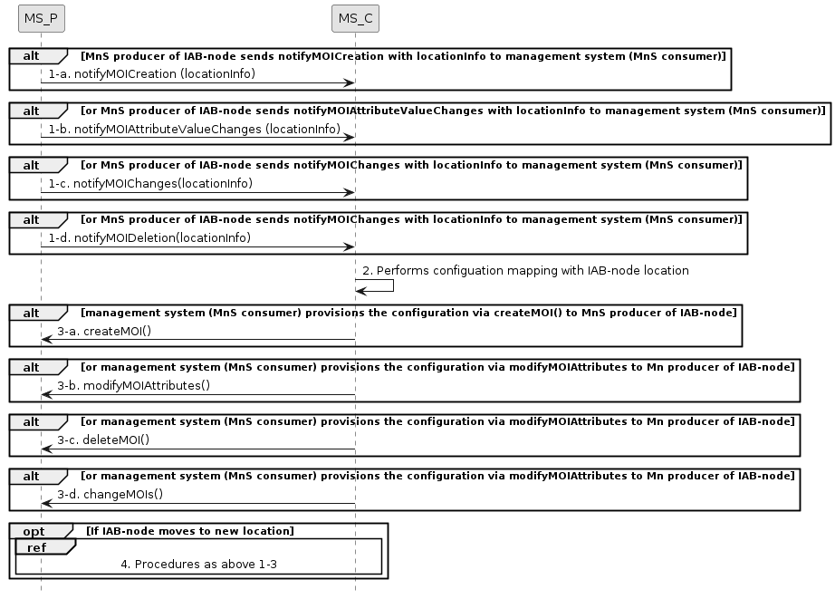
Figure 7.22-1 IAB-node configuration
1) After IAB-node connecting to 3GPP management system via PnC (see TS 28.315 [19] clause 5.6), the provisioning MnS producer of IAB-node sends location information via any of the following notifications:
- notifyMOICreation
- notifyMOIAttributeValueChanges
- notifyMOIChanges
- notifyMOIDeletion
2) The provisioning MnS consumer (management system) perfoms configuration mapping with IAB-node location.
3) The provisioning MnS consumer (management system) provisions IAB-node configuration via any of the following operations upon the reception of notifications:
- createMOI
- modifyMOIAttributes
- deleteMOI
- changeMOIs
4) When IAB-node moves to a new location which may connect to a different management system based on its location (see TS 28.315 [19] clause 5.6), procedures of step 1) to 3) as above are repeated for mobile IAB-node to obtain configuration based on its location.

7.X Procedure of WAB-node configuration
The Figure 7.X-1 illustrates the procedure of WAB-node configuration based on its location.
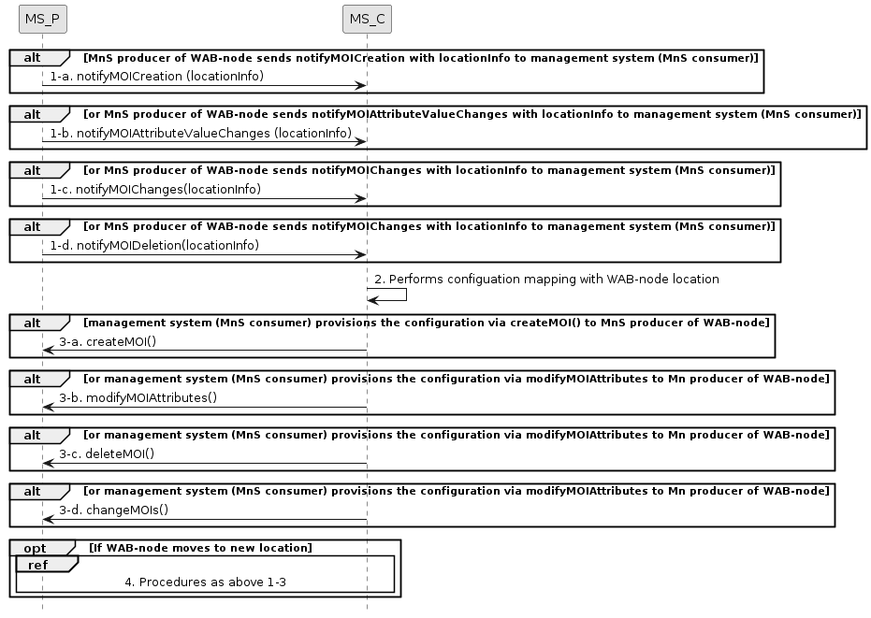
Figure 7.X-1 WAB-node configuration
The description of steps 1-4 is the same as in clause 7.22, with WAB-node instead of IAB-node.
Next Change

C.X Procedure of WAB-node configuration

@startuml
skinparam shadowing false
skinparam monochrome true
hide footbox

participant “MS_P” as MnS_Producer
participant "MS_C" as MnS_Consumer
alt MnS producer of WAB-node sends notifyMOICreation with locationInfo to management system (MnS consumer)
MnS_Producer -> MnS_Consumer: 1-a. notifyMOICreation (locationInfo)
End
alt or MnS producer of WAB-node sends notifyMOIAttributeValueChanges with locationInfo to management system (MnS consumer)
MnS_Producer -> MnS_Consumer: 1-b. notifyMOIAttributeValueChanges (locationInfo)
End
alt or MnS producer of WAB-node sends notifyMOIChanges with locationInfo to management system (MnS consumer)
MnS_Producer -> MnS_Consumer: 1-c. notifyMOIChanges(locationInfo)
End
alt or MnS producer of WAB-node sends notifyMOIChanges with locationInfo to management system (MnS consumer)
MnS_Producer -> MnS_Consumer: 1-d. notifyMOIDeletion(locationInfo)
End
MnS_Consumer -> MnS_Consumer: 2. Performs configuation mapping with WAB-node location
alt management system (MnS consumer) provisions the configuration via createMOI() to MnS producer of WAB-node
MnS_Consumer -> MnS_Producer: 3-a. createMOI()
End
alt or management system (MnS consumer) provisions the configuration via modifyMOIAttributes to Mn producer of WAB-node
MnS_Consumer -> MnS_Producer: 3-b. modifyMOIAttributes()
End
alt or management system (MnS consumer) provisions the configuration via modifyMOIAttributes to Mn producer of WAB-node
MnS_Consumer -> MnS_Producer: 3-c. deleteMOI()
End
alt or management system (MnS consumer) provisions the configuration via modifyMOIAttributes to Mn producer of WAB-node
MnS_Consumer -> MnS_Producer: 3-d. changeMOIs()
End
opt If WAB-node moves to new location
ref over MnS_Producer, MnS_Consumer
4. Procedures as above 1-3
end ref
end opt
@enduml

End of Changes

