3GPP TSG-SA5 Meeting #165 S5-260173
Goa, India, 9 – 13 February 2026

Source: Rakuten Mobile Inc.
Title: Pseudo-CR on TR 28.884 Improvements to message bus solution
Document for: Approval
Agenda item: 6.20.4
Spec: 3GPP TR 28.884
Version: 0.2.0
Work Item: FS_SBMA_Ph4

Comments
To address WT-1 of Study on Service Based Management Architecture enhancement phase 4, this contribution proposes to improve the management data streaming solution based on message bus.

Proposed Changes
Address remaining editor’s notes by adding relevant procedure

* * * First Change * * * *

2 References
The following documents contain provisions which, through reference in this text, constitute provisions of the present document.
- References are either specific (identified by date of publication, edition number, version number, etc.) or non-specific.
- For a specific reference, subsequent revisions do not apply.
- For a non-specific reference, the latest version applies. In the case of a reference to a 3GPP document (including a GSM document), a non-specific reference implicitly refers to the latest version of that document in the same Release as the present document.
[1] 3GPP TR 21.905: "Vocabulary for 3GPP Specifications".
[2] 3GPP TS 28.533: "Management and orchestration; Architecture framework".
[3] 3GPP TS 28.532: " Management and orchestration; Generic management services".
[4] 3GPP TS 28.537: " Management and orchestration; Management capabilities".
[5] 3GPP TS 28.552: " Management and orchestration; 5G performance measurements".
[6] 3GPP TS 28.554: " Management and orchestration; 5G end to end Key Performance Indicators (KPIs)".
[7] 3GPP TS 32.423: " Telecommunication management; Subscriber and equipment trace: Trace data definition and management".
[8] https://datatracker.ietf.org/doc/html/rfc6455
[9] https://websocket.org/guides/websocket-protocol/
[10] 3GPP TS 28.111: "Management and orchestration; Fault management (FM)".
[11] 3GPP TS 32.531: "Telecommunication management; Software management (SwM); Concepts and Integration Reference Point (IRP) Requirements".
[12] 3GPP TS 32.532: "Telecommunication management; Software management (SwM); Integration Reference Point (IRP); Information Service (IS)".
[13] 3GPP TS 32.533: "Telecommunication management; Software management (SwM); Integration Reference Point (IRP); Common Object Request Broker Architecture (CORBA) Solution Set (SS)".
[14] 3GPP TS 28.631: "Telecommunication management; Inventory Management (IM) Network Resource Model (NRM) Integration Reference Point (IRP); Requirements".
[15] 3GPP TS 28.632: "Telecommunication management; Inventory Management (IM) Network Resource Model (NRM) Integration Reference Point (IRP); Information Service (IS)".
[16] 3GPP TS 28.633: "Telecommunication management; Inventory Management (IM) Network Resource Model (NRM) Integration Reference Point (IRP); Solution Set (SS) definitions".
[17] SP-250863: Study on SBMA enhancement phase 4
[18] 3GPP TS 32.158: " Design rules for REpresentational State Transfer (REST) Solution Sets (SS)"
[19] RFC 6241 Network Configuration Protocol (NETCONF)
[20] 3GPP TS 32.101: "Telecommunication management;Principles and high level requirements".
[x] 3GPP TS 28.622: “Telecommunication management; Generic Network Resource Model (NRM) Integration Reference Point (IRP); Information Service (IS)”.

* * * Next Change * * * *
5.2.3.1 Solution #1: Multipoint-to-Multipoint management data streaming based on message broking MnF
This potential solution proposes introduction of a new MnF implementing the message broker(s) that mediates data with the help of new MnS services, namely, message bus data reporting MnS and message bus data retrieval MnS (for data subscribers) to enable multipoint-to-multipoint streaming data reporting. This solution is meant for use at the management level and not at the managedElement/NF level. This solution also does not impact existing MnS services and can coexist beside such services as an additional option.
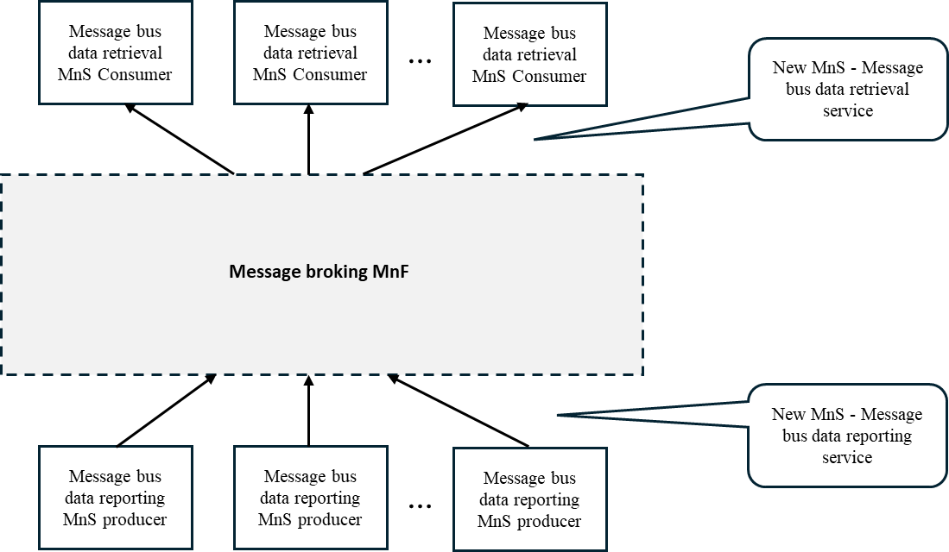
Figure 5.2.3.1-1: Potential solution for multipoint-to-multipoint management data streaming based on message bus
As shown in Figure 5.2.3.1-1, in this solution, Message bus data reporting MnS producers send management data to Message broking MnF using the message bus data reporting service based on message bus publishing protocol. Message bus data retrieval MnS consumers receive the management data using the message bus data retrieval service based on message bus retrieval protocol. This approach allows the same copy of management data produced by the Message bus data reporting MnS producer(s) to be shared across multiple Message bus data retrieval MnS consumers thus enabling multipoint-to-multipoint communication and a publishing-and-subscribing based communication pattern.
Editor’s note: The following aspects are FFS

- What specific message bus-based communication protocol to be supported (e.g. Kafka) and why?
- How to do data access control.

Five different methods related to the high-level procedures for enabling data flowing from Message bus data reporting MnS producers to Message bus data retrieval MnS consumers via the Message broking MnF for management data streaming are illustrated in Figures 5.2.3.1-2, 5.2.3.1-3, 5.2.3.1-4, 5.2.3.1-5 and 5.2.3.1-6 below.
Note: The message bus-based management data streaming method applies to performance metric data only.

Method 1
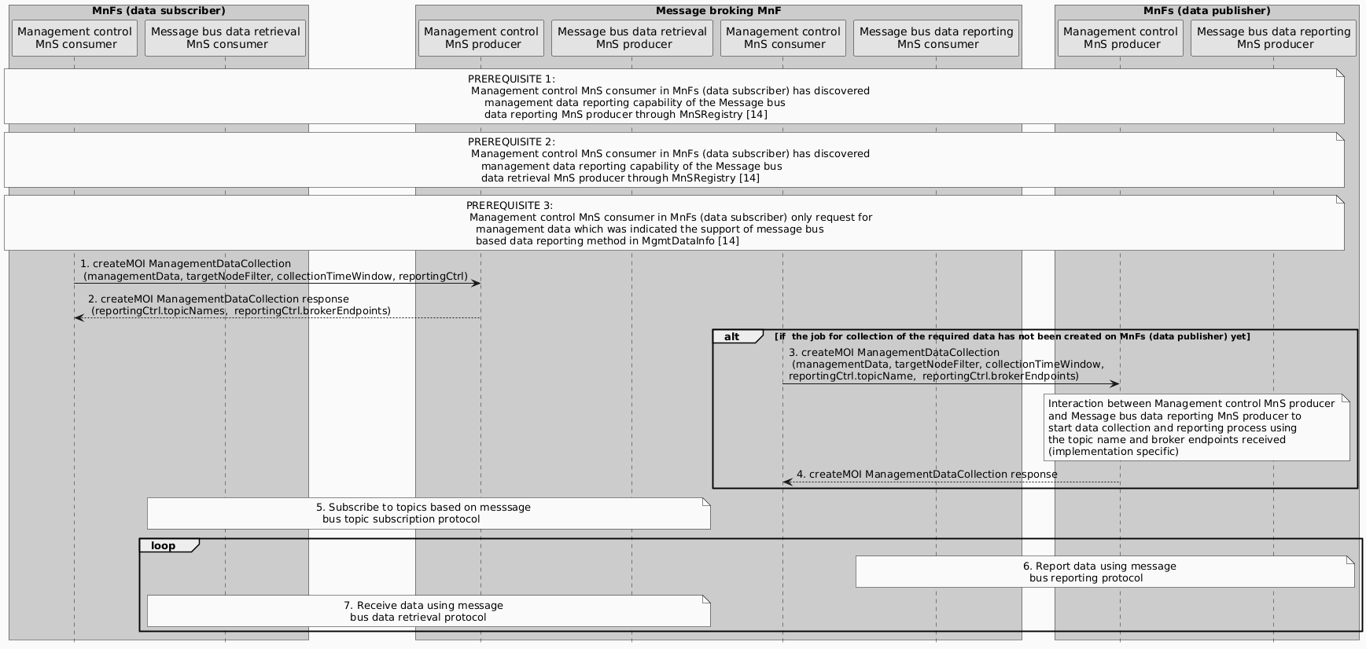
Figure 5.2.3.1-2: Method-1 Procedures for establishing management data streaming based on message bus

- Management control MnS consumer in a MnF (data subscriber) creates ManagementDataCollection MOI by invoking the createMOI operation to the Management control MnS producer in Message broking MnF including information about the data requested (managementData, TS 28.622[14]), target nodes (targetNodeFilter, TS 28.622[14]),) and data collection window (collectionTimeWindow, TS 28.622[14]),) etc.
- The Management control MnS producer in Message broking MnF responds back with a createMOI response which contains information about the message bus topic names and message broker endpoints that the Message bus data retrieval MnS consumer should receive the requested data from (add reportingCtrl.topicNames and reportingCtrl.brokerEndpoints in TS 28.622[14])).
- Management control MnS consumer in Message broking MnF creates a new ManagementDataCollectionMOI by invoking the createMOI operation to the Management control MnS producer in the related MnF (data producer) including information about the data requested (managementData), target nodes (targetNodeFilter) and data collection window (collectionTimeWindow) etc. In addition, information about the topic name and broker endpoints (reportingCtrl.topicNames and reportingCtrl.brokerEndpoints) for the Message bus data reporting MnS producer to establish data communication to the message broker, is conveyed.
- Management control MnS producer in the related MnF (data producer) sends back a createMOI response indicating the acceptance of the data production request.
- Message bus data retrieval MnS consumer then subscribes to the topics using the topic names and message broker endpoints provided in STEP 2, using message bus implementation specific subscription protocol.
- Message bus data reporting MnS producer reports data to the message broker using the topic name and message broker endpoints provided in STEP 3 using message bus implementation specific data publishing protocol.
- Message bus data retrieval MnS consumer receives the data from the message broker using message bus implementation specific data retrieval protocol.
Note: The message bus data subscription, publishing and retrieval protocols are implementation specific allowing any industry solution to be used, e.g. Kafka.
Method 2
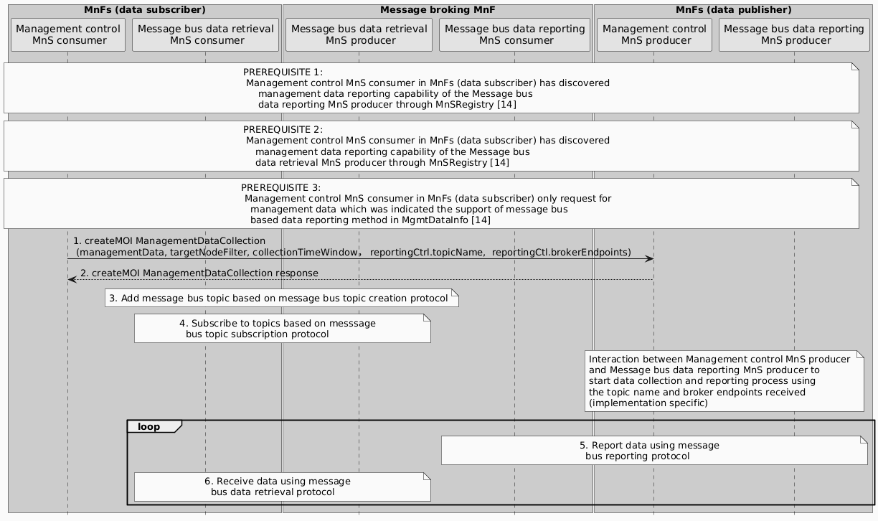
Figure 5.2.3.1-3: Method-2 Procedures for establishing management data streaming based on message bus

In comparison to Method-1, Management control MnS consumer in MnF (data subscriber) creates ManagementDataCollection MOI by invoking the createMOI operation directly to Management control MnS producer in MnF (data publisher) to request data collection and reporting. Information about topic name and broker endpoints are conveyed during the create MOI operation for the Message data reporting MnS producer to establish data communication to the message broker. The Message bus data retrieval MnS consumer then creates the topic based on message bus topic creation protocol (implementation specific) and subscribes to the topic using message bus implementation specific subscription protocol. The data reporting and data retrieving sessions then start.
Method 3
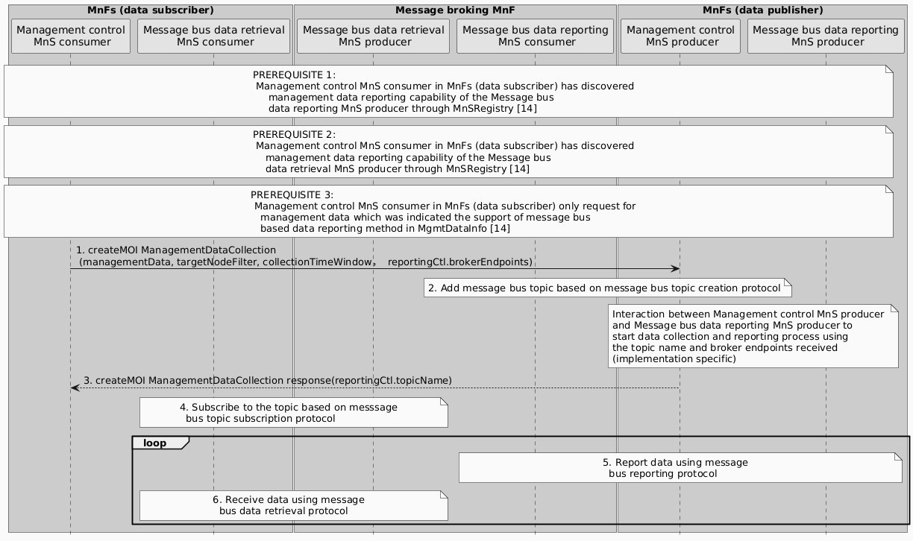
Figure 5.2.3.1-3: Method-4 Procedures for establishing management data streaming based on message bus

In comparison to Method-2, MnF (data publisher) side directly creates the topic and conveys the information to the MnF (data consumer). The Message bus data retrieval MnS consumer then subscribes to the topic using message bus implementation specific subscription protocol and the data reporting and data retrieving session starts.
Method 4
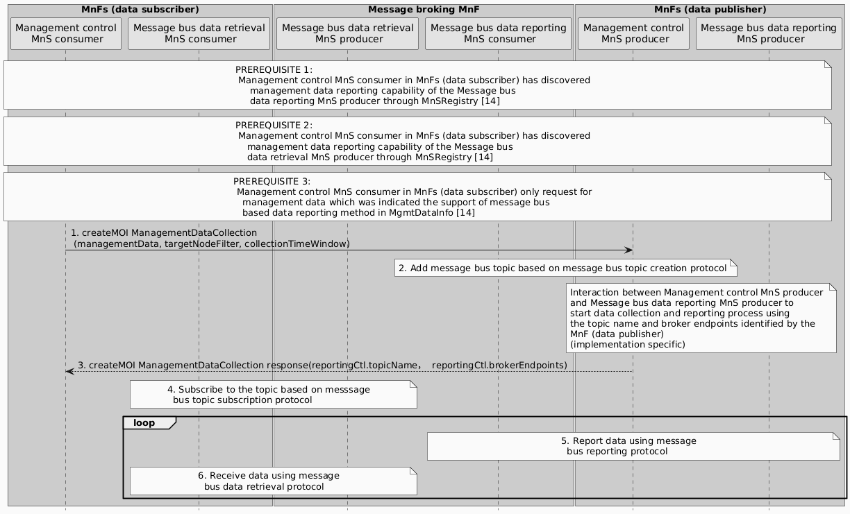
Figure 5.2.3.1-4: Method-5 Procedures for establishing management data streaming based on message bus

In comparison to Method-3, both topic name and broker endpoints are provided from the MnF (data publisher) side to the MnFs (data subscriber).
Method 5
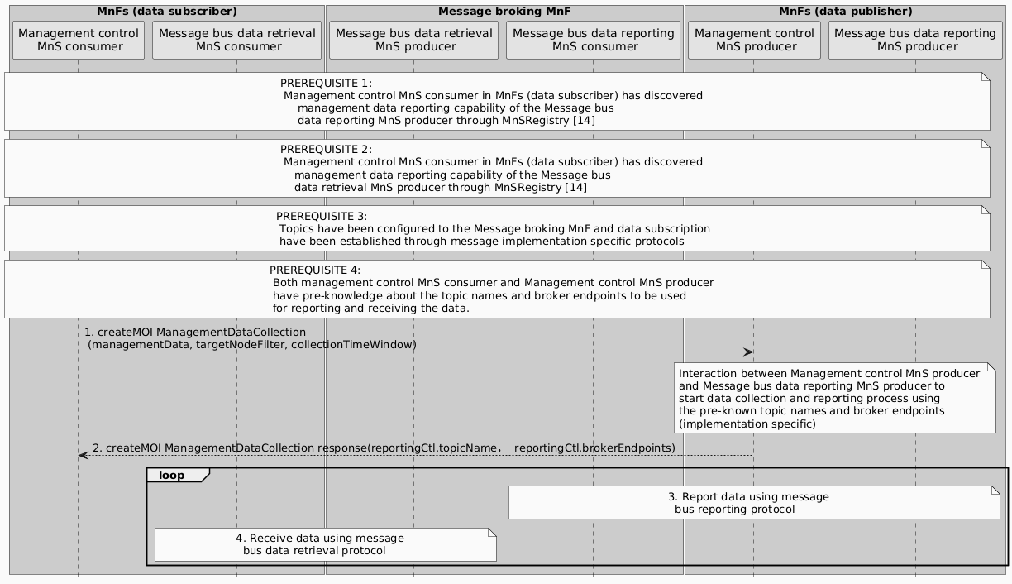
Figure 5.2.3.5-5: Method-6 Procedures for establishing management data streaming based on message bus

In comparison to Method-4, both topic names and broker endpoints are assumed to be known by the MnFs (data publisher) and MnFs (data subscriber) in advance. Topics are preconfigured to the message brokers and Message bus data retrieval MnS consumer has subscribed to the topics based on pre-configuration.
In method 1, topics and broker endpoints are both managed in a centralized manner by the message broker MnF. MnFs (Data subscriber) only indicate what data they need, the message broker MnF identifies the data source (the Data producer MnFs), creating the message bus topics internally, informing the corresponding MnFs (Data producer) where to report the data (broker endpoints and topic names in step 3) and telling the MnFs (Data subscriber) where to receive the data (broker endpoints and topic names in step 2).
In method 2, topics and broker endpoints are managed by the MnFs (Data subscriber) in a distributed manner. The multiple MnFs (Data subscriber) individually identify the message broker servers and topic names to be used for streaming the data from the corresponding MnFs (Data publisher).
In method 3, broker endpoints are managed by the MnF (Data subscribers) and topics are managed by the MnFs (Data publishers). The multiple MnFs (Data subscriber) individually identify the message broker servers to be used for streaming the data. The multiple MnFs (Data publisher) individually identify the topic names to be used
In method 4, both broker servers and topic names to be used are assigned by the MnF (Data publisher) side.
In method 5, both broker servers and topic names to be used are pre-known by both the MnFs (Data publisher) and MnFs (Data subscriber). Therefore, information about topics and broker endpoints do not need to be conveyed via standardized services (e.g. provisioning MnS).
Editor’s note: pros and cons of methods 1-5 need to be further analysed from the following aspects
- How multiple requests from different MnFs (data subscriber) for the same data are handled?
- Who manages the topics and broker servers in the management system
- Who has the resource inventory information about the brokers?
- How to handle potential overlapping or conflict between topics.
- How to handle broker server selection/path selection and load balancing across multiple broker clusters.
- How topics are discovered by other MnFs (data subscriber)?
Editor’s note: whether and how to add new attributes to ManagementDataCollection e.g. reportingCtrl.brokerEndpoints, reportingCtrl.topicNames need to be further studied
* * * End of Changes * * * *

