3GPP TSG-SA5 Meeting #165 S5-260741
Goa, India, 9 - 13 February 2026
CR-Form-v12.3
CHANGE REQUEST
 | 28.315 | CR | 0003 | rev | 1 | Current version: | 19.0.0
For HELP on using this form: comprehensive instructions can be found at
http://www.3gpp.org/Change-Requests.

Proposed change affects: | UICC apps |  | ME |  | Radio Access Network | x | Core Network | - x

Title: | Rel-20 CR TS 28.315 Add procedure for WAB-node connecting to management system
Source to WG: | Ericsson
Source to TSG: | S5
Work item code: | AdNRM_Ph4-OAM |  |  |  |  |  | Date: |  |  | 2026-01-13
Category: | B |  |  |  |  |  | Release: |  |  | Rel-20
 | Use one of the following categories:  F (correction)  A (mirror corresponding to a change in an earlier release)  B (addition of feature),  C (functional modification of feature)  D (editorial modification)  Detailed explanations of the above categories can  be found in 3GPP TR 21.900. |  |  |  |  |  |  |  | Use one of the following releases:  Rel-8 (Release 8)  Rel-9 (Release 9)  Rel-10 (Release 10)  Rel-11 (Release 11)  …  Rel-17 (Release 17)  Rel-18 (Release 18)  Rel-19 (Release 19)  Rel-20 (Release 20)
Reason for change: |  | A mobile NR node can implement different network features, including IAB and WAB.  The management of a mobile NR node includes the node connectivity to management system (specified in TS 28.314/28.315) and node configuration (specified in TS 28.531).  In TS 28.315, the mobile NR node connecting to management system only covers IAB feature; WAB feature is missing.
Summary of change: |  | Add procedure for WAB-node connecting to management system, so both IAB and WAB features are covered.
Consequences if not approved: |  | The procedure of node-OAM connectivity for WAB feature is missing.
Clauses affected: |  | 5.6, 5.x (new), A.x (new)
 |  | Y | N
Other specs |  |  | x | Other core specifications |  |  |  | TS/TR ... CR ...
affected: |  |  | x | Test specifications |  |  |  | TS/TR ... CR ...
(show related CRs) |  |  | X | O&M Specifications |  |  |  | TS/TR ... CR ...
Other comments:
This CR's revision history:

First change

5.6 IAB-node connects to management system
IAB-node connects to management system at power up and during mobility following PnC steps as described in clause 6.1.2 of TS 28.314 [2]. The management system that IAB-node connects to may change due to IAB-node mobility behaviours. The procedures for IAB-node connecting to management system based on its locations are illustrated in Figure 5.6.1, this includes step 2 of obtaining IP configuration via notification mechanism instead of initial IP autoconfiguration procedure.
In step 1, IAB-node has established a connection with its management system via PnC
In step 2, it reuses the existing notifications and operations as defined in TS 28.532 [4] to obtain IP configuration for OAM connectivity:
The provisioning MnS producer of IAB-node should provide IAB-node location information via any of the following notifications:
- notifyMOICreation
- notifyMOIAttributeValueChanges
- notififyMOIChanges

The provisioning MnS consumer (management system) should provide IP configuration for OAM connectivity via any of the following operations upon the reception of notifications:
- createMOI
- modifyMOIAttributes
In step 3, IAB-node connects to new management system by following subsequent PnC steps including connection to CA/RA, SeGW and SCS.
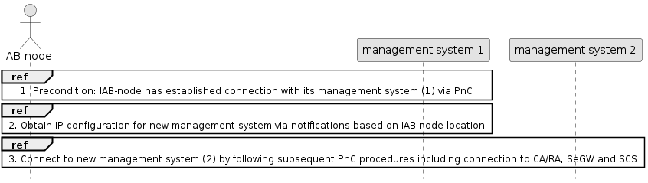
Figure 5.6.1: Procedure flows for IAB-node connects to management system

Next Change

5.X WAB-node connects to management system
WAB-node connects to management system at power up and during mobility following PnC steps as described in clause 6.2.2 of TS 28.314 [2]. The management system that WAB-node connects to may change due to WAB-node mobility behaviours. The procedures for WAB-node connecting to management system based on its locations are illustrated in Figure 5.X.1, this includes step 2 of obtaining IP configuration via notification mechanism instead of initial IP autoconfiguration procedure.
Description of step 1, step 2 and step 3 are the same as in clause 5.6, with WAB-node instead of IAB-node.
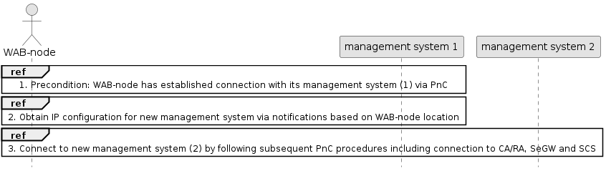
Figure 5.X.1: Procedure flows for WAB-node connects to management system

Next Change

A.X IAB-node connects to management system
The following PlantUML source code is used to describe the procedure flows for WAB-node connecting to management system, as depicted by Figure 5.X.1:
@startuml
actor “WAB-node” as WAB
participant "management system 1" as OAM_1
participant "management system 2" as OAM_2
Ref over WAB, OAM_1: 1. Precondition: WAB-node has established connection with its management system (1) via PnC
Ref over WAB, OAM_1: 2. Obtain IP configuration for new management system via notifications based on WAB-node location
Ref over WAB, OAM_2: 3. Connect to new management system (2) by following subsequent PnC procedures including connection to CA/RA, SeGW and SCS
hide footbox
skinparam DefaultFontSize 11
skinparam sequenceActorBackgroundColor #FFFFFF
skinparam sequenceParticipantBackgroundColor #FFFFFF
skinparam noteBackgroundColor #FFFFFF
autonumber "#'.'"
skinparam monochrome true
skinparam shadowing false
@enduml

End of Changes

