3GPP TSG-SA5 Meeting #165 S5-260737d1

Goa, India, 09 – 13 February 2026 Revision of S5-260436

Source: Ericsson, Huawei, AT&T
Title: Pseudo-CR TR 28.888 Add solution for authorization of the service API invocation request
Document for: Approval
Agenda item: 6.20.9
Spec: 3GPP TR 28.888
Version: 0.2.0
Work Item: FS_EnExpo

Comments
This pCR proposes to add a solution for the use case #1: “Authorization of the service API invocation request from the external MnS consumer using CAPIF” into TR 28.888.

Proposed Changes
* * * First Change * * * *
2 References
The following documents contain provisions which, through reference in this text, constitute provisions of the present document.
- References are either specific (identified by date of publication, edition number, version number, etc.) or non-specific.
- For a specific reference, subsequent revisions do not apply.
- For a non-specific reference, the latest version applies. In the case of a reference to a 3GPP document (including a GSM document), a non-specific reference implicitly refers to the latest version of that document in the same Release as the present document.
[1] 3GPP TR 21.905: "Vocabulary for 3GPP Specifications".
[2] 3GPP TS 28.533: "Management and orchestration; Architecture framework".
[3] 3GPP TS 28.579: "Management services exposure to external consumers through CAPIF".
[4] 3GPP TS 28.319: "Access control for management services".
[5] 3GPP TS 28.537: "Management and Orchestration; Management capabilities".
[6] 3GPP TS 28.622: "Telecommunication management; Generic Network Resource Model (NRM) Integration Reference point (IRP); Information Service (IS)"
[7] 3GPP TS 33.122: "Security aspects of Common API Framework for 3GPP Northbound APIs "
[8] 3GPP TS 29.222: " Common API Framework for 3GPP Northbound APIs".
[9] 3GPP TS 23.501: "System architecture for the 5G System (5GS)".
[10] 3GPP TS 23.502: "Procedures for the 5G System (5GS)".
[11] 3GPP TS 28.541: "Management and orchestration; 5G Network Resource Model (NRM); Stage 2 and stage 3".
[12] 3GPP TS 28.552: "Management and orchestration; 5G performance measurements".
[13] 3GPP TS 28.530: "Management and orchestration; Concepts, use cases and requirements".
[x1] RFC 6750: "The OAuth2.0 Authorization Framework".
[x2] RFC 9068: "JSON Web Token (JWT) Profile for OAuth 2.0 Access Tokens".
[x] <doctype> <#>[ ([up to and including]{yyyy[-mm]|V<a[.b[.c]]>}[onwards])]: "<Title>".

* * * Next Change * * * *

5 Use cases and potential solutions

5.1 Use case #1: Authorization of the service API invocation request from the external MnS consumer using CAPIF

5.1.1 Description
Editor's note: This clause provides a description of use case.
For an external MnS consumer to be able to invoke service APIs at the MSED AEF, first they send the service API authorization request (over the CAPIF-1e interface) to the CCF to request for the authorization to access one or more service APIs. If the service API authorization request is successful, the CCF issues this authorization to the API invoker in the form of an access token. This token contains the permissions granted to the API invoker for requested service APIs. These permissions are carried as part of the token’s scope, whose format is one of the three formats specified in the scope attribute of the AccessTokenReq (see clause 8.5.4.2.6 of TS 29.222[8]) and AccessTokenRsp (see clause 8.5.4.2.7 of TS 29.222[8]). For further details on the service API authorization procedure, see clause 6.5.2.3 of TS 33.122[7].
Accordingly, once an external MnS consumer has a valid access token from the CCF, they proceed to perform the service API invocation request to the AEF over the CAPIF-2e interface (see clause 6.5.2.3 of TS 33.122[7] for more details). As a pre-condition for the service API invocation request to be successful, the AEF needs to be able to understand the access token format issued by the CCF to enable the access token validation.
This use case describes how the service API invocation request from the external MnS consumer can be authorized at the MSED AEF.

5.1.2 Potential requirements
Editor's note: This clause provides potential requirements for the corresponding use case.
PREQ-FS_EnExpo-AuthCCF-01: The exposure of management services using CAPIF shall provide the capability enabling the authorization of the service API invocation request(s) at the MSED AEF.

5.1.3 Potential solutions
Editor's note: This clause provides one or more solutions. Further (sub-)clause(s) may be added to capture details.

Figure 5.1.3.X-1 illustrates the Service API invocation request procedure.
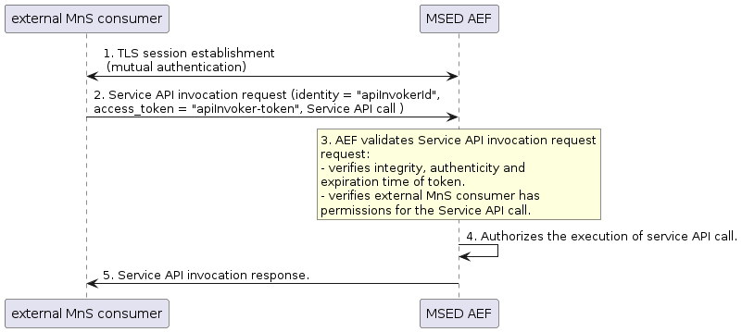
Figure 5.1.3-1: Service API invocation request procedure.
Step 1. The external MnS consumer authenticates to the AEF over CAPIF-2e interface. To that end, the external MnS consumer establishes a TLS session with the MSED AEF based on mutual authentication. The following procedure shall be performed prior to establishment of TLS session.
- The external MnS consumer shall send Authentication Initiation Request to the MSED AEF over CAPIF-2e interface, including requestor’s identity (i.e. “apiInvokerId”).
- The AEF shall request security information from the CCF to perform authentication and secure interface establishment with the external MnS consumer. The CCF provides security information related to chosen security method (TLS with OAuth token) to the AEF over CAPIF-3 interface. The CCF may return API invoker’s root CA certificate for the AEF to validate the external MnS consumer’s certificate.
- After fetching the relevant security for the authentication, the AEF shall send Authentication Initiation Response message to the external MnS consumer to initiate the TLS session establishment procedure.

Step 2. Upon successful authentication, the external MnS consumer sends API invocation request to the AEF, which includes:
- Service API call, consisting of {<Service API ID>, < resource>, <operation>}
NOTE: <Service API ID> includes the name and version of the service API, which uniquely identifies a given service API.
- Requestor’s access token: this is the digitally signed JWT token that the external MnS consumer received from CCF; in this example, the token is referred to as “apiInvoker-token”. This token contains multiple claims (i.e., “iss”, “scope”, “exp”). The “scope” claim represents the OAuth2.0 granted scope. This access token is included in the request as an HTTP header filed as specified in clause 2.1 of RFC 6750 [x1].

Step 3. The AEF validates the service API invocation request, thus performing the role of OAuth2.0 resource server. First, it verifies the integrity and authenticity of the token (see RFC 9068 [x2]) and that the token has not expired. If this validation is successful, next the AEF checks whether the external MnS consumer is authorized to invoke the Service API call. To that end, it checks the Service API call against the “scope” claim in “apiInvoker-token”, verifying that the Service API call parameters (i.e. <service API name>, <resource>, <operation>) are included within the OAuth2.0 granted scope. If within, go to step 4. Otherwise, the AEF generates an error response and step 4 is skipped.
Step 4. The MSED AEF authorizes the execution of service API call. The AEF authorizing the execution of service API call (step 4) means that the service API call can reach the target MnS producer (i.e. the MnS producer whose management service information includes the service API call parameters).
Step 5. The MSED AEF sends a response back to the API invoker with the result of service API call or error response.

How the MSED fulfils the service API call is what SA5 needs to discuss. The following details a solution on how step 4 can be fulfilled.

5.1.3.X Solution <X>: MSED AEF is internal MnS consumer
In this solution, the MSED AEF is an internal MnS consumer. To authorize the service API call execution, the MSED AEF sends a MnS request containing service API call parameters to target MnS producer. Figure 5.1.3.X-1 illustrates this scenario, with MSED AEF performing the role of MnS consumer, communicating with authentication service producer, authorization service producer and different MnS producers.

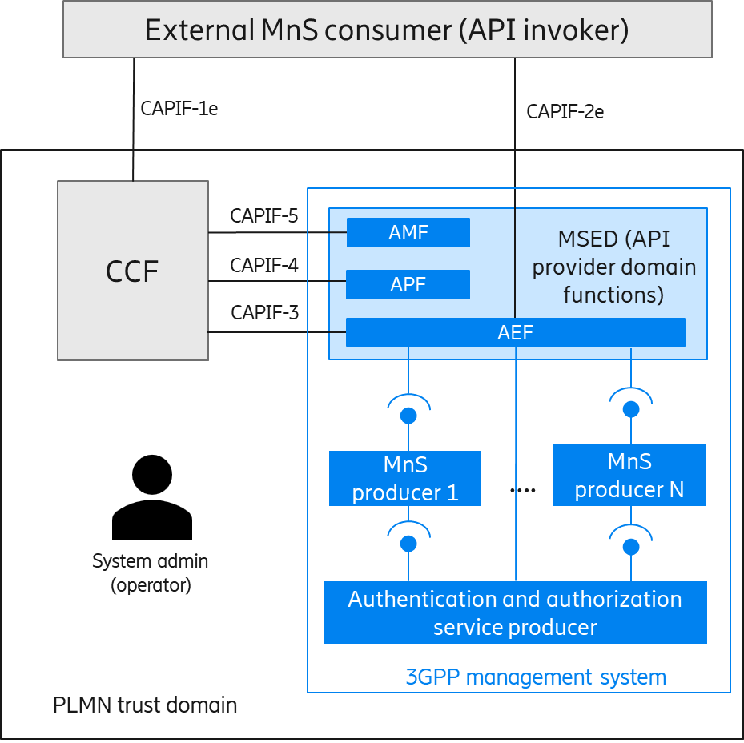
Figure 5.1.3.X-1: MSED AEF is internal MnS consumer

Figure 5.1.3.X-2 describes the solution for the MSED AEF to authorize the service API call execution (step 4 of Figure 5.1.3-1).
Step 4a. The MSED AEF identifies the target MnS producer.

Step 4b. The MSED AEF sends the MnS request to the target MnS producer. This request includes
- MnS API call, consisting of {<MnS ID>, < resource (MnS component B) >, <operation (MnS component A)>} (see NOTE 1)
- Requestor’s access token, i.e. “msedAef-token” (see NOTE 2)
- Requestor’s identity, i.e. “msedAef-Id”.
NOTE 1: <MnS ID> includes the following MnSInfo IOC attributes: “mnsLabel”, “mnsType” and “mnsVersion”. This information is used to uniquely describe a management service (see TS 28.622 [6]).
NOTE 2: This access token contains authorization information for the MSED AEF. This access token is emitted by the authorization service producer.

Step 4c The MnS producer contacts the authentication and authorization service producers. The authorization service producer verifies whether the MnS API call parameters are within the scope of the “msedAef-token”. If within, the MnS request gets authorized.

Step 4c. The MnS producer services MnS request and returns the result to the MSED AEF.

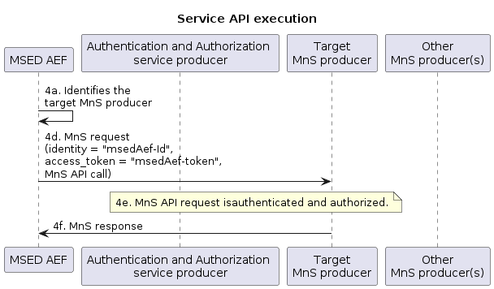
Figure 5.1.3-1: Service API execution.

5.1.4 Evaluation of potential solutions
Editor's note: This clause provides evaluation of potential solutions.

5.1.4.X Solution <X>: MSED AEF is internal MnS consumer.
This solution proposes that MSED AEF become an internal MnS consumer.
In 3GPP management system, no extensions are needed because:
- The operator configures authentication and authorization information for MSED AEF in the same way as done for any other internal MnS consumer.

- The MnS producer fulfils the MnS request from MSED AEF in the same way as done when the request comes from any other internal MnS consumer.
In MSED, only the AEF is involved. When receiving the service API request, apart from fulfilling the OAuth2.0 resource server (already recognized by CAPIF framework), the solution requires that AEF:
- identifies the target MnS producer.
- maps service API call (consisting of {<Service API ID>, < resource>, <operation>}) into MnS API call {<MnS ID>, < resource (MnS component B) >, <operation (MnS component A)>}.

