3GPP TSG SA5 Meeting #165 S5-260736
Goa, India, 9-13 February 2026

Source: Nokia
Title: Pseudo-CR on Add potential solution and evaluation for authorization of the external MnS consumers at the CCF
Document for: Approval
Agenda item: 6.20.9
Spec: 3GPP TR 28.888
Version: 0.2.0
Work Item: FS_EnExpo

Comments
<Proposals, reason for change, abstract, comments if necessary (optional)>

Proposed Changes

* * * First Change * * * *

2 References
The following documents contain provisions which, through reference in this text, constitute provisions of the present document.
- References are either specific (identified by date of publication, edition number, version number, etc.) or non-specific.
- For a specific reference, subsequent revisions do not apply.
- For a non-specific reference, the latest version applies. In the case of a reference to a 3GPP document (including a GSM document), a non-specific reference implicitly refers to the latest version of that document in the same Release as the present document.
[1] 3GPP TR 21.905: "Vocabulary for 3GPP Specifications".
[2] 3GPP TS 28.533: "Management and orchestration; Architecture framework".
[3] 3GPP TS 28.579: "Management services exposure to external consumers through CAPIF".
[4] 3GPP TS 28.319: "Access control for management services".
[5] 3GPP TS 28.537: "Management and Orchestration; Management capabilities".
[6] 3GPP TS 28.622: "Telecommunication management; Generic Network Resource Model (NRM) Integration Reference point (IRP); Information Service (IS)"
[7] 3GPP TS 33.122: "Security aspects of Common API Framework for 3GPP Northbound APIs "
[8] 3GPP TS 29.222: " Common API Framework for 3GPP Northbound APIs".
[9] 3GPP TS 23.501: "System architecture for the 5G System (5GS)".
[10] 3GPP TS 23.502: "Procedures for the 5G System (5GS)".
[11] 3GPP TS 28.541: "Management and orchestration; 5G Network Resource Model (NRM); Stage 2 and stage 3".
[12] 3GPP TS 28.552: "Management and orchestration; 5G performance measurements".
[13] 3GPP TS 28.530: "Management and orchestration; Concepts, use cases and requirements".
[X1] IETF RFC 8693: "OAuth 2.0 Token Exchange".
[X2] IETF RFC 6749: "The OAuth 2.0 Authorization Framework".
[X3] IETF RFC 7517: “JSON Web Key(JWK)”
[Y] 3GPP TS 23.222: " Common API Framework for 3GPP Northbound APIs; Stage 2"

…
[x] <doctype> <#>[ ([up to and including]{yyyy[-mm]|V<a[.b[.c]]>}[onwards])]: "<Title>".

* * * Next Change * * * *

5.1.3 Potential solutions
Editor's note: This clause provides one or more solutions. Further (sub-)clause(s) may be added to capture details.

5.1.3.X Introduction
The potential solution described in this clause addresses the authorization of the service API invocation requests from the external MnS at the MSED AEF. In the considered scenario, authorization is performed using the token exchange procedure specified in IETF RFC 8693 [X1]. Token exchange is required in this scenario since the CCF authorization function and the A&A MnS producer (within the management system) support different authorization information models, as specified in TS 33.122[7] and TS 28.319[4], respectively. By applying the token exchange mechanism, a standardized approach is provided for the transformation of authorization tokens between the respective authorization domains. This enables interoperability between the involved entities while minimizing the impact on the authorization frameworks already specified for each domain.

5.1.3.Y Authorization of the service API invocation requests at the MSED AEF using token exchange
As a precondition, the potential solution assumes that the following procedures have already occurred:
CAPIF enrolment phase
- There has been an offline enrolment procedure in which the 3GPP management system administrator and the CAPIF administrator decide which published management services (now service APIs) will be discoverable by the different external MnS consumers. This interaction enables the configuration of the proper authorization policies at the CCF by the CAPIF administrator for the different external MnS consumers (see Annex E of TS 23.222[Y]).
- The authentication and authorization (A & A) MnS producer has generated the onboarding enrolment information for the external MnS consumer (see clause 6.1 of TS 33.122[7]).
- A trust relationship is established between the CCF authorization function and the A&A MnS producer in the management domain. This process involves the A&A MnS producer being able to validate the access tokens issued by the CCF authorization function. The trust relationship can be established using standardized means based on JSON web keys (see IETF RFC 7517[X3]) or by out-of-band means. The establishment of the trust relationship between the CCF authorization function and the A&A MnS producer is out-of-scope of the present document.
API invoker onboarding procedure
- After the enrollment process concludes, the API invoker is provided with the onboarding enrolment information and begins the API invoker onboarding process (see clause 5.5.2.2 of TS 29.222[8] and clause 6.1 of TS 33.122[7].
- Upon successful onboarding, the API invoker is assigned an “API invoker id”, which is the unique identifier of the API invoker within the CCF. The API invoker provides this identifier for all subsequent interactions with the CCF.
To consume MnSs exposed using CAPIF, the API invoker needs to perform the service API invocation process. The following steps show how the token exchange mechanism can be used to enable the authorization of the service API invocation requests at the MSED AEF to enable MnS consumption by external MnS consumers at the CCF.

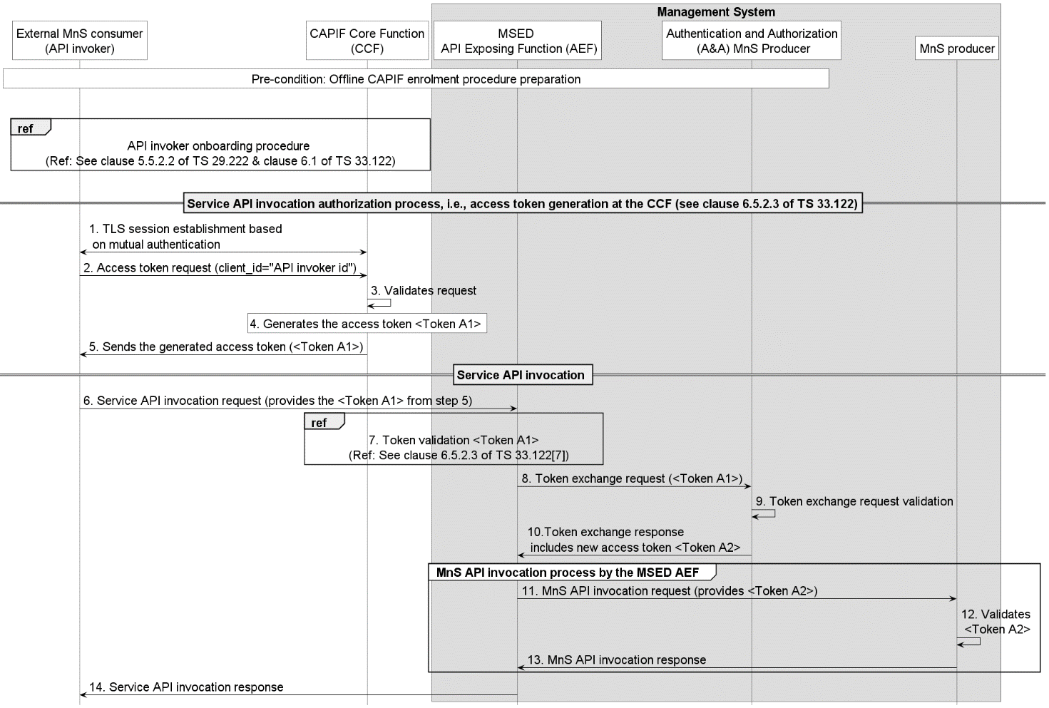
Figure 5.1.3.Y-1: Service API invocation authorization at the MSED AEF using token exchange
1. Before an API invoker can successfully invoke service APIs, they need to request for authorization from the CCF. To this end, the API invoker establishes a TLS session to enable the access token request for service API invocation.
2. Upon successful TLS session establishment, the API invoker sends an access token request to the CCF providing the “API invoker id” that was allocated to the API invoker during the onboarding procedure.
3. The CCF validates the access token request and if the request is valid, proceeds to step 4.
4. The CCF generates the access token <Token A1> (see clause 8.5.4.2.8 of TS 29.222[8]).
5. The CCF sends the generated access token <Token A1> to the API invoker.
6. On receiving the access token, the API invoker sends the service API invocation request to the MSED AEF providing <Token A1> as part of the authorization header of the request.
7. On receiving the request, the MSED AEF validates the access token <Token A1> (see clause 6.5.2.3 of TS 33.122[7] for details).
8. If the request is valid, the MSED AEF proceeds to initiate the token exchange process. The MSED AEF generates the token exchange request by specifying the following claims as part of the request:
Table 5.1.3.Y-2: Claims for the token exchange request (see clause 2.1 of RFC8693[X1])
Token Claim | S | Claim Value | Description
grant-type | M | token-exchange | Indicates to the A&A MnS producer that a token exchange is required
subject-token | M | <Token A1> | Contains the token that was presented to the MSED AEF by the API invoker. This token is presented to the A&A MnS producer by the MSED AEF and represents the token which needs to be exchanged for a new token.
subject-token-type | M | jwt | Specifies the type of the API invoker access token. In this case, the token is a JWT.
scope | M | scope values as  presented in <Token A1> | Represents the permissions assigned to an API invoker for a given service API, i.e., for a given service API, the accessible resources and allowable operations (e.g., READ, WRITE) are defined using this value.
actor-token | O | <MSED-AEF token> | This parameter informs the A&A MnS producer that the MSED-AEF (as the delegate) is acting on behalf of the API invoker (which is the subject in this case). This access token can be assigned to the MSED-AEF by the A&A MnS producer during the CAPIF enrollment phase.
actor-token-type | O | access-token/jwt | Specifies the type of the MSED-AEF access token. It’s upto the A&A MnS producer to decide what type of token is issued to the MSED AEF.

Upon successful generation of the token exchange request, the MSED AEF sends the request to the A&A MnS producer in the management system.
9. The A&A MnS producer examines and validates the token exchange request. Specifically, the A&A MnS producer examines and validates the subject token by checking to ensure that the token was issued by the CCF (as per the configured trust mechanisms between the A&A MnS producer and CCF authorization function during the enrolment phase). Optionally, the A&A MnS producer also examines and validates the provided actor token by the MSED AEF.
10. If the validation of the token exchange request is successful, the A&A MnS producer generates the token exchange response by setting the following:
Table 5.1.3.Y-3: Claims for the token exchange response (see clause 2.2 of RFC8693[X1])
Token Claim | S | Claim Value | Description
access-token | M | <Token A2> | The new token generated by the A&A MnS producer to be used by MSED-AEF to invoke MnS APIs on behalf of the API invoker
issued-token-type | M | access-token/jwt | Specifies the type of the issued access token <Token A2>. In this case, either access-token or jwt.
token-type | M | bearer | Indicates that the token will be carried as part of the authorization header in the MnS API invocation request.
scope | M | MnS API URI, resource, operations | The MnS API and resources that the MSED AEF can invoke in the management system on behalf of the API invoker. Further, this attribute can carry the allowable operations on the MnS APIs/resources.
exp | M | NumericDate | Represents the expiration time of the issued token in seconds.

The A&A function sends the generated token exchange response to the MSED AEF. This response includes the newly generated access token <Token A2>.
11. Upon receiving the newly generated access token <Token A2>, the MSED AEF can invoke the MnS APIs on behalf of the API invoker on the MnS producer providing the <Token A2> access token.
12. On receiving the MnS API invocation request, the MnS producer can validate the received access token <Token A2>, if possible. If the MnS producer can’t validate the access token <Token A2>, the MnS producer sends the token validation request to the A&A MnS producer.
13. Upon successful token validation, the MnS producer handles the MnS API invocation request and sends the invocation response to the MSED AEF.
14. Finally, the MSED AEF sends the service API invocation response to the API invoker.

* * * Next Change * * * *

5.1.4 Evaluation of potential solutions
Editor's note: This clause provides evaluation of potential solutions.
The proposed solution uses a standardized approach to enable the authorization of service API invocation requests at the MSED AEF and satisfies the use case requirements in clause 5.1.2.

* * * End of Changes * * * *

