3GPP TSG-SA5 Meeting #165 S5-260728d2
Goa, India, 09 - 13 February 2026

Source: Rapporteurs
Title: pCR on TR 32.801-01 consolidated data management contributions
Document for: Approval
Agenda item: 6.20.6
Spec: 3GPP TR 32.801-01
Version: 0.0.0
Work Item: FS_6G_OAM

Proposed Changes
* * * First Change * * * *

5 6G Management Architecture Principles
Editor’s note: add to the list of principles in clause 5:
- A data management framework in the management plane to support all the domains (e.g., RAN, Core).

* * * 2nd Change * * * *

6.1 New 6G management scenarios
Editor's note 1: This clause will contain new 6G management scenarios and the corresponding requirements.

6.1.y Data Management Framework

* * * 3rd Change * * * *

6.1.y.1 Management Scenario #1: Data Management Framework in the Management System

6.1.y.1.1 Description
With the evolution of 6G mobile networks, operators are required to manage a highly distributed and complex network. This environment spans cloud‑native core network functions, disaggregated RAN components, multiple layers of edge computing, and a wide range of network slices. These domains continually generate large volumes of heterogeneous management data with differing semantics, granularity, and temporal characteristics.
As operators progress toward higher levels of autonomy in network operation, management data becomes increasingly central to supporting intelligent network management capabilities. AI‑assisted network optimization, proactive analysis, and real‑time synchronization with network digital twins rely on timely, accurate, and semantically consistent data. However, existing data collection, storage, and exposure mechanisms are fragmented and insufficient to support the needs of AI‑driven and autonomous network management. Operators may encounter several limitations, including:
- Fragmented and inconsistent management data. Management data is produced and consumed through multiple domain-specific mechanisms, from RAN, Core, edge, and user equipment using different data formats, schemas, and semantics. Each of these domains defines its own reporting procedures, data models, and transport mechanisms. As a result, the overall data management environment is fragmented, with limited alignment across domains and increased complexity for integration with operators’ OSS/BSS systems and external data processing platforms. Hence, operators struggle to construct an accurate and coherent end‑to‑end view of network status, which increases operational complexity. Operators therefore require a unified data management approach that harmonizes data models and semantics across management data.
- Inability to meet diverse latency, granularity, and consumption requirements. Real‑time optimization may require millisecond‑level streaming, while long‑term analytics and model training rely on large volumes of historical data. Existing data control and reporting mechanisms are not always able to meet such diverse and evolving demands.
- Lack of unified data quality assurance. Management data used to support intelligent decision‑making in the management system lacks standardized quality evaluation, preventing operators from ensuring that automated and intelligent functions operate on reliable, consistent, and trustworthy data. <0156>
To address these limitations, a Data Management Framework (DMF) is needed as a key enabler for the intelligent evolution of network management in 6G. The DMF provides standardized mechanisms across the lifecycle of management data, including collection, processing, storage, and exposure. It ensures that producers supply harmonized, well‑described, and quality‑assured data, while consumers—including Intelligence and Automation Functions such as network digital twins—obtain validated and contextually enriched data that satisfies their functional requirements.
By ensuring consistent, timely, and high‑quality management data availability, the DMF enables the transition from reactive monitoring to proactive optimization and supports the realization of advanced levels of autonomy in 6G network management.

6.1.y.1.2 Potential Requirements
REQ-DMF-1: The 3GPP management system shall support the data management framework to empower intelligent and autonomous network operation and maintenance.
REQ-DMF-2: The 3GPP management system shall support the data management framework that accommodates diverse latency, granularity, and consumption demands associated with management data.
REQ-DMF-3: The 3GPP management system shall support data management framework for standardized lifecycle management of management data.
REQ-DMF-4: 3GPP management system should multiple QoS requirements for different types of data and deployment scenarios.
REQ-DMF-5: The 3GPP management system shall support data quality assurance for management data.
REQ-DMF-6: The 3GPP management system shall be able to guarantee the data quality (e.g., freshness, completeness, accuracy, completeness, consistency) and data delivery QoS.
REQ-DMF-7: The 3GPP management system shall ensure effective interoperability and coexistence between the 6G and 5G data management systems.
REQ-DMF-8: The 3GPP management system shall provide a unified capability for discovering and interpreting management data based on its attributes and semantics.
REQ-DMF-9: The 3GPP management system shall support secure access control and exposure of management data.
REQ-DMF-10: The 3GPP management system shall enable coordinated operation between the data management framework and autonomous management services (e.g., NDT, IDMS, CCL, etc.).

* * * 4th Change * * * *

7 Key Issues
Editor's note: This clause will contain the potential Key Issues related to the 6G management scenarios in clause 6. The Mapping table in Annex A will reflect the relation between the management scenarios and Key Issues.

7.1 Data Management Framework (DMF)

7.1.1 Key Issue #1: DMF Capabilities
The DMF should include capabilities to enable the following functionalities:
- Data Lifecycle Management
- Data Collection: capability for data collection. The data which are related to data collection includes:
- Existing Management Data: Performance Measurements (PM), Key Performance Indicators (KPI), Fault/Alarm data, Configuration Management (CM) data, Trace and MDT data, Quality of Experience (QoE), system logs, external management data etc.
- New 6G Management Data: the new data for network and service management. The integration of relevant external management data sources may also be considered.
- Data Reporting:
- Data Processing: capability such as data normalization, validation, quality assessment (e.g., freshness, accuracy, completeness, consistency), aggregation, correlation, semantic enrichment, and other preparation required for training or inference usage (e.g., data labelling, dataset creation).
- Data discovery
- Data registration
- Data delivery
- Data storage
- Data repository
- Job management: The framework should define unified transport protocols (i.e., data request, data subscription and notifications) and data models to ensure consistent management control and data reporting, meeting data delivery QoS (e.g., latency, throughput), avoiding duplicate collection.
- Access Control and Data Exposure: The framework shall implement secure data access and exposure. Additionally it shall allow MnS consumer to consume the data from multiple instances of CDMF and share data across multiple instances. Data Exposure: To supply authorized consumers with validated management data in the required timeliness and format, the DMF exposes data through unified file‑based and streaming‑based mechanisms, including Kafka‑based delivery for high‑throughput, low‑latency real‑time operational needs
Editor’s note: Coordination with SA3 is needed for management data access control and exposure, studying aspects like data security, privacy protection, and user consent.

- Integration with Autonomous Management Services: A critical success factor for the DMF is its seamless integration with key autonomous functions. Data is the integration backbone, i.e, data needs to be published and consumed by MnS producer, MnS consumer and external data through DMF so services share the same enriched, consistent data and context across domains and layers. The study shall therefore specify the data support and interaction mechanisms between the DMF and autonomous MnS(s) for, e.g.:
    - Network Digital Twin (NDT) (providing real-time and historical data feeds),
    - Intent-Driven Management (supporting with semantic/knowledge data),
    - Closed Control Loop (CCL) (providing timely data support for the monitor-analyze-decision-execute cycle).
- Data contracts and versioning
  - There is a need to define schemas and semantic contracts with backward/forward compatibility; support streaming, file and batch access, and formalize change control.
- Performance
  - Where applicable, the SLOs should be defied for end-to-end data handling, covering latency, throughput, streaming metrics, storage read/write latency and durability, burst tolerance, and data quality metrics so automation loops remain timely.
- Management of 6G Data Framework
  - In TR 22.870 [2], use case and potential requirements for data framework are described. The management aspects of the data framework itself (e.g., configuration of data collection requirements and tasks, performance monitoring of the data framework) shall be an integral part of this study.
Editor’s note: Coordination with SA2 and other working groups are needed according to progress of data framework study in SA2.
- Interoperability with 5G Management Systems
A smooth transition is imperative. The study shall include:
  - Backward Compatibility: Defining how to adapt and reuse interfaces between the 6G DMF and 5G management systems/NFs, evolving 5G data models where necessary.
  - Coexistence and Interworking: Establishing architectural patterns for the concurrent operation of 5G and 6G data management framework during migration.

7.1.2 Key Issue #2: DMF Architecture
Figure X shows a high-level data-centric 6G management architecture including DMF:
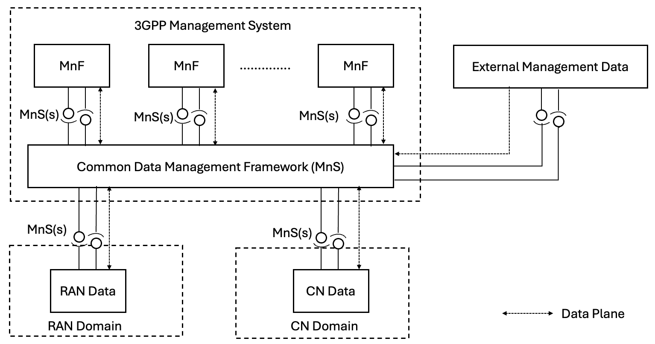

Figure x: High level Data-Centric 6G Management Architecture
The 6G DMF should be realized through new management services (separated or integrated) within the Service-Based Management Architecture (SBMA), enabling coordinated data management across domains (cross-domain, RAN-domain, and CN-domain). As depicted in Figure Y, the framework contains components of Data Repository, Data Management Functions and Data Providers, providing data MnS(s) to internal and external MnS consumers.
Figure Y: An example of a Data Management Framework

* * * End of Changes * * * *

