3GPP TSG-SA5 Meeting #165 S5-260723
Goa, India, 09 - 13 February 2026

Source: Rakuten Mobile Inc.
Title: pCR on TR 32.801-1 Add use case for hierarchical service architecture
Document for: Approval
Agenda item: 6.20.6
Spec: 3GPP TR 32.801-1
Version: 0.0.0
Work Item: FS_6G_OAM

Comments
This contribution proposes to add new/enhanced management scenario to 6G study TR 32.801-01.

Proposed Changes
* * * First Change * * * *

6.1.1 Management Architecture for 6G

6.1.1.X Management Scenario #<X>: Hierarchical Service Architecture

6.1.1.X.1 Description
Currently SA5 focuses on defining a Service-based Management Architecture (SBMA) service bus and its attached producers and consumer. This method has enables flexibility and allows developers to build an OAM system by combining various producers and consumers into an MnF. As 5G has evolved and deployed, two major concerns have emerged:
- Absence of functional elements is interpreted as lack of functionality
- Absence of callflows to enable E2E service lifecycle
Given above gaps, there is a need for a hierarchical service architecture with well-defined boundaries. Such an architecture enables a framework to deploy and manage E2E services. The below figure shows a way to describe such an architecture.

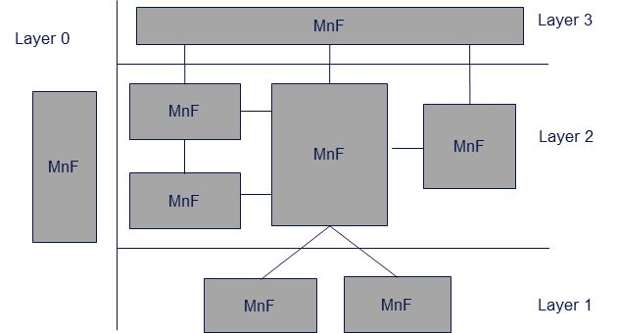
Figure 6.1.1.X.1-1 Hierarchical Service Architecture

6.1.1.X.2 Potential Requirements
MREQ-MnF_Requirement-1: The 3GPP management system should define functional entities (MnFs) to be supported by 3GPP.
MREQ-MnF_Requirement-2: The 3GPP management system should define functional behaviors and reference points to show interaction between functional entities (MnFs).

* * * End of Changes * * * *

