3GPP TSG-SA5 Meeting #165 S5-260722
Goa, India, 9 - 13 February 2026 revision of S5-260194

Source: Ericsson Hungary Ltd.

Title: DP Use Cases driving need for Equipment Representation

Document for: Endorsement
Agenda Item: 6.20.4

1 Decision/action requested
The group is asked to discuss and endorse the proposal

2 References
- TS 28.632; Telecommunication management; Inventory Management (IM) Network Resource Model (NRM) Integration Reference Point (IRP); Information Service (IS)
- TR 28.884; Study on Service Based Management Architecture enhancement phase 4
- TS 32.300; Telecommunication management; Configuration Management (CM); Name convention for managed objects
- TS 28.541; Management and orchestration; 5G Network Resource Model (NRM); Stage 2 and stage 3
- TS 28.622; Telecommunication management; Generic Network Resource Model (NRM) Integration Reference Point (IRP); Information Service (IS)

3 Rationale
Traditionally, telecommunication full-stack solutions were managed as atomic entities. With the additions of sensing, with AI in and on RAN, with advent of edge-computing, also full-stack solutions needs more fine-granular software and equipment management.
For virtualized solutions, the software lifecycle management and the equipment management is solved by the IT industry.
Present 3GPP specification with respect to equipment and software management is limited to inventory management as specified in TS 28.632, [1].
Work item FS_SBMA_Ph4 [2] addresses software management solutions, but practices for equipment handling for physical HW (non-virtualized equipment) remain to be formed. (Non-virtualized HW that is part of a physical network function, PNF, is referred to as PNF equipment.) This DP proposes to add management capabilities for PNF equipment.
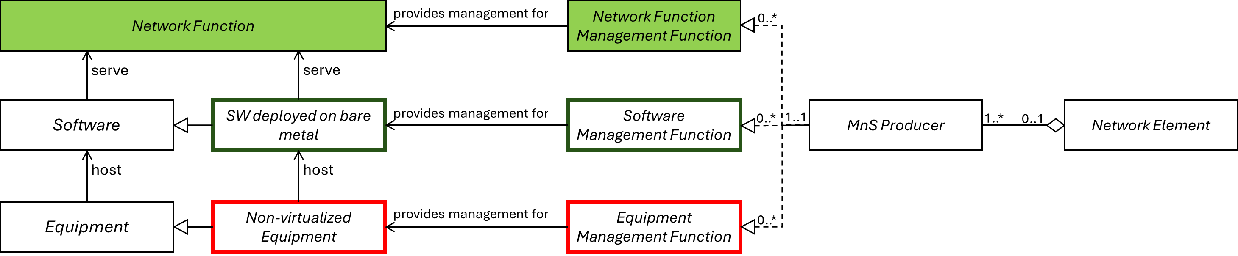
Figure 1, Management Functions for Network Functions, Software, and Equipment

4 Need for NRMs for managed PNF Equipment
3GPP management of network functionality is ManagedElement based. A ManagedElement MO acts as a local root for a local management tree and provides a management namespace for that tree, see TS 32.300, clause 3.1.5. [3].
Three sets of important entities that make up a working network include Equipment, SW and Network functions. See Figure 2
For NR, the NRMs for the managed Network Functions are specified in TS 28.541 [4].
Currently, no NRMs are defined for managed software, but this is addressed by other work in FS_SBMA_Ph4 [2].
NRMs for managed PNF equipment are needed to facilitate many use-cases. As equipment management is generic, not dependent on the RAN generation, TS 28.622 [5] may be a suitable specification to include the Managed Equipment NRM. (NRMs for virtualized equipment are not subject of this paper.)
Figure 2, ManagedElement and its child NRMs
As the functional partition between and within equipment and software is implementation specific, the mapping functions to bind a specific software to specific functions should remain implementation specific and should not be standardized.
The modeling of Managed Equipment is needed because there are many use-cases that needed it. A number of them are listed below:
- Equipment configuration
- Equipment topology
- Locating the managed equipment
- Equipment observability
- Equipment state management
- Equipment fault management
- Energy performance monitoring

5 Recommendation
Define NRMs to support generic management support of managed physical equipment used to support telecommunication functionality.
Equipment to be supported is telecommunication related equipment relevant for generic equipment management use cases. This includes for example general purpose and purpose-built compute units, radio units, antenna units, antenna near units, switches, routers, active site equipment etcetera that are part of a physical network function.

