3GPP TSG SA5 Meeting #165 S5-260719
Goa, India, 9-13 February 2026 revision of S5-260201 and S5-260470

Source: Huawei, Ericsson Hungary Ltd.
Title: pCR TR 28.884 Solution for software management
Document for: Approval
Agenda item: 6.20.4
Spec: 3GPP TR 28.884
Version: 0.2.0
Work Item: FS_SBMA_Ph4

Comments
This contribution proposes the detailed solution for software management which focuses on the NRM modelling of software for PNF.

Proposed Changes
* * * First Change * * * *

5.4.1 Description
3GPP TS 32.531 [11], TS 32.532 [12], and TS 32.533 [13] define the concepts, requirements, Information Service, and CORBA solution set for the software management of NEs for 4G, encompassing both automated and non-automated software management approaches.
Software management for 5G enhances 5G network operational efficiency. The benefits of software management retain for 5G network management:
- One benefit of software management is interoperability: standardized procedures make it possible for operators to manage software on heterogeneous network elements in a multi-vendor environment and reduces operational complexity.
- Another benefit is network service continuity. By supporting mechanisms such as staged upgrades, version control, and fallback strategies, software management capability minimizes downtime and protects user experience.
Currently, TS 28.533 [2] does not include support for software management. As 5G networks evolve in scale and complexity, it is essential to introduce software management capabilities into SBMA. These capabilities will enable operators to maintain software of NEs and NFs.
Editor's note: To enable software management within SBMA, the associated potential requirements and potential solutions are FFS, building upon the legacy of software management of NEs for LTE while adapting to the principles of SBMA.
Based on 4G definitions in [11], when describing SW management in this document we use the following terminology:
Download – move the SW from a remote server to the producer.
Verify – verify the downloaded SW's integrity and that it is fit for its purpose.

Activation: Activation of software makes it ready to be used and the software starts providing service
Installation: Installation of software puts it into a form suitable for activation or use. (Activation may include steps like unpacking, unzipping, checks, but does not include starting to provide service.)
Fallback: The process of activating a previous SW version. (Fallback may involve moving to a previous configuration content of NRM).
Cancellation: Is the process where a consumer stops an ongoing operation (e.g. download, activation). If the process is stopped by the producer, it is considered a failure of the process not a cancellation.
Deactivate: Remove a SW from providing service.
Delete: delete SW from the producer
Use cases for PNF SW management
The following are examples of possible/typical use-cases. (They are presented here as informative examples)
- UC1: Download software on MnS producer: In preparation for a software upgrade, relevant software artefacts are downloaded by suitable means to the MnS producer. After download, other preparatory steps (a.k.a. software installation) may be performed (such as unzipping, integrity validation) to make sure the software artefacts are suitable and ready for subsequent activation. This download/installation activity is typically not traffic-impacting and may happen sometime before the software is activated. The activity might be triggered by an MnS consumer, or might be triggered by some other event (perhaps the installation of new hardware on the PNF, requiring a software upgrade). The download/installation is typically long-running, and its progress can be externally observed. At the end of this use case, the software is ready to be activated. In exceptional error situations (such as unsuitable software being installed; checksum errors), activation of this software will not be possible.
- UC2: Activate software: Previously downloaded/installed software is activated. The activation of the software brings the software into service, effectively replacing the previously running software. As part of the software activation, the PNF’s configuration may be automatically updated. Software activation may or may not be traffic-impacting, depending on the particulars of the PNF implementation. The activation activity is usually triggered by an MnS consumer; but may be triggered by an event or a scheduler. The software activation is typically long-running, and its progress can be externally observed. At the end of this use case, the activated software has been brought into service. In exceptional error situations, the software activation procedure is aborted, the previous software brought (back) into service, and any automated updates to the PNFs configuration undone.
- UC3: Cancellation: The software installation and activation are typically long-running operations. In some scenarios (e.g., ongoing emergency, slow/faulty O&M network, a mistake having been made), the ongoing operation is cancelled. A cancellation is typically triggered by an MnS consumer. After the cancellation, the MnS producer will be in the same state as it was before the operation started. It is possible to re-start the same operation.
- UC4: Fallback to previous software: After the PNF’s software has been successfully upgraded, after observing the system's behaviour for some time, a decision may be made that the upgraded software is unsatisfactory (perhaps it is functionally or performance-wise inferior to the previously installed software). In this case, a software fallback may be triggered. The software fallback will re-activate previously activated software and effectively repeat the steps of the software activation (see UC2) for the previously activated software.
- UC5: Remove inactive software (house cleaning): Software residing on the producer may become unneeded. Unneeded and in-active software is removed from the producer. This operation is typically triggered by the MnS consumer. At the end of this use case the in-active software has been removed from the PNF and therefore is not available anymore for fallback or activation. One typical case when software becomes unneeded is when a PNF’s software is successfully activated, and found to be operating satisfactorily (perhaps after having been observed for a while), other software still present on the PNF, but not in service, may be removed in order to free resources on the PNF.

Implementation considerations for further study
The producer should check the SW intended to be activated. Whether these checks are executed immediately after download, in a separate step, or at the beginning of activation is implementation dependent.
The producer may take additional preparatory steps before activation (e.g. unpacking the SW). Whether these are executed immediately after download, in a separate installation step or at the beginning of activation is implementation dependent.
Open issues for further study:
-Whether fallback shall be initiated by the consumer or by the producer or potentially both
- Whether activation shall be triggered explicitly by the consumer or automatically in the producer (e.g. by a scheduler) or both
Two modes shall be considered:
- a single step activation that includes download, any checks and activation. Activation may be immediate or delayed, triggered by a scheduler or some other condition.
- a multi-step activation, where after download, activation is executed as a separate step within the producer. The separate activation step shall be initiated by a consumer operation.

* * * Next Change * * * *

5.4.3 Potential solutions
It is the goal to define a flexible solution for PNF SW management.
It shall be possible to handle upgrades that consist of a single overall SW package but also upgrades that use a set of separate SW packages in a single activation. It shall be possible to handle systems where the full functionality of the system has to be upgraded at the same time (using one or more SW packages) but also systems that allow upgrading different parts of the system separately at different times.
It is assumed that the consumer knows a priori which SW packages can be installed/activated on which ManagedElements, and whether there are dependencies between SW packages.
A solution is proposed that follows SBMA principles. IOCs are defined in the NRM to facilitate SWM. The solution takes ideas and some solution elements from TS 32.532.
New IOCs SwPnfPackage, SwPnfJob, SwPnfProcess are introduced to satisfy the requirements given in clause 5.4.2. Relationship and inheritance diagrams are captured in 5.4.3.x -1 and 5.4.3.x -2 respectively. The <<ProxyClass>>ManagedEntity representing ManagedELement is only applicable when the MnS producer is embedded in the NE.
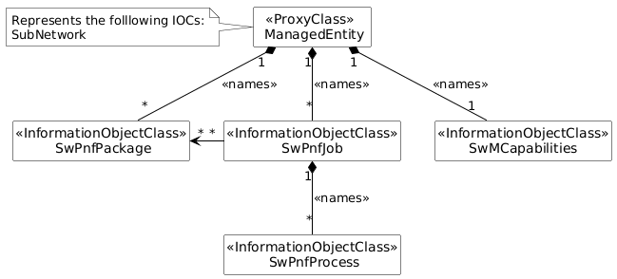
Figure 5.4.3.x.1 -1: Relationship UML diagram for software management

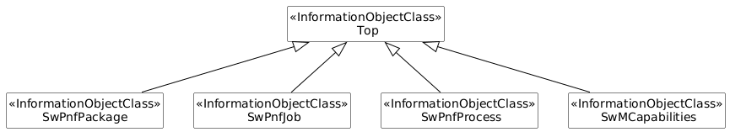
Figure 5.4.3.x.1 -2: Inheritance UML diagram for software management
The SwPnfPackage IOC includes attributes inherited from Top IOC and the following attributes in Table 5.4.3.x-1.
The attribute name is a human readable name of a software package.
The attribute version is a version identifier of the software package.
The attribute size represents the size of software. It is an integer. The unit is KB.
The attribute location represents the location of software. It is a string of the software file path on a server.
The attribute integrityCheck is a hash value which is used for software package integrity verification. It helps to ensure the downloaded software package is not corrupted during the transmission or storage.
The attribute vendorName is a name of inventory unit vendor (or vendors may provide manufacturer name)
The attribute userLabel is a user friendly free string for the operator to use. It has no effect on the procedures or states of the IOCs.
The attribute activationTime indicates the time when the SwPnfPackage was activated.
The attribute installationTime indicates the time when the SwPnfPackage was installed.
The attribute creationTime indicates the time when the SwPnfPackage was created by the implementing vendor.
The attribute downloadTime indicates the time when the SwPnfPackage was downloaded to the producer. E.g. if the IOC is under SubNetwork this can be the download to the element manager, if the IOC is under ManagedElement this can be the download to the network element.
The attribute state represents the state of a software package. The ENUM value could be remote, downloaded, activated, etc. It is conditionally mandatory when this package is associated with one single network element. A state transit figure is given below.
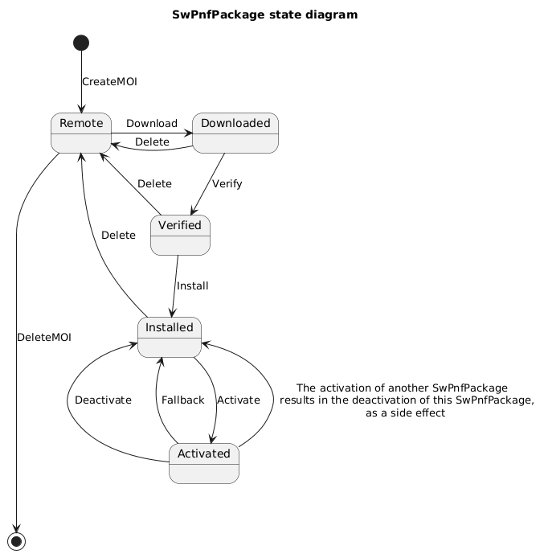

Table 5.4.3.x.1-1 SwPnfPackage attributes
Attribute Name | Support Qualifier | isReadable | isWritable | isInvariant | isNotifyable
name | M | T | T | T | T
version | M | T | T | T | T
userLabel | O | T | T | N | T
type | O | T | T | T | T
size | O | T | T | T | T
location | M | T | T | T | T
integrityCheck | O | T | T | T | T
vendorName | O | T | T | T | T
creationTime | M | T | F | T | T
downloadTime | M | T | F | F | T
state | CM | F | T | T | T
installationTime | CM | T | F | T | T
activationTime | CM | T | F | T | T

The SwPnfJob IOC represents MnS consumer's requirements for PNF software management. It includes attributes inherited from Top IOC and the following attributes in Table 5.4.3.x-2.
The attribute nEInformation specifies the NEs or NE types for which this SwPnfJob instance is valid. If theIOC is under a ManagedElement the attribute nEInformation has no effect and should not be used.
The attribute swJobId is a unique identifier of a software management job.
The attribute name is a human readable name of a software management job.
The attribute type represents the actions for which this software management job asks. Its type is string. Examples of allowed value could be UPGRADE, FALLBACK, etc.
Note: Whether this attribute can be removed and its functionality included in steps should be decided in the normative TS phase.
The attribute startTime represents the start time of a software management job.
The attribute stopTime represents the end time of a software management job. If the SW management process is still running at the stop time the process is cancelled.
vendorParameters is list of key value pairs that can hold additional vendor specificvendor parameters. There is no guarantee that the producer will handle these.
The attribute steps represents the steps to execute (only steps in SWMcapabilities are accepted). The following SWM steps are specified:
- Download
- Verify
- Install
- Activate – may imply a full or partial restart
- Deactivate – step is only applicable if partial upgrade is supported, as it is not allowed to remove all SW from the activated state
- Delete
Vendors are allowed not to expose some step explicitly, e.g. the activate step may implicitly include installation or it might be possible that the downloaded SW package is ready for installation thus there is no need for installation. The activate step is mandatory to expose.
Vendors may specify additional step.
Table 5.4.3.x.1-2 SwPnfProcess attributes
Attribute Name | Support Qualifier | isReadable | isWritable | isInvariant | isNotifyable
nEInformation | M | T | T | T | T
swJobId | M | T | T | T | T
swJobName | M | T | T | T | T
type | M | T | T | T | T
startTime | O | T | T | T | T
stopTime | O | T | T | T | T
steps | TBD | T | T | T | T
vendorParameters | O | T | T | N | T
Attribute related roles
packageListRef | M | T | T | T | T

The SwPnfProcess IOC represents the software management process for a RAN NE, which allows the MnS consumer to configure and be informed about the current situation of the software management process. It includes attributes inherited from Top IOC and the following attributes in Table 5.4.3.x-3. While a SwPnfJob MOI can handle one or more network elements, a separate SwPnfProcess MOI is created for each network element. wPnfProcess MOIs are created by the producer.
The SwProcessMonitor attribute represents the status of software management process for a single RAN NE and includes information the MnS consumer can use to monitor the progress and result of the software management process. The data type of this attribute is ProcessMonitor in TS 28.622 [x]. The following specializations are provided for this data type for the software management process:
- The value of attribute status are "NOT_STARTED", "RUNNING", "CANCELLING","FINISHED", "SUSPENDED","FAILED" and "CANCELLED". The values "PARTIALLY_FAILED" is not used.
- The attribute progessPercentage indicates progress of the process as percentage.
- When the attribute status is equal to "RUNNING" the attribute progressStateInfo attribute shall indicate states like: "PRECHECK_BEFORE_DOWNLOAD", "SW_DOWNLOAD", "PRECHECK_BEFORE_ACTIVATION", "SW_ACTIVATION". Vendor specific information may be provided though.
Editor’s note: The exact status values shall be defined during execution.
- For the case that the attribute status is equal to "FAILED" the attribute resultStateInfo shall indicate one of the failure reason, e.g. "UNKNOWN", " NE_HEALTH_CHECK_FAILED", "SW_DOWNLOAD_FAILED", " SW_ACTIVATION_FAILED", "DISCONNECTION_BETWEEN_NE_AND_OAM", "RESPONSE_TIMEOUT_BETWEEN_NE_AND_OAM","FTPS_CONNECTTION_FAILED_BETWEEN_NE_AND_OAM". Vendor specific information may be provided though.
The attribute stopPointSetIndication represents a True or False indication on whether this software management process instance will stop when the progressStateInfo attribute changes its value. If the value of stopPointSetIndication is True, when the progressStateInfo attribute changes its value, e.g., from "SW_DOWNLOAD" to "PRECHECK_BEFORE_ACTIVATION", this software management process will automatically stop and the value of stopPointStatus becomes "STOPPED". In this case only when the MnS consumer sets the value of stopPointStatus becomes "CONTINUED", this software management process will continue. If the value of stopPointSetIndication is False, this software management process will not automatically stop.
The attribute stopPointStatus represents whether the software management process is stopped or continued. It is applicable and mandatory when the value of stopPointSetIndication is True.
MnS consumer can terminate a software management process which is currently ongoing (the value of the attribute status is "RUNING" and the attribute progressStateInfo is not "SW_ACTIVATION") by configuring attribute cancelScProcess to "True". Then the attribute status will change from "RUNGING" to "CANCELLED" when MnS producer have terminated the software management process as MnS consumer requested.
Table 5.4.3.x.1-3 SwPnfProcess attributes
Attribute Name | Support Qualifier | isReadable | isWritable | isInvariant | isNotifyable
nEId | M | T | F | T | T
swProgressMonitor | M | T | F | F | T
detailedResult | M | T | F | F | T
stopPointSetIndication | O | T | T | F | T
stopPointStatus | CM | T | T | F | T
cancelSwProgress | O | T | T | F | T

The SwMCapabilities IOC shall indicate which of the 3GPP specified steps (see clause 5.4.3.x.1) the producer exposes (and thus can be invoked explicitly) and whether any additional vendor specific steps are supported.
The IOC provides a read-only ordered set of steps. Each step can be invoked by setting the appropriate data in the SwPnfJob. The SwMCapabilities IOC is created by the producer and is strictly read-only.

Attributes
Exposed steps
Name (extensible enumeration)
additionalProperties: nameValuePair – this allows both for future standard and for vendor extensions

5.4.3.x.2 Procedures for PNF software management
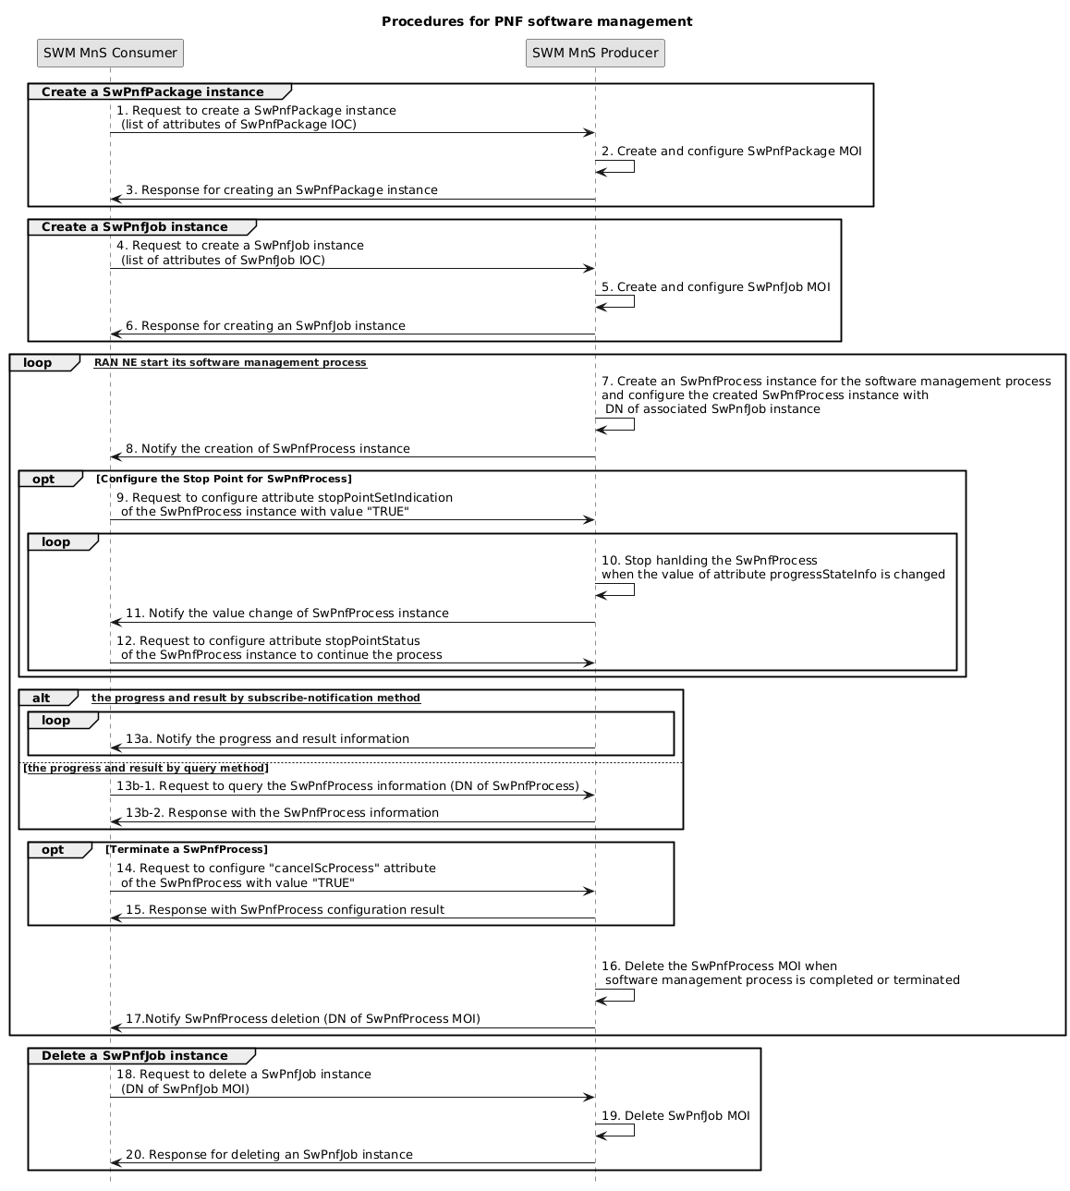
Figure 5.4.3.x.2 -1: Procedures for software management
1. MnS consumer sends a request to create a SwPnfPackage instance (see createMOI operation defined in TS 28.532 [3]) to MnS producer with software package information.
2. Based on the received request, the MnS producer creates the concrete SwPnfPackage instance (i.e. instance of SwPnfPackage).
3. MnS Producer sends a response (see createMOI operation defined in TS 28.532 [3]) to the MnS Consumer with attribute "objectInstance" of the created SwPnfPackage instance.
4. MnS consumer sends a request to create a SwPnfJob instance (see createMOI operation defined in TS 28.532 [3]) to MnS producer with software package information.
5. Based on the received request, the MnS producer creates the concrete SwPnfJob instance (i.e. instance of SwPnfJob) for NE(s) or NE type(s) specified by attribute "neInformation".
6. MnS Producer sends a response (see createMOI operation defined in TS 28.532 [3]) to the MnS Consumer with attribute "objectInstance" of the created SwPnfJob instance.
7. For each NE (specified in the created SwPnfJob) starting its software management process, MnS producer creates an SwPnfProcess instance for the started software management process and configure the created SwPnfProcess instance with DN of the associated SwPnfJob.
8. MnS producer notifies (see notifyMOICreation notification defined in TS 28.532 [3]) the MnS consumer about the creation of a new SwPnfProcess instance, including DN of SwPnfProcess instance.
9. In the case that MnS consumer manually controls the software management process, the MnS consumer requests to configure attribute stopPointSetIndication of the SwPnfProcess instance with value "TRUE", which means when the attribute progressStateInfo changes, the process will stop and wait for MnS consumer’s command to continue.
10. When the value of attribute progressStateInfo changes, MnS producer stops handling the software management process.
11. MnS producer notifies the MnS consumer about the value change of the SwPnfProcess instance.
12. MnS consumer requests to configure attribute stopPointStatus of the SwPnfProcess instance with value "CONTUNUED" to continue the process.
The following step 13 describes the procedures for MnS consumer to monitor software management progress and result. These steps can happen any time after the SwPnfProcess instance is created until the SwPnfProcess instance is deleted
13a) The MnS producer sends notification (see notifyMOIAttributeValueChanges defined in TS 28.532 [3]) to MnS consumer to notify the progress and result for software management process (see attributes in SwPnfProcess IOC).
13b) The MnS consumer sends query request to MnS producer to query the attribute values of SwPnfProcess instance (see getMOIAttributes operation defined in TS 28.532 [3]) to obtain the progress and result (including DN of the SwPnfProcess instance and other attributes of SwPnfProcess instance) for software management process.
Following Steps 14 and 15 are the steps for MnS consumer request to terminate an ongoing software management process.
14. The MnS consumer sends a request (see modifyMOIAttributes operation defined in TS 28.532 [3]) to MnS producer to configure cancelScProcess attribute of the SwPnfProcess instance with value "TRUE" to terminate an ongoing software management process.
15. The MnS producer sends a response (see modifyMOIAttributes operation defined in TS 28.532 [3]) for terminating an ongoing software management process to MnS consumer.
16. MnS consumer deletes the SwPnfProcess instance when software management process is completed or terminated.
17. MnS producer notifies the MnS consumer about the deletion of a SwPnfProcess instance.
The following steps describes the procedures for MnS consumer request to delete a SwPnfJob instance to ultimate deactivation of requirements for software management management for a set of RAN NEs.
18. MnS consumer sends a request to delete a SwPnfJob instance (see deleteMOI operation defined in TS 28.532 [3]) to MnS producer with the DN of the SwPnfJob instance.
19. Based on the received request, the MnS producer delete the concrete SwPnfJob instance
20. MnS Producer sends a response (see deleteMOI operation defined in TS 28.532 [3]) to the MnS Consumer.

* * * Next Change * * * *

Annex A (informative): PlantUML source code

A.1 Relationship UML diagram for PNF software management
@startuml
hide circle
hide methods
hide members

skinparam class {
AttributeIconSize 0
BackgroundColor white
BorderColor black
ArrowColor black
}
skinparam Shadowing false
skinparam Monochrome true
skinparam ClassBackgroundColor White
skinparam NoteBackgroundColor White

class "<<ProxyClass>> \n ManagedEntity " as ManagedEntity{}
class "<<InformationObjectClass>>\n SwPnfJob " as SwPnfJob {}
class "<<InformationObjectClass>>\n SwPnfProcess" as SwPnfProcess{}
class "<<InformationObjectClass>>\n SwPnfPackage" as SwPnfPackage{}

ManagedEntity "1" *-- "*" SwPnfJob : <<names>>
ManagedEntity "1" *-- "*" SwPnfProcess : <<names>>
SwPnfJob "*" <-left-> "*"SwPnfPackage
SwPnfJob "1" <-right-> "*"SwPnfProcess
note left of ManagedEntity
Represents the folllowing IOCs:
SubNetwork
end note

@enduml

A.2 Inheritance UML diagram for PNF software management
@startuml
hide circle
hide methods
hide members

skinparam class {
AttributeIconSize 0
BackgroundColor white
BorderColor black
ArrowColor black
}
skinparam Shadowing false
skinparam Monochrome true
skinparam ClassBackgroundColor White
skinparam NoteBackgroundColor White

class "<<ProxyClass>> \n ManagedEntity " as ManagedEntity{}
class "<<InformationObjectClass>>\n SwPnfJob " as SwPnfJob {}
class "<<InformationObjectClass>>\n SwPnfProcess" as SwPnfProcess{}
class "<<InformationObjectClass>>\n SwPnfPackage" as SwPnfPackage{}
class "<<InformationObjectClass>>\n SwMCapabilities " as SwMCapabilities {}

ManagedEntity "1" *-- "1" SwMCapabilities : <<names>>
ManagedEntity "1" *-- "*" SwPnfJob : <<names>>
ManagedEntity "1" *-- "*" SwPnfPackage : <<names>>
SwPnfJob "1" *-d- "*" SwPnfProcess : <<names>>
SwPnfJob "*" -left-> "*"SwPnfPackage
note left of ManagedEntity
Represents the folllowing IOCs:
SubNetwork
end note
@enduml

A.3 SwPnfPackage state diagram
@startuml
title SwPnfPackage state diagram
[*] -d-> Remote : CreateMOI
Remote -d----> [*] : DeleteMOI
Remote -r---> Downloaded : Download
Downloaded --right--> Verified : Verify
Verified -d-> Installed : Install
Installed -d-> Activated : Activate
Activated --> Installed : The activation of another SwPnfPackage \n results in the deactivation of this SwPnfPackage,\n as a side effect
Activated --> Installed : Deactivate
Activated --> Installed : Fallback
Downloaded -l----> Remote : Delete
Verified --> Remote : Delete
Installed --> Remote : Delete
@enduml

A.4 Procedures UML diagram for PNF software management
@startuml
title " Procedures for PNF software management "
participant "SWM MnS Consumer" as SC
participant "SWM MnS Producer" as SP

group Create a SwPnfPackage instance
SC -> SP: 1. Request to create a SwPnfPackage instance \n (list of attributes of SwPnfPackage IOC)
SP -> SP: 2. Create and configure SwPnfPackage MOI
SP -> SC: 3. Response for creating an SwPnfPackage instance
end

group Create a SwPnfJob instance
SC -> SP: 4. Request to create a SwPnfJob instance \n (list of attributes of SwPnfJob IOC)
SP -> SP: 5. Create and configure SwPnfJob MOI
SP -> SC: 6. Response for creating an SwPnfJob instance
end

loop [Corresponding RAN NE start its software management process]

SP -> SP: 7. Create an SwPnfProcess instance for the software management process \nand configure the created SwPnfProcess instance with \n DN of associated SwPnfJob instance
SP -> SC: 8. Notify the creation of SwPnfProcess instance
opt Configure the Stop Point for SwPnfProcess
SC -> SP: 9. Request to configure attribute stopPointSetIndication\n of the SwPnfProcess instance with value "TRUE"
loop
SP -> SP: 10. Stop hanlding the SwPnfProcess \nwhen the value of attribute progressStateInfo is changed
SP -> SC: 11. Notify the value change of SwPnfProcess instance
SC -> SP: 12. Request to configure attribute stopPointStatus\n of the SwPnfProcess instance to continue the process
end
end

alt [obtain the progress and result by subscribe-notification method]
loop
SP -> SC: 13a. Notify the progress and result information
end
else [[obtain the progress and result by query method]]
SC -> SP: 13b-1. Request to query the SwPnfProcess information (DN of SwPnfProcess)
SP -> SC: 13b-2. Response with the SwPnfProcess information
end
opt Terminate a SwPnfProcess
SC -> SP: 14. Request to configure "cancelScProcess" attribute \n of the SwPnfProcess with value "TRUE"
SP -> SC: 15. Response with SwPnfProcess configuration result
end

|||

SC -> SP: 16. Request to delete a SwPnfProcess instance \n software management process must be completed or terminated
SP -> SP: 16a. Delete SwPnfProcess MOI
SP->SC: 17. Response for deleting an SwPnfProcess instance
end
group Delete a SwPnfJob instance
SC -> SP: 18. Request to delete a SwPnfJob instance \n (DN of SwPnfJob MOI)
SP -> SP: 19. Delete SwPnfJob MOI
SP -> SC: 20. Response for deleting an SwPnfJob instance
end

skinparam sequenceActorBackgroundColor #FFFFFF
skinparam sequenceParticipantBackgroundColor #FFFFFF
skinparam noteBackgroundColor #FFFFFF
autonumber "#'.'"
skinparam monochrome true
skinparam shadowing false
hide footbox
@enduml

Annex B: Change history

* * * End of Changes * * * *

