3GPP TSG SA5 Meeting #165 S5-260717
Goa, India, 9-13 February 2026

Source: Nokia
Title: Pseudo-CR on Add potential solution and evaluation for MnS selection in distributed deployment scenarios for SBMA
Document for: Approval
Agenda item: 6.20.4
Spec: 3GPP TR 28.884
Version: 0.2.0
Work Item: FS_SBMA_Ph4

Comments
This pCR adds a potential solution and solution evaluation to enable MnS cconsumers select the appropriate MnS(s) from multiple discovered MnSs. The proposed solution adds some clarification text on the MnSInfo IOC defined TS 28.622.

Proposed Changes
* * * First Change * * * *

5.7 Use case#7: MnS selection in distributed deployment scenarios for SBMA

5.7.1 Description
3GPP management system introduce Service-Based Management Architecture in 5G which has improved system flexibility to adapt to different types of deployment scenarios. In SBMA, MnS producer and MnS consumer are two fundamental entities as defined in TS 28.533[2]. According to definitions in and TS 28.537[4] and TS 32.101[20], figure 1 shows the discovery mechanism of MnS. MnS producer registers service to MnS registry. MnS consumer retrieves service from MnS registry. Then MnS consumer invokes service from MnS producer.
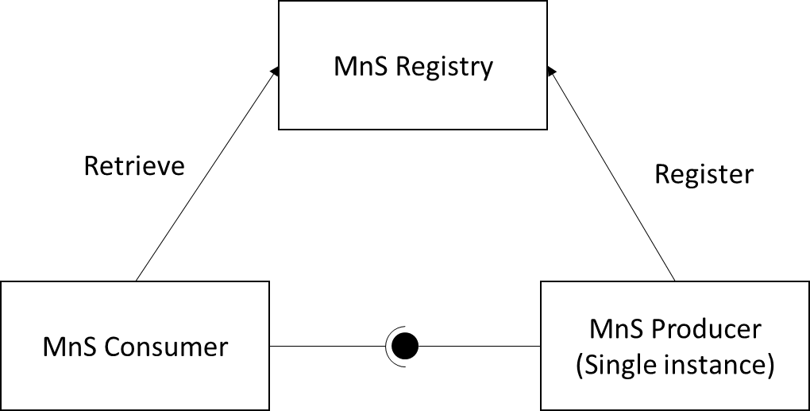
Figure 1. Discovery mechanism of MnS
In distributed deployment scenarios, MnS consumers may get multiple MnSs returned when retrieving MnSs from the MnS registry. MnS consumer has to decide which MnS to invoke. Figure 2 depicts the discovery mechanism in the distributed scenario. The current challenge is how an MnS consumer can select the most appropriate MnS from a set of discovered MnS(s) from the MnS registry.
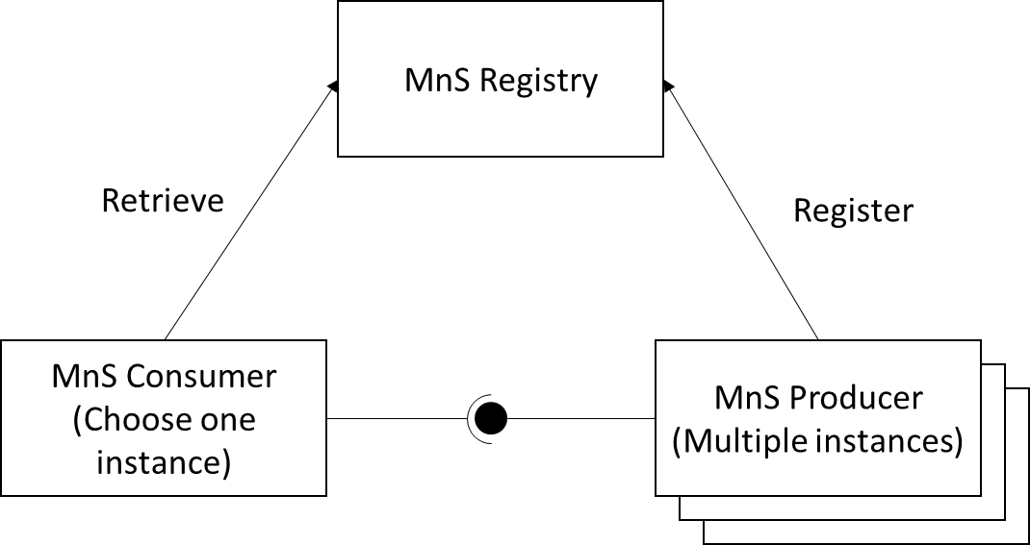
Figure 2. Discovery mechanism in the distributed scenario

5.7.2 Potential requirements
REQ-Distributed-FUN-1: The 3GPP management system should have capability to assist the MnS consumer to select the appropriate MnS(s) from multiple discovered MnS(s).

5.7.X Potential solutions
As specified in clause 4.3.42 of TS 28.622[6], the MnSInfo IOC provides information that enables an MnS consumer to discover a management service.
For the purpose of MnS selection, the mnsCapability attribute of the MnSInfo IOC can be utilized by the MnS consumer when performing an “MnS discovery request” towards the MnS Registry. This attribute allows the MnS consumer to retrieve only those MnS producer instances that support the requested MnS capability.

* * * Next Change * * * *

5.7.Y Evaluation of potential solutions
The proposed solution adds some clarification text to the MnSInfo IOC, explaining how the mnsCapability attribute can be used by the MnS consumer for MnS selection. This clarification ensures that the MnS consumer can identify MnS producer instances offering specific MnS capabilities and satisfies the use case requirements in clause 5.7.2.

* * * End of Changes * * * *

