3GPP TSG SA5 Meeting #165 S5-260715
Goa, India, 9-13 February 2026

Source: Huawei
Title: pCR TR 28.884 Update of management data streaming based on message bus
Document for: Approval
Agenda item: 6.20.4
Spec: 3GPP TR 28.884
Version: 0.2.0
Work Item: FS_SBMA_Ph4

Comments
This contribution proposes updates to the existing content on management data streaming based on a message bus in TR 28.884. The intention is to improve clarity.

Proposed Changes
* * * First Change * * * *

4.2 Management data streaming based on Message Bus and WebSocket technologies
3GPP TS 28.532 [3] defines Stage 2 and Stage 3 of the streaming data reporting service. Currently, the 3GPP management system supports WebSocket-based data streaming for PM, tracing, and analytics, establishing a point-to-point transport connection between the streaming data reporting MnS consumer and MnS producer. The producer initiates the connection with the consumer and exchanges metadata (informing the consumer about its identity and the nature of the data to be reported, i.e., streamInfo). After this phase, the producer reports streaming data to the consumer via the established connection.
Using point-to-point WebSocket communication protocol, which operates over a single TCP connection between a client and a server, a separate connection would be established between each consumer and the producer, causing the producer to generate and transmit multiple copies of the same data. The WebSocket protocol is standardized by the IETF in RFC 6455 [8]. It defines WebSocket as a protocol that enables ongoing, full-duplex, bidirectional communication between web servers and web clients over an underlying TCP connection, see [9]. Though a server can maintain multiple WebSocket connections simultaneously and broadcast messages to all connected clients. However, this is not a protocol-level feature, it is an application-level point-to-multipoint behaviour.

NOTE: The management data includes performance measurements or KPIs defined in TS 28.552 [5] and TS 28.554 [6], trace reporting data defined in TS 32.423 [7] and analytic reporting data defined in TS 28.532 [3].

4.3 Message bus principles integrated in SBMA
Message bus principles
A message bus is a middleware architecture that enables different systems or services to communicate through a shared messaging infrastructure in a decoupled way. Key principles include the following:
- Loose Coupling: Services interact without knowing each other’s internal details. Enhances modularity and allows independent evolution of components.
- Asynchronous Messaging: Messages are sent without waiting for immediate responses. Improves system responsiveness and fault tolerance.
- Publish/Subscribe Model: Producers publish messages to a topic; consumers subscribe to topics of interest. Enables one-to-many and many-to-many communication.
- Scalability and Resilience: Supports high-throughput, fault-tolerant communication with buffering, retries, and failover etc. Maintains service continuity under load or failure.
Table 4.3-1 shows how the message bus principles are supported in the SBMA.
Table 4.3-1: Message bus principles supported in the SBMA
Message bus principle | SBMA implementation
Loose Coupling | MnS producers and consumers interact via service exposure. Scaling of one side, e.g. MnS producer, does not affect the other side, e.g. MnS consumer. Adding a greater number of MnS consumers, does not affect the MnS producer. Error handling and failure recover does not require coupled proprietary implementation between MnS producer and MnS consumer.
Asynchronous Messaging | SBMA supports subscription/notification and streaming interfaces for non-blocking data flow (i.e., MnS producer sends the message data and continues its work without delay, while MnS consumer processes the message independently).
Publish/Subscribe | Publish: MnS producers register their management capabilities or management data information to MnS discovery service producer which could be used by MnS consumers.  Subscribe: MnS consumers can subscribe to events or data streams exposed by MnS producers.
Scalability and Resilience | SBMA supports multipoint-to-multipoint streaming, improving efficiency and fault tolerance.

* * * Next Change * * * *

5.2 Use case #2: Management data streaming based on message bus

5.2.1 Description
The 5G network employs a distributed, service-oriented architecture, leading to scenarios where multiple consumers may request the same management data for multiple uses. In a typical network performance data reporting scenario, an MnS producer collects and transmits performance data to multiple MnS consumers within the network management system (e.g., real-time analytics, network optimization engines, visualization dashboards, and audit services).

Using point-to-point WebSocket communication protocol, which operates over a single TCP connection between a client and a server, a separate connection would be established between each consumer and the producer. For the case of multiple consumers requesting the same performance data, it causes the producer to retrieve and duplicate the relevant performance data from its cache for each connection individually.
By adopting a message bus architecture, the producer establishes connection(s) with the message bus and publishes the performance data only once. Consumers retrieve the data whenever they want (i.e., the consumer either pulls the data from the message bus or subscribes and receives messages pushed by the bus) - hence the principle of loose coupling. No additional connections are initiated by the producer, and no duplicate data reporting occurs on its side for the case that multiple consumers request the same performance data. As a comparison example between WebSocket and message bus for the case that multiple consumers request the same performance data as an assumption:
- WebSocket option: duplicate data reporting occurs N times on the producer's side for sending the data to N consumers who request the same performance data.
- Message bus option: depending on the collection job, no duplicate data reporting occurs on the producer's side for sending the data to N consumers (regardless of the number of consumers)who request the same performance data because the only one copy of data buffered on the message bus broker (i.e., a middleware that facilitates communication between different participants by acting as an intermediary for messages) can be polled by all the consumers.
While the message bus architecture introduces certain operational considerations, such as the need for proper message category segmentation and consumer coordination management to avoid throughput bottlenecks. These aspects are addressed through established internal mechanisms and configuration practices. Such implementation details are outside the scope of this document. The message bus interface is not used on ManagedElement/NF level but only on management function level.

5.2.2 Potential requirements

5.2.3 Potential solutions
5.2.3.1 Solution #1: Multipoint-to-Multipoint management data streaming based on message broking MnF
This potential solution proposes introduction of a new MnF implementing the message broker(s) that mediates data with the help of new MnS services, namely, message bus data reporting MnS and message bus data retrieval MnS (for data subscribers) to enable multipoint-to-multipoint streaming data reporting. This solution is meant for use at the management level and not at the managedElement/NF level. This solution also does not impact existing MnS services and can coexist beside such services as an additional option.
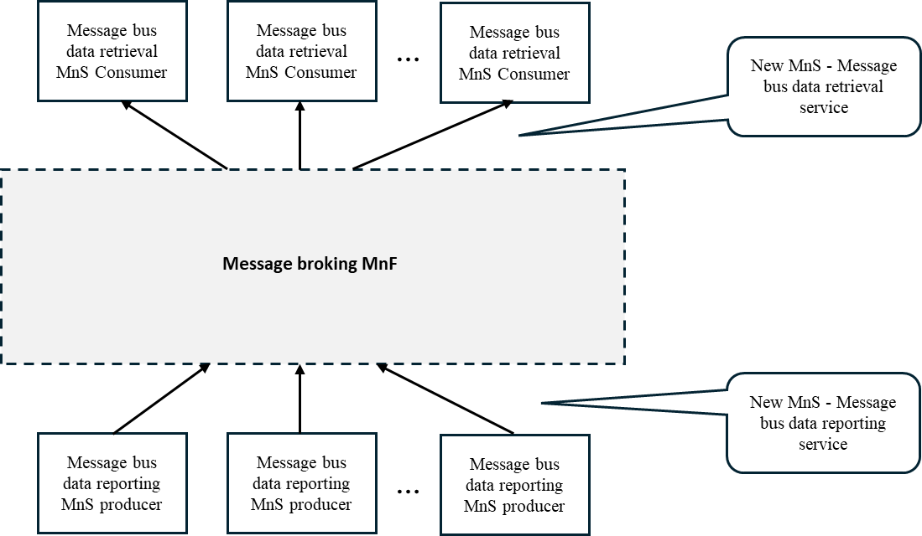
Figure 5.2.3.1-1: Potential solution for multipoint-to-multipoint management data streaming based on message bus
As shown in Figure 5.2.3.1-1, in this solution, message bus data reporting MnS producers send management data to Message broking MnF using the message bus data reporting service based on message bus publishing protocol. Message bus data retrieval MnS consumers receive the management data using the message bus data retrieval service based on message bus retrieval protocol. This approach allows the same copy of management data produced by the message bus data reporting MnS producer(s) to be shared across multiple message bus data retrieval MnS consumers thus enabling multipoint-to-multipoint communication and a publishing-and-subscribing based communication pattern.
Editor’s note: The following aspects are FFS
- What types of management data (e.g. PM) to be supported.
- What specific message bus-based communication protocol to be supported (e.g. Kafka) and why?
3. How to do data access control.
4. How the information related to the message bus (e.g., end-point URIs) is conveyed or configured to the MnS producers and MnS consumers needs to be clarified.
5. Whether new MnSs is needed is to be studied

* * * End of Changes * * * *

