3GPP TSG-SA5 Meeting #165 S5-260699
Goa, India, 09 - 13 February 2026

Source: L.M. Ericsson Limited
Title: Rel-20 pCR TR 28.883 Solution for Defining the Lifecycle and Runtime Behaviour of NDT Jobs
Document for: Approval
Agenda item: 6.20.3
Spec: 3GPP TR 28.883
Version: V0.2.0
Work Item: FS_NDT_Ph2

Comments
Solution for the definition of the lifecycle and runtime behaviour of NDTJobs.

Proposed Changes
* * * First Change * * * *

5 Use cases

5.7 Use Case #7 Defining the Lifecycle and Runtime Behaviour of NDT Jobs

5.7.1 Description
The NDTJob lifecycle is not clear, there are some items open to interpretation and some items missing which are described below.
The MnS Consumer should have a method to know which configuration of NDTJob has produced a given report. In the current specification NDTReport refer to the NDT job (i.e NDTJobRef). In the existing specification, it is possible to modify the NDTJob which may result in the different NDTReport. This will result in losing the link between produced NDT Report and the original NDT Job. The MnS Consumer would benefit from understanding the implications of reconfiguring the NDTJob. At the moment, the NDTReports refer to the DN of the NDTJob – if a NDTJob is reconfigured, this means the same DN is applied to each report, even if the simulation has changed. Likewise, there is no clear procedure described in Clause 6.4, despite the “Modify” use-case being possible for the NDTJob Instances.
Excerpt: Table 6.2.1.3.8.2-1 describes the attributes associated with the NDTReport <<IOC>>
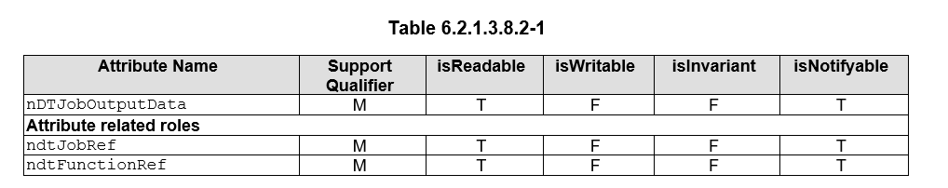
Excerpt: From 6.3 Attribute definitions, the explanation of the ndtJobRef of the NDTReport <<IOC>> refers to
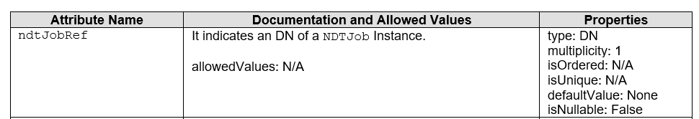

5.7.2 Potential requirements
REQ-DTLCM-XX: The MnS Producer should provide a mechanism for the MnS Consumer to distinguish between different configurations of the same NDTJob instance that may exist over time as a result of modify operations.

5.7.3 Potential solutions

5.7.3.1 Solution1: New attribute to the ndtJob and ndtReport to maintain the version information
An NDTJob MOI represents the job request and configuration provided by the MnS Consumer, including the network scenario, synchronization scope, and execution requirements.
To enable unambiguous correlation between NDTReports and the configuration used during NDTJob execution:
- A new read-only attribute (e.g. ndtJobSnapshotId) is added to the NDTJob IOC.
- The attribute identifies the NDTJob configuration information used when an NDTJob execution is started.
- The ndtJobSnapshotId added to the NDTJob is maintained solely by the MnS Producer.
The identifier may be implementation-specific (e.g. internal reference) but shall uniquely identify the configuration used for execution.
Association with NDTReport
- The same new read-only attribute (e.g. ndtJobSnapshotId) is added to the NDTReport IOC.
- The MnS Producer shall populate this attribute with the ndtJobSnapshotId identifier corresponding to the NDTJob execution that produced the NDTReport.
- The ndtJobSnapshotId added to the NDTReport is maintained solely by the MnS Producer.
This ensures that each NDTReport can be correlated both to:
- the NDTJob request (ndtJobRef), and
- the configuration information (ndtJobSnapshotId) used during execution.

5.7.3.2 Solution2: MnS Consumer maintains the configuration change information as required.
The MnS Consumer(s) of the ndtJob maintain the ndtJob configuration identity information.
They can do this by subscribing to the notification regarding modification of the ndtJob MOI. If it receives a notification that the simulation related attributes of the ndtJob MOI have been modified, then it can internally maintain a version/configuration reference for that ndtJob.
This allows the MnS Consumer to determine when it receives multiple ndtReports produced by the same ndtJob (e.g. same ndtJob DN on multiple reports), whether the ndtReports have been produced by different configurations of the same ndtJob.

5.7.4 Evaluation of potential solutions
Both solutions are feasible, however, to keep aligned with common behaviour in 3GPP SA5, the recommendation is to move forward with solution 2 as in clause 5.7.3.2.
Solution 2 has no normative impacts.

6 Conclusions and Recommendations

6.X Use case #7: Defining the Lifecycle and Runtime Behaviour of NDT Jobs
The use-case and solution as proposed in clause 5.7.3.2. explains how the MnS Consumer can achieve the use-case, by monitoring the modification of the ndtJob and tracking which version of the ndtJob has produced which ndtReport.
No new normative work is expected as a result of this solution.

* * * End of Changes * * * *

