3GPP TSG SA5 Meeting #165 S5-260692d1
Goa, India, 9-13 February 2026

Source: China Unicom
Title: Pseudo-CR on Rel-20 TR 28.885 Add new solution for EC and EE per PLMNID in Network sharing scenario
Document for: Approval
Agenda item: 6.20.5
Spec: 3GPP TR 28.885
Version: V0.3.0
Work Item: FS_Energy_Ph4_OAM

Comments
This contribution proposes to add a new solution for energy consumption and energy efficiency per PLMNID in network sharing scenario.

Proposed Changes
* * * First Change * * * *

5.4.3 Use case #3: Support estimation of EC and EE KPIs at per PLMN-ID granularity in Network sharing scenario

5.4.3.1 Description
When a NG-RAN is shared between multiple operators in the network sharing (see TS 32.130 [11]), the participating operators are interested in the operator-specific energy consumption (EC) and energy efficiency (EE) of the NG-RAN.
The NG-RAN can support and serve multiple operators (i.e., PLMN-IDs) in Network sharing scenarios. The existing EE and EC KPIs do not consider network sharing scenarios, and do not provide KPIs at operator-specific (i.e., PLMN-ID) granularity.
Following are the currently supported measurements and KPIs related to energy consumption and energy efficiency:
- Power, Energy and Environmental (PEE) measurements are defined in clause 5.1.1.19 of TS 28.552 [10], and PNF Energy consumption for ManagedElement is defined in clause 5.1.1.19.3 of TS 28.552 [10].
- Energy consumption and energy efficiency related KPIs are defined in clause 6.7 of TS 28.554 [4].
This use case is to study the enhancements to enable monitoring and/or estimation of energy consumption and energy efficiency KPIs and reporting of a NG-RAN at operator-specific (i.e., at a per PLMN-ID) granularity in network sharing scenarios.

5.4.3.2 Potential requirements
PREQ-Energy_Consumption_Network_Sharing-1: The 3GPP management system should be able to report the energy consumption and energy efficiency of a NG-RAN at operator-specific, i.e., at a per PLMN-ID granularity.

5.4.3.3 Potential solutions
5.4.3.3.i Potential solution #<i> New KPIs of PLMN-level gNB EC and PLMN-level gNB EE

5.4.3.3.i.1 Introduction
This solution proposes to calculate the PLMN level EC and EE in network sharing scenario based on the existing measurements 5.1.1.19.3 defined in TS 28.552[10]. The detailed mechanism for spliting energy consumption among PLMNs is described in the following part.

5.4.3.3.i.2 Description
This solution proposes to define two new KPIs based on the existing measurements to represent the EC and EE of a shared gNB in PLMN granularity.
−PLMN-level Energy Consumption KPI
The new EC KPI describes the PLMN-level Energy Consumption (EC) of the gNB when the gNB is shared by multiple operators. A gNB comprises several network functions (NFs), such as BBU, RRU, etc.. The new KPI can be derived by summing up the per- PLMN energy consumption of each NF that constitutes the shared gNB. The unit of this KPI is kWh.
Below is the equation for gNB energy consumption per PLMN
𝑄𝑈𝑂𝑇𝐸 ECgNBperPLMN=NFstaticiPEE.EnergyNFBBUstaticiN+DVPLMNDVsum×NFdynamicjPEE.EnergyNFRRUdynamicj
Where PEE.EnergyBBUiPEE.EnergyNFstatic and PEE.EnergyRRUjPEE.EnergyNFdynamic are energy consumption of BBUs and RRUs that constitute the shared gNB. The enegy consumption of these NFs can be measured as defined in clause 5.1.1.19.3 in TS 28.552 which is obtained according to 4.4.3.1 in ETSI ES 202 336-12. According to ETSI ES 202 336-12, The original measurement in ETSI ES 202 336-12 is applied for the network element defined in table 1, shown as follows,
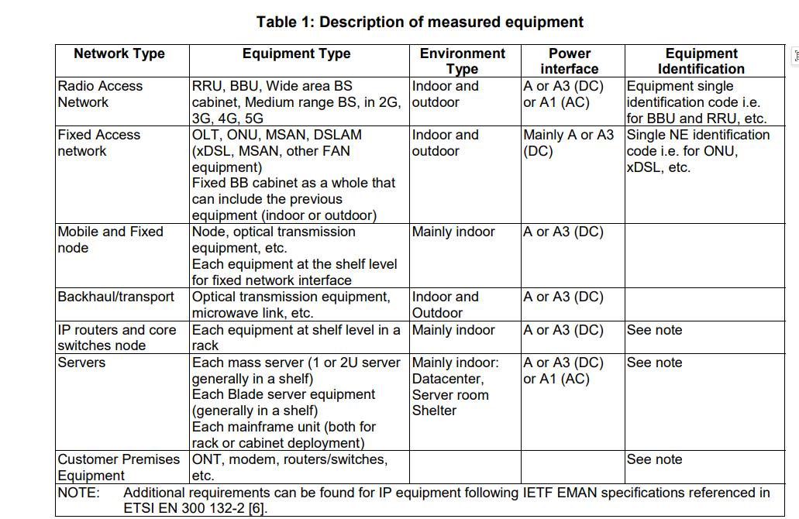
N is the number of PLMNs sharing the same gNB.
${DV}_{PLMN}$ is the sum of DRB.PdcpSduVolumeDL_PLMN and DRB.PdcpSduVolumeUL_PLMN of NR Cells of the shared gNB. ${DV}_{sum}$ is the sum of DRB.PdcpSduVolumeDL and DRB.PdcpSduVolumeUL of NR Cells of the shared gNB. DRB.PdcpSduVolumeDL_PLMN, DRB.PdcpSduVolumeUL_PLMN, DRB.PdcpSduVolumeDL and DRB.PdcpSduVolumeUL are all defined in clause 5.1.2.1 in TS 28.552.
NOTE: BBU is the kind of NF which energy consumption is independent from data volume whereas RRU is the kind of NFs which energy consumption is affected by data volume. Thus, the method for splitting energy consumption among PLMNs differs between the BBU and the RRU.
−PLMN-level Energy Efficiency KPI
The new EE KPI is defined to reflect per PLMN energy efficiency with data volume as performance indicator. It can help each participating operators be aware of its individual energy efficiency in network sharing scenario. The unit of this KPI is kbit/kWh.
Below is the equation for gNB energy efficiency per PLMN on data volume
${EE}_{gNBperPLMN}=\frac{DataVolumeperPLMN}{ECgNBperPLMN}$
The performance indicator DataVolumeperPLMN is the sum of the data volume delivered over air interface both in uplink and down link per PLMN for NR Cells of the shared gNB. DataVolumeperPLMN is the sum of DRB.PdcpSduVolumeDL_PLMN and DRB.PdcpSduVolumeUL_PLMN, defined in clause 5.1.2.1 in TS 28.552. ECgNBperplmn is the energy consumption per PLMN as defined in the above paragraph.

5.4.3.4 Evaluation of potential solutions

* * * End of Changes * * * *

