3GPP TSG SA5 Meeting #165 S5-260691
Goa, India, 9-13 February 2026 (revision of S5-260269)

Source: Nokia
Title: Pseudo-CR on Rel-20 TR 28.885 Add potential solution for EC measurement of NE at per Energy Supply granularity
Document for: Approval
Agenda item: 6.20.5
Spec: 3GPP TR 28.885
Version: 0.3.0
Work Item: FS_Energy_Ph4_OAM

Comments
To introduce a potential solution and update the evaluation of the potential solutions, conclusions and recommendations for the following use case defined in clause 5.4.2 of TR 28.885.
- Use case #2: Support EC measurement of NE at per Energy Supply granularity

Proposed Changes
* * * First Change * * * *

2 References
The following documents contain provisions which, through reference in this text, constitute provisions of the present document.
- References are either specific (identified by date of publication, edition number, version number, etc.) or non-specific.
- For a specific reference, subsequent revisions do not apply.
- For a non-specific reference, the latest version applies. In the case of a reference to a 3GPP document (including a GSM document), a non-specific reference implicitly refers to the latest version of that document in the same Release as the present document.
[1] 3GPP TR 21.905: "Vocabulary for 3GPP Specifications".
[2] 3GPP TS 22.261: "Service requirements for the 5G system".
[3] 3GPP TS 28.310: "Management and orchestration; Energy efficiency of 5G".
[4] 3GPP TS 28.554: "Management and orchestration; 5G end to end Key Performance Indicators (KPI)".
[5] ETSI GS OEU 020 (v1.1.1): "Operational energy Efficiency for Users (OEU); Carbon equivalent Intensity measurement; Operational infrastructures; Global KPIs; Global KPIs for ICT Sites".
[6] ETSI ES 202 706-1 V1.7.1 (2022-08): "Environmental Engineering (EE); Metrics and measurement method for energy efficiency of wireless access network equipment; Part 1: Power consumption - static measurement method".
[7] 3GPP TS 28.541: "Management and orchestration; 5G Network Resource Model (NRM); Stage 2 and stage 3".
[8] 3GPP TS 23.501: "System architecture for the 5G System (5GS)".
[9] 3GPP TR 23.700-67: "Study on Energy Efficiency and Energy Saving; Phase 2".
[10] 3GPP TS 28.552: "Management and orchestration; 5G performance measurements".
[11] 3GPP TS 32.130: " Telecommunication management; Network sharing; Concepts and requirements".
[L] ETSI ES 202 336-12 V1.2.1 "Environmental Engineering (EE); Monitoring and Control Interface for Infrastructure Equipment (Power, Cooling and Building Environment Systems used in Telecommunication Networks) Part 12: ICT equipment power, energy and environmental parameters monitoring information model"
[M] 3GPP TS 28.622: "Telecommunication management; Generic Network Resource Model (NRM) Integration Reference Point (IRP); Information Service (IS)".

* * * Next Change * * * *

5.4.2.3.x Potential solution #<x>: Enhancements to EnergyInfoGroup and Energy consumption measurement

5.4.2.3.x.1 Introduction
A Network Element can be powered using multiple energy supplies.
ETSI ES 202 336-12 [L] clause 4.3.2 specifies the following, which indicates that the measurements can be provided at individual power inputs on the same ICT equipment. An example is illustrated in Figure 3 of ETSI ES 202 336-12 [L].
"
When there are several power interface A or A3 inputs on the same ICT equipment, the sum of all power and energy measurements shall be provided in the monitored data in addition to individual values.
"
PNF Energy consumption for the ManagedElement IOC is defined in clause 5.1.1.19.3 of TS 28.552 [10]. This measurement is obtained according to the method defined in ETSI ES 202 336-12 [L] – clauses 4.4.3.1, 4.4.3.4, Annex A.
ManagedElement IOC (defined in TS 28.622 [M])) does not have any attributes related to the power, energy and environmental (PEE) parameters. The attribute peeParametersList in ManagedFunction IOC (defined in TS 28.622 [M]) represents a list of PeeParameters relates to power, energy and environmental (PEE) parameters representing the equipment information defined in clause 4.4.1 of ETSI ES 202 336-12 [L].
The measurement and monitoring defined in clause 4.4 ETSI ES 202 336-12 [L] includes "Internal measurements type 1 (Built-in in ICT equipment)" (see clause 4.4.1 of ETSI ES 202 336-12 [L]) and "External measurements type 2 (external sensors) for ICT equipment" (clause 4.4.1 of ETSI ES 202 336-12 [L]). This is illustrated in an example in Figure 5.4.2.3.x.1-1. These measurements and monitoring are supported for ICT Equipment and Network Elements, and do not relate to ManagedFunctions (which represent a telecommunication function either realized by software running on dedicated hardware or realized by software running on virtualized infrastructure).
The Figure 5.4.2.3.x.1-1, reproduced from clause 4.4.1 of ETSI ES 202 336-12 [L], depicts an example of monitoring of PEE in a complex site where the Telecon/ICT Equipment can have multiple energy supplies (depicted by "AC or DC power source 1" and "AC or DC power source 1") and PEE monitoring using different types of PEE sensors.
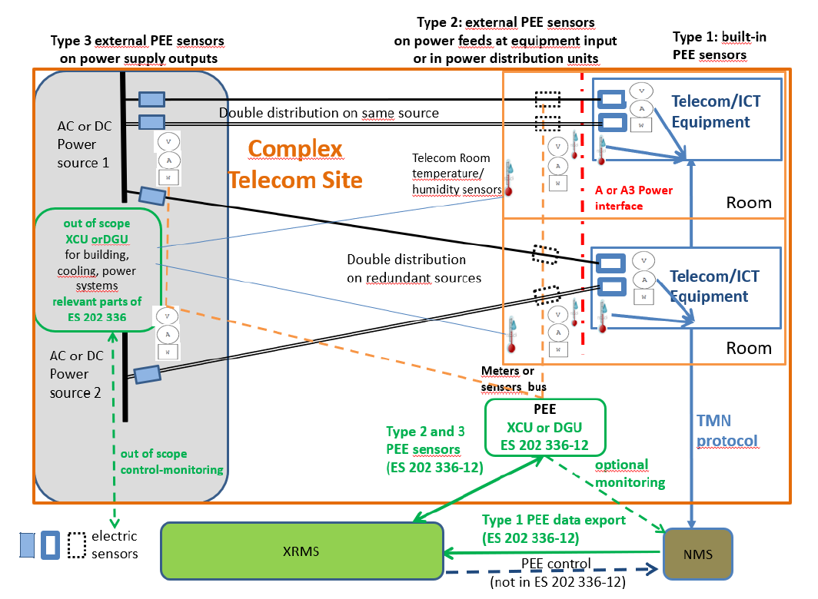
Figure 5.4.2.3.x.1-1: "Figure 3: Example of cohabitation of ICT equipment internal and external power/energy/environment measurement acquisition in a site considering 3 cases of implementations (power frame measurement, input junction box measurements, built-in measurements)”, reproduced from clause 4.4.1 of ETSI ES 202 336-12 [L]
This potential solution identifies the issues and enhancements to support measure and report the energy consumption of a Network Element at a per energy supply granularity utilizing the measurements defined in ETSI ES 202 336-12 [L].

5.4.2.3.x.2 Description
As described in clause 5.4.2.3.x.1, the energy consumption cannot be measured at ManagedFunction granularity.
EnergyInfoGroup IOC (defined in TS 28.310 [3]) is used to associate multiple energy supplies that are used to power the Managed Elements (representing the Network Elements). The power, energy and environmental (PEE) parameters should be associated with EnergyInfoGroup IOC to enable to associate the monitored data as defined in ETSI ES 202 336-12 [L].
The association of PeeParameters with ManagedFunction IOC is incorrect as the power, energy and environmental (PEE) parameters as described in ETSI ES 202 336-12 [L] do not relate to managed functions.
As described in clause 5.4.2.3.x.1 and ETSI ES 202 336-12 [L], the energy measurements are provided in monitored data at individual power interfaces when multiple PEE sensors are used to measure the energy consumption for different sources, that is utilized by this potential solution.
PNF Energy consumption measurement (defined in clause 5.1.1.19.3 of TS 28.552 [10]) can be enhanced to include filters per energy supply, such that the measurement can be used to measure
1) Total PNF Energy consumption
2) PNF Energy consumption from each energy supply.
The PNF Energy consumption measurement can be enhanced as below:
a) This measurement provides the energy consumed. The measurement is optionally split into subcounter per associated energy supplies.
b) SI.
c) This measurement is obtained according to the method defined in ETSI ES 202 336-12 [L] – clauses 4.4.3.1, 4.4.3.4, Annex A.
NOTE: The measurement is obtained at energy supply granularity when supported using PEE monitoring for each power input lines is as described in clause 4.3.2 of ETSI ES 202 336-12 [L].
d) A real value in kilowatt-hours (kWh).
e) The measurement name has the form PEE.Energy, or optionally PEE.Energy.EnergySupply where EnergySupply refers to the energy supply used to power the Network Element.
f) ManagedElement
g) Valid for packet switching.
h) 5GS.
These proposed enhancements enable the 3GPP management system to support the measurements and report the energy consumption of a Network Element at a per energy supply granularity.

* * * Next Change * * * *

5.4.2.4 Evaluation of potential solutions
The potential solution #<x> Enhancements to EnergyInfoGroup and Energy consumption measurement (described in clause 5.4.2.3.x), describes the enhancements to ManagedFunction IOC (defined in TS 28.622 [M]), EnergyInfoGroup IOC (defined in TS 28.310 [3]) and PNF Energy consumption measurement (defined in clause 5.1.1.19.3 of TS 28.552 [10]).
The potential solution #<x> fulfils the requirement PREQ-Energy_Consumption-1. This is a feasible candidate as input to the normative phase.

* * * Next Change * * * *

6.4.A Use case #2: Support EC measurement of NE at per Energy Supply granularity
The use case, requirements (PREQ-Energy_Consumption-1) and potential solutions to support EC measurement of NE at per Energy Supply granularity are described in clause 5.4.2. The evaluation and feasibility of the potential solution is described in clause 5.4.2.4. It is proposed to enhance ManagedFunction IOC (defined in TS 28.622 [M]), EnergyInfoGroup IOC (defined in TS 28.310 [3]) and PNF Energy consumption measurement (defined in clause 5.1.1.19.3 of TS 28.552 [10]) in the normative phase.

* * * End of Changes * * * *

