3GPP TSG-SA5 Meeting #165 S5-260687
Goa, India, 9-13 February 2026

Source: Huawei, Orange, ZTE
Title: Pseudo-CR on TR 32.801-01 New use case on network issue handling management
Document for: Approval
Agenda item: 6.20.6
Spec: 3GPP TR 32.801-01
Version: 0.0.0
Work Item: FS_6G_OAM

Comments
The contribution proposes to add use case for network issue handling management, addressing performance issues (e.g., weak coverage, interference) and faults (e.g., hardware failures) to ensure service continuity. It enables operators to detect anomalies, diagnose root causes, and trigger self-healing actions, improving operational efficiency through intelligent automation.
Proposed Changes
* * * First Change * * * *

6 6G Management Scenarios

6.x Management scenarios#1: Network issues handling

6.x.1 Description
Network issues, including network performance and fault management are the critical concern for operators. These issues may affect the normal operation of the network and the quality of service. The operators need to ensure that network issues can be automatically identified, and network services can recover automatically, enabling operators' real-time intelligent diagnosis, predictive analytics, and autonomous recovery, ensuring seamless network operations and superior Quality of Service (QoS).
This use case considers intelligent network diagnosis and self-recovery to restore operators 6G service, leveraging machine learning, data analytics, and autonomous agent to realize closed-loop automation across two key scenarios:
1) Intelligent Network performance issues diagnostic analysis, prediction and recovery
- Autonomous diagnosis and mitigation of performance issues upon the specific network issues identified and requested by the Operator; The network issues can be weak coverage, overlapping coverage, high interference, low uplink/downlink traffic rate, high network load, voice quality problems (low access rate, high call drop rate, low handover success rate, high packet loss rate), etc. Predictive analytics identify potential degradations before they impact users, enabling self-recovery to dynamically adjust parameters (e.g., beamforming, power allocation, or load balancing). For example, use autonomous agent enables fault diagnosis.
2) Intelligent Fault diagnostic analysis, prediction and recovery
- Autonomous root cause analysis and automated remediation for faults identified and requested by the Operator; The Fault can be radio unit failures, wireless link disruptions, or core network anomalies, ensuring uninterrupted essential services (e.g., data/voice connectivity).
Following Figure 6.x.1-1 illustrates the end to end service flows:
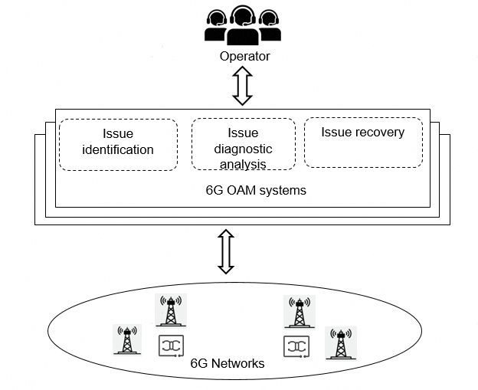
Figure 6.x.1-1: Network issue handling management
- The 6G OAM systems detects anomalies (e.g., KPI degradation: high interference, poor coverage), then report the anomalies to Operator.
- Operator reviews the anomalies report and performs issues identification, then requests issue diagnostics and recovery to 6G OAM systems
- The 6G OAM systems perform issue diagnostic analysis and recovery and report the issue diagnostic analysis and recovery result to Operator. For example, Issue ID, Root Cause: Weak Coverage: Building shadowing (RSRP <-115dBm), Overlapping Coverage: 3 cells with PCI mod3 conflict, Actions: Adjusted down tilt (Cells 12/15), Optimized PCI (Cells 8/9/11 → new PCI 42/45/48).
- The monitoring of progress or status for the network issue diagnostic and recovery by the Operator to make sure whether the PMs and KPIs of the network are satisfying or not.

6.x.2 Potential Requirements
[PR.6.x.2-1] The 6G OAM system should be able to support intelligent network issues identification and prediction including Network performance issues and fault issues.
[PR.6.x.2-2] The 6G OAM system should be able to support mechanisms for operator to provide the on-demand diagnotic and recovery from network issues.
[PR.6.x.2-3] The 6G OAM system should be able to monitor the progress or status for the network issue diagnostic and provide the network issue diagnostic and recovery result report for the operator.
* * * End of Changes * * * *

