3GPP TSG SA5 Meeting #165 S5-260685
Goa, India, 9-13 February 2026

Source: Huawei, Orange, ZTE
Title: Rel-20 pCR TR 32.801-01 New use case on RAN energy saving and energy efficiency optimization
Document for: Approval
Agenda item: 6.20.6
Spec: 3GPP TR 32.801-01
Version: V0.0.0
Work Item: FS_6G_OAM

Comments
This contribution proposes a new use case for 6G OAM on RAN energy saving and energy efficiency optimization for 6G network.

Proposed Changes
* * * First Change * * * *

6 6G Management Scenarios

6.1 New 6G management scenarios

6.1.x Management Scenario for Energy Saving and Energy Efficiency

6.1.x.1 Management Scenario #<x>: RAN energy saving

6.1.x.1.1 Description
Energy saving and efficiency is a key focus for 6G, as networks are expected to support exponentially higher data rates and device densities. For 6G network evolution, the network energy efficiency optimization still plays an important role in operator network management. Operators are aiming at decreasing power consumption in 6G networks to lower their operational expense with energy saving management solutions.
One typical scenario of energy saving is to switch off capacity boosters when the traffic demand is low, and re-activated them on a need basis. In 6G context, the scenarios will become more complex considering the interworking among multiple RAT.

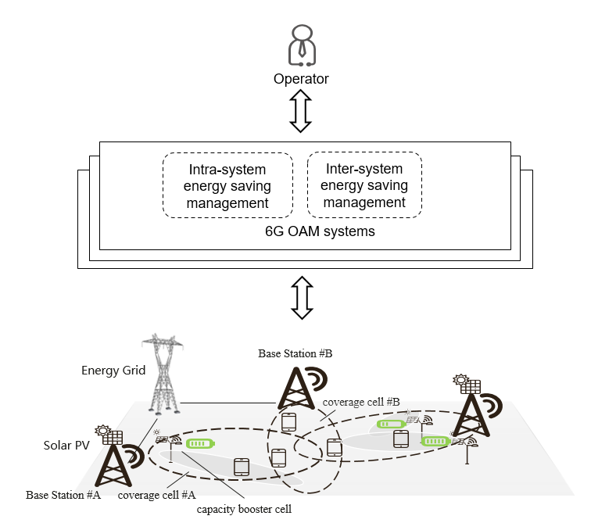
Figure 6.1.x.1.1-1: Example of 6G RAN energy saving
Figure 6.1.x.1.1-1 shows that a 6G RAN capacity booster cell is overlaid by coverage cell(s) which can be in the same RAT or different RAT. There may be two typical cases of energy saving:
- Intra-System energy saving
- Inter-System energy saving

6G OAM system collects the traffic load performance measurements from the 6G RAN capacity booster cell and coverage cells, and may request the capacity booster cell to enter the energy saving mode when its traffic is below certain threshold. The capacity booster cell can be re-activated when additional capacity is needed.
For the third case, 6G OAM system collects the traffic load performance measurements from both Base station #A and #B and may configure a policy to indicate the traffic load transfer from Base Station #B to Base Station #A when Base Station #A traffic is below certain threshold to reduce the carbon emission caused by Base Station #B.

6.1.x.1.2 Potential Requirements
[REQ-6G-ES-01] The 6G OAM system should have the management capability for energy saving in Intra-system and Inter-system scenarios.

NOTE: A pre-condition for PR 6.1.x.1.2-1 is the Intra-system energy saving and Inter-system energy saving are supported by RAN in 6G.

[REQ-6G-ES-02] The 6G OAM system should have the management capability allowing its authorized consumer to configure neighbour cell relations, configure energy saving policies to enable or disable a 6G RAN capacity booster cell to enter energy saving mode.
[REQ-6G-ES-03] The 6G OAM system should have the management capability notifying an authorized consumer when the energy saving mode of a 6G RAN capacity booster cell is activated or deactivated.

6.1.x.2 Management Scenario #<x>: Carbon emission control to reduce carbon emission

6.1.x.2.1 Description
Besides the energy saving management, the attention on reduction of carbon emission is raised in the communication industry for 6G. The operators can power base stations using energy supplies where energy is produced using renewable or non-renewable energy sources, and with varying carbon emission factors. There is the scenario where 6G base stations powered by solar PV and/or Energy Grid both exist and their coverage area may overlap as shown in Figure 6.1.x.2.1-1. The Base Station #A to which the coverage cell #A belongs uses energy having less carbon footprint which is generated by its attached solar PV, while its neighbour, Base Station #B to which the coverage cell #B, uses the traditional powering method – Energy Grid, which may use fossil energy and emits more carbon dioxide.
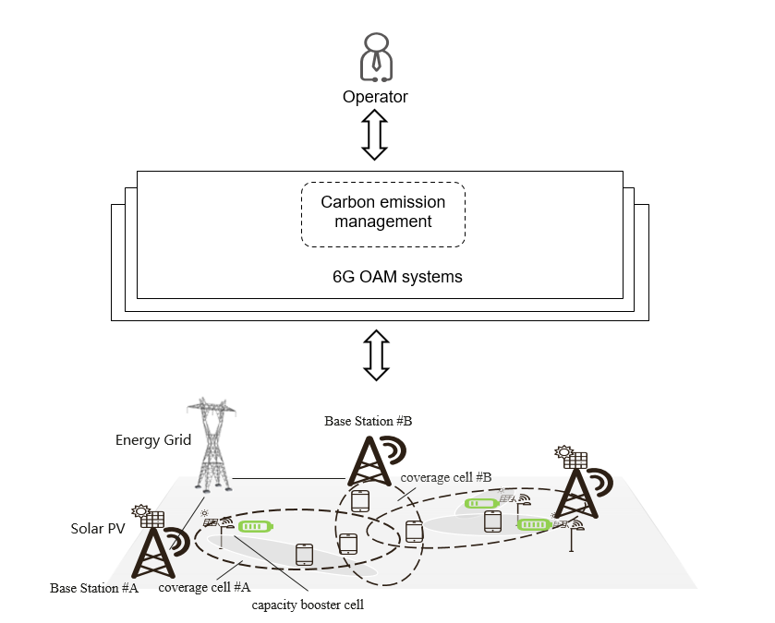
Figure 6.1.x.2.1-1: Example of 6G RAN Carbon emission control to reduce carbon emission
Figure 6.1.x.2.1-1 shows that a 6G RAN capacity booster cell is overlaid by coverage cell(s) which is either powered by energy supplies Grid or locally generated etc. The typical cases of energy efficiency optimization is:
- Carbon emission control to reduce carbon emission
6G OAM system collects the traffic load performance measurements from both Base station #A and #B and may configure a policy to indicate the traffic load transfer from Base Station #B to Base Station #A when Base Station #A traffic is below certain threshold to reduce the carbon emission caused by Base Station #B.

6.1.x.2.2 Potential Requirements
[REQ-6G-EECARBON-01] The 6G OAM system should have the management capability to optimize carbon emission in 6G network

* * * End of Changes * * * *

