3GPP TSG SA5 Meeting #165 S5-260683
Goa, India, 9-13 February 2026

Source: Huawei, China Mobile, Orange, ZTE
Title: Pseudo-CR on TR 32.801-01 Add use case on individual mobile service delivery and assurance for specific events
Document for: Approval
Agenda item: 6.20.6
Spec: 3GPP TR 32.801-01
Version: 0.0.0
Work Item: FS_6G_OAM

Comments
The contribution proposes a use case of individual mobile service delivery and assurance for specific events (e.g. music festival), which reveals critical gaps in current network operations. 6G OAM system needs to provide multiple management capabilities (e.g. network pre-evaluation, network resource adjustment, network performance monitoring and network performance optimization) and coordinate all the management capabilities to deliver individual mobile services on time and ensure the user experience for the users participating the specific events.

Proposed Changes
* * * First Change * * * *

6 6G Management Scenarios

6.1 Management Scenario#1: Mobile service delivery and assurance for specific events

6.X.1 Description
This management scenario focus on the scenarios for 6G OAM systems supporting mobile service delivery and assurance for specific events. Following uses the Large-scale music festival scenario as an example, in which an opening ceremony and subsequent live performances are supported across multiple geographically distributed venues. During the opening ceremony, AIGC-based virtual hosts and dynamically generated virtual scenes are presented and enable real-time interaction with audiences, which require the mobile network to provide high requirements for latency on both uplink and downlink transmissions. During the performance period, multiple fixed and mobile video capture devices are deployed to support live streaming, which requires the mobile network to provide high requirements on both latency and bandwidth for uplink transmission under mobility conditions. It is important for the 6G OAM systems to provide and coordinate multiple management capabilities (e.g. network pre-evaluation, network resource adjustment, network performance monitoring and network performance optimization) by utilizing automation and intelligent mechanisms to support mobile service delivery and assurance. The mobile services in this scenario are 3GPP services, examples of 3GPP services can be eMBB services and URLLC service and other 6G new services investigated in TR 22.870.
Following illustrates the end to end service flows (including pre-event evaluation and planning phase, event assurance phase and post-event evaluation phase) for the mobile service delivery and assurance for specific events.

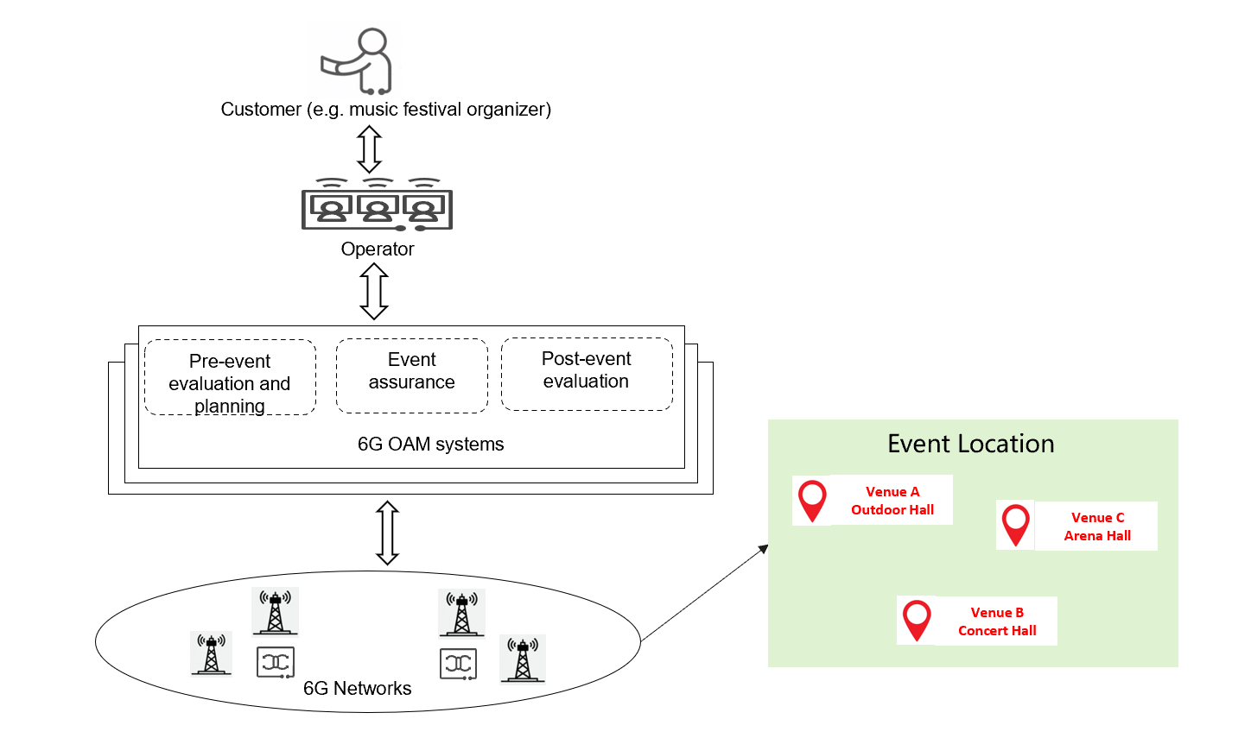
Editor’s Note: For the interaction between customer and operator in the context of mobile service delivering and assurance, the boundary and collaboration between 3GPP and TM Forum need further investigation.
Pre-event evaluation and planning phase:
1. The music festival organizer expresses the mobile service deliver and assurance requirements to the operator, which includes the overall event plan (e.g. event times, venue names) and corresponding service requirements (e.g. service type, service targets) to the operator to offer corresponding mobile service packages.
2. The operator express the requirements to corresponding 6G OAM systems to generate a detailed management plan to support the mobile service delivery and assurance and pre-evaluate of mobile network capacity for specific services(e.g. live streaming service). Iteratively negotiations may happen between operator and 6G OAM systems to finalize the management plan to support mobile service delivery and assurance. Regarding the event covering multiple areas in which mobile network managed by different 6G OAM systems, operator needs to send the request to different 6G OAM systems.
3. The 6G OAM systems predicts the traffic load and network performance, evaluates the mobile network capacity and performs evaluation for multiple network performance optimization tasks (e.g. load balance optimization among different cells, energy saving optimization) for the specified areas to release more network resources for the requested mobile services. If the existing mobile network cannot provide enough resources, 6G OAM systems may recommend operator to provide the mobile communication equipment (e.g. emergency communication vehicles, mobile wireless access base stations) for specific areas to expand mobile network capacity for the requested mobile services.
4. Operator confirms the detailed management plan to support mobile service delivery and assurance (e.g., network optimization activities, mobile communication equipment’s deployment) and execute the user subscription policy based on the mobile network capacity evaluation result. The management plan will be evaluated and tested until it works smoothly before the event.
Event assurance phase
5. The operator express the requirements to the 6G OAM systems to monitor and assure the network and service performance for the specific areas and UE groups covered by the specific event.
6. 6G OAM systems collects the network and service performance metrics from the 6G network, analyzing the network and service performance to identify performance issues (e.g. Poor-performing cell, low UL/RL UE throughput) and predict the performance deterioration risk for corresponding areas and UE groups. Multiple network optimization and adjustment actions need to be taken in a collaborative way to resolve the identified issues and predicted risks to minimize the impact on user experience. 6G OAM systems also needs to provide the proactive fault intervention and recovery to avoid the service outage. 6G OAM systems may interact with operator to finalize the network optimization and fault recovery actions.
7. The 6G OAM systems also provides network and service performance metrics for operator for the specific areas and UE groups to monitor the network and service.
Post-event evaluation phase
8. After completion of the event, operator request the 6G OAM systems to provide the post-event analysis and evaluation report.
9. 6G OAM systems performs post-event evaluation by analyzing corresponding network and service performance for specific areas or UE groups and generate the evaluation report for the operator. The evaluation report also includes the presentation of dynamic network resource adjustments and the fulfillment result, thereby providing evidence of the effectiveness of automated and intelligent service assurance capabilities of 6G OAM systems. The post-evaluation results can be used as input for the 6G OAM systems to learn and refine the pre-event evaluation and event assurance for other events in the future.
10. Based on the post-event evaluation report from the 6G OAM systems, operator generate the fulfilment report (include the service delivery and assurance successful ratio) for the mobile service delivery and assurance for specific events to the music festival organizer.

6.X.2 Potential Requirements
[PR.6.x.2-1] The 6G OAM systems should be able to generate a detailed mobile network management plan to support delivery and assurance for specific events.
[PR.6.x.2-2] The 6G OAM systems should be able to predicts the traffic load and network performance for different areas.
[PR.6.x.2-3] The 6G OAM systems should be able to evaluates the mobile network capacity for specific service type.
[PR.6.x.2-4] The 6G OAM systems should be able to perform and coordinate multiple network performance optimization tasks to generate a detailed management plan to support mobile service delivery and assurance for specific events.
[PR.6.x.2-5] The 6G OAM systems should be able to recommend the operator to provide the mobile communication equipment (e.g. mobile wireless access base stations) for specific areas to expand mobile network capacity for specific events.
[PR.6.x.2-6] The 6G OAM systems should be able to monitor network and service performance for the specific areas and UE groups.
[PR.6.x.2-7] The 6G OAM systems should be able to assure the network and service performance for specific event.
[PR.6.x.2-8] The 6G OAM systems should be able to identify performance issues (e.g. Poor-performing cell, low UL/RL UE throughput) and predict the performance deterioration risk for corresponding areas and UE groups.
[PR.6.x.2-9] The 6G OAM systems should be able to perform post-event evaluation by analysing corresponding network and service performance for specific areas or UE groups and generate the evaluation report for the operator.
[PR.6.x.2-10] The 6G OAM systems should be able to provide and coordinate multiple management capabilities (e.g. network pre-evaluation, network resource adjustment, network performance monitoring and network performance optimization) by utilizing automation and intelligent mechanisms to support mobile service delivery and assurance for specific event in different phases (including Pre-event evaluation and planning phase, Event assurance phase and Post-event evaluation phase).

* * * End of Changes * * * *

