3GPP TSG-SA5 Meeting #165 S5-260682
Goa, India 09 – 15 February 2026 revision of S5-260088

Source: Nokia
Title: Pseudo-CR on 6G principles on Network functions and management functions
Document for: Approval
Agenda item: 6.20.6
Spec: 3GPP TR32.801
Version: 0.0.0
Work Item: Study on 6G Management and Orchestration (FS_6G_OAM)

Comments
Similar to 5G, some 6G management capabilities are needed to be supported by RAN and core network entities. This pCR is to add an architectural principle emphasizing that RAN and Core Network entities can embed management service producers that are implemented to produce management services

Proposed Changes
* * * First Change * * * *

7 6G Management Features

7.X Management Architecture

7.X.K RAN and Core Network entities can embed management functions
Similar to 5G, some 6G management capabilities are needed to be supported on RAN and core network entities. For example, as illustrated in Figure 5.X.K-1, a core network NF can embed a functionality actings as a producer of management service(s) for
- Provisioning which enables an MnS consumer to configure the NF,
- Data Collection enabling an MnS consumer to instantiate data collection on the NF, i.e. for the NF to collect different kinds of data e.g. PM data, inventory data, alarm information etc.
- ML Training enabling an MnS consumer to instantiate and manage ML training Jobs.
In the 6G management framework, RAN and Core Network entities can embed management functions implemented to produce management services specified in 3GPP SA5 specifications.
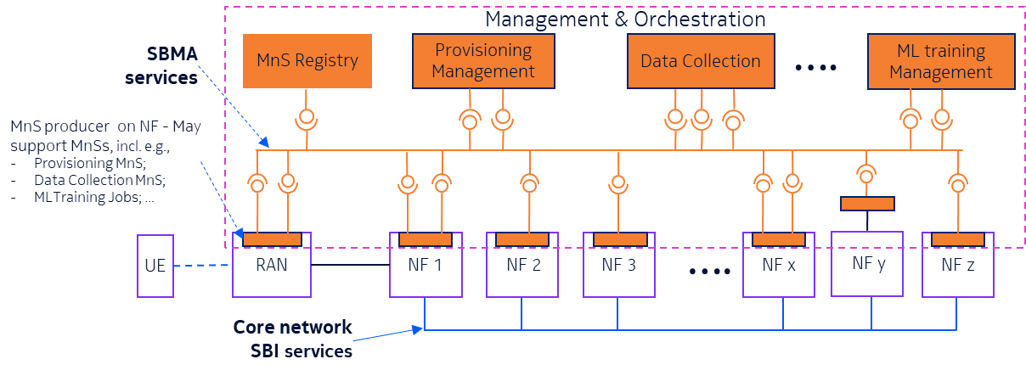
Figure 7.K-1: Management functions can be deployed as separate from or as embedded in RAN nodes or Core Network Functions - any management service can be implemented in the same network element as any Network Function. Some network functions may only consume MnSs(e.g. NF2), others may only produce MnS (e.g. NF3) while others may concurrently consume and producer MnSs (e.g. NF1). Some network functions (e.g. NF y) may also rely on another function for access to management capabilities

* * * End of Changes * * * *

