3GPP TSG-SA5 Meeting #165 S5-260681
Goa, India 09 – 15 February 2026 revision of S5-260087

Source: Nokia
Title: Pseudo-CR on 6G principles on end-to-end Automation
Document for: Approval
Agenda item: 6.20.6
Spec: 3GPP TR32.801
Version: 0.0.0
Work Item: Study on 6G Management and Orchestration (FS_6G_OAM)

Comments
Similar to 5G, some 6G management capabilities are needed to be supported by RAN and core network entities. This pCR is to add an architectural principle emphasizing that RAN and Core Network entities are management service producers that are can be implemented to produce management services

Proposed Changes
* * * First Change * * * *

6 6G Management Features

7.X Management Architecture

6.X.K End-to-end Automation
In 5G, several automation capabilities have been specified. Although related, no implicit relationships have been are inherent in the specifications. In 6G, these capabilities and their potential relationships should be described more clearly. Based on what has been specified and illustrated by Figure 5.K-1, the automation enablers are related in a way that they may consume each other's services to realize their outcomes. These automation capabilities and their potential relationship should be reused in 6G as illustrated and described below.
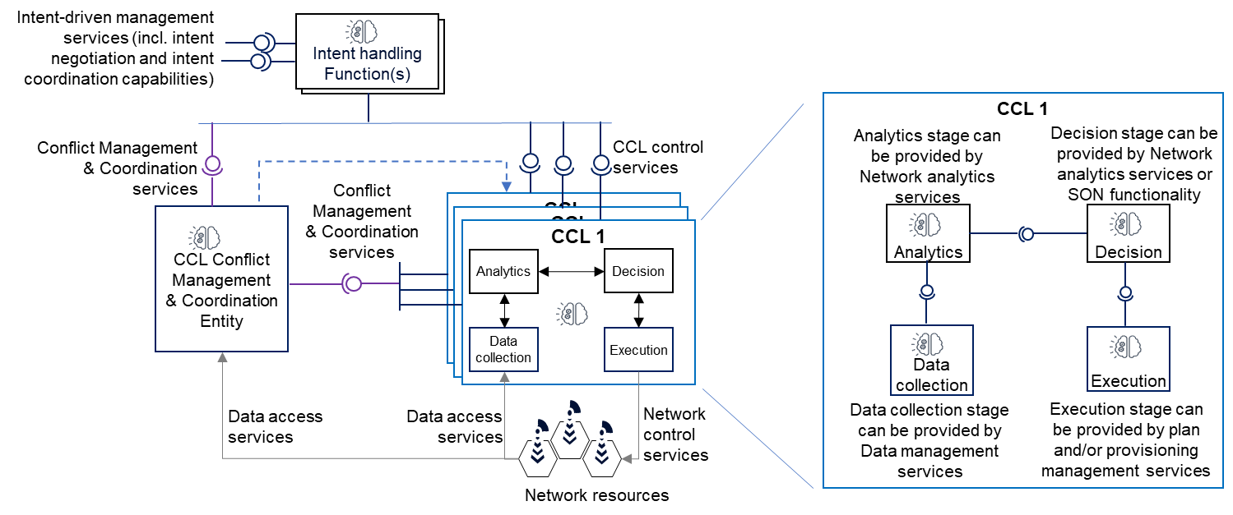
Figure 7.X.K-1: 6G automation builds on 5G management foundations (like fault management) and inherits (and enhances) the 5G automation enablers and their relationships.

NOTE 1: Any of the Entities (Intent handling functions, CCL stages or the coordination entities) may apply AI/ML inference capabilities, e.g. by the analytics functionality to get analytics inferences or by the coordination entity to derive the relationship between executed actions and impact on network.
NONTE 2: Any of the Entities (Intent handling functions, CCL stages or the coordination entities) may apply NDT capabilities, e.g. by the analytics functionality to simulate on the NDT the effects of certain events on to the network or for CCL decision stage to simulate on the NDT the likely impact of potential actions before executing those actions.
In the 6G management framework, automation enablers should support relations with automation enablers as consumers of services from other automation enablers, layered so that (from bottom to top):
- Auto-1: Network functions and resources provide foundations for management that include data definitions, data access services, provisioning management services and plan management services.
- Auto-2: Network functions and non-network data management functions produce data management services that enable the data service consumers to instantiate jobs for collection, processing or storage of data at the network functions and resources. Data management functions consume data access services of enabler E1.
- Auto-3: Network functions and non-network AIML functionalities produce AIML management services that enable service consumers to manage and use AIML functionality, e.g., to trigger training of models needed for inference or to specific inference characteristics. AIML functionalities consume data access services of enabler E1 and may be used or integrated into any of the automation functionalities.
- Auto-4: Network digital Twins (NDTs) produce digital twinning services that enable the NDT service consumers to instantiate jobs for modelling, simulating/emulating and evaluating events and configurations in/on the network functions and resources. Network digital Twins consume services of the lower layers, specifically data access and data management
- Auto-5: Analytics functions produce analytics services that enable the analytics service consumers to obtain analytics on specific use cases related to the network. Analytics functions consume services of the lower layers, specifically data management services, digital twinning services
- Auto-6: Closed control loops (CCLs) including SON function produce control services that enable the service consumers to define and configure automation control scopes, characteristics and behaviors that should be executed on to the network for specific uses cases. CCLs consume services of the lower layers, specifically analytics services; provisioning- or plan management services; data management services; digital twinning services
- Auto-7: Coordination functions produce coordination services that enable consumers to coordinate control capabilities from several CCLs, SON functions and Analytics functions. Coordination functions consume control services produced by CCLs.
- Auto-8: Intent handling Functions Autonomous functionalities produce Intent-driven management services that enable service consumers to define network management requirement by stating the desired state of the system instead of stating what should be executed. Intent handling Functions consume services of the lower layers, specifically control services produced by closed control loops; analytics services; provisioning- or plan management services; data management services; and digital twinning services

* * * End of Changes * * * *

