3GPP TSG-SA5 Meeting #165 S5-260663

Goa, India, 09 – 13 February 2026 Revision of S5-260433

Source: Ericsson
Title: Pseudo-CR TR 28.882 Add solution to two-sided ML model training use case
Document for: Approval
Agenda item: 6.20.2
Spec: 3GPP TR 28.882
Version: 0.2.0
Work Item: FS_AIML_MGT_Ph3

Comments
This pCR proposes a solution for two-sided ML model training use case reported in clause 5.1.1.4.1

Proposed Changes
* * * First change * * * *

5.1.1.4 Management support to data collection for two-sided model training

5.1.1.4.1 Management support to CSI compression

5.1.1.4.1.1 Description
To support CSI compression defined in TR 38.843 [3], the operator can deliver relevant data for two-sided model training (see NOTE 1) to a UE-side model training entity (e.g. a server deployed by an MNO or by an OTT service provider). The UE-side model training entity uses the received data to perform UE-part model training for CSI compression.
For this use case, the following approach is considered: gNB -> OAM -> UE-side training entity (a server inside MNO or an OTT server), where the gNB is the data-collection entity for relevant data for two-sided model training.
The operator uses the 3GPP management system to control and supervise how relevant data for CSI compression is delivered to the UE-side training entity (see NOTE 2).

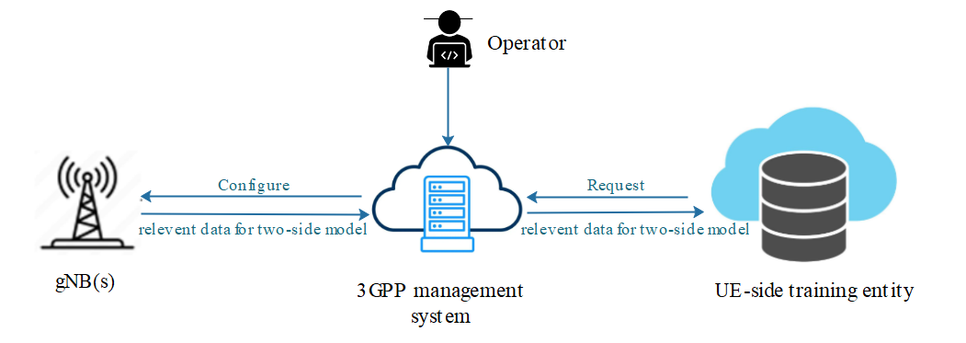
Figure 5.1.1.4.1.1-1 Illustration of data collection for two-side CSI model training
The UE-side training entity sends a subscription request (see NOTE 3) to the 3GPP management system, expressing its interest to receive the data for CSI compression. The UE-side training entity can also include some conditions related to locations (e.g., geographic area) or time (e.g., time windows) for when it expects this data. The 3GPP management system registers this request, which includes the identifier of the UE-side training entity (see NOTE 5). If the subscribed data is not available at the 3GPP management system, the 3GPP management system then decides from which gNB(s) this data needs to be collected and proceeds with their configuration. Each selected gNB (see NOTE 4) is configured with information that specifies what data this gNB needs to produce for CSI compression, and how this data when available needs to be reported to the 3GPP management system . Based on this configuration and the network status, the gNB reports the requested data to the 3GPP management system.
Upon collecting the data from the different gNBs, the management system delivers it to the UE-side training entity based on access control information specified by the operator (see NOTE 2).
NOTE 1: The relevant data for two-side model (see arrows in Figure 5.1.1.4.1.1-1) is subject to further discussion, pending ongoing correspondence and confirmation by RAN2.
NOTE 2: Access control information is for further discussion.
NOTE 3: The term ‘subscription request’ does not specifically imply adoption of a subscribe/notify mechanism in the solution. It is used to capture the requirement that the UE-side training entity can declare its interest in data delivery.
NOTE 4: The selected gNB(s) support the AI/ML feature for CSI compression use case.
NOTE 5: The information of the UE-side training entity is managed by the operator within the 3GPP management system. The 3GPP management system will use this information to select appropriate gNB(s).

5.1.1.4.1.2 Potential requirements
REQ-ML_TWOSIDE-01: The 3GPP management system should have a capability allowing a UE-side training entity to subscribe for receiving relevant data for CSI compression.
REQ-ML_TWOSIDE-02: The 3GPP management system should have a capability to configure one or more gNBs to produce and report relevant data for CSI compression.
REQ-ML_TWOSIDE-03: The 3GPP management system should have a capability to deliver relevant data to a subscribed UE-side training entity.

5.1.1.4.1.3 Possible solutions

NOTE: Since this use case will be discussed again in 6G timeframe, as per SA guidance, the proposed solution should be taken as possible in the context of 5G only.

The workflow below describes the use case as in Figure 5.1.1.4.1.1-1.

Step 1a. The UE-side training entity (external MnS consumer) sends request to the 3GPP management system (management service producer), using an IOC. This IOC represents a request to 3GPP management system to access “relevant data for two-sided ML model”. This IOC includes attributes specifying the following information:
- The data that is requested, i.e. the “relevant data for two-sided ML model”.
- Context information for the requested data, including e.g. area-based conditions (geographic area(s) where the data is expected to be collected), time-based conditions (time window(s) expressing when the collected data is expected to be delivered) or frequency-based conditions.
- Information of the NW vendor(s), e.g. identifier, name, etc. which the UE-side training entity has tested the use case before. The 3GPP management system will use this information to select appropriate gNB(s).

- Reporting control information, to report requested data to the requestor (i.e., UE-side training entity). This includes selected reporting method (e.g., file-based reporting, streaming-based reporting) and associated control parameters.
- Information for the requestor (i.e. UE-side training entity) to monitor the progress of the request fulfilment, e.g. status, percentage completion, etc, given the async nature of the request.
NOTE 1: The above list of information can be revisited.

Step 2. The 3GPP management system processes the information received in step 1, checks access rights for UE-side training entity and checks whether the requested data i.e. “relevant data for two-sided ML model” is already available at the 3GPP management system. If available, then go to step 8. Otherwise, go to step 3.
NOTE 2: Access rights are configured by the operator. Their definition is for FFS.
Step 3. The 3GPP management system processes the information received in step 1 and select one or more or more gNBs to produce data. For each gNB, the 3GPP management system performs steps 4, 5 and 6.
Step 4. The 3GPP management system (management service consumer) sends request to the gNB (management service producer), using an IOC. The IOC represents a request to gNB to produce “relevant data for two-sided ML model”. This IOC includes attributes specifying the following information:

- The data that is requested to be produced.
- Configuration parameters associated to the requested data.
NOTE: These parameters can be used by gNB on step 5.
- Reporting control information to deliver requested data to the requestor (i.e., 3GPP management system). This includes selected reporting method (e.g., file-based reporting, streaming-based reporting) and associated control parameters.
NOTE 3: The above list of information can be revisited.

Step 5. Based on information received in step 4, the gNB interacts with UEs over the air interface, configuring them to measure and log relevant and report them back to the gNB.
NOTE 4: Step 5 is outside SA5 scope.
Step 6. The gNB reports produced data to the 3GPP management system, using the reporting method that the management system had previously configured in step 4.
Step 7. Once the 3GPP management system receives data produced by all the configured gNBs, it deliver

“relevant data for two-sided ML model” using the reporting method that the management system had previously configured in step 7.
.
Whether the IOC used in step 1 and step 4 is the same is FFS.
There exists a relationship between IOC used in step 1 and step 4. The modelling of these relationship is FFS.
The role (if any) of OAM in pairing ID is FFS.

5.1.1.4.1.3.1 Possible solutions for IOC used in the management service interface between UE-side training and 3GPP management system.
Possible solutions for the IOC used in step 1 include using one of these:
- ManagementDataCollection IOC
- PerfMetricJob IOC
- TraceJob IOC
- Brand-new IOC

5.1.1.4.1.3.2 Possible solutions for IOC used in the management service interface 3GPP management system and gNB
Possible solutions for the IOC used in step 4 include using one of these:
- PerfMetricJob IOC
- TraceJob IOC
- Brand-new IOC

5.1.1.4.1.4 Possible solutions evaluation
TBD

Annex A (informative):
Change history
Change history
Date | Meeting | TDoc | CR | Rev | Cat | Subject/Comment | New version
2025-08 | SA5#162 |  |  |  |  | Initial skeleton | 0.0.0
2025-10 | SA5#163 | S5-254664  S5-254666  S5-254667  S5-254744 | pCR  pCR  pCR  pCR |  |  | pCR TR 28.882 initial ToC  Pseudo-CR on TR 28.882 add Management support to UE-Side model training use case  Pseudo-CR on TR 28.882 add Management support to NW-Side model training use case  Pseudo-CR on TR 28.882 Add New Use Case on Management of Vertical Federated Learning | 0.1.0
2025-11 | SA5#164 | S5-255505  S5-255506  S5-255515  S5-255518  S5-255519  S5-255687 | pCR  pCR  pCR  pCR  pCR  pCR |  |  | Pseudo-CR TR 28.882 Use case on ML model transfer delivery to UE  Pseudo-CR on TR 28.882 add Management support use case and requirement for two-sided model training  Pseudo-CR TR 28.882 Add Solution for Management of Vertical Federated Learning  pCR on Rel-20 TR 28.882 Adding Enhancements on LCM of Federated Learning  Pseudo-CR TR 28.882 Sustainability aspects of ML model training and inference  Rel-20 Pseudo-CR TR 28.882 Use case on enhancing Reinforcement Learning with performance targets | 0.2.0

