3GPP TSG SA5 Meeting #165 S5-260115
Goa, India, 9-13 February 2026

Source: ZTE Corporation, Qualcomm
Title: Pseudo-CR TR 28.882 Add Solution for Management Support to Data Collection for Two-sided Model Training
Document for: Approval
Agenda item: 6.20.2
Spec: 3GPP TR 28.882
Version: 0.2.0
Work Item: FS_AIML_MGT_Ph3

Comments
In SP-251707, TSG SA asks SA5 to continue 5GA study on dataset and model parameters exchange in Rel-20.
This contribution therefore proposes to add solution for data collection for two-sided model training.
Proposed Changes
* * * First Change * * * *

5.1.1.4 Management support to data collection for two-sided model training

5.1.1.4.1 Management support to CSI compression

5.1.1.4.1.1 Description
To support CSI compression defined in TR 38.843 [3], the operator can deliver relevant data for two-sided model training (see NOTE 1) to a UE-side model training entity (e.g. a server deployed by an MNO or by an OTT service provider). The UE-side model training entity uses the received data to perform UE-part model training for CSI compression.
For this use case, the following approach is considered: gNB -> OAM -> UE-side training entity (a server inside MNO or an OTT server), where the gNB is the data-collection entity for relevant data for two-sided model training.
The operator uses the 3GPP management system to control and supervise how relevant data for CSI compression is delivered to the UE-side training entity (see NOTE 2).

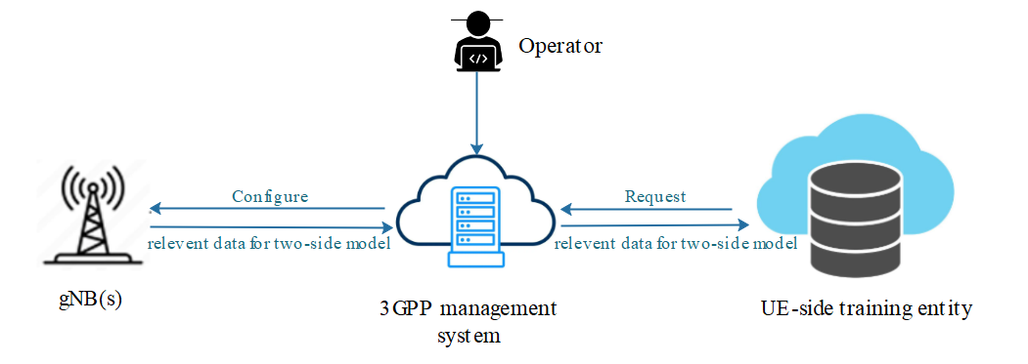
Figure 5.1.1.4.1.1-1 Illustration of data collection for two-side CSI model training
The UE-side training entity sends a subscription request (see NOTE 3) to the 3GPP management system, expressing its interest to receive the data for CSI compression to perform the UE-sided model training. The UE-side training entity can also include some conditions related to locations (e.g., geographic area) or time (e.g., time windows) for when it expects this data. The 3GPP management system registers this request, which includes the identifier of the UE-side training entity. If the subscribed data is not available at the 3GPP management system, the 3GPP management system then decides from which gNB(s) this data needs to be collected and proceeds with their configuration. Each selected gNB (see NOTE 4) is configured with information that specifies what data this gNB needs to produce for CSI compression, and how this data when available needs to be reported to the 3GPP management system (see NOTE 5). Based on this configuration and the network status, the gNB reports the requested data to the 3GPP management system.
Upon collecting the data from the different gNBs, the management system delivers it to the UE-side training entity based on access control information specified by the operator (see NOTE 2).
NOTE 1: The relevant data for two-side model/ relevant data for CSI compression (see arrows in Figure 5.1.1.4.1.1-1) is subject to further discussion, pending ongoing correspondence and confirmation by RAN2.
NOTE 2: Access control information is for further discussion.
NOTE 3: The term ‘subscription request’ does not specifically imply adoption of a subscribe/notify mechanism in the solution. It is used to capture the requirement that the UE-side training entity can declare its interest in data delivery.
NOTE 4: The selected gNB(s) support the AI/ML feature for CSI compression use case.
NOTE 5: The UE-side training entity identity is managed by the operator within the 3GPP management system, whether it needs to be included in the configuration for traceability purposes is for further discussion.

5.1.1.4.1.2 Potential requirements
REQ-ML_TWOSIDE-01: The 3GPP management system should have a capability allowing a UE-side training entity to subscribe for receiving relevant data for CSI compression.
REQ-ML_TWOSIDE-02: The 3GPP management system should have a capability to configure one or more gNBs to produce and report relevant data for CSI compression.
REQ-ML_TWOSIDE-03: The 3GPP management system should have a capability to deliver relevant data to a subscribed UE-side training entity.

* * * Next Change * * * *

5.1.1.4.1.3 Possible solutions
For this use case, the following approach is considered: gNB -> OAM -> UE-side training entity (a server inside MNO or an OTT server), where the gNB is the data-collection entity for relevant data for CSI Compression. The proposed solution below is only applicable for the case that gNB is the data-collection entity for relevant data for two-sided model training. It requires the gNB as the data collection entity to assemble the dataset and model parameter, and deliver them to the UE training entity via management system for UE-sided model training. The following figure shows the overview of proposed solution.
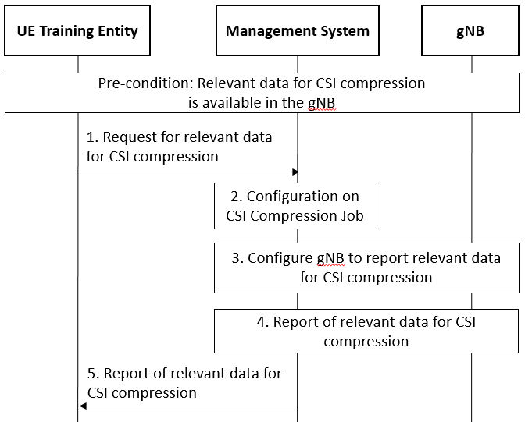
Fig. 1 Procedure for request and delivery of relevant data for CSI compression
Pre-Condition: The relevant data for CSI compression is available in the gNB. The content of the relevant data for CSI compression depends on RAN WGs
Step 1: The UE Training Entity as the Consumer requests the Management System to report relevant data for CSI Compression, which includes information of the relevant data for CSI compression and information of the UE Training Entity. The following options can be considered:
- Option 1: The UE Training Entity request to create an management data collection job instance in the management system. ManagemntDataCollection IOC defined in clause 4.3.47 in TS 28.622 can be enhanced by the following:
  - Introduce a new choice “relevant data for CSI compression” for the ManagementData attribute.
  - Add a new attribute “UETrainingEntityID”, it represents the information of the UE training entity.
NOTE x: The above list of information can be revisited.
- Option x1: The UE Training Entity request to create an management data collection job instance in the management system. PerfMetricJob IOC defined in clause 4.3.47 in TS 28.622 can be enhanced by the following:
  - Introduce a new choice “relevant data for CSI compression” for the ManagementData attribute.
  - Add a new attribute “UETrainingEntityID”, it represents the information of the UE training entity.
NOTE x: The above list of information can be revisited.
- Option x2: The UE Training Entity request to create an management data collection job instance in the management system. TraceJob IOC defined in clause 4.3.47 in TS 28.622 can be enhanced by the following:
  - Introduce a new choice “relevant data for CSI compression” for the ManagementData attribute.
  - Add a new attribute “UETrainingEntityID”, it represents the information of the UE training entity.
NOTE x: The above list of information can be revisited.
- Option 2: The UE Training Entity request to create an ML data collection job instance in the management system. It requires to introduce a new MLDataCollection IOC, which includes the following attributes:
  - dataforCSICompression, it indicates that the consumer requests to report the relevant data for CSI compression.
  - reportingCtrl, it represents the reporting method to MnS consumers (see clause 4.3.33 in TS 28.622). The consumer can specify the reporting method including file or stream.
  - UETrainingEntityID, it represents the information of the UE training entity..
NOTE x: The above list of information can be revisited.
Note 1: The selection of the options depends on the content of “relevant data for CSI compression”, which is out the scope of SA5.
Note 2: The definition of “information of the UE Training Entity” is FFS.
Step 2: The producer creates the management data collection job instance/ ML data collection job instance according to the request in step 1..
Step 3: The management system configures the gNB to report relevant data for CSI compression. Specifically, the Management System may:
- Option 1: request to create an management data collection job instance in the gNB. The attributes of the management data collection job instance are same as these in step 1 option 1 but exclude “UETrainingEntityID”.
- Option x1: request to create an management data collection job instance in the gNB. The attributes of the management data collection job instance are same as these in step 1 option x1 but exclude “UETrainingEntityID”.
- Option x2: request to create an management data collection job instance in the gNB. The attributes of the management data collection job instance are same as these in step 1 option x2 but exclude “UETrainingEntityID”.

- Option 2: request to create an ML data collection job instance in the gNB. The attributes of the management data collection job instance are same as these in step 1 option 2 but exclude “UETrainingEntityID”.
Note 3: The selection of the options depends on the content of “relevant data for CSI compression”, which is out the scope of SA5.

Step 4: gNB reports the relevant data for CSI compression to Management System according to the received request (represented by the “reportingCtrl” attribute). For delivery of relevant data for CSI compression, it can be achieved by reusing the following management capabilities:
  - Streaming data reporting service defined in clause 11.5 in TS 28.532.
  - File data reporting service defined in clause 11.6 in TS 28.532.
Step 5: Management System reports the relevant data for CSI compression to the UE Training Entity via the streaming data reporting service or file data reporting service defined in clause 11.5 and clause 11.6 in TS 28.532, respectively.
Editor's note1: How to select the target gNB by management system is FFS.
Editor's note2: How to match the ID of requested data to be transferred between gNB and OAM is FFS and requires RAN's feedback on the data ID definition.
Editor's note3: Whether and how to collect the data from UE by OAM is FFS.

