TSG SA5 Meeting #165 S5-260661d1
(was S5-260493)
Goa, India, 9 – 13 February 2026

Source: NEC
Title: pCR 28.882 clarifications to the two-sided model training use case
Document for: Approval
Agenda item: 6.20.2
Spec: 3GPP TR 28.882
Version: 0.2.0
Work Item: FS_AIML_MGT_Ph3

Decision/action requested
The group is asked to discuss and agree on the proposal.

Rational and background information
To avoid ambiguity in interpretation, SA5 should clarify the applicability and underlying assumptions of the two-sided CSI compression use case described in TR 28.882 [9]. In particular, it is useful to distinguish between different realization scenarios of two-sided CSI compression, including:
- scenarios where post-deployment, dataset-based training or refinement of a two-sided model is envisaged, potentially requiring management-supported data collection; and
- scenarios where CSI compression is realized using fully standardized reference model(s) with fixed parameters, for which post-deployment data collection for training purposes may not be required.
This document therefore proposes to add a note to clarify the above distinctions, together with minor editorial updates to the use case description, with the objective of improving clarity and ensuring consistent interpretation across working groups, while preserving flexibility for different technical realizations and deployment timelines.

References
[1] SP-250867, Study on AI/ML management phase 3
[2] SP-251650, Revised SID: Study on AI/ML management phase 3
[3] RP-253823, RAN endorsed moderator summary
[4] RP-253340, approved Revised WID Artificial Intelligence (AI)/Machine Learning (ML) for NR air interface Phase 2
[5] RP-253846, Reply LS on specification of dataset and model parameters exchange
[6] RP-253847, Reply LS on AI/ML UE sided data collection
[7] SP-251687, Reply LS on AI/ML UE sided data collection
[8] SP-251707, Reply LS on specification of dataset and model parameters exchange
[9] 3GPP TR 28.882, v0.2.0; Study on Artificial Intelligence / Machine Learning (AI/ML) management Phase 3

* * * 1st change * * * *

2 References
The following documents contain provisions which, through reference in this text, constitute provisions of the present document.
- References are either specific (identified by date of publication, edition number, version number, etc.) or non-specific.
- For a specific reference, subsequent revisions do not apply.
- For a non-specific reference, the latest version applies. In the case of a reference to a 3GPP document (including a GSM document), a non-specific reference implicitly refers to the latest version of that document in the same Release as the present document.
[1] 3GPP TR 21.905: "Vocabulary for 3GPP Specifications".
[2] 3GPP TS 38.300: "NR and NG-RAN Overall Description; Stage 2".
[3] 3GPP TR 38.843: " Study on Artificial Intelligence (AI)/Machine Learning (ML) for NR air interface ".
[4] 3GPP TS 28.105 "Management and orchestration; Artificial Intelligence / Machine Learning (AI/ML) management".
[5] RP-221348: "Study on Artificial Intelligence (AI) / Machine Learning (ML) for NR air interface (FS_NR_AIML_air)".
[6] SP-241567: "Study on AI/ML management – phase 2 (FS_AIML_MGT_Ph2) ".
[7] TR 28.858: "Study on Artificial Intelligence (AI) / Machine Learning (ML) management phase 2", v19.0.0 (2025-01).
[8] RAN1#120 meeting Chair Notes (https://www.3gpp.org/ftp/tsg_ran/wg1_rl1/tsgr1_120/inbox/chair_notes/chair%20notes%20ran1%2023120%20eom1.zip).
[9] 3GPP TS 28.310 "Management and orchestration; Energy efficiency of 5G".
[x1] RP-253340, Revised WID Artificial Intelligence (AI)/Machine Learning (ML) for NR air interface Phase 2
[x2] SP-251707, Reply LS on specification of dataset and model parameters exchange

* * * Next change * * * *

5.1.1.3.4 Possible solutions evaluation

5.1.1.4 Management support to data collection for two-sided model training

5.1.1.4.1 Management support to CSI compression

5.1.1.4.1.1 Description
To support CSI compression defined in TR 38.843 [3], the operator may support the collection and deliver of relevant data for two-sided model training (see NOTE 1) to a UE-side model training entity (e.g. a server deployed by an MNO or by an OTT service provider). The UE-side model training entity uses the received data to perform UE-part model training (i.e., training of the UE-side part of a two-sided model) for CSI compression.
For this use case, the following approach is considered: gNB -> OAM -> UE-side training entity (a server inside MNO or an OTT server), where the gNB is the data-collection entity for relevant data for two-sided model training.
The operator uses the 3GPP management system to control and supervise how relevant data for CSI compression is delivered to the UE-side training entity (see NOTE 2).

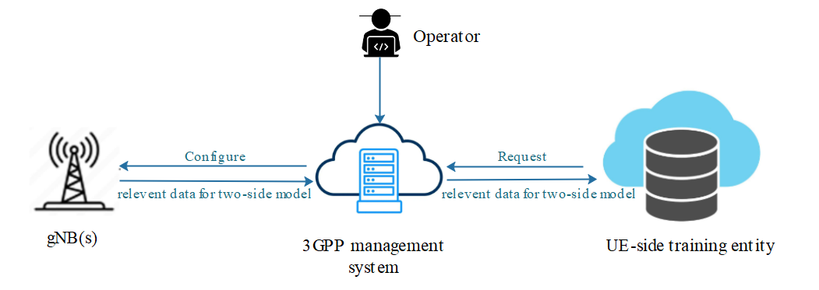
Figure 5.1.1.4.1.1-1 Illustration of data collection for two-side CSI model training
The UE-side training entity sends a subscription request (see NOTE 3) to the 3GPP management system, expressing its interest to receive the data for CSI compression. The UE-side training entity can also include some conditions related to locations (e.g., geographic area) or time (e.g., time windows) for when it expects this data. The 3GPP management system registers this request, which includes the identifier of the UE-side training entity. If the subscribed data is not available at the 3GPP management system, the 3GPP management system then decides from which gNB(s) this data needs to be collected and proceeds with their configuration. Each selected gNB (see NOTE 4) is configured with information that specifies what data this gNB needs to produce for CSI compression, and how this data when available needs to be reported to the 3GPP management system (see NOTE 5). Based on this configuration and the network status, the gNB reports the requested data to the 3GPP management system.
Upon collecting the data from the different gNBs, the management system delivers it to the UE-side training entity based on access control information specified by the operator (see NOTE 2).
The applicability of this use case depends on the CSI compression realization adopted in RAN [x1] (see NOTE 6).
NOTE 1: The relevant data for two-side model (see arrows in Figure 5.1.1.4.1.1-1) is subject to further discussion, pending ongoing correspondence and confirmation by RAN2.
NOTE 2: Access control information is for further discussion.
NOTE 3: The term ‘subscription request’ does not specifically imply adoption of a subscribe/notify mechanism in the solution. It is used to capture the requirement that the UE-side training entity can declare its interest in data delivery.
NOTE 4: The selected gNB(s) support the AI/ML feature for CSI compression use case.
NOTE 5: The UE-side training entity identity is managed by the operator within the 3GPP management system, whether it needs to be included in the configuration for traceability purposes is for further discussion.
NOTE 6: The applicability of this use case depends on how CSI compression is implemented in the RAN. If post-deployment training of a two-sided model is needed (e.g., option 4-1 in Direction A scenarios), management-supported data collection as described in this use case is relevant. If post-deployment training of a two-sided model is needed (e.g., option 3a-1 in Direction A scenarios), the need for such management-supported data collection is subject to further discussion, pending ongoing correspondence and confirmation by RAN. If CSI compression uses fully standardized models with fixed parameters (e.g., Direction C scenarios), such management-supported data collection is not required.

5.1.1.4.1.2 Potential requirements
REQ-ML_TWOSIDE-01: The 3GPP management system should have a capability allowing a UE-side training entity to subscribe for receiving relevant data for CSI compression.
REQ-ML_TWOSIDE-02: The 3GPP management system should have a capability to configure one or more gNBs to produce and report relevant data for CSI compression.
REQ-ML_TWOSIDE-03: The 3GPP management system should have a capability to deliver relevant data to a subscribed UE-side training entity.

* * * End of Changes * * * *

