TSG SA5 Meeting #165 S5-260660d1 (was S5-260492)
Goa, India, 9 – 13 February 2026

Source: NEC
Title: pCR 28.882 clarifications to management support for UE-side and NW-side model training use case
Document for: Approval
Agenda item: 6.20.2
Spec: 3GPP TR 28.882
Version: 0.2.0
Work Item: FS_AIML_MGT_Ph3

Decision/action requested
The group is asked to discuss and agree on the proposal.

Rational and background information
Recent discussions at TSG RAN [2], [3] and subsequent LSs from RAN and TSG SA [6], [7] concluded that AI/ML UE-sided data collection is postponed and will not be addressed in Rel-20. In particular, TSG SA instructed the relevant SA working groups, including SA5, to postpone further work on UE-sided data collection in the current release [7].
This document therefore proposes to add an Editor’s note in TR 28.882 to reflect this guidance and to clearly indicate that further work on UE-sided data collection, including documentation of potential solutions, is postponed in Rel-20.

References
[1] SP-250867, Study on AI/ML management phase 3
[2] SP-251650, Revised SID: Study on AI/ML management phase 3
[3] RP-253823, RAN endorsed moderator summary
[4] RP-253340, approved Revised WID Artificial Intelligence (AI)/Machine Learning (ML) for NR air interface Phase 2
[5] RP-253846, Reply LS on specification of dataset and model parameters exchange
[6] RP-253847, Reply LS on AI/ML UE sided data collection
[7] SP-251687, Reply LS on AI/ML UE sided data collection
[8] SP-251707, Reply LS on specification of dataset and model parameters exchange
[9] 3GPP TR 28.882, v0.2.0; Study on Artificial Intelligence / Machine Learning (AI/ML) management Phase 3

Proposals
* * * 1st change * * * *

2 References
The following documents contain provisions which, through reference in this text, constitute provisions of the present document.
- References are either specific (identified by date of publication, edition number, version number, etc.) or non-specific.
- For a specific reference, subsequent revisions do not apply.
- For a non-specific reference, the latest version applies. In the case of a reference to a 3GPP document (including a GSM document), a non-specific reference implicitly refers to the latest version of that document in the same Release as the present document.
[1] 3GPP TR 21.905: "Vocabulary for 3GPP Specifications".
[2] 3GPP TS 38.300: "NR and NG-RAN Overall Description; Stage 2".
[3] 3GPP TR 38.843: " Study on Artificial Intelligence (AI)/Machine Learning (ML) for NR air interface ".
[4] 3GPP TS 28.105 "Management and orchestration; Artificial Intelligence / Machine Learning (AI/ML) management".
[5] RP-221348: "Study on Artificial Intelligence (AI) / Machine Learning (ML) for NR air interface (FS_NR_AIML_air)".
[6] SP-241567: "Study on AI/ML management – phase 2 (FS_AIML_MGT_Ph2) ".
[7] TR 28.858: "Study on Artificial Intelligence (AI) / Machine Learning (ML) management phase 2", v19.0.0 (2025-01).
[8] RAN1#120 meeting Chair Notes (https://www.3gpp.org/ftp/tsg_ran/wg1_rl1/tsgr1_120/inbox/chair_notes/chair%20notes%20ran1%2023120%20eom1.zip).
[9] 3GPP TS 28.310 "Management and orchestration; Energy efficiency of 5G".
[x1] SP-251687, Reply LS on AI/ML UE sided data collection

* * * Next change * * * *

55 Management capabilities for AI/ML lifecycle

5.1 ML model training

5.1.1 Use cases

5.1.1.1 Management support for UE-side model training
Editor’s note: Further work on UE-side data collection for RAN-related use case, including documentation of potential solutions, is postponed in Rel-20 in accordance with TSG SA guidance [x1].

5.1.1.1.1 Management support to AI/ML-based beam management

5.1.1.1.1.1 Description
To support AI/ML-based beam management defined in TS 38.300 [2], for beam prediction management, UE can send the data of beam prediction management to a UE-side training entity (e.g. a server inside MNO or an OTT server) via gNB and 3GPP management system for UE-side model training (see NOTE 1). 3GPP management system needs to collect data from gNB and report it to UE-side training entity to management support of training for UE-side model.

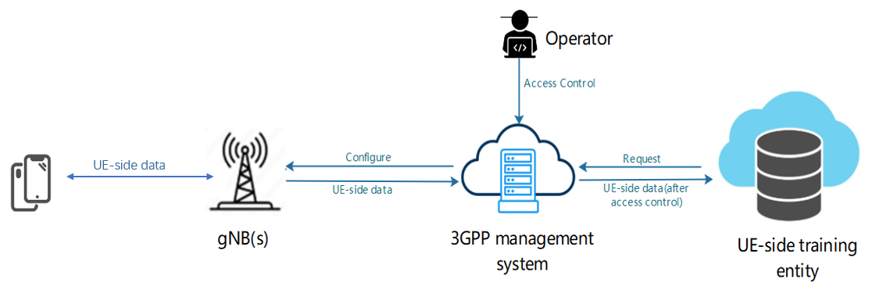
Figure 5.1.1.1.1.1-1: Management of data collection and reporting for UE-side model training
Being a MnS consumer, the UE-side training entity requests 3GPP management system to collect the UE-side data of beam prediction management, then 3GPP management system configures the gNB(s) to collect data from specified UEs, and gNB shall send configuration information to the UE(s). The request from UE-side training entity shall include the type of data (e.g. based on UE/UE Group, location, time) to be produced and the gNB(s) where the data shall be collected.
After the UE-side training data such as beam prediction data are produced, UE(s) shall report the UE-side data to gNB(s), and 3GPP management system shall collect data from the gNB(s). 3GPP management system reports the collected data to UE-side training entity depending on access information specified by operator (see NOTE 2).
NOTE 1: The UE-side data are subject to further clarification in future release, subject to progress and agreement in RAN2 and RAN1.
NOTE 2: Access control information is for further discussion.

5.1.1.1.1.2 Potential requirements
REQ-ML_UESIDE-01: The 3GPP management system should have a capability allowing the authorized UE-side training entity to request the UE-side training data for the UE-side model training.
REQ-ML_UESIDE-02: The 3GPP management system should have a capability to request and get the UE-side training data from gNB(s) for the UE-side model training.
REQ-ML_UESIDE-03: The 3GPP management system should have a capability to report the UE-side data to authorized UE-side training entity for UE-side model training.

5.1.1.1.1.3 Possible solutions
Editor’s note: Possible solutions, addressing the requirements for this use case, are for further discussion in future release(s)

* * * Next change * * * *

5.1.1.2 Management support to OAM-centric training for NG-RAN NW-side model

5.1.1.2.1 Management support to AI/ML-based beam management

5.1.1.2.1.1 Description
To support AI/ML-based beam management defined in TS 38.300 [2], UE can provide data of beam management to 3GPP management system via gNB (see NOTE 1). 3GPP management system needs to collect data from gNB for OAM-centric training for NG-RAN NW-side model.
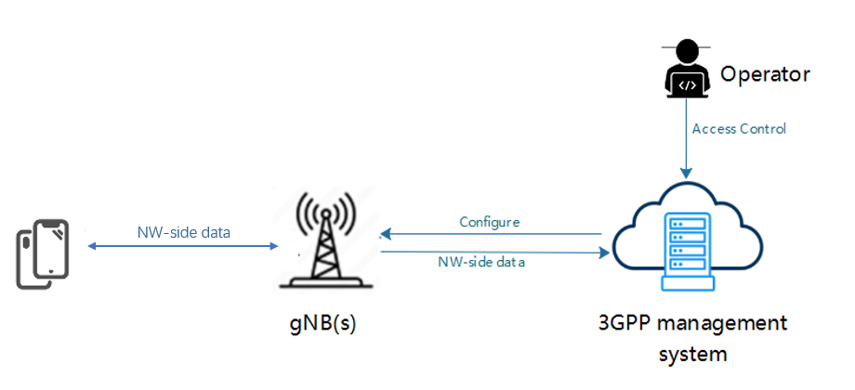
Figure 5.1.1.2.1.1-1: Management of NW-side data collection and reporting for NW-side model training
The 3GPP management system request gNB(s) to collect the NW-side training data of beam management and provides the configuration to gNB(s), then gNB(s) shall send configuration information to the UE(s) for NW-side training data collection. After the NW-side training data are produced, UE(s) shall report the NW-side training data to gNB(s), and 3GPP management system shall collect data from the gNB(s). Collection of data by the 3GPP management system should depend on access control information specified by operator (see NOTE 2).
NOTE 1: The OAM centric NW-side training data are subject to further discussion, pending ongoing correspondence and confirmation by RAN2.
NOTE 2: Access control information is for further discussion.
Editor’s notes: The need for user consent is subject to ongoing correspondence and confirmation by SA3 and RAN2.

5.1.1.2.1.2 Potential requirements
REQ-ML_NWSIDE-01: The 3GPP management system should have a capability to configure the NW-side training data collection for OAM-centric NW-side model training.
REQ-ML_NWSIDE-02: The 3GPP management system should have a capability to obtain the NW-side training data for OAM-centric NW-side model training.

5.1.1.2.1.3 Possible solutions
TBD

5.1.1.2.1.4 Possible solutions evaluation
TBD

* * * End of Changes * * * *

