3GPP TSG-SA5 Meeting #163 S5-260658
Goar, India, 9 - 13 February 2026

Source: Ericsson Canada Inc.
Title: pCR TR 28.892 Add evaluation and recommendation for UC#4 Intent traceability
Document for: Approval
Agenda item: 6.20.1
Spec: TR 28.881
Version: 1.0.0
Work Item: FS_IDMS_MN_Ph4

Comments
This document proposes addition of evaluation and recommendation to TR 28.881 for UC#4 Intent traceability.

Proposed Changes
* * * First Change * * * *

4.4 Use case #4: Intent traceability

4.4.1 Description
An intent consumer (owner) submits an intent to a single intent handling function. In some cases, in order to fulfil the intent an intent handling function may need to submit additional intent(s) to other intent handling functions. Such handling can occur multiple times across intent handling functions across multiple management and/or domain layers.
An operator/administrator needs visibility of the relationships between intents which have been created by the system. Since these are being created within/by the management systems (and not explicit consumers the operator may implement) it’s important to know where they came from to allow ‘trace-back’ to the original consumer intent which started the cascade of subsequent intents. There is however no identified method, standardized or otherwise, which allows for such traceability.
Since intents can result in new intent(s) to multiple intent handling functions, likely with different implementations, it is insufficient to rely on external mechanisms such as logging or local network management audit tools to trace the intent. The information identifying each intent handling function which has handled the intent must be preserved along with the intent itself and accessible/meaningful within the content of each intent handling function. The intent consumer (owner) (e.g. Consumer A in figure 4.4.1-1) should be enabled to indicate whether they agree that their information be propagated beyond the recipient intent producer (e.g. Producer 1 in figure 4.1.1-1) to other intent producers (e.g. Producer 2 or 3 in figure 4.4.1-1).
The following figure provides an overview of such information and its handling:

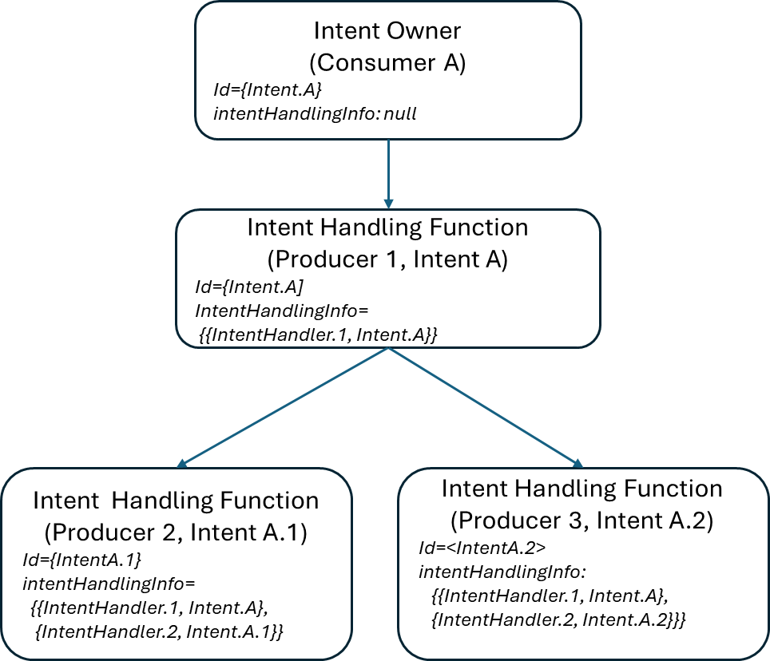
Figure 4.4.1-1: Intent traceability information handling

4.4.2 Potential requirements
REQ-Intent_Trace-1: The intent driven MnS producer should provide information in the intent to identify that an intent has been handled by a particular intent handling function.
REQ-Intent_Trace-2: The intent driven MnS producer should provide information (as defined in REQ-Intent_Trace-1) to identify any subsequent intents created by it as part of fulfilment.
REQ-Intent_Trace-3: The intent driven MnS producer should provide information (as defined in REQ-Intent_Trace-1) identifying the intent handling functions to subsequent intent(s) to allow traceability of the intent across multiple intent handling functions.
REQ-Intent_Trace-4: The intent driven MnS producer should provide a capability allowing the intent MnS consumer (owner) to indicate whether the MnS consumer agrees that their information can be propagated in case of intent decomposition beyond the recipient intent producer to other intent producers.

4.4.3 Potential solutions

4.4.3.1 Potential solution #1
To address REQ-Intent_Trace-1, REQ-Intent_Trace-2 and REQ-Intent_Trace-3 this solution proposes adding a new data structure to the intent model definition to define the information to trace the decomposition of an intent into subsequent intents. The information is updated and propagated as new intent(s) are created as part of fulfilment.
The content proposed for the intent model definition would include
- the identity of each intent handling function which decomposed the intent
- the identity of each intent resulting from the decomposition
The handling of the information would be:
- a new intent created by an MnS Consumer is not required to populate this value, i.e. default is empty string.
- upon receipt of an intent, the Intent Handling Function updates the information to indicate it handled the intent by adding its identity to the incoming intent
- in the event the Intent Handling Function determines intent decomposition is required it create new intent(s) and propagates the information from the source intent to the new intent(s)
The visibility of this information is subject to the same access control as any other information exchanged between an authorised MnS consumer and producer. For example, the originating Intent Owner Consumer A in Figure 4.4.1-1 will have access/visibility to its intents, including Intent A at Producer 1. Producer 1 is an authorised MnS consumer of and will have access/visibility of its intents at Producer 2 and Producer 3, including Intent A.1 and A.2 resulting from the decomposition of Intent A. When no further decomposition is required, no further update is made to the information.

4.4.3.1 Potential solution #2
To address REQ-Intent_Trace-4, this solution proposes adding a new attribute to the intent model definition to allow the MnS consumer indicate its preference for the propagation of intent traceability information.
The content proposed for the intent model definition would include:
- an attribute to indicate intent decomposition, e.g. ‘includeTraceInfo’ of type boolean
- default value of True
- value would be invariant
- configurable by MnS Consumer
The handling of includeTraceInfo would be:
- a new intent will have includeTraceInfo default value of True
- MnS Consumer may modify value of includeTraceInfo
- if includeTraceInfo =True, the recipient MnS Producer may include intent traceability information from the originating intent.
- if includeTraceInfo =False, the recipient MnS Producer may not include intent traceability information from the originating intent
- In the event of intent decomposition, the value of includeTraceInfo may or may not be propagated to subsequent intents at the discretion of each MnS Producer, i.e. in its role as MnS Consumer towards the subsequent MnS Producer(s).

4.4.4 Evaluation of potential solutions
Potential solution #1 is feasible and addresses requirements REQ-Intent_Trace-1, REQ-Intent_Trace-2, and REQ-Intent_Trace-3. It is recommended to proceed to normative phase.
Potential solution #2 is feasible and addresses requirement REQ-Intent_Trace-4. It is recommended to proceed to normative phase.

* * * Second Change * * * *

5 Conclusions and Recommendations
Editor's note: this clause will contain conclusions and recommendations for corresponding key issues identified in clause 4.

5.X Use case #4 Intent traceability
The use case description, requirements and potential solutions for Intent traceability are described in clause 4.4.
The use case proposes updates to support the control and reporting for intent traceability.
Both use cases defined in clause 4.4.3 are proposed to proceed to normative phase.

* * * End of Changes * * * *

