3GPP TSG-SA5 Meeting #165 S5-260654
Goa, India, 9-13 February 2026

Source: Huawei
Title: Pseudo-CR on TR 28.881 Add use case for the investigation on Intent utility function enhancement
Document for: Approval
Agenda item: 6.20.1
Spec: 3GPP TR 28.881
Version: V1.0.0
Work Item: FS_IDMS_MN_Ph4

Comments
In TS 28.312, intent utility functions are mathematical expressions that indicate the MnS Consumer’s preference for expectation targets by quantifying the utility derived from the various levels of fulfilment. Currently, the basic components include variables, weights, function and result. However, the function is either not straightforward for the MnS consumer to understand and use, which is in the form of mathematical functions (example of it can see figure 1), or lacks the flexibility, which is predefined and vendor specific, the MnS consumer can only see the description and limited parameters (example of it can see figure 2).
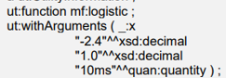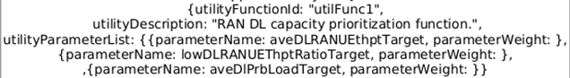Figure 1 mathematical function Figure 2 vendor specific description
Thus, except using function in the form of mathematical functions or predefined and vendor specific, the MnS consumer can express the preference in the form of a utility list, which contains the candidate target values and the corresponding utility, to indicate the preference for expectation targets. In the case of RANEnergyConsumptionTarget, the MnS consumer can specify that a candidate target value of '900' has a utility value of 1, while '1000' has a utility value of 0. Each expectation target has a utility list. The MnS producer can select a suitable utility function to fit all the utility lists provided by the MnS consumer.
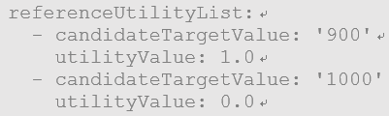
Figure 3: Utility list usage example
Therefore, this tdoc proposes to add use case for the investigation on Intent utility function enhancement.
This contribution related to WT-3.3
Proposed Changes
* * * First Change * * * *

4.X Use case #X: Intent Utility Function Enhancement

4.X.1 Description
In TS 28.312[1], the usage of intent utility function is explored, including how an MnS producer can expose its supported Intent Utility Functions via intent capabilities, and how the MnS consumer can use such information to provision the function. Intent utility functions are mathematical expressions that indicate the MnS consumer’s preference for expectation targets by quantifying the utility derived from the various levels of fulfilment.
The basic components for an intent utility function include variables, weights, function and result. However, the current implementations of the function component present challenges. On one hand, when expressed as generic mathematical functions (e.g., linear, logarithmic, polynomial), they can be difficult for an MnS consumer to understand and use without deep technical knowledge. On the other hand, when provided as predefined, vendor-specific functions, they lack flexibility, confining the MnS consumer to a description and a limited set of parameters.
To address these issues and reduce the burden on the MnS consumer, a new method is introduced: expressing the function as a utility list. Each utility list contains the candidate values (or candidate value ranges) for a corresponding target name and the corresponding utility, to indicate the preference for expectation targets. It can also be considered as a piecewise discontinuous utility function. In the case of RANEnergyConsumptionTarget, the MnS consumer can specify that a candidate value of '900' has a utility value of 1, while '1000' has a utility value of 0. The MnS consumer can also specify that a candidate value range from '700' to '900', with a utility value of 0.8, while from '900' to '1200' has a utility value of 0.4. Each expectation target has a utility list. The MnS producer can then construct (or derive) an appropriate utility function based on these lists and other parameters like weights to fulfil the intent.

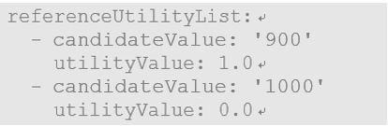
Figure 4.X.1-1: Utility list usage example-1
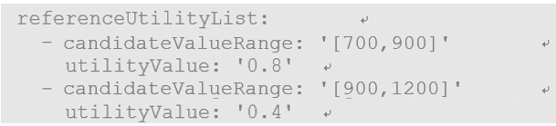
Figure 4.X.1-2: Utility list usage example-2

4.X.2 Potential requirements
REQ-IDMS_IntentUtility-CON-01: The intent driven MnS producer should allow an authorized MnS consumer to specify a piecewise discontinuous utility function as a list of values.

4.X.3 Potential solutions
This solution proposes to reuse and enhance the existing IntentUtilityFormula IOC defined in 3GPP TS 28.312 [1].
To support REQ-IDMS_IntentUtility-CON-01, an attribute "referenceUtilityList" needs to be introduced in IntentUtilityFormula <<IOC>> to represent the MnS consumer's preference for expectation targets in the form of a list, i.e., a piecewise discontinuous utility function as a list of values, which contains the candidate values (or candidate value ranges) and the corresponding utility value.

4.X.4 Evaluation of potential solutions
Only one potential solution has been identified, which is feasible.
* * * End of Changes * * * *

