3GPP TSG-SA5 Meeting #164 S5-255119
Dallas, USA, 17 - 21 November 2025

Source: Huawei
Title: Pseudo-CR on TR 28.881 Update Use case #16 Investigation on the applicability and potential impacts to support natural language intents translation
Document for: Approval
Agenda item: 6.20.1
Spec: 3GPP TR 28.881
Version: 0.2.0
Work Item: FS_IDMS_MN_Ph4

Comments
The contribution proposes to update Use case #16: Investigation on the applicability and potential impacts to support natural language intents translation and add corresponding requirements for Intent interpreter.
Proposed Changes
* * * First Change * * * *

4.16 Use case #16: Investigation on the applicability and potential impacts to support natural language intents translation

4.16.1 Description
In TR 28.914 [9], clause 5.6 described the use case for investigating potential impacts to support natural language intents translation. It also states that there are some use cases where the use of natural language for intent expression would be preferred. For example, on the human-machine interface presenting and expressing intent using natural language can lead to a more intuitive experience for human users. A concrete example of natural language RAN ES intent can be “Reduce 10% RAN energy consumption without impact on user experience for Region X”. The use case also described that if an intent interpreter is introduced to process intents described in natural language, it is necessary to clarify its position within the existing intent management framework, especially its relationship with the MnS consumer.
Scnenario#1: Intent Interpreter as a separate function outside the intent handling function. In this scenario, Intent interpreter receive the natural language intent and translate it into a formal intent (the formal intent contains the attributes and corresponding values to enable the intent handling function to decide the actions to fulfil the intent expectation) according to intent model defined in TS 28.312 [1] and consume the 3GPP Intent driven MnS with formal intent model provided by intent handling function.
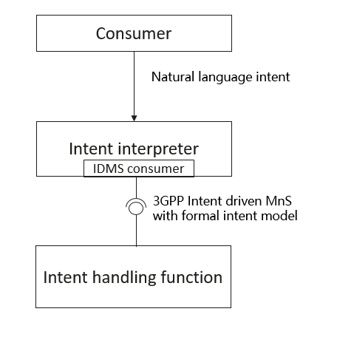
Figure 4.16-1 Deployment scnenario#1: Intent Interpreter as a separate function outside the intent handling function.
Scnenario#2: Intent Interpreter is a function integrated in intent handling function. In this scenario, Intent Interpreter receives the natural language intent from consumer and translates it into detailed actions to be executed to fulfil the intent.
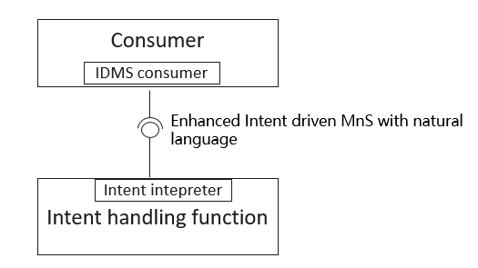
Figure 4.16-2 Deployment scnenario#2: Intent Interpreter is a function integrated in intent handling function.
Based on above two deployment scenarios, this study can investigate whether there is a need for a potential solution to enhance the intent-driven management service to support natural language.

* * * Next Change * * * *

5 Conclusions and Recommendations

5.16 Use case #16: Enhancement of radio service delivering and assurance scenarios

Regarding the Deployment scnenario#1(Intent Interpreter as a separate function outside the intent handling function), the Intent Interpreter is MnS consumer’s internal implementation and the existing intent driven management service can be used to satisfy the interaction between intent handling function and MnS consumer with Intent Interpreter embedded.
Regarding the Deployment scnenario#2(Intent Interpreter is a function integrated in intent handling function), needs further investigation and discussion in 6G to identify corresponding requirements.

* * * End of Changes * * * *

