3GPP TSG-SA5 Meeting #164 S5-255660
Dallas, USA, 17 - 21 November 2025 Revision of S5-254640

Source: China Mobile, Verizon, SK Telecom, CATT, ZTE, Rakuten Mobile, NEC, Orange, China Telecom, China Unicom

Title: Proposals to guide the 6G OAM Study

Document for: Discussion/Endorsement
Agenda Item: 6.2.1

1 Decision/action requested
The group is asked to discuss & endorse the proposals.

2 References
[1] SP-251191; SA5 chair status report to SA#109, September 2025.
[2] S5-254905; New SID on 6G Management and Orchestration.

3 Rationale
This paper provides suggestions for the 6G OAM Study Item, drawing on lessons from 5G OAM specification development and early discussions in SA1, SA2 and RAN.

1. Organization of 6G OAM SID discussion

1.1 Timing and work coordination
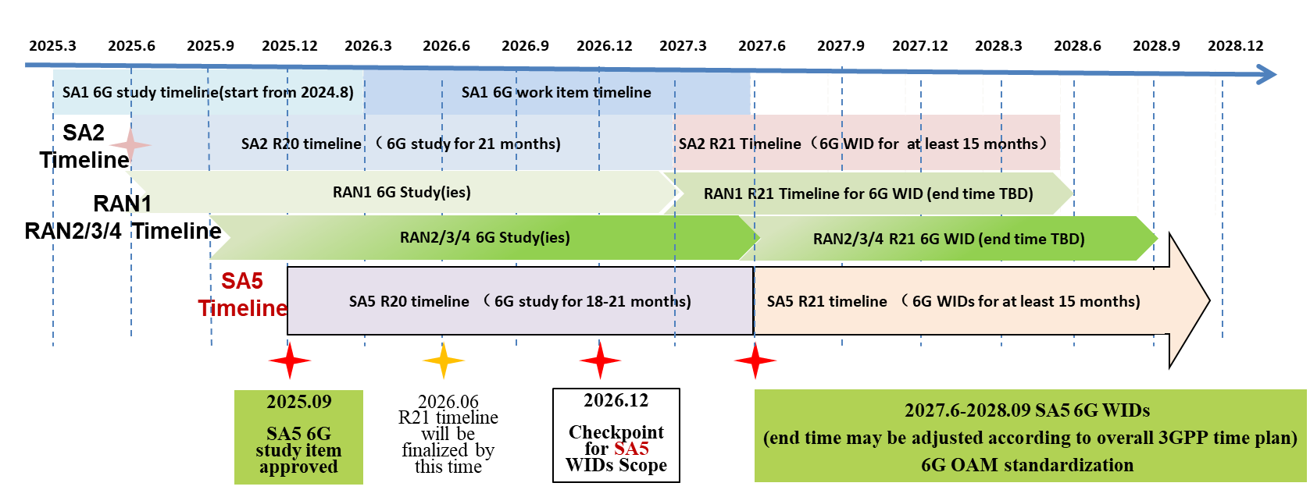
Figure 1 Timeline of 6G OAM items in SA5 (Align with the SA5 statues report to SA#109 in SP-251191 [1])
The 6G study item of SA1 reached 77% in September 2025. It is expected that the TR will be consolidated by the end of 2025 and conclude in March 2026. For SA2, the 6G Architecture SID reached 5% in September 2025 and might be finalized no later than March 2027.
For SA5 6G OAM [2], it expects to start in December 2025 and propose to continue the two categories: OAM prime feature and management support to network feature. Therefore, it should start by fully considering new scenarios and requirements for 6G management, identifying necessary prime features. Supported features related to SA1/2/RAN could be maintained with a few months’ offset after a stable RAN and architecture are in place, to provide a comprehensive 6G management system.
The supporting features for SA1 use cases and requirements, SA2 architecture and RAN need to be carefully considered. Several checkpoints with SA1, SA2, RAN2/RAN3 and other WGs can be set to see whether SA5 6G OAM study satisfies their management requirements, the specific timing of these checkpoints could depend on the topics that need to be aligned.
NOTE: A check point around March 2026 (SA#111/SA5#165) could review the overall 6G end time and future 6G workplan, as described in SP-251191.

1.2 Considerations on the timeline
To ensure that 6G OAM day one prime features have sufficient discussions on solutions and conclusions, it is necessary to set a finalized time for new use cases and requirements:
- Overview and Use cases should be fully discussed before September 2026.
- New requirements should finalised by December 2026.
- Potential solutions by March 2027, with the TR concluding no later than June 2027.
The 6G OAM shall start as a single SID within the unified study framework, the study time windows of the technical directions can allow for variability, with those that have clear solutions allowed to conclude first.
The single SID can be developed into multiple WIDs based on the OAM study conclusions and the outcomes considered from other WGs (e.g., OAM requirements, foundational architecture and management services, AI topics). It is expected to be completed 80% or checked in December 2026 for WIDs scope discussion.
The 6G OAM should initially focus on primary features, the supported features of management for 6G system, 6G architecture and RAN can be checked with other WGs during their 6G mid-term study, as their characteristics and functionalities will be relatively stable by that time, making the new demands on the management system clearer.

Proposal 1:
To ensure that 6G OAM day one features have sufficient discussions on solutions and conclusions, it is necessary to set a finalized time for new use cases and requirements:
- Overview and Use cases should be fully discussed before September 2026.
- New requirements should finalised by December 2026.
- Potential solutions by March 2027, with the TR concluding no later than June 2027.
NOTE: The timing may be adjusted to sync with SA2 and overall 3GPP 6G time plan.
Proposal 2:
Introduce checkpoints to align with SA2 and RAN studies:
- December 2026: discussion on how to split WIDs/SIDs based on SID conclusions and other WG requirements.
- Additional checkpoints with SA1, SA2 and RAN2/RAN3, with timing depending on topics needing alignment.
NOTE: Rapporteurs should provide recommendations on which topic and timing for checkpoint on a case-by-case basis, the checkpoints timing may be adjusted according to the overall 6G work progress and could be coordinated by Rapporteurs with Chairs.

2. Principles of 6G OAM
At the outset of the 6G Operations and Management (OAM) study, it is essential to thoroughly analyze the specific requirements and use cases that 6G aims to address, as well as the new services that OAM will need to provide or support. In order to ensure SA5 maintains its essential role in the 6G management and orchestration, the coordination with other SDOs needs to be considered if needed. This comprehensive analysis is crucial because it allows stakeholders to identify the unique challenges and opportunities that 6G presents compared to previous generations. The 6G OAM Architecture should be discussed from the use case perspective and also from a functional perspective. By systematically evaluating these needs and potential use cases, we can explore solutions by leveraging advanced technologies, ensuring that the OAM framework is robust enough to handle the complexities of 6G. Ultimately, this will facilitate the management and service provisioning of seamless, efficient, and reliable services in an increasingly interconnected world.
Recommendations:
  - The study should start by analysing specific requirements and use cases for 6G OAM, building on 5G OAM capabilities to identify gaps.
  - Coordination with other SDOs should be considered where relevant.
  - Both use case and functional perspectives should guide the OAM architecture discussion.
  - By systematically assessing requirements and use cases, SA5 can ensure that 6G OAM is robust enough to manage the new complexities of 6G.

3. Structure of 6G OAM Specification
Experience from 5G OAM shows that the growing number of specifications has made it difficult to track, understand, and use the standards effectively. While there may be various factors for this, creating unnecessary complexity and reducing scalability, readability, and usability of specifications.
Therefore, we propose that the 6G OAM specifications adopt a lean and streamlined structure from the outset: fewer specifications, with stronger usability of the core ones.
The experience learned from the 5G SA5 specifications is that the specifications are fragmented, with TS28.533 serving as the fundamental management architecture combined with 40+ concrete specifications. The current issue is that there are too many specifications, and the relationships among them lack a clear view and logic, resulting in low readability. Therefore, we propose developing a few foundational specifications within SA5 for 6G OAM: Use case and Requirements, Management Architecture and Functions, NRM, PM/KPI, etc. If there is a need to add some specific functional specifications later, these specific functions should be updated in the Management Architecture and Functions foundational document, clearly outlining their relationships with the management architecture and other functions. Detailed procedures, IOC, data types, etc., can be defined in separate specifications, but they should at least be indexed from the foundational Management Architecture and Functions specification. Similar approach to the requirement specification, a single requirement specification could be maintained, primarily sourced from SA1, SA5 itself, and other SDOs.
Key lessons and recommendations:
  - In 5G, SA5 specifications became fragmented: TS 28.533 formed the core, but was accompanied by 40+ related specifications, with weak logical links between them. This reduced readability and usability.
  - For 6G, a leaner, more streamlined approach is proposed, with a small number of foundational specifications (e.g., Use Cases & Requirements, Management Architecture & Functions, NRM, PM/KPI).
  - Specific functional specifications could still be developed if needed, but their relationships should be clearly documented in the core Management Architecture and Functions specification.
  - A single requirements specification could be maintained, sourcing input from SA1, SA5 itself, and possibly other SDOs.

4 Detailed proposals

Proposal 1:
To ensure that 6G OAM day one features have sufficient discussions on solutions and conclusions, it is necessary to set a finalized time for new use cases and requirements:
- Overview and Use cases should be fully discussed before September 2026.
- New requirements should finalised by December 2026.
- Potential solutions by March 2027, with the TR concluding no later than June 2027.
NOTE: The timing may be adjusted to sync with SA2 and overall 3GPP 6G time plan.
Proposal 2:
Introduce checkpoints to align with SA2 and RAN studies:
- December 2026: discussion on how to split WIDs/SIDs based on SID conclusions and other WG requirements.
- Additional checkpoints with SA1, SA2 and RAN2/RAN3, with timing depending on topics needing alignment.
NOTE: Rapporteurs should provide recommendations on which topic and timing for checkpoint on a case-by-case basis, the checkpoints timing may be adjusted according to the overall 6G work progress and could be coordinated by Rapporteurs with Chairs.

