3GPP TSG-SA5 Meeting #164 S5-255635
Dallas, USA, 17 - 21 November 2025
CR-Form-v12.3
CHANGE REQUEST
 | 28.533 | CR | 0175 | rev | 1 | Current version: | 19.3.0
For HELP on using this form: comprehensive instructions can be found at
http://www.3gpp.org/Change-Requests.

Proposed change affects: |  |  | UICC apps |  |  |  |  | ME |  | Radio Access Network |  |  |  |  | X | Core Network | X
Title: | Rel-19 CR TS 28.533 Correct description of 3GPP management services exposure
Source to WG: | Ericsson
Source to TSG: | S5
Work item code: | SBMA_Ph3 |  |  |  |  |  |  |  |  |  | Date: |  |  | 2025-11-01
Category: | F |  |  |  |  |  |  |  |  |  | Release: |  |  | Rel-19
 | Use one of the following categories:  F (correction)  A (mirror corresponding to a change in an earlier release)  B (addition of feature),  C (functional modification of feature)  D (editorial modification)  Detailed explanations of the above categories can  be found in 3GPP TR 21.900. |  |  |  |  |  |  |  |  |  |  |  | Use one of the following releases:  Rel-8 (Release 8)  Rel-9 (Release 9)  Rel-10 (Release 10)  Rel-11 (Release 11)  …  Rel-17 (Release 17)  Rel-18 (Release 18)  Rel-19 (Release 19)  Rel-20 (Release 20)
Reason for change: |  | The current description of 3GPP managemnet services exposure is confusing and present some issues.  Issue #1: It is said that the exposure of management services includes two aspects: discovery and access control. However, this is only applicable to the non-CAPIF scenarios; for CAPIF scenario, additional aspects (e.g., API provider domain registration, publishing) are needed.  Issue #2: For MnS consumers X1, X2 and Y1, the focus of discussion is on discovery, but the other aspect (i.e., access control, see issue #1) is missing. It is proposed to add it together with the appropriate reference.  Issue #3: For MnS consumers Y2, it said that “TS 28.579 specifies how to discover the registered MnSs to this category of external MnS consumers through MnS registration, MnS publishing and MnS invocation logging capabilities”. There are various problems in this description.  - What’s discoverable in CAPIF is not “registered MnS”, but “service APIs conveying MnS information”.  - The discovery happens over CAPIF-1e interface; this interface is outside the TS 28.579.  - The MnS registration is not part of the TS 28.579, as it relies on clause 5 of TS 28.537, and it is a pre-requisite for exposing any MnS, regardless of the targeted MnS consumer.  - There does not exist MnS publishing, but publishing of service API conveying MnS information.  - The logging capabilities has nothing to do with the fact that service APIs are discoverable.  - In addition, the MSED is pcitured in the figure but never mentioned in the text. Without reference, the reader may get lost.  Issue #4: Las sentence quotes: “It is up to the network operator’s discretion to determine the appropriate discovery and access control rights for the different MnS consumers when consuming a MnS”. This sentence is only applicable to non-CAPIF scenarios; however the intention should be for it to cover all the scenarios.
Summary of change: |  | It is proposed to make some changes on the clause to address the issues above.
Consequences if not approved: |  | Wrong description of the 3GPP management services exposure framework.
Clauses affected: |  | 5.6
 |  | Y |  | N
Other specs |  |  |  | x | Other core specifications |  |  |  |  |  |  | TS/TR ... CR ...
affected: |  |  |  | x | Test specifications |  |  |  |  |  |  | TS/TR ... CR ...
(show related CRs) |  |  |  | X | O&M Specifications |  |  |  |  |  |  | TS/TR ... CR ...
Other comments:
This CR's revision history:

First change

5.6 3GPP management services exposure
In the context of 3GPP management services exposure, management services can be exposed to internal MnS consumers (i.e., MnS consumers within the PLMN trust domain) and external MnS consumers (i.e., MnS consumers outside the PLMN trust domain). These consumers can be classified into the following categories:
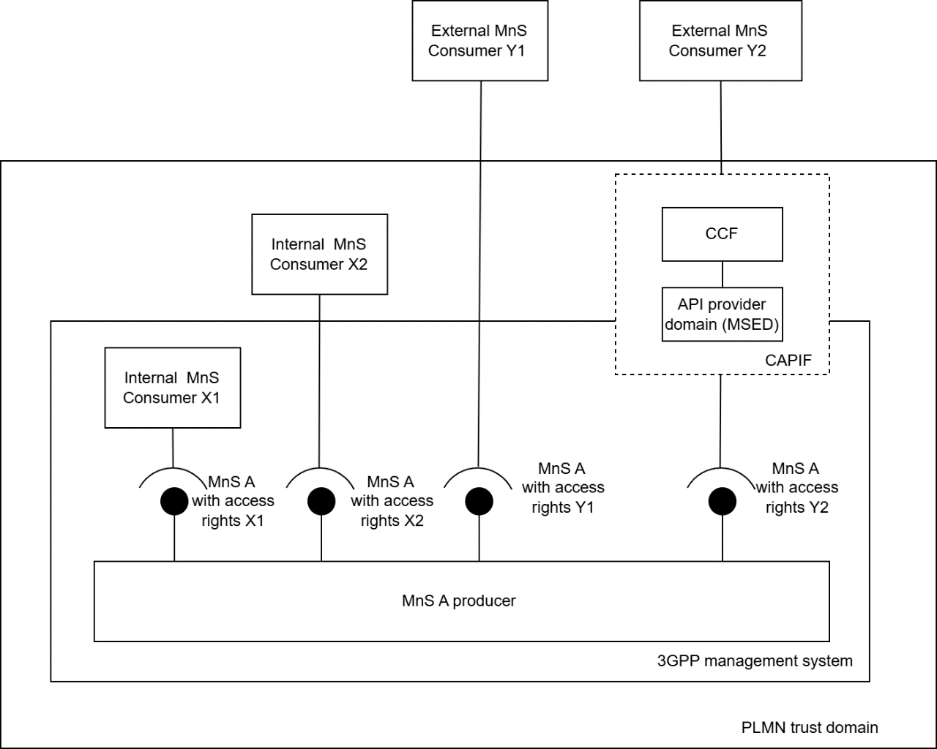
Figure 5.6-1: Management services exposure scenarios
- Internal MnS consumer X1: an
MnS consumer within the 3GPP management system, e.g. provisioning MnS consumer, fault management MnS consumer and streaming MnS consumer.

- Internal MnS Consumer X2: an MnS consumer outside the 3GPP management system but within the PLMN trust domain, e.g. NWDAF, operator’s AFs (e.g., EAS).
- External MnS Consumer Y1 : an
MnS consumer outside the PLMN trust domain consuming management services directly from the 3GPP management system, e.g., participating operators in RAN sharing scenarios (see TS 32.130 [55]), energy utility verticals (see TS 28.318 [69]), and other verticals.

- External MnS Consumer Y2: an MnS consumer outside the PLMN trust domain consuming management services through exposure framework CAPIF (see TS 23.222 [76]), e.g., Energy utility verticals (see TS 28.318 [69]), and other verticals.

Every management service in 3GPP management system can be exposed to different types of MnS consumers. Figure 5.6-1 illustrates different exposure scenarios, depending on the type of MnS consumer. For MnS consumers accessing to the 3GPP management system (e.g., internal MnS consumer X1, internal MnS consumer X2 and external MnS consumer Y1), management services are exposed using the mechanisms defined for MnS discovery (see clause 5 of TS 28.537 [39]) and access control (see clause 4.9 of the present document).
For MnS consumers accessing to the 3GPP management system via CAPIF (e.g., external MnS consumer Y2), management services are exposed utilizing CAPIF framework, which includes CCF and API provider domain functions. When 3GPP management system becomes an API provider domain in CAPIF, the API provider domain funcitons are performed by the Management Service Exposure Domain (MSED), as specified in 3GPP TS 28.579 [77]

End of Changes

