3GPP TSG-SA5 Meeting #164 S5-255624

Dallas, United States, 17th Nov 2025 - 21st Nov 2025
CR-Form-v12.4
CHANGE REQUEST
 | 28.533 | CR | 0173 | rev | - | Current version: | 19.3.0
For HELP on using this form: comprehensive instructions can be found at
https://www.3gpp.org/Change-Requests.

Proposed change affects: | UICC apps |  | ME |  | Radio Access Network | X | Core Network | X

Title: | Rel-19 TS 28.533 Update Annex management features
Source to WG: | Huawei Technologies Sweden AB
Source to TSG: | S5
Work item code: | SBMA_Ph3 |  |  |  |  |  | Date: |  |  | 2025-11-07
Category: | F |  |  |  |  |  | Release: |  |  | Rel-19
 | Use one of the following categories:  F (correction)  A (mirror corresponding to a change in an earlier release)  B (addition of feature),  C (functional modification of feature)  D (editorial modification)  Detailed explanations of the above categories can  be found in 3GPP TR 21.900. |  |  |  |  |  |  |  | Use one of the following releases:  Rel-8 (Release 8)  Rel-9 (Release 9)  Rel-10 (Release 10)  Rel-11 (Release 11)  …  Rel-17 (Release 17)  Rel-18 (Release 18)  Rel-19 (Release 19)  Rel-20 (Release 20)
Reason for change: |  | Align Annex E with the features developed in Rel-19. Rearrange the grouping of management features.
Summary of change: |  | Update Annex E.
Consequences if not approved: |  | The list of 5G management features are not complete, the structure of feature table is not easy to be understood.
Clauses affected: |  | Annex E
 |  | Y | N
Other specs |  |  | X | Other core specifications |  |  |  | TS/TR ... CR ...
affected: |  |  | X | Test specifications |  |  |  | TS/TR ... CR ...
(show related CRs) |  |  | X | O&M Specifications |  |  |  | TS/TR ... CR ...
Other comments:
This CR's revision history:

==============First change==============

Annex E (informative):
5G specifications overview
The following figure and table show the overview information of 5G specifications which capture corresponding management features:

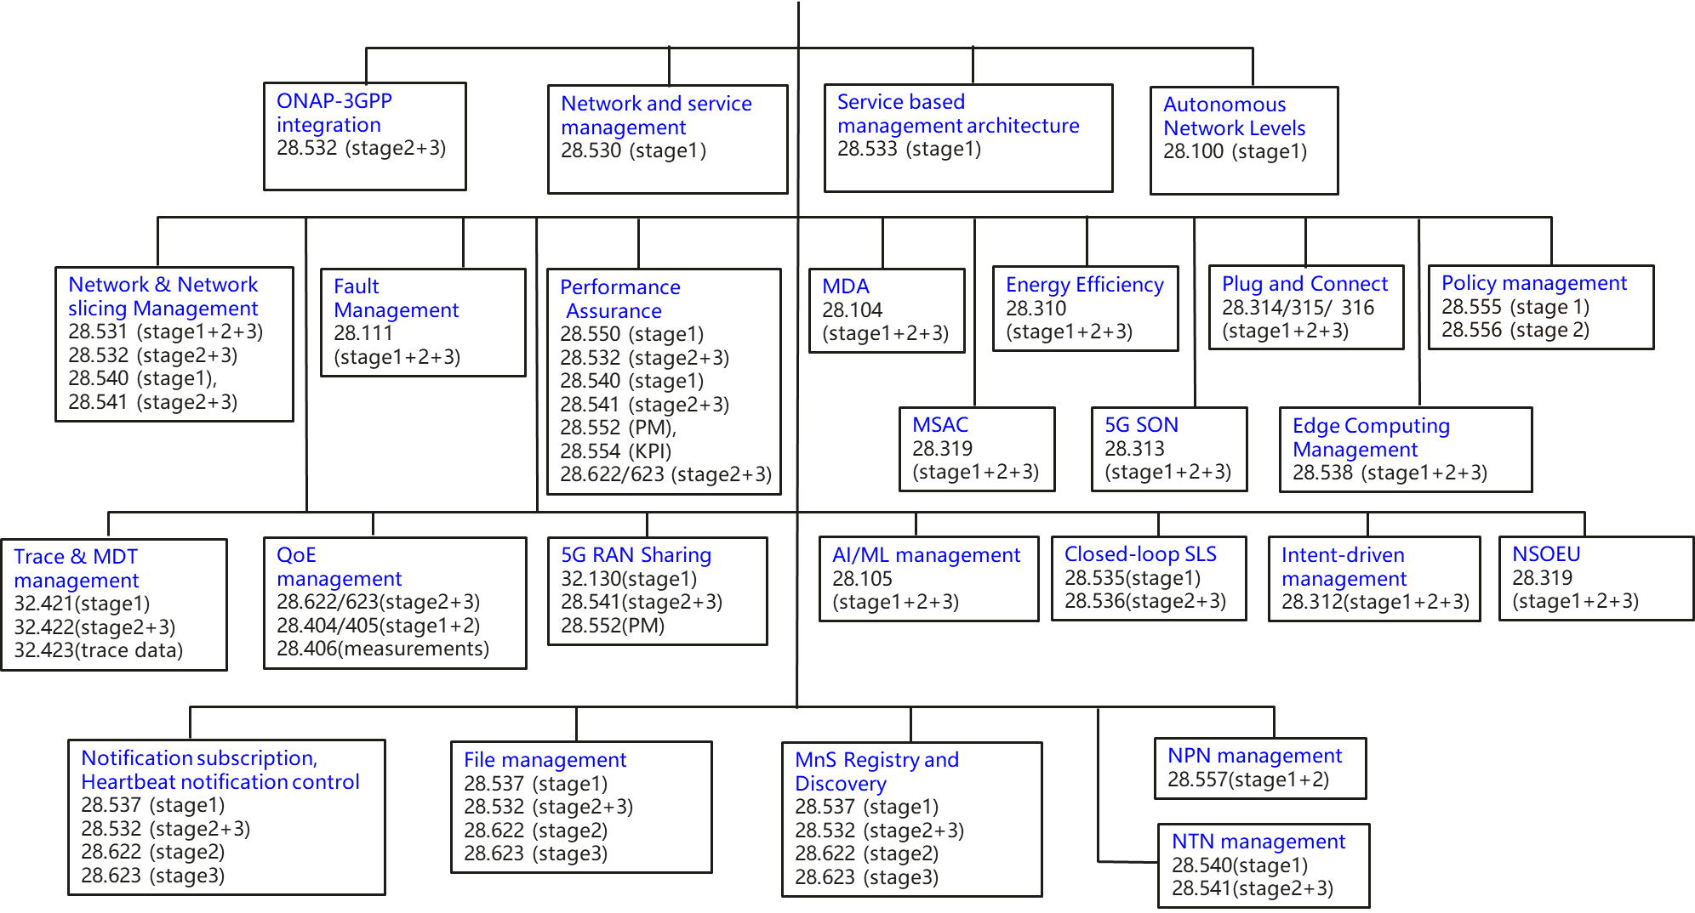
Figure E-1: Overview of 5G management specifications
The following table provides the overall 5G management features. For each listed 5G management feature, the table specifies the supporting management capabilities (see Table F-1) and the related specification information.
Table E-1 Overall 5G management features, supporting management capabilities and related specification information
5G related management feature |  | Supporting management capabilities | Related specifications
1. SBMA Infrastructure
1.1 | Service based management architecture |  | TS 28.533 (stage 1) [36]
1.2 | MnS Registry and Discovery | MnS Registry and Discovery | TS 28.537 (stage 1) [39] (see NOTE),  TS 28.622 (stage 2) [32],  TS 28.623 (stage 3) [54]
1.3 | Access Control for Management Services (MSAC) | MnS Access Control | TS 28.319 (stage 1, stage 2 and stage 3) [70]
1.4 | External Data Management | External Data Discovery and Request | TS 28.537 (stage 1) [39] (see NOTE),  TS 28.532 (stage 2 and stage 3) [9]  TS 28.622 (stage 2) [32],  TS 28.623 (stage 3) [54]
1.5 | Notification Subscription and Heartbeat notification control | Heartbeat Control;  Heartbeat Notification;  Subscription Control | TS 28.537 (stage 1) [39],  TS 28.532 (stage 2 and 3) [9],  TS 28.622 (stage 2) [32],  TS 28.623 (stage 3) [54].
1.6 | File Management | File Retrieval;  File Download | TS 28.537 (stage 1) [39] (see NOTE),  TS 28.532 (stage 2 and 3) [9]  TS 28.622 (stage 2) [32]  TS 28.623 (stage 3) [54].
2. Basic Management
2.1 | Network and service management |  | TS 28.530 (stage 1) [3]
2.2 | Network and Network slicing provisioning (management of IAB, Redcap, AIoT, MWAB, NWDAF, NTN etc.) | NR Provisioning;  5GC Provisioning;  Network Slicing Provisioning | TS 28.531 (stage 1, stage2 and stage3) [8] (see NOTE),  TS 28.532 (stage 2 and stage 3) [9],  TS 28.540 (stage 1) [41],  TS 28.541 (stage 2 and stage 3) [4]
2.3 | Fault Management | Fault control;  Fault Notification | TS 28.111 (stage 1, stage 2 and stage 3) [68]
2.4 | Performance Assurance | Performance Metric Collection Control;  Performance Metric Data Report;  Performance Metric Threshold Monitor Control;  Performance Metric Threshold Notification | TS 28.550 (stage 1) [42] (see NOTE),  TS 28.532 (stage 2 and stage3) [9],  TS 28.540 (stage 1) [41],  TS 28.541 (stage 2 and stage 3) [4],  TS 28.552 (PM) 5],  TS 28.554 (KPI) [6]  TS 28.622 (stage 2) [32],  TS 28.623 (stage 3) [54]
2.5 | Trace & MDT management | Trace/MDT data collection control;  Trace/MDT data report | TS 32.421 (stage 1) [43] (see NOTE),  TS 32.422 (stage 2 and stage 3) [44],  TS 32.423 (trace data) [45]
2.6 | Signalling traffic monitoring management | STM provisioning  STM streaming | TS 3GPP TS 28.560 [x],  TS 28.532 (stage 2 and stage3) [9]
2.7 | QoE Management | QoE data collection control;  QoE data report | TS 28.622 (stage 2) [32],  TS 28.623 (stage 3) [54],  TS 28.404 (stage 1) [48] (see NOTE),  TS 28.405 (stage 2) [49],  TS 28.406 (measurements) [50]
2.8 | Plan management | Configuration plan management | TS 28.572 [Y]
2.8
2.9 | 5G RAN Sharing | NR Provisioning | TS 32.130 (stage 1) [55] (see NOTE),  TS 28.541 (stage 2 and stage 3) [4],  TS 28.552 (PM) [5]
2.10 | Edge Computing Management | Edge Computing Provisioning | TS 28.538 (stage 1, stage 2 and stage 3) [40]
2.11 | NPN management | NR Provisioning;  5GC Provisioning;  Network Slicing Provisioning  Performance Metric Collection Control;  Performance Metric Data Report;  Performance Metric Threshold Monitor Control;  Performance Metric Threshold Notification | TS 28.557 (stage 1 and stage 2) [47]  TS 28.532 (stage 2 and stage 3) [9],  TS 28.552 (PM) [5],  TS 28.554 (KPI) [6]
3. Advanced Management
3.1 | Autonomous Network Levels |  | TS 28.100 (stage 1) [35]
3.2 | Management Data Analytics (MDA) | Management Data Analytics | TS 28.104 (stage 1, stage 2 and stage 3) [57]
3.3 | 5G SON Self-optimization | SON policy | TS 28.313 (stage 1, stage 2 and stage 3) [58] (see NOTE),  TS 28.541 (stage 2 and stage 3) [4]
3.4 | 5G SON Self-configuration | RANSC management | TS 28.314 (stage 1) [59] (see NOTE),  TS 28.315 (stage 2) [60],  TS 28.316 (stage 3) [61]  TS 28.317 (stage 1, stage 2 and stage 3) [67]
3.5 | AI/ML management | ML model management | TS 28.105 (stage 1, stage 2 and stage 3) [66]
3.6 | Intent driven management | Intent Driven Management | TS 28.312 (stage 1, stage 2 and stage 3) [46]
3.6
3.7 | Closed-loop Management | Communication Service Assurance Control | TS 28.535 (stage 1) [37] (see NOTE),  TS 28.536 (stage 2 and stage 3) [38]  TS 28.567 [Z]
3.8 | NDT management | NDT Lifecycle Management | TS 28.561 (stage 1, stage 2 and stage 3) [73],  TS 28.532 (stage 2 and stage 3) [9]
3.9 | Policy management |  | TS 28.555 (stage 1) [62] (see NOTE),  TS 28.556 (stage 2) [63]
3.10 | Energy Efficiency Management | NR Provisioning;  5GC Provisioning;  Network Slicing Provisioning  Performance Metric Collection Control;  Performance Metric Data Report;  Performance Metric Threshold Monitor Control;  Performance Metric Threshold Notification | TS 28.310 (stage 1, stage 2 and stage 3) [56] (see NOTE),  TS 28.532 (stage 2 and stage 3) [9],  TS 28.552 (PM) [5],  TS 28.554 (KPI) [6]
3.11 | Management Service Exposure | MnS Registry and Discovery  MgmtData Registry and Discovery  MnS Access Control | TS 28.579 [77]  TS 28.537 (stage 1) [39] (see NOTE),  TS 28.622 (stage 2) [32],  TS 28.623 (stage 3) [54]  TS 28.319 [70]
3.12 | Network and Service Operations for Energy Utilities (NSOEU) | DSO Rapid Discovery and Threshold Monitoring | TS 28.318 (stage 1, stage 2 and stage 3) [69] (see NOTE)  TS 28.554 (KPI) [6]
4. 3GPP integration
4.1 | ONAP-3GPP integration | NR Provisioning;  5GC Provisioning;  Fault Notification;  Heartbeat Notification;  Performance Metric Data Report | TS 28.532 (stage 2 and stage 3) [9]
NOTE: This specification is the recommended starting point for implementation of the 5G related management feature.

==============End of change==============

