3GPP TSG-SA5 Meeting #164 S5-255618
Dallas, Texas, USA, 17 – 21 November 2025 revision of S5-255368
CR-Form-v12.3
CHANGE REQUEST
 | 28.567 | CR | 0011 | rev | 01 | Current version: | 19.0.0
For HELP on using this form: comprehensive instructions can be found at
http://www.3gpp.org/Change-Requests.

Proposed change affects: | UICC apps |  | ME |  | Radio Access Network | X | Core Network | X

Title: | Rel-19 CR TS28.567 Small corrections
Source to WG: | Nokia
Source to TSG: | S5
Work item code: | CCLM |  |  |  |  |  | Date: |  |  | 2025-11-07
Category: | F |  |  |  |  |  | Release: |  |  | Rel-19
 | Use one of the following categories:  F (correction)  A (mirror corresponding to a change in an earlier release)  B (addition of feature),  C (functional modification of feature)  D (editorial modification)  Detailed explanations of the above categories can  be found in 3GPP TR 21.900. |  |  |  |  |  |  |  | Use one of the following releases:  Rel-8 (Release 8)  Rel-9 (Release 9)  Rel-10 (Release 10)  Rel-11 (Release 11)  …  Rel-17 (Release 17)  Rel-18 (Release 18)  Rel-19 (Release 19)  Rel-20 (Release 20)
Reason for change: |  | There are several small corrections needed throughout the specification
Summary of change: |  | Revised the caption number for tables and figures  Added a table for stage 3 solutions
Consequences if not approved: |  | The specification may be mistinteroreted
Clauses affected: |  | 6.3.18, 7.6, 7.7, 7.10, 9
 |  | Y | N
Other specs |  |  | X | Other core specifications |  |  |  | TS/TR ... CR ...
affected: |  |  | X | Test specifications |  |  |  | TS/TR ... CR ...
(show related CRs) |  |  | X | O&M Specifications |  |  |  | TS/TR ... CR ...
Other comments:
This CR's revision history:

Start of First change

6.3.18 TriggerConflict <<datatype>>

6.3.18.1 Definition
This data type represents the information on a trigger conflict.
Each conflict includes an indication in ConflictType attribute for whether it is a potential conflict or an actual conflict that is observed.

6.3.18.2 Attributes
Table 6.3.18.2-1
Attribute name | S | isReadable | isWritable | isInvariant | isNotifyable
conflictID | M | T | T | F | T
conflictingCCLs | M | T | T | F | T
ConflictType | M | T | T | F | T

6.3.18.3 Attribute constraints
None

6.3.18.4 Notifications
The subclause 6.5 of the <<IOC>> using this <<dataType>> as one of its attributes, shall be applicable.

Next change

7.6 CCL Scope conflicts avoidance, detection and resolution
To coordinate scope assignments, a CCL coordination functionality, say in CCL Coordination entity, needs a capability to coordinate the scope assignment across multiple CCLs, say called the scope assignment coordination capability. The scope assignment coordination capability considers a defined full scope space Sp and a set of scope rules to define the best scope to be assigned to each CCL. An example rule may be that the defined CCL scope should not overlap. The rules may for example be defined by an operator or can be implementation specific depending on the types of CCLs that are to be configured.
Each CCL has four scopes - the measurement scope, target scope, control scope and impact scope, all of which can configured by the MnS consumer, i.e., an operator or the CCL Coordination entity may derive the required scope and configure it onto the CCL. There maybe different rules that each scope definition should adhere to for a given use case. The CCLs register their scopes with the CoordinationEntity (e.g., for the case where the scope is not defined by the CCL Coordination entity). The notification of the CCL scope to the CCL Coordination entity triggers an evaluation of potential conflict, i.e. whether those scopes are likely to conflict with the scopes of another CCL. The potential conflicts can be confirmed as actual conflicts by the CCL or the Coordination entity which then triggers resolution by computing a new reassignment of scopes.
To assign scopes, the scope coordination capability Applies the scope assignment rules defined in the scope coordination capability and divides the scope space into regions such that each region is matched to a CCL in a way that maximizes fulfilment of the assignment rules. The For example, if the benefit is to avoid overlaps, the subregions are assigned to the different CCLs in a way that ensures no overlaps and that all the scope space has been assigned.

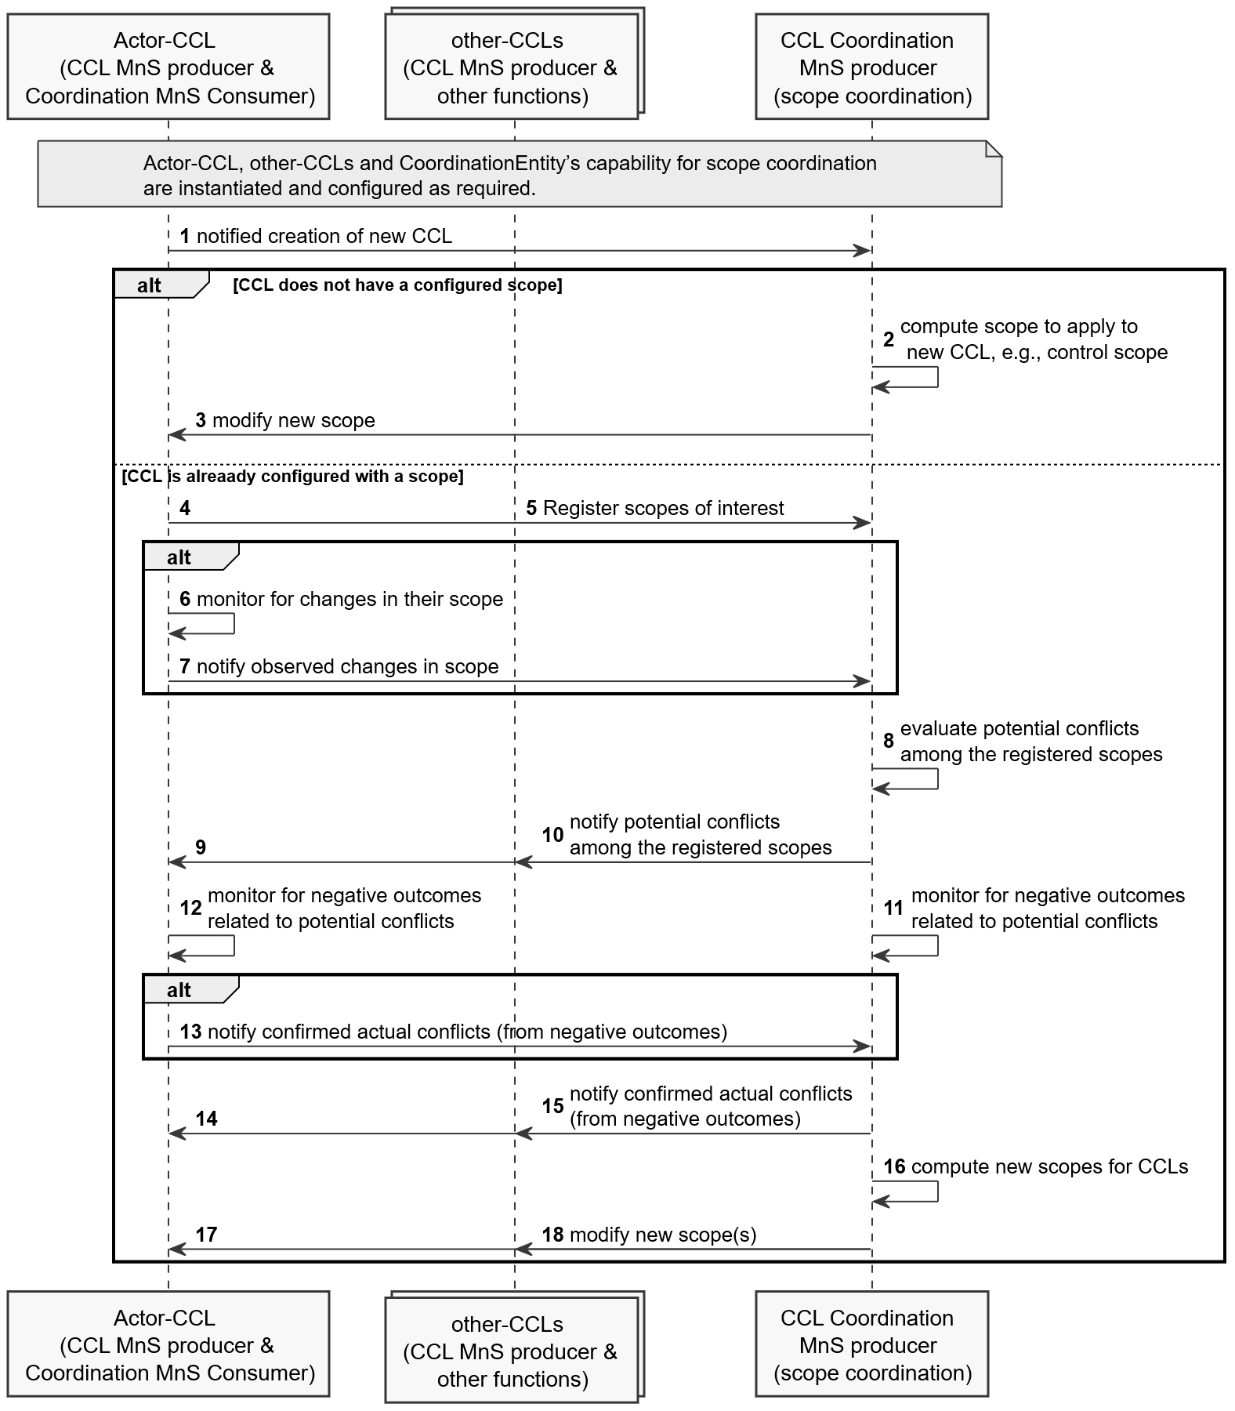
Figure 7.6-1: CCL-impact assessment and actual metric-value conflicts resolution

Step 0-1. The CoordinationEntity’s capability for scope coordination is instantiated and configured ( e.g., with the rules for evaluating and coordinating scopes for different use cases)
Step 0-2. The set of CCLs are composed, configured and instantiated;
Step 1. Instantiation of a new CCL is notified to the CoordinationEntity.
Alternative: the CCL does not have a configured scope and the CoordinationEntity needs to assign the scope
Step 2. the CoordinationEntity computes the scope to be applied by the new CCL, e.g., it divides the scope space into regions matched to the CCLs e.g. to ensure no overlaps and that all the scope space has been assigned.
Step 3. the CoordinationEntity notifies the new CCL of the assigned scope
Otherwise
Step 4, 5. The CCLs register their scopes of interest to the coordination entity including the scopes where they take measurements, take control actions as well as where their actions are expected to impact. The CCL may register by writing into the toBeCoordinatedCCLScopes attribute of the CoordinationEntity.
Step 6. The CCLs monitor for changes in their scope to detect misalignments in scope
Step 7. If the scope is changed, the CCL registers the observed changes in the scope to the CoordinationEntity’s scope coordination capability. The CCL registers differences between what was configured and the actual scopes e.g., if the considered scope for taking measurement data are affected by the actions of another CCL. The CCL may register by writing into the toBeCoordinatedCCLScopes attribute of the CoordinationEntity.
Step 8. A registration of scope or scope changes triggers the CoordinationEntity to evaluate if there are any potential conflicts among the registered scopes,
Step 9, 10. If scope conflicts are potential detected, the CoordinationEntity notifies the CCLs of the potential conflicts, so that both the CCLs and the CoordinationEntity monitor to see if potential scope conflicts results into actual conflicts. The CoordinationEntity adds a new entry in the detectedScopeConflicts list with a value of POTENTIAL_CONFLICT for the conflictType .
Step 11, 12. CCLs and the CoordinationEntity monitor to see if there are negative outcomes.
Step 13. If negative outcomes are observed by a CCL, the CCLs notifies the CoordinationEntity of the confirmed scope conflicts. The CCL updates the conflictType value of the detectedScopeConflicts entry from potential to actual conflict.
Step 14, 15. Alternatively, if the negative outcomes are observed by the CoordinationEntity, the CoordinationEntity notifies all affected CCLs of the confirmed scope conflicts. The CoordinationEntity updates the conflictType value of the detectedScopeConflicts form potential to actual conflict.
Step 16. The CoordinationEntity computes new scopes to be applied by the different CCLs, e.g., similar to an initial assignment.
Step 17, 18. If there are CCLs whose scope should be revised, the CoordinationEntity notifies the CCLs whose scope is revised of the newly computed scope.
Next change

7.7 CCL Trigger-time conflicts avoidance, detection and resolution
CCL could require to operate in a hierarchy. For example, to ensure that handovers are always optimal, a CCL on handover optimization may need to be triggered every after a CCL on Energy saving has been executed to be sure that there are appropriate handover relations even when some cells may have been disabled. The handover CCL would be in lower hierarchy to the Energy saving CCL. Each CCL (say CCL-A) has an operational profile (described in the CCL purpose) that includes the level of hierarchy and describing characteristics under which the CCL-A operates, e.g. when or after which precedent CCLs this CCL-A should be executed.
A CCL may be involved in more than 1 hierarchies or within a single hierarchy, the CCL may relate to multiple other CCLs operating on related scope in one or more domains, e.g., on the same or related managed objects. The CoordinationEntity needs to configure the appropriate hierarchy for the CCLs considering the different relationships. For a CCL C3 with relationships to 2 other CCLs C1 and C2, considering the hierarchies defined in the operational profiles P1 and P2 of the CCLs C1 and C2, the CoordinationEntity evaluates the description of CCL C3 against at least one of the profiles P1 and P2 and accordingly determines and configures the operational profile of CCL C3.
There are cases where it is not clear which CCL should be triggered, e.g. if there are multiple degraded KPIs. The CoordinationEntity may evaluate the network state of a given network scope to diagnose what the problem might be occurring. Alternatively, it may obtain an analytics report for that problem. For the identified problem, the CoordinationEntity finds the most appropriate CCL to trigger. The CoordinationEntity queries the capabilities of the available CCLs to match the identified problem to one of the CCLs. The identified CCL is then triggered to find an appropriate response for the problem.
To coordinate within each hierarchy, when a CCL C1 generates an action, it needs to informs the related CCL C2 of such an action, so that CCL C2 the considers the actions of CCL C1 in determining C2’s actions to be taken on the shared or related managed scope. Accordingly, C1 actions should be notified to the CoordinationEntity so that the CoordinationEntity indicates them to C2 when triggering C2.
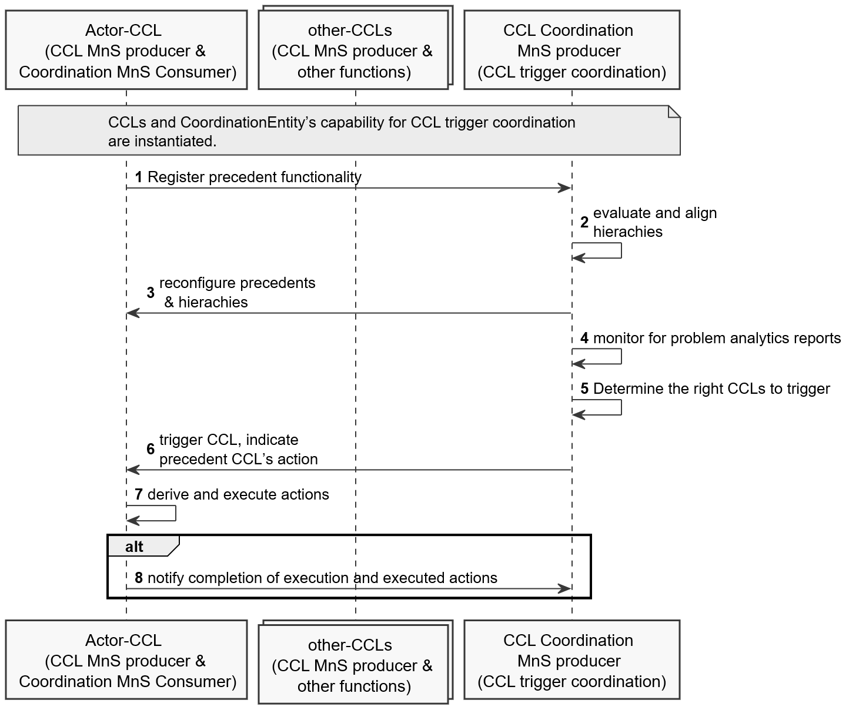
Figure 7.7-1: CCL-impact assessment and actual metric-value conflicts resolution

Step 0. The CoordinationEntity’s capability for CCL trigger coordination is instantiated and configured. The set of CCLs are composed, configured and instantiated but not triggered to evaluate the network or execute actions.
Step 1. Each CCL registers its precedent functionality which is the set of higher hierarchy automation functionality or CCLs, for which after their execution this CCL should be executed.
Step 2. The CoordinationEntity evaluates the sets of precedent functionality to align hierarchies of the CCLs and determine if there is need to configure the hierarchies.
Step 3. If reconfiguration is needed, the CoordinationEntity (re)configures the operational profiles of the CCLs, e.g. hierarchies and relations among the CCLs.
Step 4. The CoordinationEntity analyses network problem scope or obtains analytics report on network problem.
Step 5. If a problem is identified, the CoordinationEntity evaluates what the most appropriate CCL to be triggered should be.
Step 6. If the CoordinationEntity has identified a new CCL to trigger or a previous execution in a hierarchy has been completed, the CoordinationEntity triggers the CCL identified as most appropriate, i.e., it toggles the administrativeState from LOCKED to UNLOCKED.
Step 7. The triggered CCL generates and executes its desired action
Step 8. The triggered CCL notifies its action to the CoordinationEntity for onward transfer when triggering lower hierarchy CCLs
Next change

7.10 CCL metric-value conflicts avoidance and detection

7.10.1 Avoiding concurrent and non-concurrent metric-values conflicts
Each CCL has a control scope including a set of metrics. The metrics ma have prioritization among them, e.g. a handover optimization CCL may have more interest (higher priority) in controlling Cell individual offsets compared to controlling antenna tilts. To support detection and avoidance of potential non-concurrent metric-value conflicts, if the CCL has been pre-configured e.g., by the operator with the expected outcomes, the CCL may register its desired metrics, their priorities and outcomes with the CCLCoordinationEntity. This triggers the first evaluation for potential conflict, i.e. whether these metrics and outcomes are likely to conflict with those of another CCL.
Subsequently, potential metric-value conflicts are avoided using likely-impact of planned actions. For any CCL, large and frequent changes to network parameters may affect network stability since they increase the probability of occurrence of conflicts, i.e. avoiding making unnecessary configuration changes to the managed objects guarantees network stability and minimize the probability of conflicts between CCLs. This may then imply that executing large changes, e.g. to quickly improve the performance, in case of a poor decision, may also result in significant degradation. So, it is preferred to take small smooth changes in the case where the impact is not so clear, and only make the large changes when the CCL is sure that the impact is positive.
In case of a plan that results in a conflict, the CoordinationEntity sends its decision and possibly the failed criteria to the CCL - to either be executed or to be used to compute better decisions. It is assumed that based on feedback on the quality of its decisions, the CCL updates its decision-making engine and repeats the decision evaluation process. Then if the CCL has consistently made good large action-decisions, the coordinator CCL can consider the CCL as trusted to make such large decisions. The coordinator CCL informs the CCL that the CCL has consistently made good decisions and achieved its ultimate trust.

7.10.2 Detecting concurrent metric-values conflicts
For metric-values conflicts where actions are executed in a short interval form one another, detection can be possible. Two CCLs (CCL1 and CCL2) may optimize 2 target metrics Y1 and Y2, e.g. one intending to ensure "HO failure is < 2 %" while the other wants "SINR > 10dB". Due to coupling between Y1 and Y2, actions to optimize these by CCLs may lead to correlated oscillations/degradations in Y1 or Y2. The correlated oscillations indicate a potential conflict, but the CCLs may not see the oscillations in the metric that is not of their interest. The CoordinationEntity analyses the behavior of Y1 and Y2 to see if there are correlated oscillations as result of actions by any of the CCLs which then indicates potential conflict between CCL1 and CCL2. When the oscillations are observed, the CoordinationEntity informs the related CCLs (i.e. CCL1 and CCL2) about the detected potential conflict.
For detected potential conflict the CCL coordination service producer needs to confirm that it is an actual harmful conflict. This can be determined based on the severity of degradation in the performance metrics of the related CCLs. The threshold to determine the severity may be defined by the MnS consumer (e.g. the operator or coordinator CCL). If the degree of degradation is higher than the threshold then it is a confirmed conflict that requires resolution. Otherwise, no action is needed.

7.10.3 Detecting non-concurrent metric-values conflicts
For actions that are not executed within the same time frame, there are no correlated oscillations in the metrics, so the CCLs should detect potential conflicts themselves. The CCLs attempt to fulfil desired outcomes, and where they ae unable to, the CCL sends feedback to the CoordinationEntity indicating which outcomes on which metrics cannot be fulfilled. A CCL may for example indicate that there are ping-pong effects on a target, i.e. whenever the target is pushed in a given direction, it flips back to a previous state. The flipflop is an indication of a potential conflict which the CCL should notify to the CoordinationEntity. The CCL should notify the CoordinationEntity, e.g., the response could be that “desired outcomes on metric x cannot be achieved because it causes problems on higher priority metric y.”. Based on the feedback, the CoordinationEntity can confirm the existence of conflict, e.g. that other CCLs are requesting to readjust related parameters. The CoordinationEntity derives recommendations to the CCL including whether the CCL should change the prioritisation of its desired control metrics. The CoordinationEntity notifies the proposed changes to the CCL including setting control metrics or their priorities.
Note the resolution of concurrent and non-concurrent metric-values can apply the procedure for CCL-impact assessment and metric conflicts resolution as described in clause 7.5.

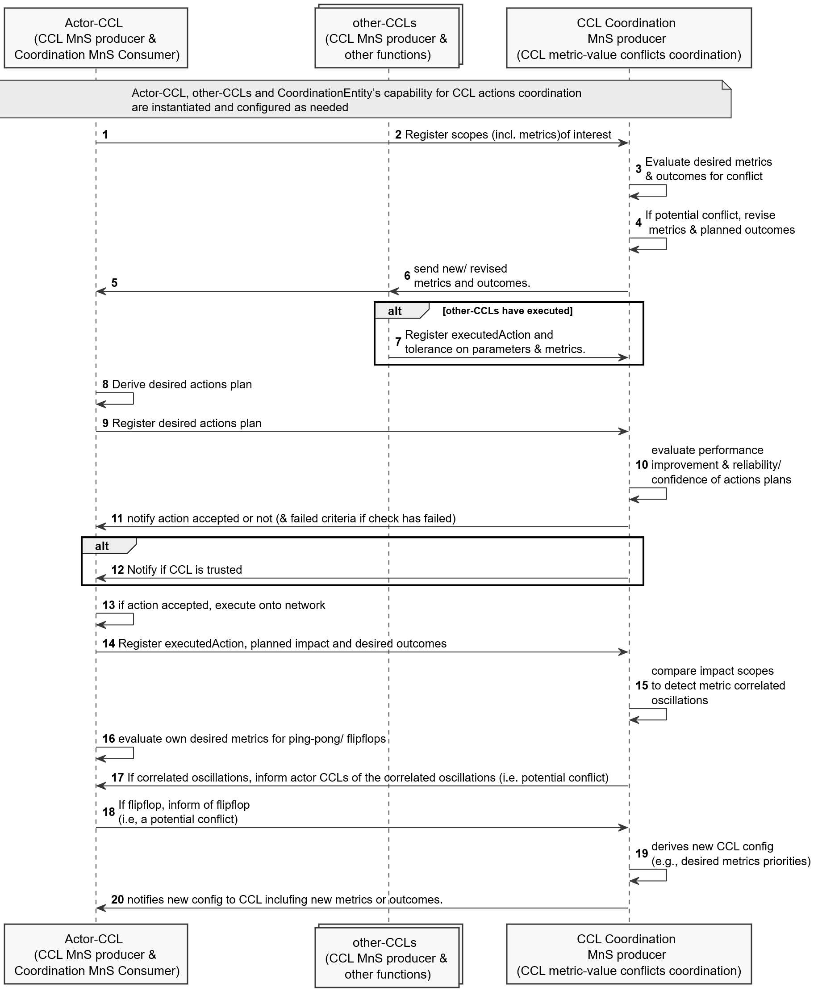

Figure 7.10-1: CCL metric-value conflicts avoidance and detection
Step 0 The set of CCLs and CoordinationEntity’s capability for metric-values conflicts coordination is instantiated and configured ( e.g., with the rules for evaluating and coordinating scopes for different use cases)
Step 1,2. The CCLs register their scopes of interest to the coordination entity including the scopes where they take measurements, take control actions, where their actions are expected to impact and their desired outcomes on those impact scopes. Where applicable, the scope have also been coordinated to ensure there are no conflicts for desired impacted scopes, the desired outcomes ion the impacted scopes, cross impacts between measurement and control scopes.
Step 3. The CCL coordination entity evaluates the metrics of interest and desired outcomes to see if they conflict with other CCLs. For example, based on the defined general objectives for the network scope (e.g. derived form an intent), the CCLCoordinationEntity may select the appropriate metrics and outcomes for the CCL.
Step 4. In case of a potential conflict, the CCL coordination entity derives revisions in the assigned metrics of interest and planned outcomes, to minimize contradictions or conflicts among the metrics and outcomes.
Step 5,6. The CCL coordination entity sends the selected new or revised metrics and outcomes to each CCL.
Step 7. Previous CCLs that have executed actions have registered to the CoordinationEntity, their executed actions, the scopes they expect to impact and their desired outcomes on those impact scopes.
Step 8. The actor CCL derives its desired action plan on to the network
Step 9. The actor CCL registers to the CoordinationEntity its desired action plan and the expected impact of that action plan (its claimed/predicted performance improvement) and reliability/confidence in that action/decision to be evaluated for potential significant degradation, i.e., that the actions are no unnecessarily too large.
Step 10 The coordinator CCL evaluates the claimed performance improvement and reliability/confidence to determine if the action should be allowed or not to avoid counter-productive actions - CCL making large changes, should have high reliability/ confidence and significant improvement in performance.
Step 11. The CoordinationEntity sends to the actor CCL its decision and the failed criteria in case the action plan has failed the evaluation For this, the CoordinationEntity updates the proposedReviseddActionPlan which is then notified to the respective CCL
Step 12. The coordinator CCL may also inform the CCL that the CCL has consistently made good decisions and achieved its ultimate trust. The CCL would not need to recheck its decision for appropriateness of the step change . For this the coordinationEntity updates the TrustedCCLs attribute with the DN of the CCL that has achieved full trust. The change is then notified to the CCL
Step 13. If the action is accepted, the actor CCL executes its desired action plan on to the network
Step 14. The actor CCL registers the executed action plans to the CoordinationEntity including the scopes they expect to impact and their desired outcomes on those impact scopes. The CCL writes into the desiredCCLActions attribute on the CoordinationEntity.
Step 15. The CoordinationEntity evaluates the impact scopes of the previous CCLs to detect metric oscillations which indicate a potential conflict.
Step 16. The CCL evaluates its desired metrics to see if there are ping-pong/ flipflop effects. The flipflop is an indication of a potential conflict which the CCL should notify to the CoordinationEntity.
Step 17. In case of correlated oscillations, the CoordinationEntity informs the actor CCLs of the correlated oscillations indicating a potential conflict. For this, the coordinationEntity updates the correlatedOscillation attribute in the metricValueConflict added to the list of observedMetricValueConflicts. It then notifies the CCL of the metricValueConflict
Step 18. In case of flipflop, the CCL informs the CoordinationEntity of the flipflop indicating a potential conflict. For this the CCL adds the metric that is flipflopping as an entry in the flipflopMetrics attribute of the coordination entity.
Step 19. The CoordinationEntity derives recommendations to the CCL including whether the CCL should change the prioritisation of its desired control metrics
Step 20. The CoordinationEntity notifies the proposed changes to the CCL including setting control metrics or their priorities.
Next change

9 Stage 3 definition for Closed Control Loop

9.1 RESTful HTTP-based solution set
The RESTful HTTP-based solution set for generic provisioning management service is defined in clause 12.1.1 in 3GPP TS 28.532 [3]. Corresponding className is ClosedControlLoop.
Following is the SS to support CCL lifecycle management and lifecycle management of Conflict management and Coordination entity(s) based on Table 12.1.1.1.1-1 in TS 28.532 [3].
Table 9.1-1: SS to support CCL lifecycle management
CCL lifecycle management | IS operation | HTTP Method | Resource URI
Create a  - CCL  - CCLScope | createMOI operation | PUT | {MnSRoot}/ProvMnS/{MnSVersion}/{URI-LDN-first-part}/{ClosedControlLoop}={id}  {MnSRoot}/ProvMnS/{MnSVersion}/{URI-LDN-first-part}/{CCLScope}={id}
Delete a  - CCL  - CCLReport  - CCLScope | deleteMOI operation | DELETE | {MnSRoot}/ProvMnS/{MnSVersion}/{URI-LDN-first-part}/{ClosedControlLoop}={id}  {MnSRoot}/ProvMnS/{MnSVersion}/{URI-LDN-first-part}/{CCLReport}={id}  {MnSRoot}/ProvMnS/{MnSVersion}/{URI-LDN-first-part}/{CCLScope}={id}
Modify a  - CCL  - CCLScope | modifyMOIAttributes operation | PUT  PATCH | {MnSRoot}/ProvMnS/{MnSVersion}/{URI-LDN-first-part}/{ClosedControlLoop}={id}  {MnSRoot}/ProvMnS/{MnSVersion}/{URI-LDN-first-part}/{CCLScope}={id}
Query a  - CCL  - CCLReport  - CCLScope | getMOIAttributes operation | GET | {MnSRoot}/ProvMnS/{MnSVersion}/{URI-LDN-first-part}/{in ClosedControlLoop}={id}  {MnSRoot}/ProvMnS/{MnSVersion}/{URI-LDN-first-part}/{CCLReport}={id}  {MnSRoot}/ProvMnS/{MnSVersion}/{URI-LDN-first-part}/{CCLScope}={id}

9.2 OpenAPI specification

9.2.1 OpenAPI document for provisioning MnS
The OpenAPI/YAML definitions for provisioning MnS are specified in 3GPP Forge, refer to clause 4.3 (OpenAPI Definitions) of TS 28.623 [17] for the Forge location. An example of Forge location is: "https://forge.3gpp.org/rep/sa5/MnS/-/tree/Tag_Rel18_SA104/".

Directory: OpenAPI
File: TS28532_ProvMnS.yaml

9.2.2 OpenAPI document for CCL NRM
The OpenAPI/YAML definitions for CCL NRM are specified in 3GPP Forge , refer to clause 4.3 (OpenAPI Definitions) of TS 28.623 [17] for the Forge location. An example of Forge location is: "https://forge.3gpp.org/rep/sa5/MnS/-/tree/Tag_Rel18_SA104/".
Directory: OpenAPI
File: CCLNrm.yaml

End of changes

