3GPP TSG-SA5 Meeting #164 S5-255537
Dallas, US 17 - 21 Nov 2025

Source: Rakuten Mobile
Title: pCR TR 28.884 Management Data Streaming based on Message Bus Potential Solution 2
Document for: Approval
Agenda item: 6.20.4
Spec: 3GPP TR 28.884
Version: 0.1.0
Work Item: FS_SBMA_Ph4

Comments
To address WT-1 of Study on Service Based Management Architecture enhancement phase 4, this contribution proposes to add potential solution for management data streaming based on message bus.

Proposed Changes
* * * First Change * * * *

Use case #2: Management data streaming based on Message Bus

5.2.3 Potential solutions
5.2.3.X Solution #2: Multipoint-to-Multipoint management data streaming based on message broking MnF
This potential solution proposes introduction of a new MnF implementing the message broker(s) that mediates data with the help of new MnS services, namely, message bus data reporting MnS and message bus data polling MnS (for data subscribers) to enable multipoint-to-multipoint streaming data reporting. This solution is meant for use at the management level and not at the managedElement/NF level.

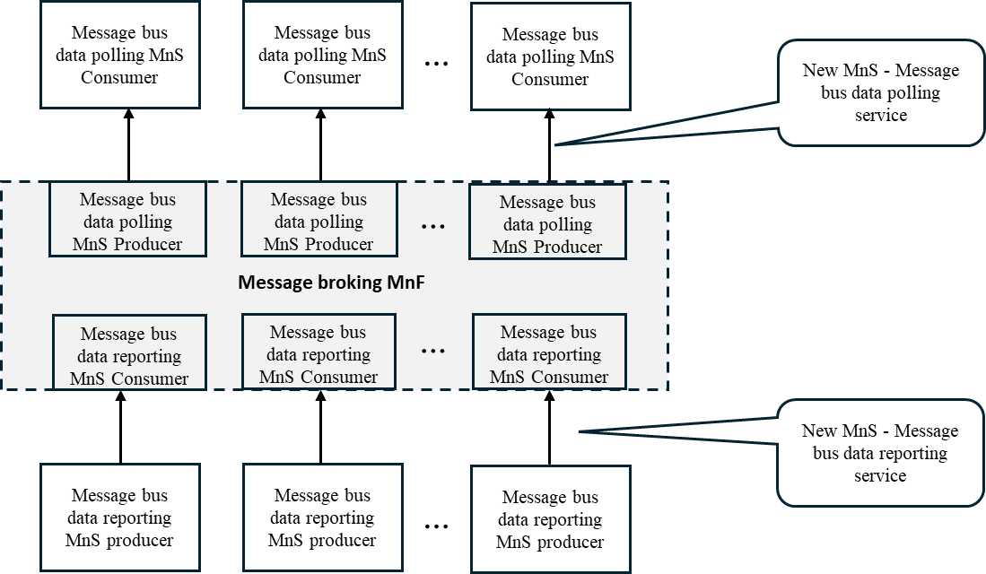
Figure 5.2.3.X-1: Potential solution for multipoint-to-multipoint management data streaming based on message bus
As shown in Figure 5.2.3.X-1, in this solution, Message bus data reporting MnS producers send management data to Message broking MnF using the message bus data reporting service based on message bus publishing protocol. Message bus data polling MnS consumers receive the management data using the message bus data polling service based on message bus polling protocol. This approach allows the same copy of management data produced by the Message bus data reporting MnS producer(s) to be shared across multiple Message bus data polling MnS consumers thus enabling multipoint-to-multipoint communication and a publishing-and-subscribing based communication pattern.
Editor’s note: The following aspects are FFS
- What types of management data (e.g. PM, tracing, analytic) to be supported.
- What specific message bus-based communication protocol to be supported (e.g. Kafka).
- How to configure message bus data reporting MnS producers about topics to be produced by the message bus data reporting MnS producers and message broker endpoint(s).
- How to configure message bus data polling MnS producers about topics to be subscribed by the message bus data polling MnS consumers.
5. How to do data access control.
* * * End of Changes * * * *

