3GPP TSG-SA5 Meeting #164 S5-255536
Dallas, US 17 - 21 Nov 2025

Source: Rakuten Mobile
Title: pCR TR 28.884 Management Data Streaming based on Message Bus Potential Solution 1
Document for: Approval
Agenda item: 6.20.4
Spec: 3GPP TR 28.884
Version: 0.1.0
Work Item: FS_SBMA_Ph4

Comments
To address WT-1 of Study on Service Based Management Architecture enhancement phase 4, this contribution proposes to add potential solution for management data streaming based on message bus.

Proposed Changes
* * * First Change * * * *

Use case #2: Management data streaming based on Message Bus

5.2.3 Potential solutions
5.2.3.X Solution #1: Point-to-Point management data streaming based on message bus communication protocol
The solution proposes the use of message bus for the reporting of management data from the MnS producer to the MnS consumer as shown in figure 5.2.3.X-1.
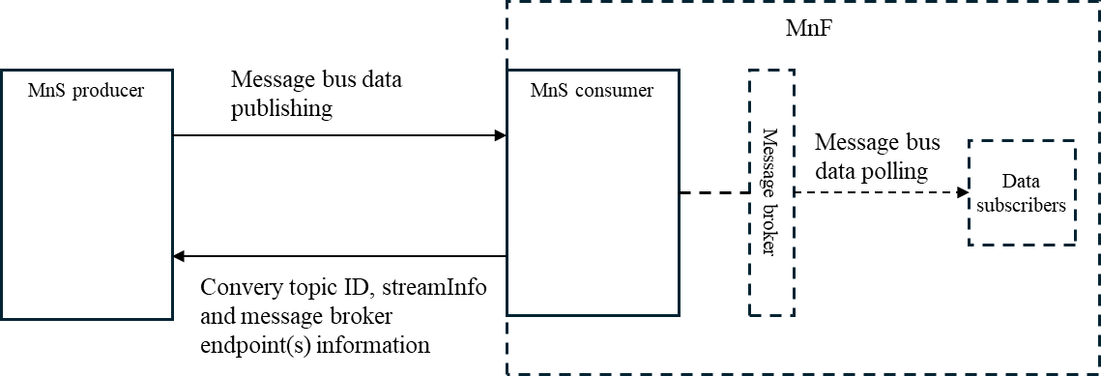
Figure 5.2.3.X-1: Potential solution for management data streaming based on message bus
The MnS consumer conveys topic ID, stream information and message broker endpoint(s) to the MnS producer. The same streamInfoList defined in 3GPP TS 28.532, clause 12.5 can be reused as the stream information to indicate what data types are requested to be reported in a particular topic. The MnS producer then starts reporting the data indicated in the streamInfoList to the message broker endpoint(s) provided by the MnS consumer using message bus data publishing protocol.

The solution enables multiple data subscribers within the MnF implementing the MnS consumer. However, between the MnS producer and consumer, it is still point-to-point communication.
A new streaming data reporting service may need to be introduced in 3GPP TS 28.532 to support the above operations. In the existing streaming data reporting service in 3GPP TS 28.532, the MnS producer initiates the streaming session and conveys streamInfoList to the MnS consumer. In the new streaming reporting service, it is the MnS consumer who initiates the streaming session by conveying topic ID, streamInfoList and broker endpoints(s) to the MnS producer. The new initiator direction enables management of topics, data types, reporting start time, reporting granularities period, message broker endpoints etc. at the MnS consumer side based on its need of data.
* * * End of Changes * * * *

