3GPP TSG-SA5 Meeting #164 S5-255534d1
Dallas, USA, 17 - 21 November 2025

Source: Huawei
Title: pCR TR 28.884 Update use case on management data streaming based on message bus
Document for: Approval
Agenda item: 6.20.4
Spec: 3GPP TR 28.884
Version: 0.1.0
Work Item: FS_SBMA_Ph4

Comments
This contribution proposes to update use case on management data streaming based on message bus in SBMA for 5G.

Proposed Changes
* * * First Change * * * *

5.2 Use case #2: Management data streaming based on Message Bus

5.2.1 Description
The 5G network employs a distributed, service-oriented architecture, leading to scenarios where multiple consumers request the same management data for multiple uses. In a typical network performance data reporting scenario, an MnS producer collects and transmits performance data to multiple MnS consumers within the network management system (e.g., real-time analytics, network optimization engines, visualization dashboards, and audit services).
The WebSocket protocol is standardized by the IETF in RFC 6455 [f]. It defines WebSocket as a protocol that enables ongoing, full-duplex, bidirectional communication between web servers and web clients over an underlying TCP connection, see [g].
Using point-to-point WebSocket communication protocol, which operates over a single TCP connection between a client and a server, a separate connection would be established between each consumer and the producer. For the case of multiple consumers requesting the same performance data, it causes the producer to retrieve and duplicate the relevant performance data from its cache for each connection individually.

By adopting a message bus architecture, the producer establishes connection(s) with the message bus and publishes the performance data only once. Consumers retrieve the data whenever they want (i.e., the consumer either pulls the data from the message bus or subscribes and receives messages pushed by the bus) - hence the principle of loose coupling. No additional connections are initiated by the producer, and no duplicate data reporting occurs on its side for the case that multiple consumers request the same performance data. Also, there is no strict limit on the number of consumers that connect to the message bus, supporting reliable large-scale scalability. Figure 5.2.1-x is a comparison example between WebSocket and Message Bus for the case that multiple consumers request the same performance data as an assumption. In this example:
- for the (a) WebSocket option, duplicate data reporting occurs N times on the producer's side for sending the data to the N consumers who request the same performance data.
- for the (b) Message Bus option, no duplicate data reporting occurs on the producer's side for sending the data to the N consumers who request the same performance data because the only one copy of data buffered on the message bus broker (i.e., a middleware that facilitates communication between different participants by acting as an intermediary for messages) can be polled by all the consumers.

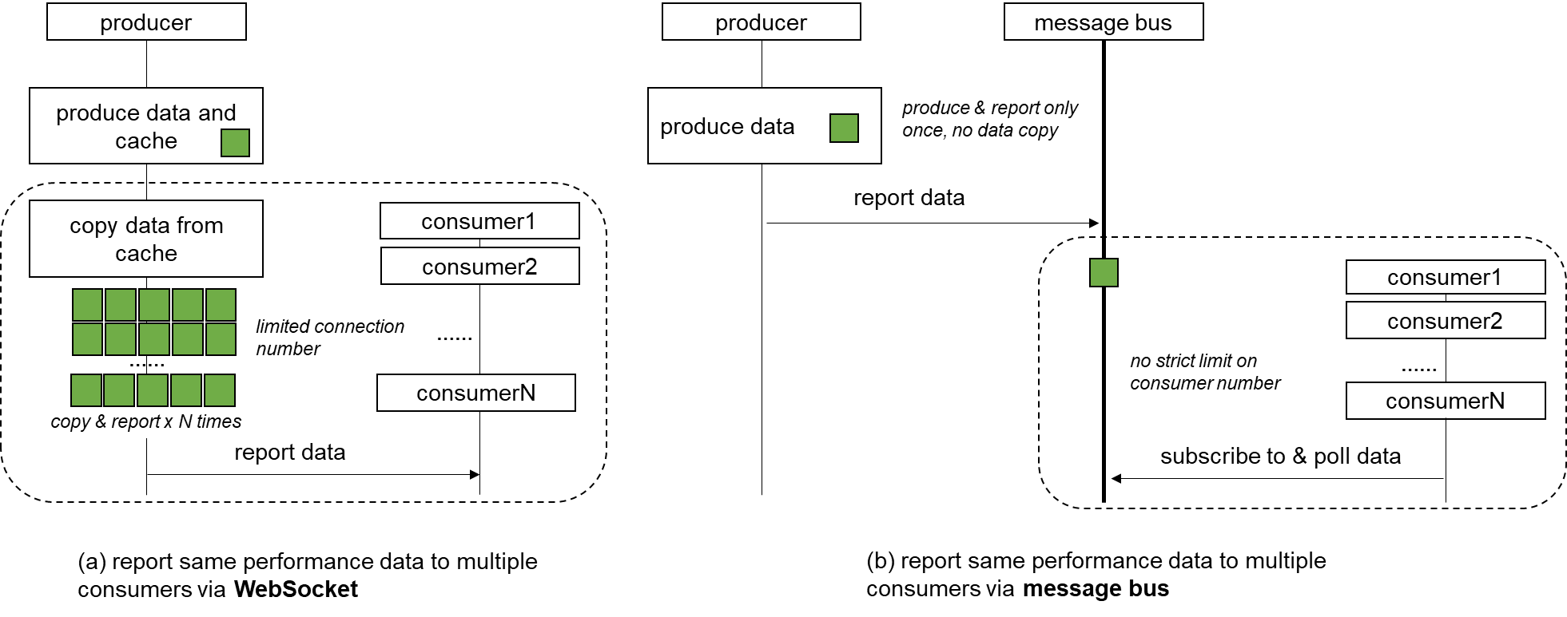
Figure 5.2.1-x: Comparison example between WebSocket and Message Bus for the case that multiple consumers request the same performance data
While the message bus architecture introduces certain operational considerations, such as the need for proper message category segmentation and consumer coordination management to avoid throughput bottlenecks. These aspects are addressed through established internal mechanisms and configuration practices. Such implementation details are outside the scope of this document. The message bus interface is not used on ManagedElement/NF level but only on management level.

* * * End of Changes * * * *

